Application for Tree Preservation Order (TPO): Wooden Garden Room

This section outlines the process and main considerations for applying for a Tree Preservation Order (TPO) related to building a wooden garden room within the rear garden of the detached property: 45 Oakwood Road, Chandlers Ford, Hampshire, SO531LW.
The application aims to ensure that the development respects and preserves protected trees within the designated area and meets the requirements of a permitted development.

Purpose of the Application
The application is submitted to request permission for the installation of a wooden single storey garden room. The proposed structure will be designed and installed in a manner that avoids interference with any trees subject to a TPO, maintaining their health and integrity throughout the construction and subsequent use of the garden room and complies with all relevant permitted development rights.

Permitted Development Considerations
The garden room has been designed and planned to comply with all relvant permitted development rights requirements. Its location, dimensions, construction materials and intended use have been carefully considered to ensure that the structure meets the statutory requirements for a permitted development.
Details (Important regulated dimensions highlighted)
- Dimensions:
Single Storey / Pitched Roof.
Exterior Dimensions (Footprint): 7200mm(W) x 4200mm (D).
Exterior Dimensions (Inc. Roof): 8000mm (W) x 4200mm (D) x 3650mm (H Roof).
Interior Dimensions 7000mm (W) x 4000mm(D) x 2285mm (H Roof Eaves) x 3250mm (H Roof Apex).
- Distance From Boundary / Fence Lines:
Distance to rear boundary / fence line will be 3 metres.
Distance to left and right boundaries / fence line will be 3.75 metres.
(Confirmed via survey visit).
- Use:
Garden Gym / Chill Out Area.
Not for Commercial Use.
Not for Accommodation.

- Area / Location:
The garden room will be located at the rear of the property, and it does not cover more than 50% of the total area of the site. We have no additional sheds / garden buildings anywhere in the property.

- Construction:
Eco friendly construction with fire resistant materials and insulation.
- Plans

Example Pic (Identical Design)

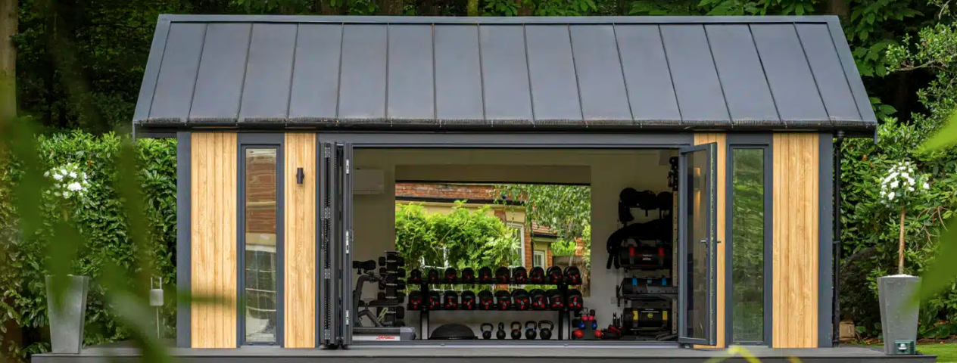
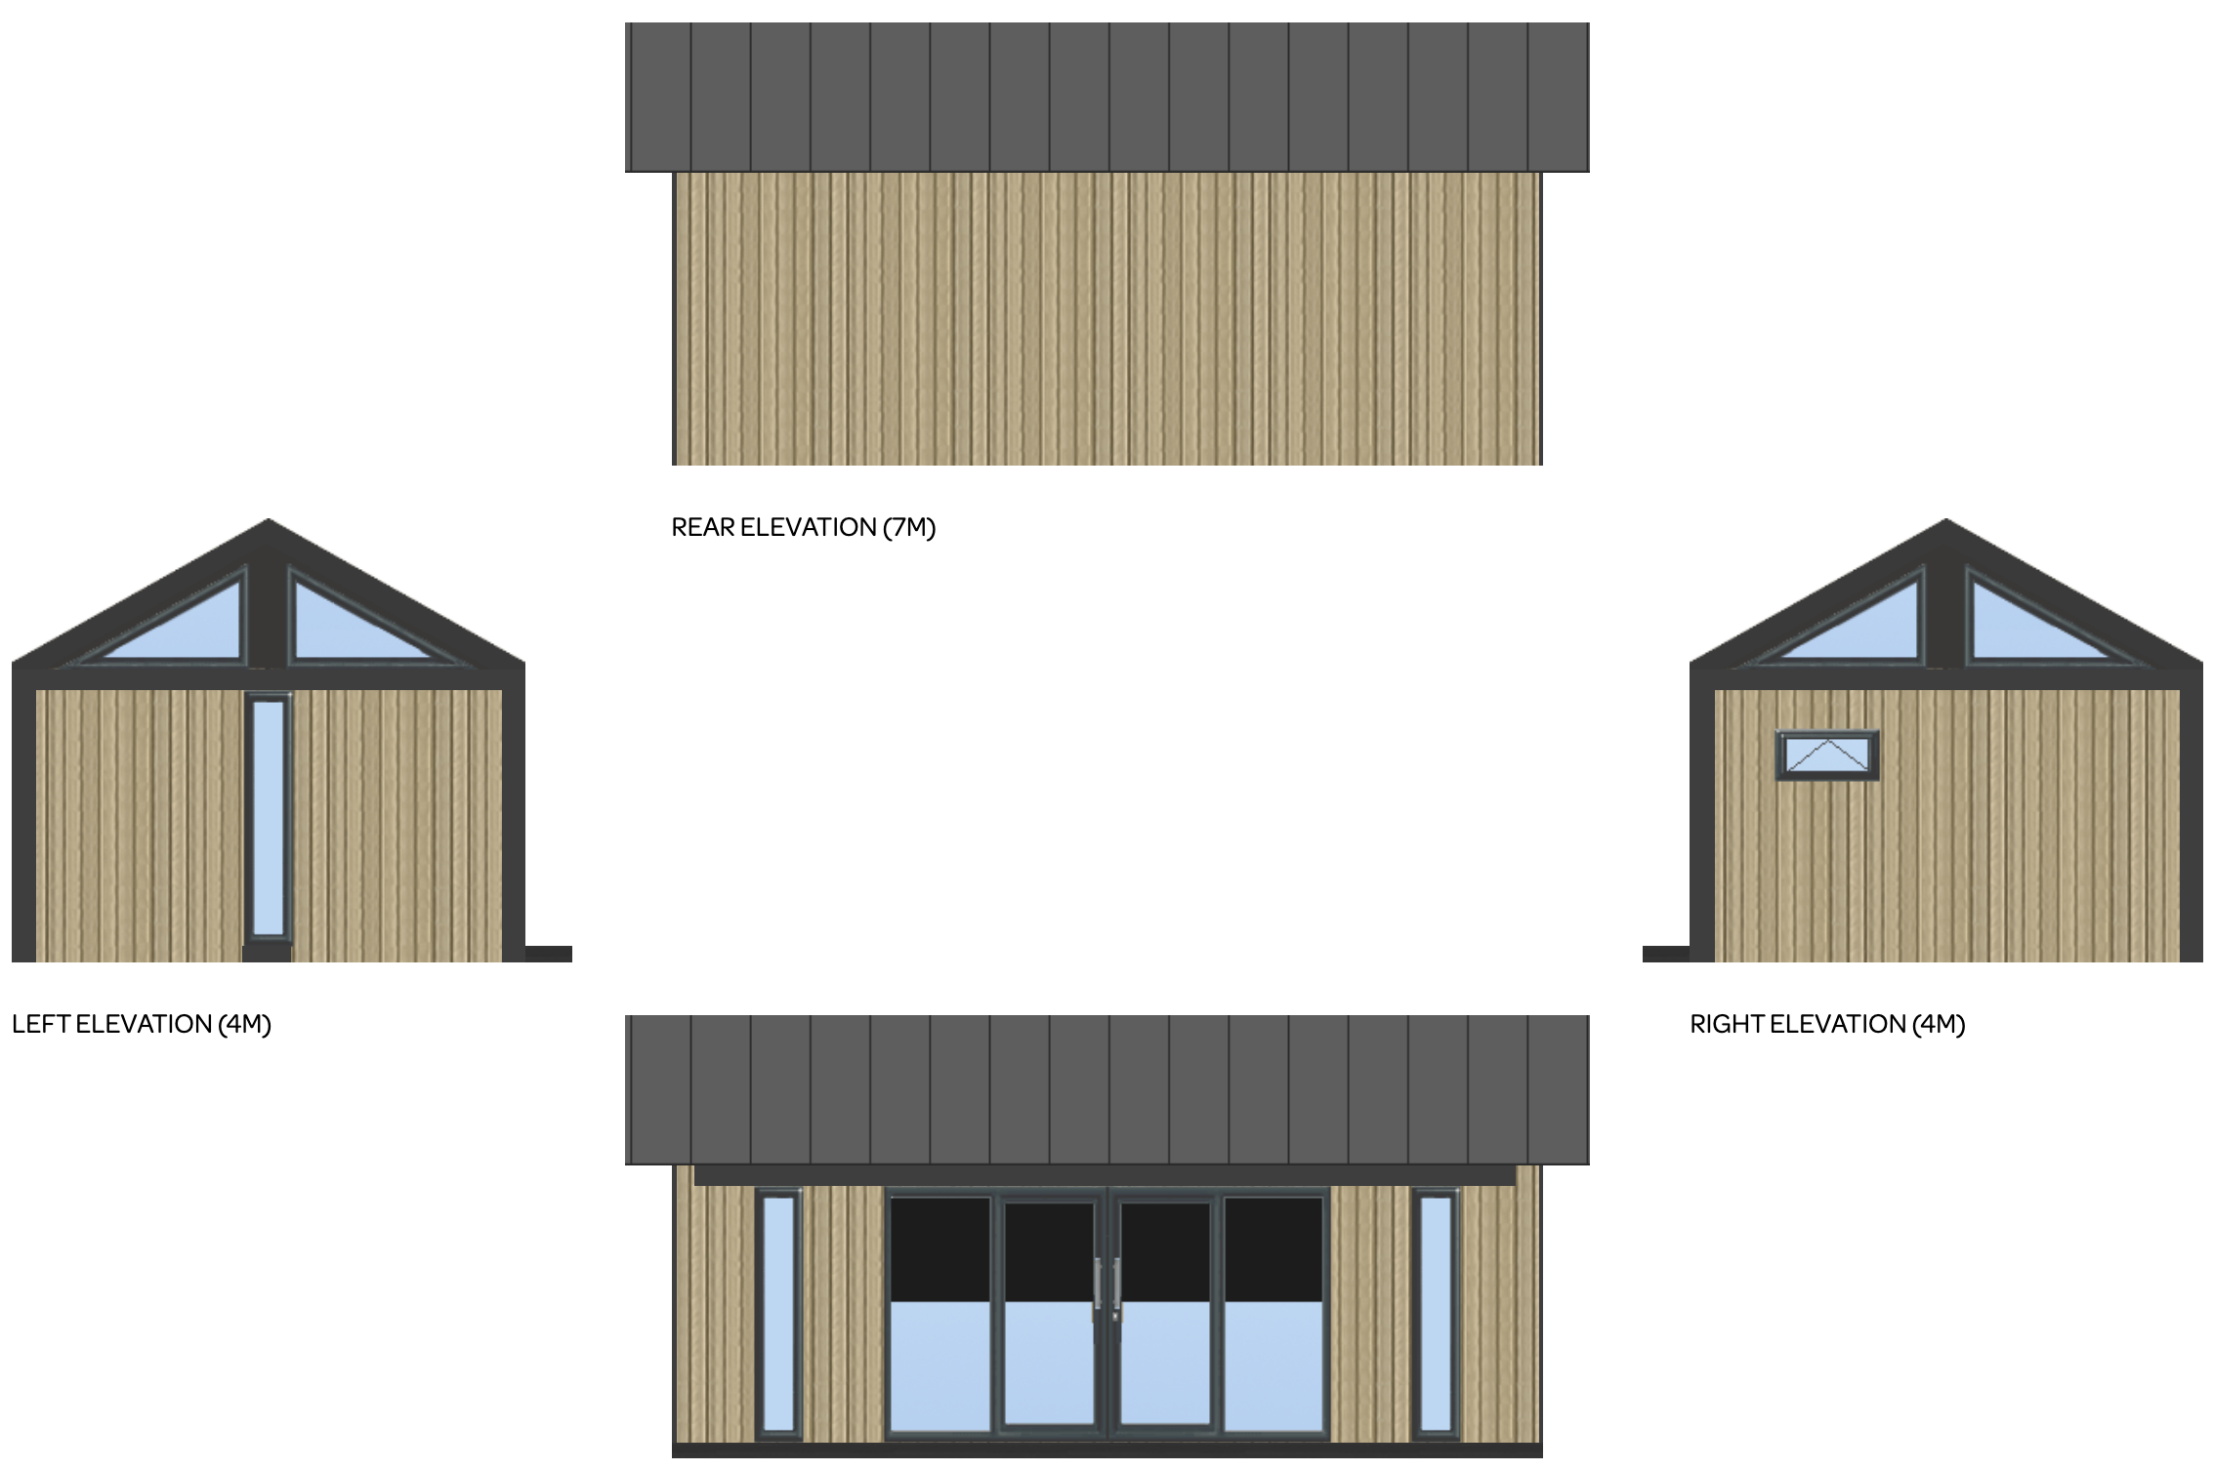

TPO Considerations
All works associated with the garden room will adhere strictly to TPO guidelines, safeguarding the roots, canopy, and overall condition of protected trees. The construction and install includes specific formal TPO method statements to prevent damage or disturbance, demonstrating commitment to the ongoing conservation of local arboreal assets.
The left and right edges of the wooden building will be approx. 2-3 metres from 3 mature TPO trees located right in the rear corners of our garden. 2 x OAK / 1 x PINE.
No tree pruning or damage of lower branches will be required for the install.
Green Retreats have a specific method statement (see below) for cases where garden rooms are installed in TPO areas. We can ensure photographic evidence of the TPO pile foundation process for records. The pile system is installed via their own engineers and they do not use 3rd party teams.
We have no existing sheds / garden rooms in our property and many of the other properties on the street have med / large garden sheds / rooms within their rear gardens.
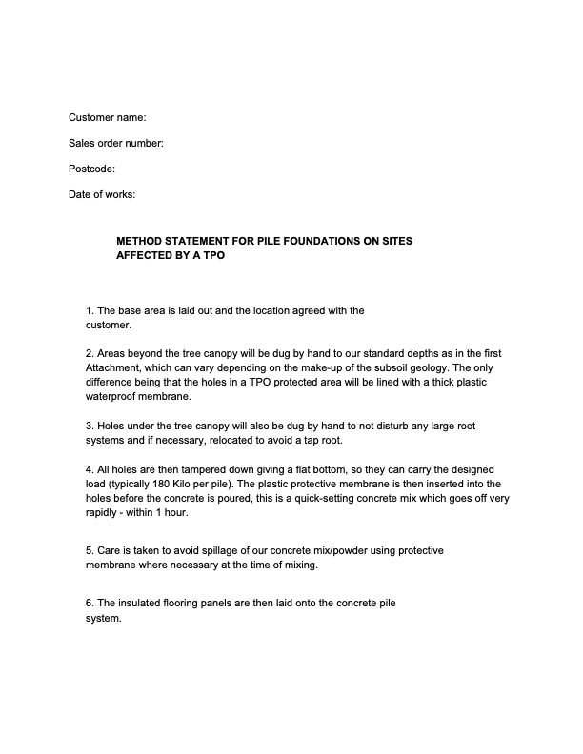
Green Retreats are the largest and most experienced garden room manufacturer in the UK. Formed in 2005.
Website: greenretreats.co.uk

Garden Plan / Photos

