O/26/101177 Land at Holly Tree Far, Boorley Green
Interim Ecology Comments 28.5.26
I have not yet thoroughly looked at all of the documents. Generally, the development appears well designed. Initial comments are only in note form below. I would welcome a conversation with the drainage consultants, maybe also with the LLFA so we’re all on the same page.

- The plans in the DAS do not have scale bars and therefore is it difficult to determine distances.

- There must not be any development, including SuDS features within 20m of the SINCs. This will also provide more robust wildlife corridors. It looks like the SuDS basins may potentially be within the 20m buffers.

- It is a really positive approach to have limited development, within 65m of the ancient woodland of Holly Tree Farm Wood SINC (1A/ 1Cii) (to the east of the existing PRoW). The SuDS basins proposed can be designed sympathetically to enhance the ecological function of the immediate area.

- The loss of 140m of hedgerow as shown on plans (shown as 120m in BNG metric) along Maddoxford Road (primarily for visibility splays but also for a pedestrian and cycle connection) is not ideal. I appreciate the clear proposals though. The fact it is a species poor hedgerow which is managed to be fairly low and narrow provides some comfort – a replacement hedge can be species rich and managed in a more favourable way for wildlife.

- It may just be the scale of the map, but there are a couple of points which appear to be too close to the boundary vegetation (circled red below). The development should be set back from these features to provide edge habitat and ensure tree works will not be required to facilitate the development or for other reasons into the future (protection of RPA, no development under the canopy, allowing for growth).

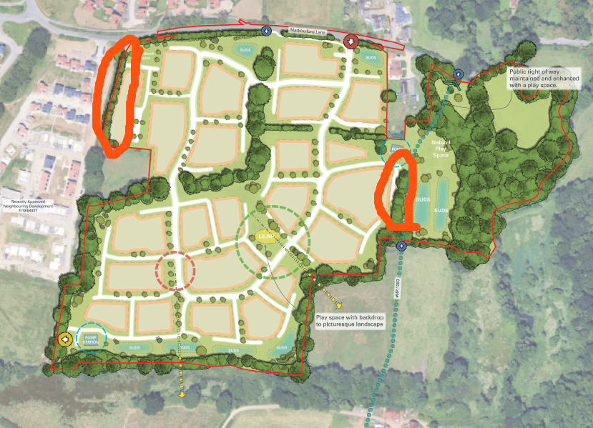

- There are some inconsistencies between the layout used for the BNG calculations and the indicative layout in the DAS. Notably the N-S road link at the west, the footpath network and SuDS features. The footpath network should be positioned to minimise losses and fragmentation of the existing hedgerows:
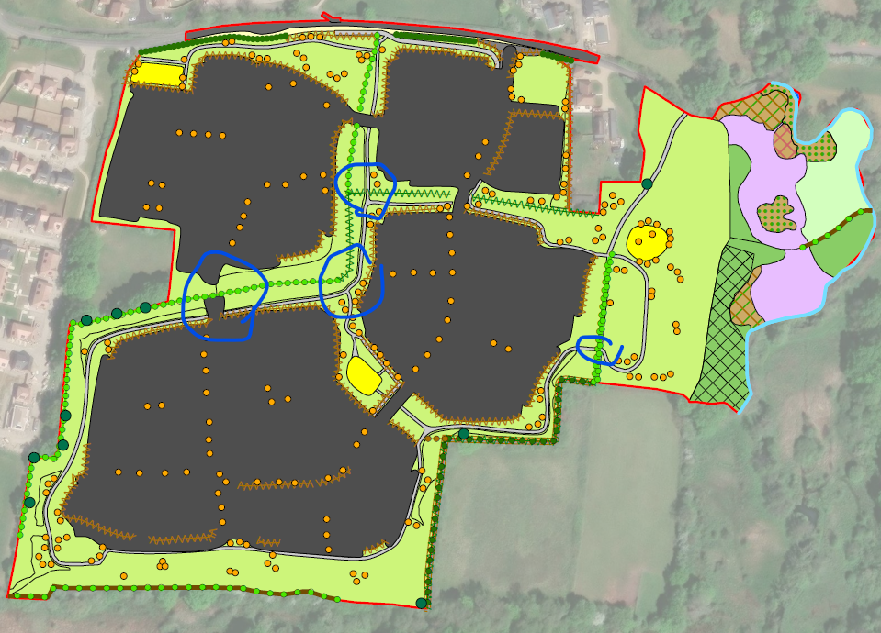
The SuDS basins are included in the BNG metric but not shown on the BNG plan.

- The BNG metric does not demonstrate 10% BNG for the watercourse. Additionally, the watercourse to the south of the site is not shown in the BNG metric or plans. If any of the watercourse or its riparian corridor (10m from the top of bank) is within the red line boundary, it must be included in the metric.

- The BNG metric does not satisfy the trading rules regarding bramble and mixed scrub. There is a net loss of these scrub habitats. Scrub habitat is extremely valuable to wildlife and there must be a greater provision of it on site to ensure the trading standards are met. More of scrub parcel 23 (location marked with an x below), north of the proposed LEAP, could be retained as this is also an excellent aspect for wildlife (such as reptiles and invertebrates) as well as humans. It would benefit wildlife and its movement if the green corridor circled below was strengthened.
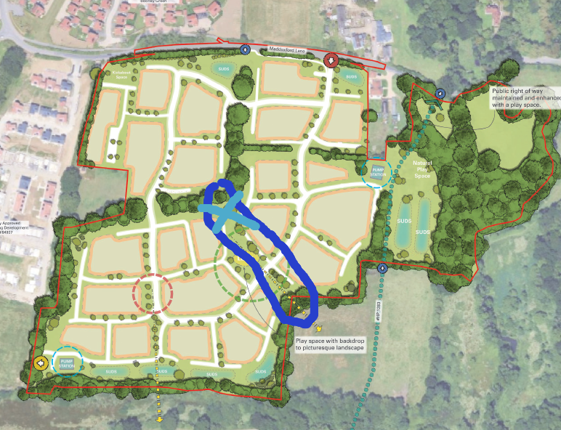
- BNG metric – the parcel numbers in Figure 1 Baseline Habitats, are not referenced in the metric and therefore it is difficult to correlate the two.

- BNG metric and LNRS (strategic significance) – following on from the point above, only one individual veteran tree (circled red) is potentially in the LNRS (blue highlight below) – this would not equate to 0.37Ha. Please can clarity/ explanation to aid my understanding be given please?

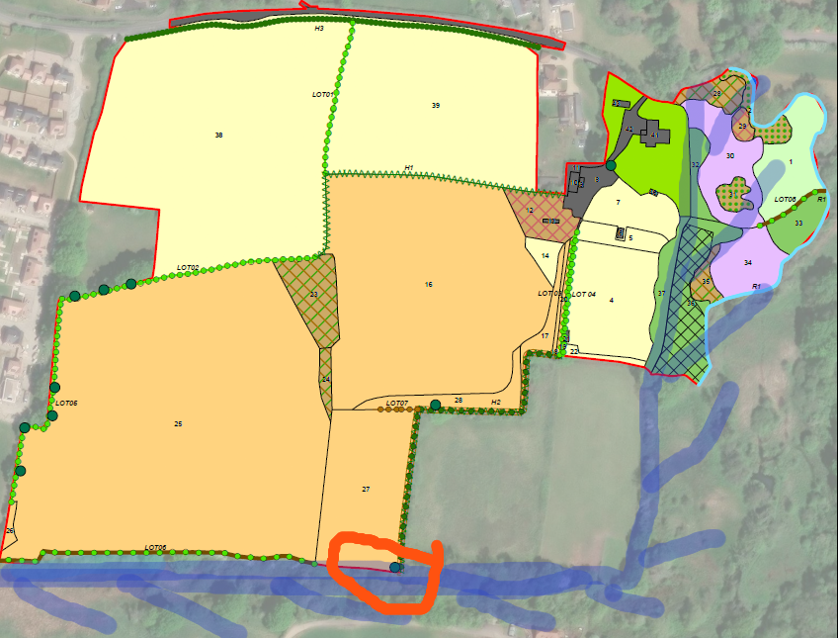

- Ecological enhancement of the SINCs within the ownership of the applicant is not proposed. The SINC is within the LNRS and therefore has measures attributed to it. Have any potential enhancement measures been identified following survey work? It is important that there is ongoing management of the SINC habitats to maintain (and potentially enhance) their ecological value. The development has the potential to negatively impact the SINCs and any access, unauthorised or other, must therefore be managed. An access and habitat management plan for the SINCs must therefore be produced and followed.

- Access to the adjacent SINC to the south, out of the ownership of the applicant, must also be controlled.

- Are any works to the PRoW needed or proposed, being mindful of any impact to tree roots/ other ecological impact.

- I have not looked beyond the headline species results yet but any impacts must be mitigated by provision of appropriate habitats within the greenspaces (to complement the BNG proposals) and within the built development (detailed plans can be conditioned). Enhancements must be provided also.

- Other impacts beyond direct habitat loss, such as lighting and construction impacts must also be considered – probably conditioned. However, information on building heights should be provided at this stage with any taller buildings being moved away from the greenspaces to reduce shading impacts.

- I haven’t looked at the HRA and AQ yet but I don’t anticipate any significant issues.

- FRA: Surface water runoff quality s5.19 – DM6 also needs to be complied with. All runoff (even from the lower areas) needs to flow through three forms of filtration in a train. Usually this provides one more form of filtration than the Simple Index Approach alone.

- Treatment at source and interception must be maximised. Rather than having all treatment at the low points in basins, swales and similar can penetrate the whole site from the upper parts of the catchment down to the lower parts.

- Discharge points – mimicking the existing hydrological regime is best. Although I like the concept of a dispursement swale which avoids the impacts of installing infrastructure for a discharge point, concentrating all the water to a smaller area of woodland (circled red below) may have a detrimental impact on the woodland e.g. too much water inundation. A series of dispursement swales along the dotted line should not change the existing regime as significantly, especially if water slowing measures (SuDS features) are integrated in the upper part of the site.

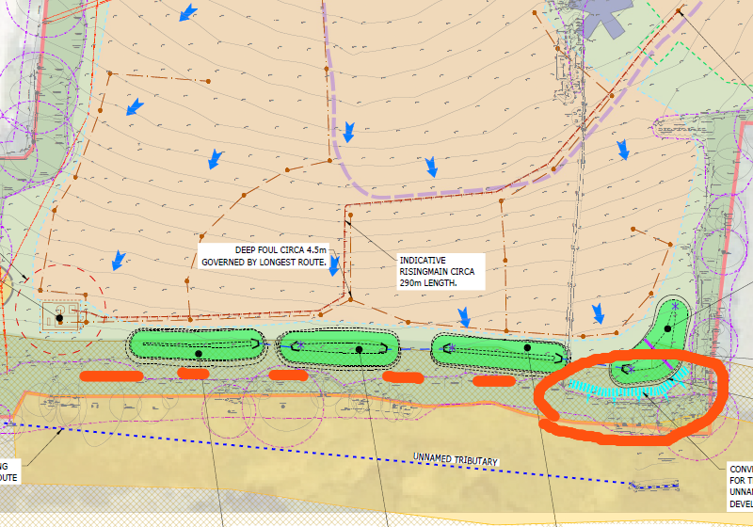

- Similarly, as above, a lot of water is being concentrated by the ancient woodland (circled red below). This change of hydrological regime potentially could cause significant damage to this irreplaceable habitat. A good amount of this water currently must enter the highway ditch along Maddoxford Road (possibly along the alignment of the purple dotted line?) before it enters the River Hamble (very badly drawn blue line):
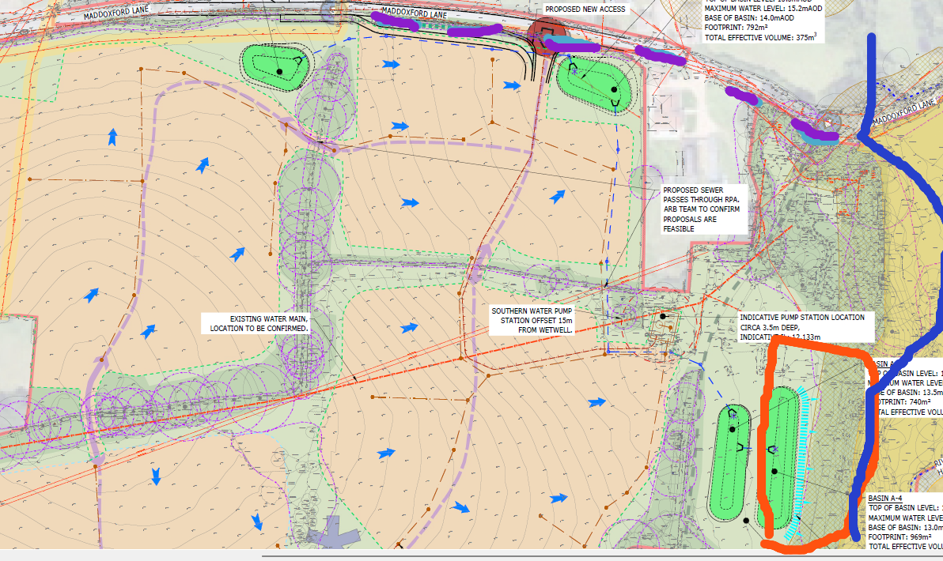

I’m not sure of a solution here as putting a discharge pipe through the ancient woodland is also not favourable. Maybe we could have a conversation with the consultants to talk about other options.

