No 12 GOLDSMITH ROAD
EASTLEIGH, HAMPSHIRE SO50 5EP

Design & Access Statement

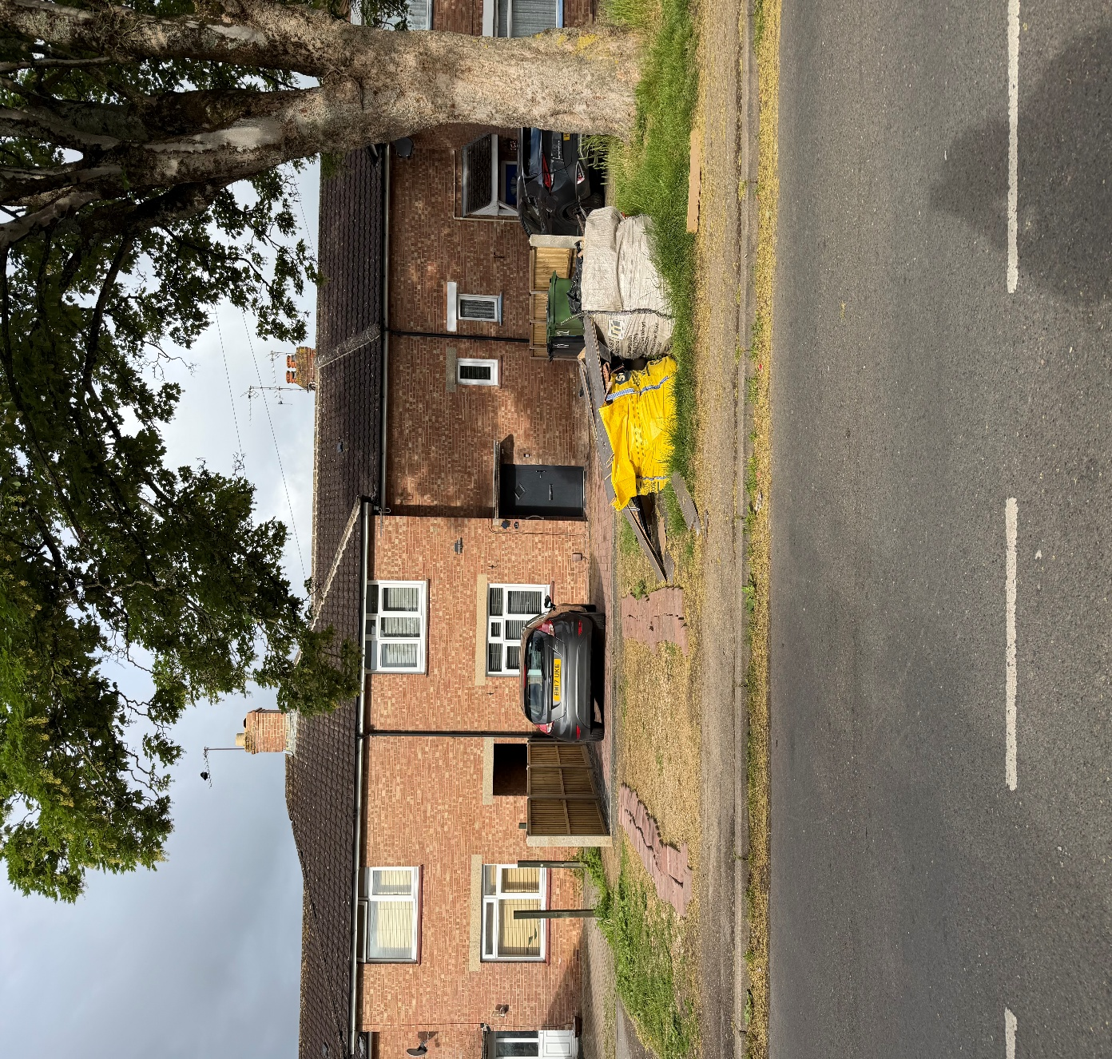

Prepared by BJC Design Southeast Ltd

No 12 GOLDSMITH ROAD
EASTLEIGH, HAMPSHIRE SO50 5EP

Design & Access Statement

Prepared by Mr. Brendan Carroll MCIAT
of
BJC Design Southeast Ltd

JUNE 2026

© BJC Design Southeast Ltd
Disclaimer:
This document has been prepared for the titled project or named part thereof and should not be
relied upon or used for any other project without an independent check being carried out as to
its suitability and prior written authority of BJC Design Southeast Ltd being obtained. BJC Design Southeast Ltd
accepts no responsibility or liability for the consequences of this document
being used for a purpose other than the purposes for which it was commissioned. Any
person/party using or relying on the document for such other purposes agrees, and will by such
use or reliance be taken to confirm their agreement to indemnify BJC Design Southeast Ltd for
all loss or damage resulting therefrom. BJC Design Southeast Ltd accepts no responsibility or
liability for this document to any party other than the person/party by whom it was
commissioned.
No 12 GOLDSMITH ROAD
EASTLEIGH, HAMPSHIRE SO50 5EP
Design & Access Statement
1.0 INTRODUCTION
1.1 No. 12 Goldsmith Road is a mid-20th century building located on the West side of Goldsmith
Road which is in the Borough of Eastleigh Hampshire. The owners of the property are seeking planning
permission to provide a clean & safe crossover for their family vehicle. Plans for the proposals have
been prepared by BJC Design (Southeast) Ltd.
1.2 The local planning authority, Eastleigh Borough Council, have requested an access & design
statement to consider the potential impact of the development upon the character and appearance
of the designated Local area.
1.3 BJC Design Southeast Ltd has been commissioned to make an assessment of the contribution of the
property to the character and appearance of the Local area and review the potential impact of the
proposal upon that significance.

2.0 DESCRIPTION
2.1 No. 12 Goldsmith rd is in a mid-terrace of two storey houses constructed in orange-red brick
with hipped dark brown tiles roofs. There are two three-light casements to ground and first floor
levels with a small window giving light to the mid-landing of the staircase. The principal entrance
is located midway on the front elevation
2.2 The property is set back from the street frontage and is approached across rough terrain between the
public pavement and a block-paved parking area, which extends across the full width of the front garden.
2.3 The front boundary of the property is open, and the side boundaries are separated from the adjoining
properties by a wooden fence.
2.4 The adjoining properties have Tarmac crossovers and dropped kerbs, which give safe, clean access to
the parking areas within their front gardens.
2.5 There is a large Sycamore tree whose trunk is located in front of No.14 Goldsmith rd.

3.0 PROPOSALS & ASSESSMENT OF IMPACT
Proposals
3.1 The excavate to a depth of approximately 200mm and provide a 125mm porous sub-base and
A top layer of 75mm Porous Tarmac, rolled smoothly to finish. The area between the tree-trunk
and new crossover will be re-seeded with grass seed, and the area tidied and left clean.
3.2 The low level of the proposed development will be in keeping with the adjoining properties,
And will improve the appearance of the property and surrounding area in general

4.0 DESIGN & ACCESS
Design
4.1 The proposed crossover is designed to respect the character of the existing building and adjoining
properties in terms of its materials, design and appearance. As such, it is believed that the proposed
work will enhance and be in keeping with the wider character of Goldsmith Road.

Access
4.2 The owners of the property, Mr and Mrs Cousins, have a disabled daughter and urgently
require safe access and parking. They find access with a vehicle & pushchair to the highway
very difficult. They have placed loose bricks on the existing crossover to try and prevent their
car from getting bogged-in or slewing sideways when the area is wet.

5.0 CONCLUSION
5.1 It is considered that the proposed crossover to 12 Goldsmith Rd will not cause harm
to the character and appearance of the Local Area. Accordingly, I can find no conflict in
the proposed development and conclude that the application should be allowed.

BJC Design Southeast Ltd

