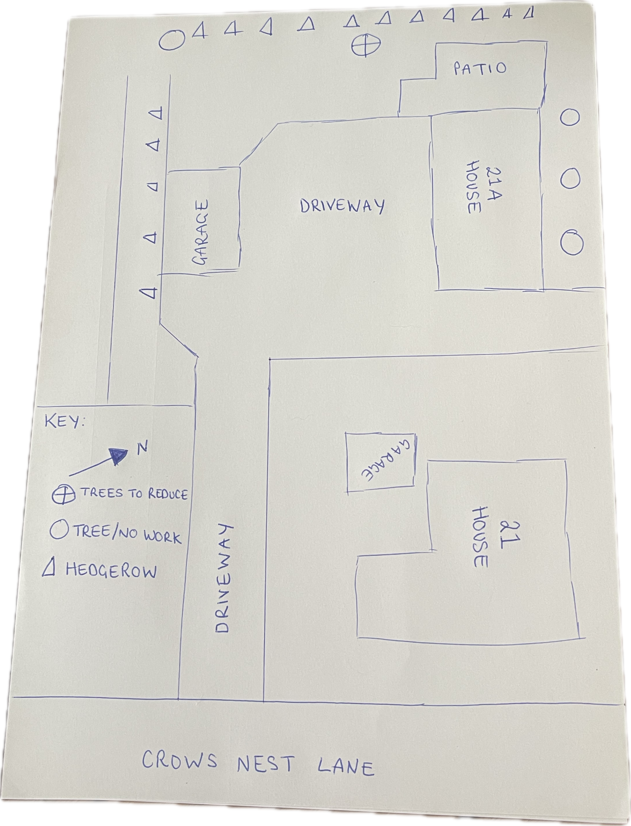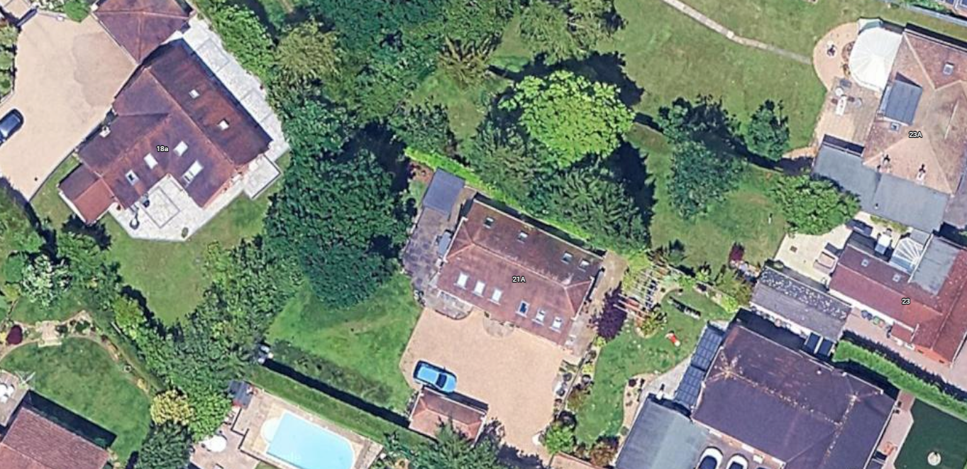

Works description:
Reduce the overall crown of the Oak Tree by approximately two metres, pruning back to suitable growth points, appropriate pruning techniques and retaining the trees natural shape and form. The reduction will be carried out evenly throughout the crown to maintain a balanced canopy.
The proposed works are intended to reduce the overall size and spread of the tree while maintaining its structural integrity, health and amenity value. All works will be carried out in accordance with BS 3998:2010.

The proposed works are intended to reduce the overall size and spread of the tree and allow increased levels of natural light to reach the garden and patio area. The tree is also situated within falling distance of the property, and the proposed reduction will help to manage the overall size and extent of the tree while retaining its structural integrity and health.

