DC/26/101673 91B The Crescent
Ecology comments 18.8.26
Further information is required.
Please note that information has not yet been submitted regarding the conditions relating to BNG and ecological enhancements which are very closely related to the conditions below.

Condition 7 Drainage
Insufficient information has been submitted to discharge this condition and there remain outstanding unknowns.
Site investigation still has not been carried out so it is still not known how the surface water will be discharged from site. Soakaways are proposed on the plans but ground conditions are still to be investigated (“subject to ground condition investigation” is stated on the proposed SuDS plan):
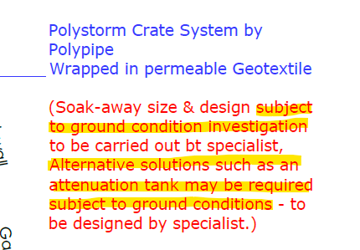
Site investigation may conclude that discharge by infiltration is not feasible. If this is the case, a discharge point will need to be identified and suitability assessed.
Sufficient filtration of the surface water to satisfy policy DM6 is required whether this is via discharge to ground or surface water. Information needs to be submitted regarding this.
The SuDS plan also states that permeable paving is assumed:
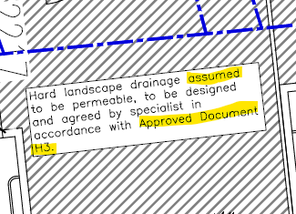
Certainty is required. All paving (for car park and dwellings) should be permeable. This will provide a form of treatment for water quality purposes and will also reduce run off rates and required storage volumes. I cannot find any information regarding run off rates, flows or storage volumes. The LLFA does not comment on applications of this size but it is the responsibility of the LPA to ensure flood risk is not increased by the development.
I cannot find the “approved document H3” in the full application mentioned on the SuDS plan. There is no reference to this in the decision notice either. This document may have additional information on the above apparent omissions.
A rain garden is proposed thus adhering to the updated discharge mitigation hierarchy which also provides surface water treatment and biodiversity benefit. However, the drainage infrastructure appears to be bypassing it and therefore the only rain it will get is that falling directly onto it, which is not different to any other landscaped area:
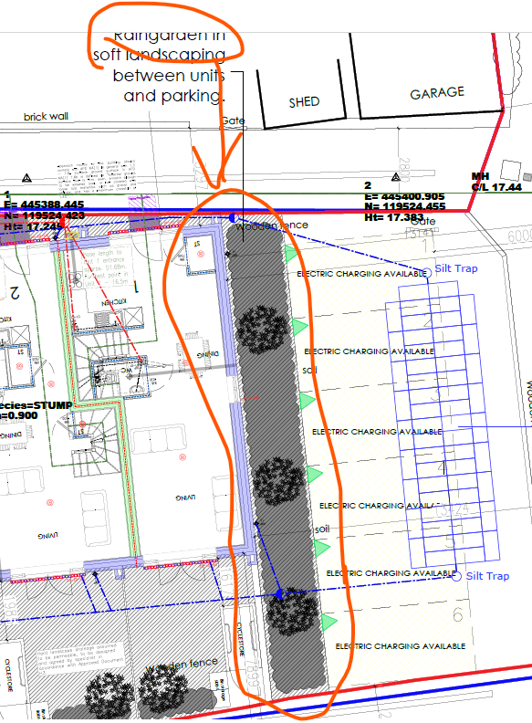
Please can cross-sections be provided to show how the drainage interacts with the rain garden.
There is no indication of what the light blue dashed line on the drainage plan shown below is:
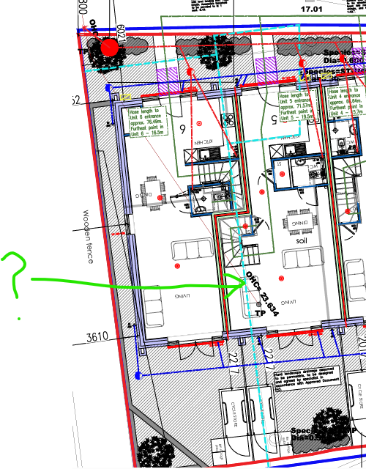

Condition 12 Landscape Scheme
I support the Landscape Officer’s comments.
From a BNG perspective, no habitat is being retained. There is a 95.7% net habitat loss on site. Offsite units will need to be purchased. The habitats being created on site as shown on the landscape plan is broadly in line with the BNG onsite calculations, although the hedgerow to be created onsite is not included in the metric and proposed condition is therefore unknown. In terms of the metric, the proposed urban trees on site are anticipated to be of “poor” condition, presumably because of the limited space to reach a mature height and spread.
Condition 12 requires details of timings for all landscaping and any future maintenance. The 30-year Landscape Plan (The Landscape Service, Jan 2026) submitted in the full application, has a lot this information within it. Some information however is missing, such as the height of the hedgerow (out of the visibility splays) and how often it will be maintained e.g. will it be cut every few years to maximise its biodiversity value? It may be more practicable to modify this existing document to include all relevant information for the site in one document for individuals carrying out the management. Can it also state who will be responsible for the management of different parts of the development (maybe different areas under different management can be shown on a plan) and who will be responsible for monitoring and ensuring correct management is carried out.
I too have concerns that not all the plant and tree species proposed for the rain garden will be compatible with the conditions present in the rain garden. I defer to the Landscape Officer’s recommendations regarding species specifications. Management of the rain garden to optimise biodiversity benefits will need to be specified. Please note, access for management of the rain garden may be difficult with the proposals as they stand as most of its perimeter is surrounded by the hornbeam hedge.
Condition 12 also requires details of boundary treatment and all hard landscaping. A brick wall is proposed around the west, south and east sides of the houses. The rear gardens will therefore be largely impenetrable to wildlife and the rain garden will also be disconnected from the rear gardens and become isolated in its surroundings. To enhance the site for biodiversity, more permeability for wildlife must be incorporated into the design of the boundary features. This must include regular holes in the base of the boundary features (and between gardens and across the whole site) to allow mammals such as hedgehogs and other fauna to move around the site.
Regarding other hard landscaping, the design notes on the landscape plan state that the hard surfacing must comply with the SuDS. Please see drainage comments above regarding the need for all hardstanding to be permeable. It may be beneficial to state permeable paving on the landscape plan too.

Condition 11 Materials
This condition states that details of the materials to be used for various items including rainwater goods must be submitted. I cannot find any submitted information regarding rainwater goods. Please can details be submitted.

Condition 8 CEMP
We would like more information regarding the control of dust and dirt, particularly that carried in surface water runoff. Section 7.3 in the CEMP mentions this to some extent but not in sufficient detail. Can the appropriate measures to stop silt leaving the site be outlined and locations of these shown on a plan.

Sarah Boyd
Ecologist

