South House,
School Lane,
Hamble,
Southampton,
SO31 4JD

PHASE 2 BAT EMERGENCE
SURVEYS
May 2026

Dr.Jonty Denton (Chartered Ecologist) FRES FLS MCIEEM CECol

Prepared by
Dr. Jonty Denton Bsc (Hons) D(Phil) FRES, FLS, MCIEEM, CEcol
(Chartered Ecologist)
31 Thorn Lane, Four Marks, Hampshire, GU34 5BX
Phone: (01420) 565647 mobile: 07935594093

SUMMARY
A dusk emergence survey was carried out on evening of 3rd and 31st May 2026. All potential openings were covered by the surveyors with Canon XA60 HD digital camcorders with IR illumination and EchotouchPro and batlogger detectors employed to monitor and record bat activity.
No bats emerged from the property and activity was low on both visits
No further surveys are recommended.

Survey Team
Dr.J.Denton is a licensed bat ecologist with over 30-years experience monitoring bats across England & Wales.
Ruby Denton Bsc (Hons) has over 8-years experience, clocking up over 700 hours on Phase 2 emergence/re-entry and transect work, and has experience of 11 species across Southern England.
Laura Denton Bsc (Hons) Msc has over 7-years experience, clocking up over 300 hours on Phase 2 emergence/re-entry and transect work, and has experience of 10 species across South-East England.

TIMING AND METHODS
The surveys were conducted at dusk on the 3rd and 31st May 2026.
Canon XA40 HD digital camcorders with IR illumination were employed to cover all potential openings (see figure 1).
Survey commenced 30 minutes before sunset and continued until 90 minutes after sundown. EchotouchPro detectors were employed to monitor and record bat activity.
RESULTS
The nights were suitable for bats with common pipistrelle active.
The evening of the 3rd May was clear and mild with a starting temperature of 15°C. Just two passes by common pipistrelles were recorded.
The evening of the 31st May was clear and warm with a starting temperature of 18°C, once again only two passes by common pipistrelles were recorded.
SPECIES ENCOUNTERED
Common Pipistrelle
Two passes recorded on each survey. One foraging briefly under street light to west on 3rd May.

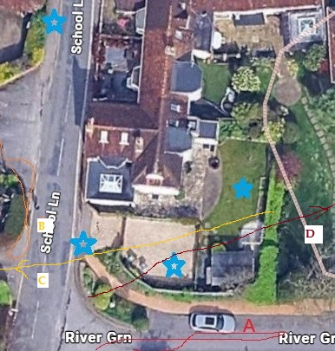
Figure 1. Surveyors and cameras (blue stars), passes (red, yellow, crimson and orange lines)

CONCLUSIONS
No bats emerged from the property and activity was very low.
No further surveys are recommended
In the unlikely event of any bats being found during demolition or construction, all work must stop immediately, and Natural England must be called. Additional information is available on the Bat Conservation Trust website at https://www.bats.org.uk/advice/imworking-on-a-building-with-bats/ive-found-a-bat-during-works.

New exterior lighting should be avoided, but if necessary for security purposes, then the latest updated lighting guidance note (GN08/23) should be followed. This is available at Guidance Note 8 Bats and Artificial Lighting | Institution of Lighting Professionals (theilp.org.uk) and supersedes all previous guidance.

APPENDIX 1. FIELD DATA
Project |  | Start time | 20.00 | Finish | 22.15 | Temperature | 15 C at start 13.5 C at finish
 |  | 3.5.26 |  | sunset | 20.31 | Weather  0% cloud beaufort 0
 | Bat passes heard
Station no. | Start time |  | No. | passes | comments
S | 20.47 | Common Pipistrelle | 1 | 1 | over road on house on River Green Lane (flightpath A fig 1)
w | 21.11 | Common Pipistrelle | 1 | 1 | under streetlight on School Lane opposite the driveway (flightpath B on fig 1)

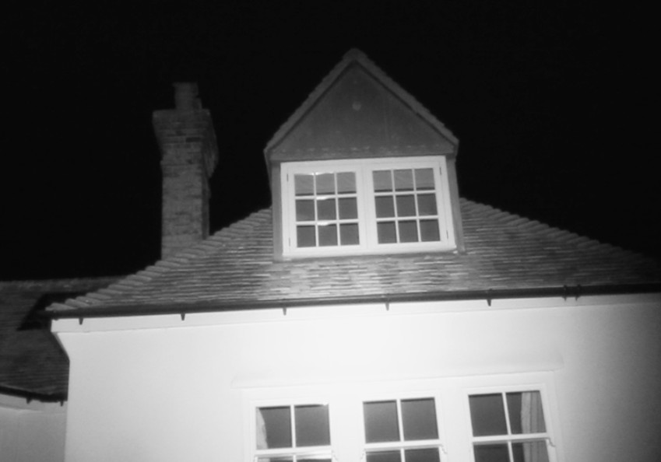
Figure 2. South camera dark sky 3.5.2026
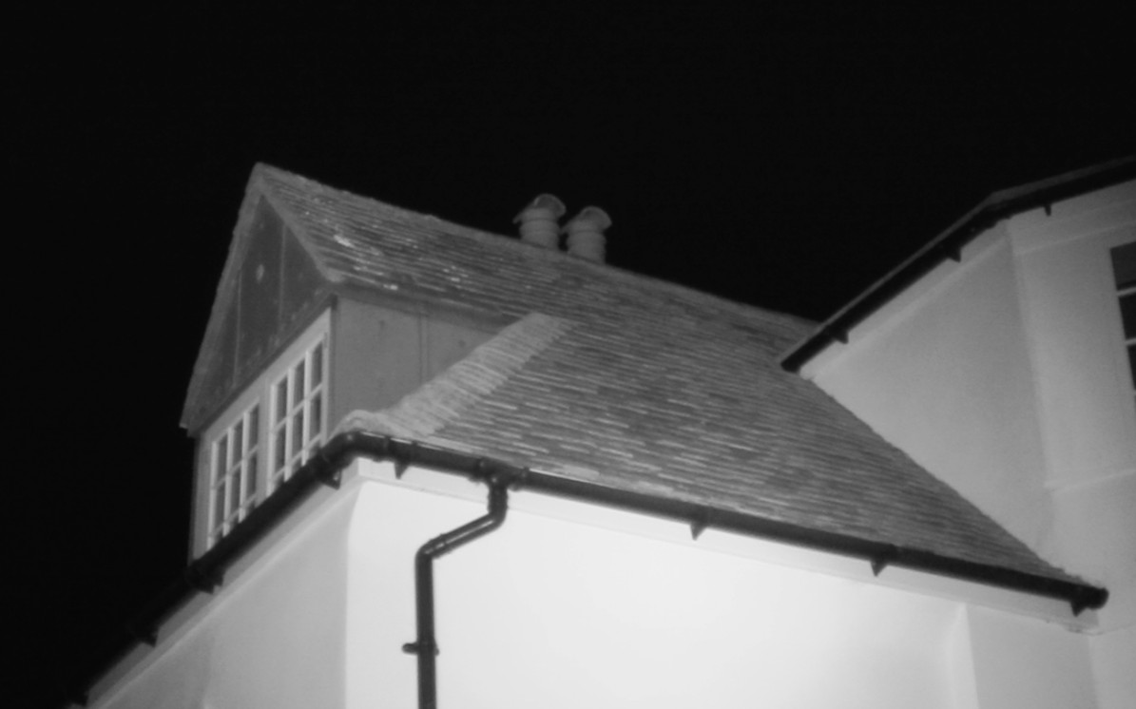
Figure 3. Southeast camera dark sky 3.5.2026

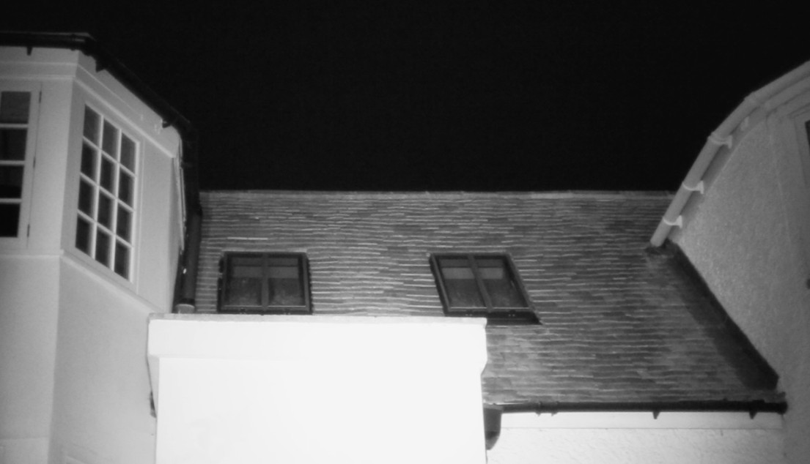
Figure 4. East camera dark sky 3.5.2026

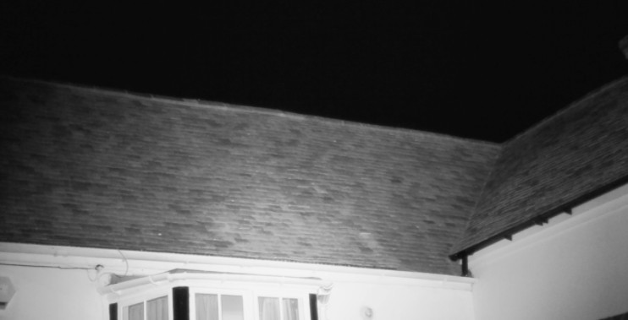
Figure 5. Northwest camera dark sky 3.5.2026
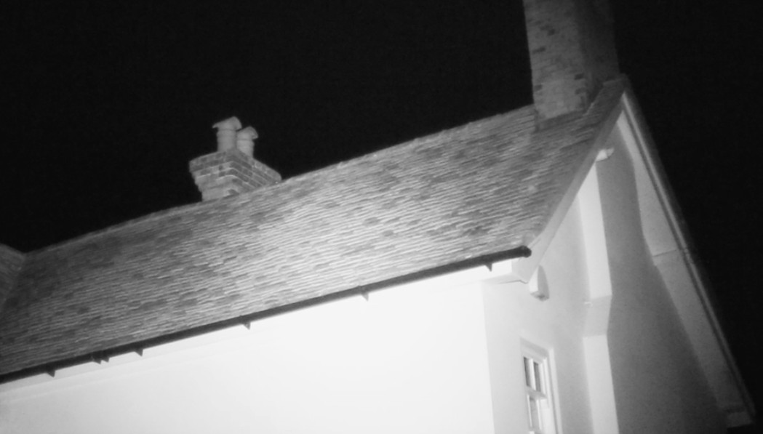
Figure 6. Northwest wing camera dark sky 3.5.2026

Project |  | Start time | 20.00 | Finish | 22.40 | Temperature | 18 C at start 16.5 C at finish
 |  | 31.5.26 |  | sunset | 21.10 | Weather  0% cloud beaufort 0 | Full moon
 | Bat passes heard
Station no. | Start time |  | No. | passes | comments
S | 21.44 | Common Pipistrelle | 1 | 1 | Flew in from east toward street light (flightpath C fig 1)
w | 21.54 | Common Pipistrelle | 1 | 1 | Flew over south fence off to east (flightpath D on fig 1)

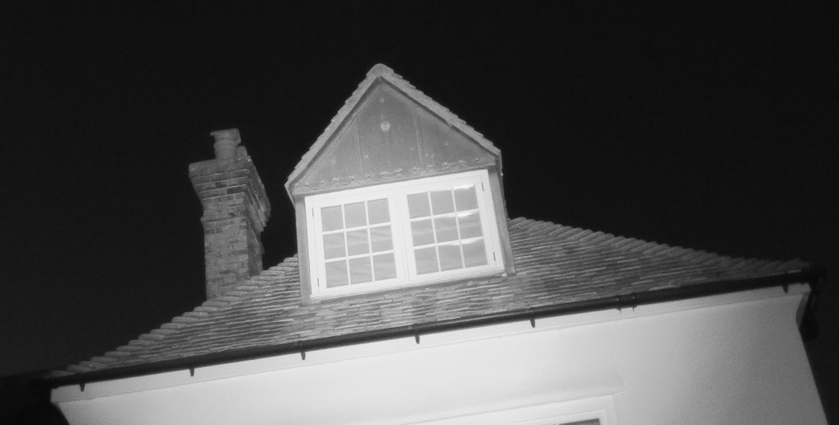
Figure 7. South camera dark sky 31.5.2026
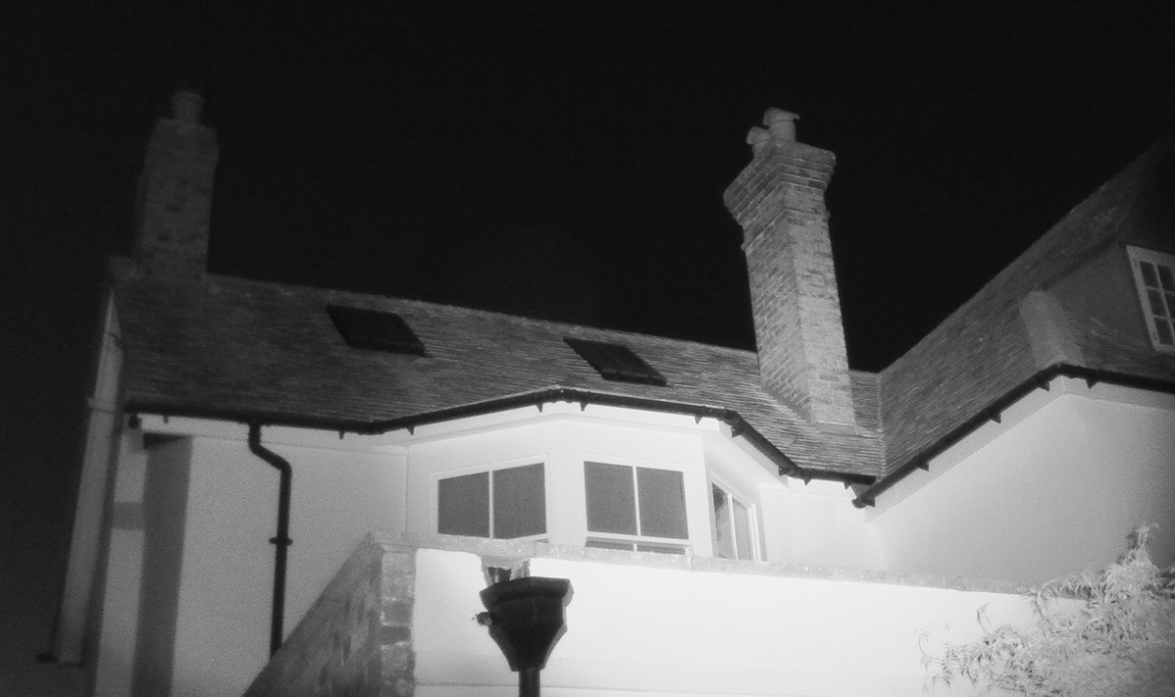
Figure 8. Southeast camera dark sky 31.5.2026

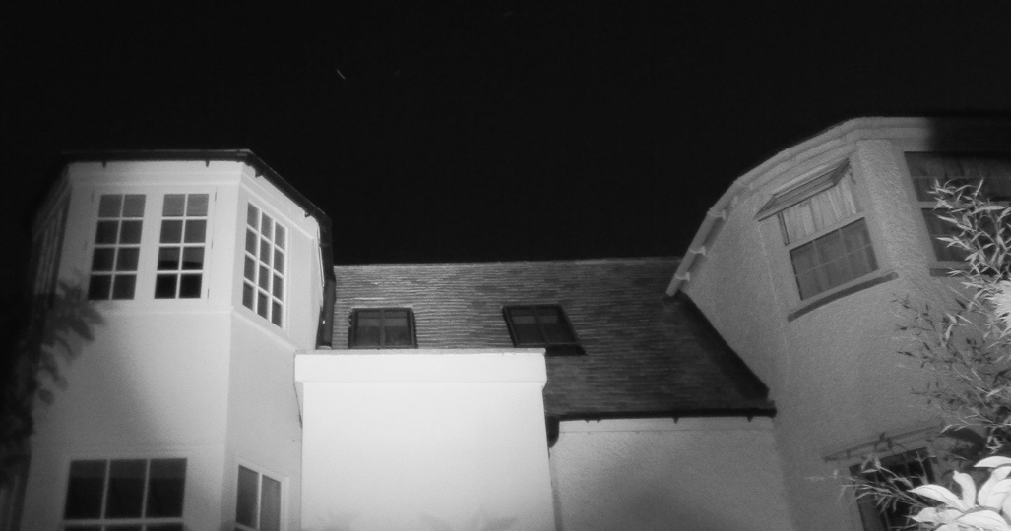
Figure 9. East camera dark sky 31.5.2026

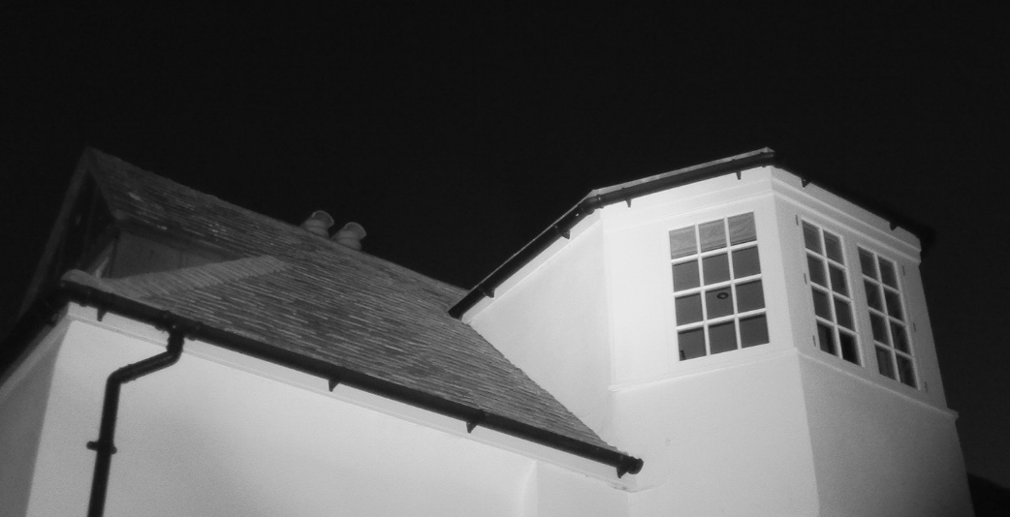
Figure 10. Northwest camera dark sky 31.5.2026
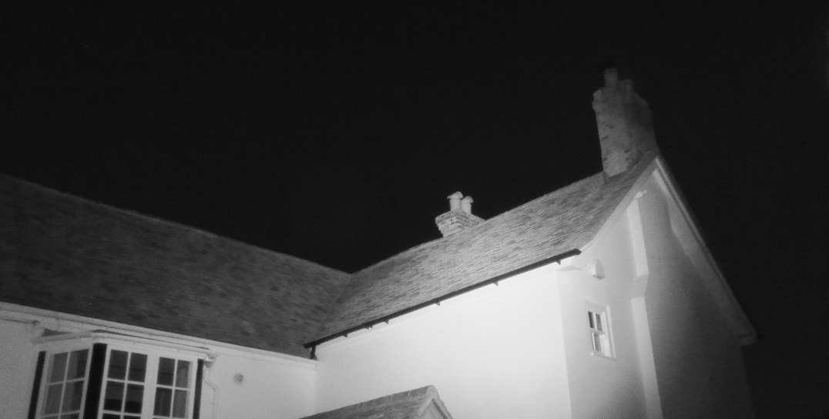
Figure 11. Northwest wing camera dark sky 31.5.2026

