South House,
School Lane,
Hamble,
Southampton,
SO31 4JD

Preliminary Roost assessment
(Phase 1 Daytime Bat Survey)

September 2025

Dr.Jonty Denton (Chartered Ecologist) FRES FLS MCIEEM CECol

(Bat license: 2025-82187-CL17-BAT)


Prepared by
Dr. Jonty Denton Bsc (Hons) D(Phil) FRES, FLS, MCIEEM, CEcol
(Chartered Ecologist)
31 Thorn Lane, Four Marks, Hampshire, GU34 5BX
Phone: (01420) 565647 mobile: 07385752793
SUMMARY
This report constitutes a site survey carried out on the 24th September 2025 and further assessment of the potential impacts arising from the proposed re-development of
South House, School Lane, Hamble, Southampton, SO31 4JD

The property has medium potential for crevice roosting bats on the main roof; therefore, a phase 2 emergence survey is recommended.

INTRODUCTION
Site Proposals
Re development of roof to incorporate dormers at South House, School Lane, Hamble, Southampton, SO31 4JD (GR:SU482067)

Site Setting and Description
The property is situated in Hamble-le-Rice west of the Hamble harbour and is flanked by other semi-detached and detached dwellings with small mature gardens (See figure 1). There are three woodland blocks included on the priority habitats inventory within 500m of the site, and the tree lined streets, gardens and paddocks in the vicinity provide foraging and commuting habitats for common bat species.
METHODS
Datasearch
According to the DEFRA MAGICmap no protected species licences have been issued for properties within 1km.
Phase 1 Bat Survey Methods
The Phase 1 bat survey was carried out on 24th September 2025 and comprised of a walkover of the site to record evidence of any protected bat species.
Details of the survey methods are given below;-
The building was investigated externally to identify potential bat access/egress locations and roosting areas such as gaps or holes in roof tiles, fascias and soffits and to record direct evidence of bat presence such as droppings and urine staining. This was followed by a detailed investigation of all accessible internal spaces to record evidence of bat roosting activity such as droppings, feeding remains, live animals, corpses, urine staining and fur staining. The building was assessed as to its suitability for supporting roosting bats. The survey conformed to current Bat Conservation Trust guidelines (Bat Conservation, (2023) Bat surveys for professional ecologists: Good practice guidelines 4th edition).
The details of the assessment criteria used to determine the ecological value of on-site attributes is outlined below. During the Phase 1 survey the assessment criteria are based on the potential for the site to support the species considered. However, in many cases Phase 2 surveys will be required to confirm presence /absence of any bat species and hence the importance of a population at the site, therefore the assessment of value should be considered a provisional.
Where possible, a provisional assessment of potential will be made although this may well require Phase 2 surveys to confirm status.
High Potential- High potential buildings are those that have features highly suitable for use by roosting bats, including gaps around soffits, hanging tiles, extensive roof spaces etc. High potential buildings are often, but not always, buildings of more historic construction. Further Phase 2 surveys will be required to confirm the presence/absence of bats.
Medium Potential- Medium potential buildings have a moderate number of features that may be utilised by bats for roosting, these may include loose fascias, roof spaces etc. Further Phase 2 surveys are likely to be required to confirm the presence/absence of bats.
Low Potential- Low potential buildings are those that provide limited bat roosting potential although some features that may be utilised by bats may be present. Further Phase 2 surveys are likely to be required to confirm the presence/absence of bats.
No/Negligible Potential – These are buildings that are extremely unlikely to support roosting bats due to the absence of suitable features. Further Phase 2 surveys are unlikely to be required for buildings with negligible potential.
RESULTS
Phase 1 Bat Survey Results
According to Magicmaps no EPS licenses have been issued for properties within 1km of School House.
Building Assessments
The property is a semi-detached, three storey house dating to the late 18th Century. It has a roof faced with clay tile tiles which have numerous potential access points into the undertile spaces (see figure 3-6). The south facing dormer is faced with lead sheeting which is closed off with no openings.
The roof space is incorporated into the third floor living rooms.

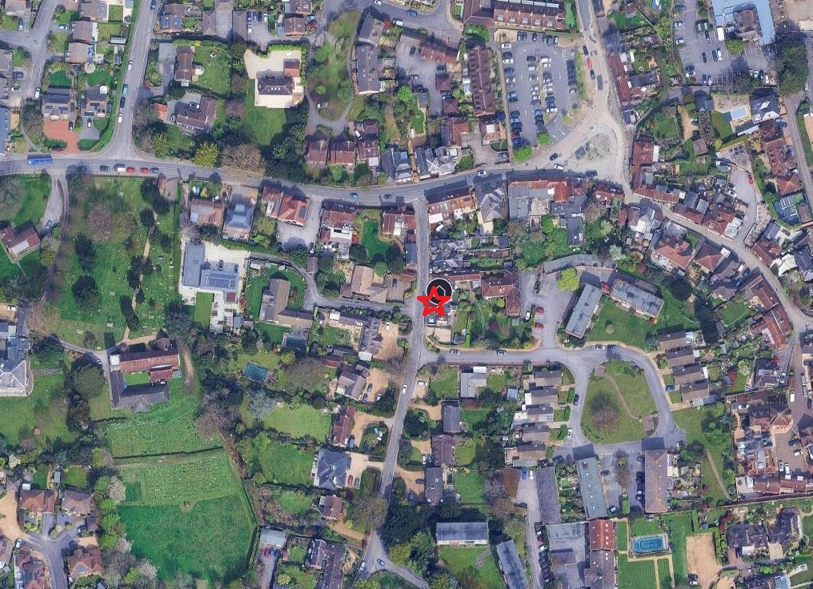
Figure 1. Site location. Courtesy of Googlemaps

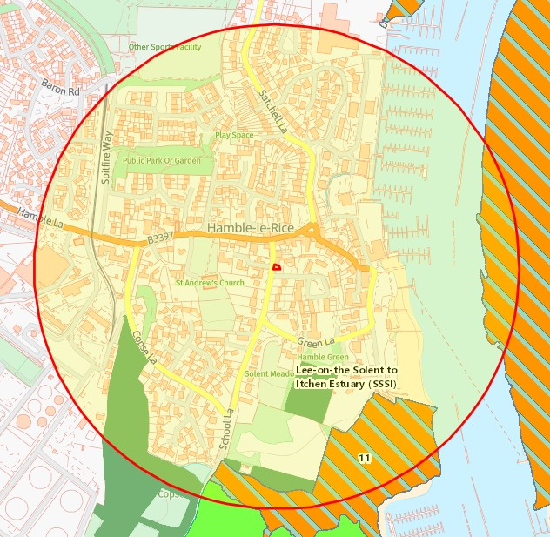
Figure 2. Priority habitats map. Courtesy of Magicmaps

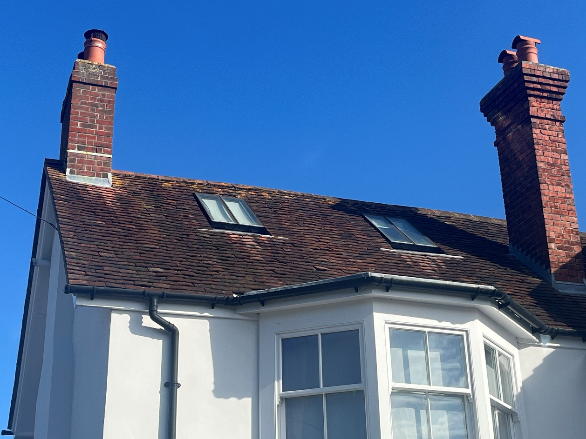
Figure 3. North gable looking west.

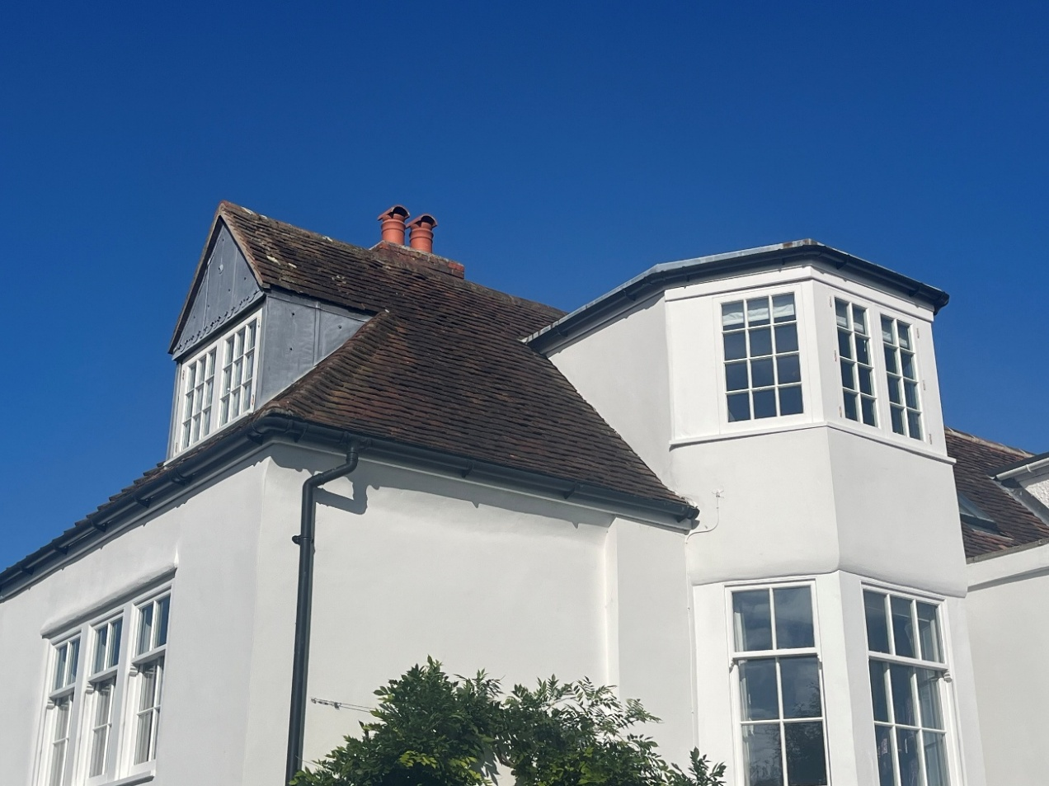
Figure 4. North gable looking southwest.

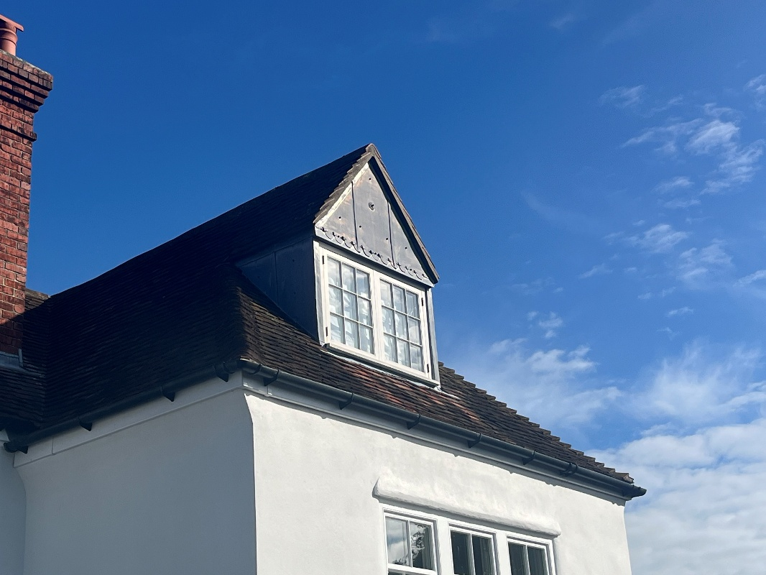
Figure 5. Southern elevations looking north.

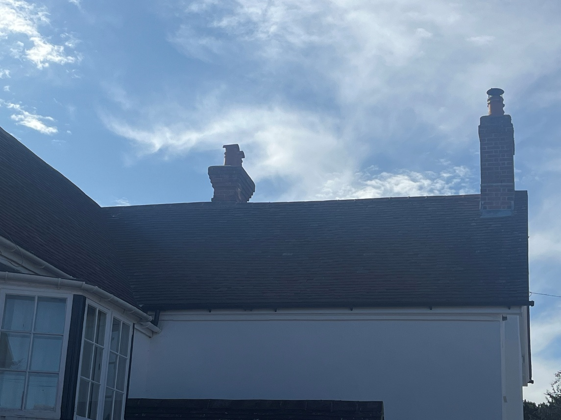
Figure 6. North face of west wing

EVALUATION, IMPACTS AND RECOMMENDATIONS
The property has medium potential for crevice roosting bats on the main roof; therefore, a phase 2 emergence survey is recommended.
This would entail positioning a surveyor and cameras such that all potential entrance/exit points are covered. The structure would then be watched from 30 minutes before sunset to 90 minutes after sunset.
Any emerging or re-entering bats are recorded along with their flight path, their species and the time of flight.
An emergence survey would identify:
- Whether bats are present in a structure, the species and number involved
- Entrance and exit points for the roost
- The type of roost
- Actions needed to be taken to ensure legal compliance.
REFERENCES
Collins, J. (ed.) (2023) Bat Surveys for Professional Ecologists: Good Practice Guidelines (4th Edition). The Bat Conservation Trust, London.
INTERNET RESOURCES
Google Maps: www.maps.google.co.uk
Magic Interactive Map: www.magic.gov.uk

