Design and Access Statement PP-12742684

The Flat (First Floor), 11 St Johns Centre, Hedge End, Eastleigh, SO30 4QU
Proposed Change of Use from Class C3(a) Dwellinghouses (2no Bed Residential Flat) to Class E Provision of Services (2no Therapy Rooms with Kitchen & Toilet Facilities)

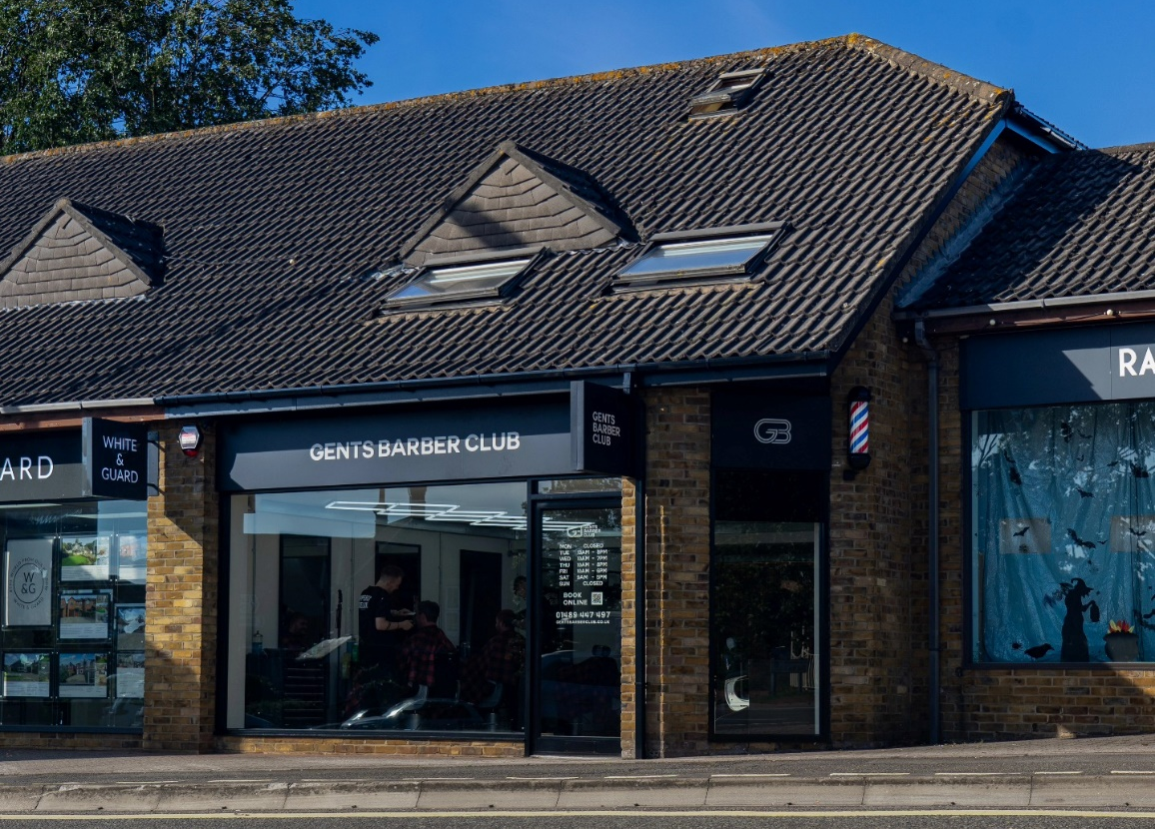

- Proposed Use
The existing 2no bed flat is situated above a barbershop within a parade of shops in Hedge End Village Centre, Eastleigh. It is currently vacant and has been for the last 7 months. The assumed use is Class C3(a) Dwellinghouses.

The proposals are for a change of use to Class E Provision of Services. This is with a view of a business renting the space and utilising it as treatment / therapy rooms for counselling purposes. Changes would also include internal decoration to the property.

For the avoidance of doubt, this application solely relates to the first floor flat.

- Amount
There are no extensions proposed to the building.

- Site Access and Parking
The site is located on St Johns Road, close to the junction with Lower Northam Road (B3033) which is one of the main roads running through Hedge End Village Centre.

There is a safe, well-lit and maintained carpark to the rear of the building, providing ample off street parking.

All access routes into the building are to be retained as existing. Primary access to the first floor flat is found at the rear of the property, leading directly from the carpark.

- Planning History
According to Eastleigh Borough Council’s online planning register, there are three planning applications which relate to the site as follows,

F/23/96275 – Planning permission for change of use to Class E – Granted

Z/31006/001/00 – Planning permission to create first floor flat – Granted

Z/31006/000/11 – Planning permission for change of use to Class A3 - Granted

- Scale
There are no alterations proposed to the scale of the building.

- Landscaping
There are no alterations proposed to the landscaping around the building.

- Appearance
There are no alterations proposed to the exterior of the building.

- Layout
The internal floor plan and layout of the building will remain the same. The two rooms which are currently bedrooms will become therapy / treatment rooms. The existing kitchen and bathrooms shall remain as such.

- Scheduled Ancient Monument (SAM)
The proposals do not affect a scheduled ancient monument or it’s setting.

- Archaeological Sensitive Area (ASM)
The proposals do not affect an archeologically sensitive area.

- Listed Buildings
The application site is not a listed building.

- Conservation Area
The site is not located within a conservation area.

- Historic Parks and Gardens
The site does not form part of a historic park or garden.
- Flood Risk Assessment
The site is situated in the area of flood zone 1, an area with a low probability of flooding. The site is less than 1 hectare in size and is not in an area with critical drainage problems as notified by the Environment Agency. The proposals are for a change of use only with no additional hard standings or extensions proposed. The below is for visual (actual map included within planning application).
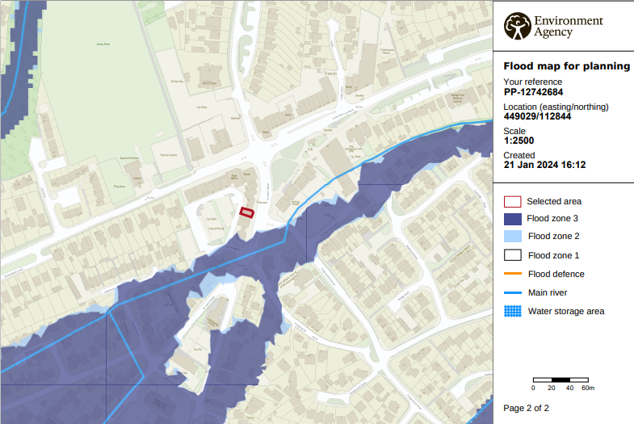

- Site Photos
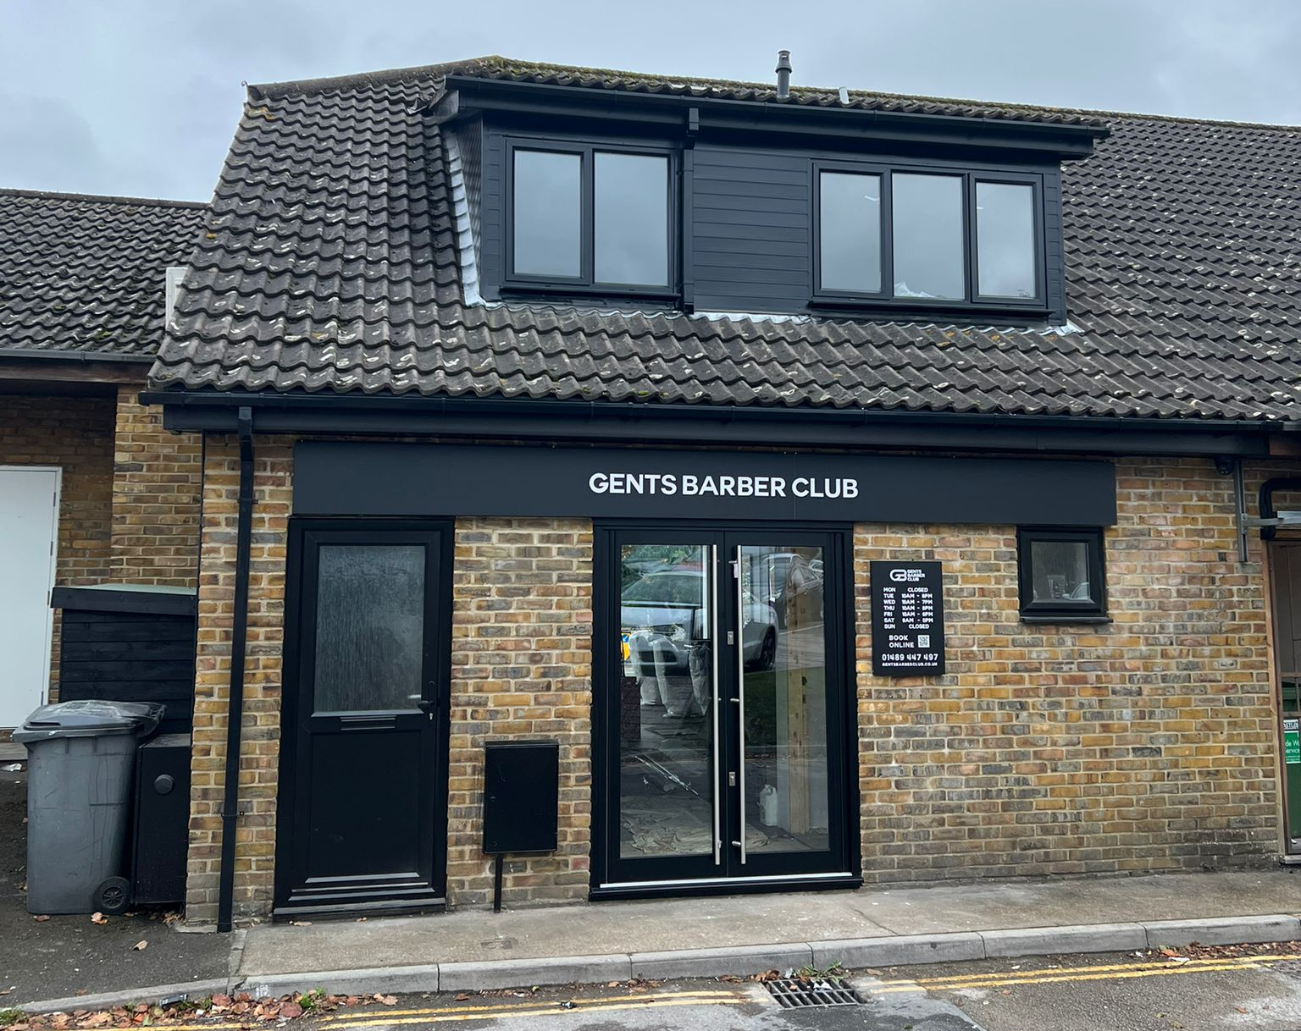
This photograph shows the entrance door to the first floor flat on the left side.
Conclusion
The proposed change of use would create investment into the area and provide an opportunity to make more efficient use an existing building within the existing street scene in Hedge End Village.

Hedge End Village is well served by existing infrastructure, and given the nature of the intended business, it will create a much needed service and additional footfall whilst also providing additional employment opportunities for members of the local community.

