T6 – Pruning – x1 Holly – Weight reduction by 2.5m
T8 – removal – x2 Birch interfering with building

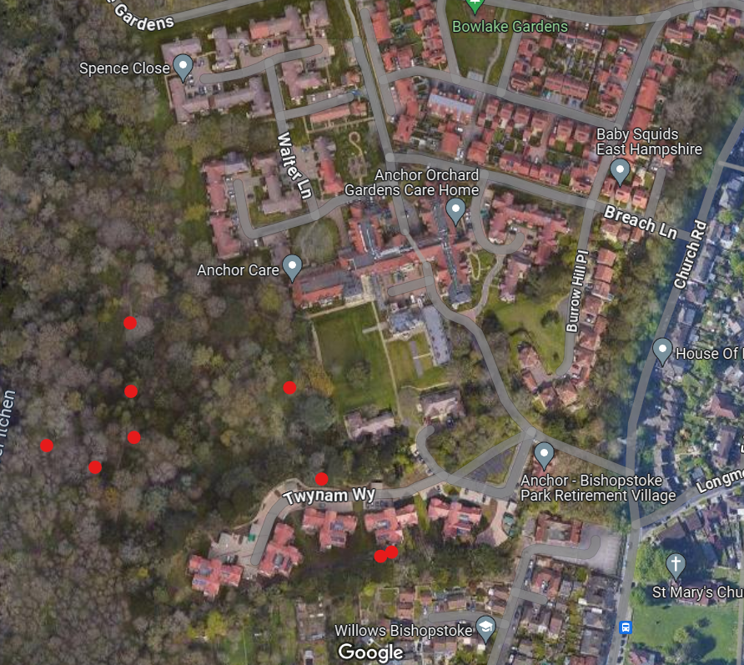
T8

T6

