Condition 4
The visual appearance will be to match the existing house and boathouse
- Bricks FLB Multi stock….same as house
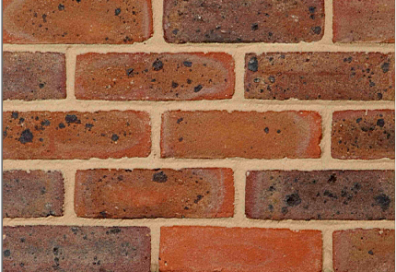
- Glazing…same as boathouse
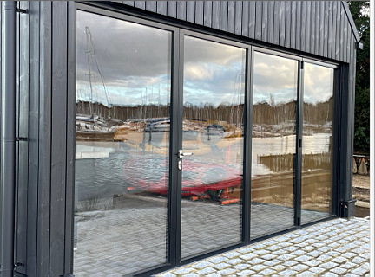

- Roofing
Black roof construction using RubberGard™ EPDM Single-Ply Roofing System. https://www.permaroof.co.uk/wp-content/uploads/2020/12/Firestone-RubberGard-Quick-Specs-Fully-Adhered-System-qs_rg_fas_concrete_roof_aka_may2020.pdf
Condition 5
The visual appearance will again provide landscaping to match the house grasses planting.
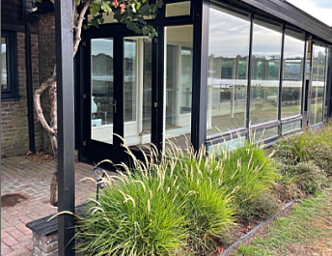
See below Summerhouse layout planting incorporating existing hedge, Buddlela bush and tree with addition of grasses Pennisetum “Fairy Tales” & “Red Heads”
