CEMP

Introduction:
Site Address: 19 Swaythling Road, West End, Southampton, SO30 3AG
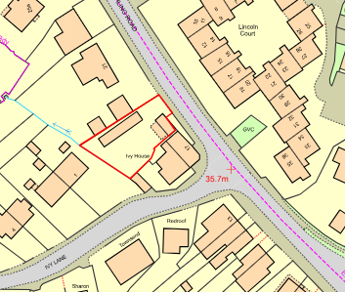
The site is a flat and clear site, with no current buildings present, there are no known sensitive constraints on the site.
Planning was approved for 4No 1 bedroom flats under planning application number F/23/95533/Ful
This document has been produced to satisfy condition 3 of the approval notice. 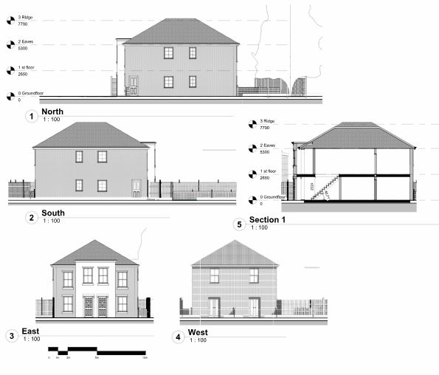

Site Operations:
Working hours will be within
08:00 to 18:00 hours Monday to Friday,
09:00 to 13:00 hours on Saturdays,
No works at all on Sundays or Bank Holidays.

Where it is necessary for work to be carried out outside normal working
hours, contractors will be required to demonstrate and justify the need to do
so at least ten days in advance to the LPA, and contact the possibly affected
receptors (residential dwellings, commercial/ public premises, etc) to let them
know the details of the out of hours works, along with any mitigation
measures to reduce the impact to neighbourhood.
Work outside of normal hours will only be permitted in exceptional circumstances.

Delivery / waste collection hours:
It is expected that all deliveries and waste collections will be taking place
within the working hours stated above

Site Management:

Site manager details: Gary Mattingly 07788 975194

Site layout:
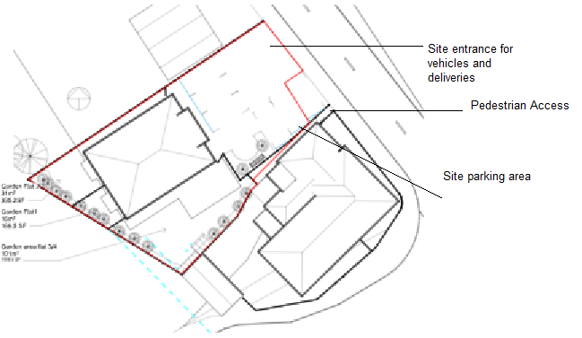

Security: The site has a secure fenced hoarding running along the front with metal gates which will be padlocked after work has finished each day

Communications and complaints procedures:
Should any member of the public or LPA feel it necessary to communicate with the developer or raise a complaint they can do so by contacting :

Hayden Ebert on 07717 276832
Or by email to maidanbuilddevelopments@gmail.com

When a complaint about nuisance or adverse impacts to amenity is received, then that is to be appropriately investigated; and a commitment to remedial actions, if determined to be necessary, being in placed promptly. Good site records shall be kept of regular monitoring and audit of the works, complaints received, and remedial actions implemented in respect of these. These records shall be made available to Council upon reasonable request such when visiting the site to investigate a complaint stemming from pollution.

Demolition

The site is clear land and there is no demolition required.

Environmental Protection

Noise and vibration control:

All construction/ demolition activities will be undertaken in a manner that Best Practicable Means, as defined in Section 72 of the Control of Pollution Act 1974, in order to minimise noise and vibration, including identification of potential noise/ vibration sources and any mitigation measures to be put in place to avoid nuisance to neighbouring properties or site users.

Equipment to be used:

- Diggers will be used for short periods throughout the ground works stage of the build
- Concrete mixer will be used for external brick/blockwork
- General carpentry power tools such as drills, chop saws, nail guns etc will be used when constructing the roof and during internal carpentry, first and second fix.

All of the above are deemed not to cause excessive noise however should there be any complaints from neighbours, they can write to us at maidanbuilddevelopements@gmail.com or contact our site manager for an informal discussion so corrective action may be taken.

Mud prevention:

Wheel washing facilities will be available on site to prevent excessive mud from being transferred to the public highway

Dust Management/Air Quality:

Measures will be taken to avoid excessive dust causing a nuisance during contruction, which will include screening where required and dust extraction equipment being fitted to tools during any works that may cause such issues.

Records of any complaints will be kept along with remedial actions taken and will be available to the council upon request

Waste Management:

All disposal of waste will be either carried out using a grab lorry, skips or licenced waste carrier.
If any contaminated or hazardous waste were uncovered an appropriate specialist firm would be instructed to remove it.

Managing materials and site storage:

All construction materials and plant will be stored neatly within the site curtilage behind the secure fencing taking special care not to cause any disruption to neighbouring properties.

Ecology:

There are not any protected species on site

