Retrospective Planning for fence

30 Pine Crescent, Chandlers Ford, SO53 1LL

Planning Statement

Application Site:
The application site is an existing single storey detached bungalow which has recently been extended and renovated, primarily constructed of brick with tile roof but the exterior was completely rendered, and new windows and doors installed. Off-road parking has been completed to the front of the bungalow by way of a new drop kerb. The property is located on the corner of Pine Crescent and Pine Road in a residential setting. The plot is unusual as the property has limited back garden space but is afforded a large area to the side which is sloping and tiered to form the property’s main garden area. A newly erected Garden Room with Storage Area has been built to the far right of the plot in line with Number 12 Pine Road under Permitted Development Rights. The structure is 2.5 metres high to top of eaves height. The small rear garden area receives minimal direct sunlight throughout the day. The lower garden area is still under construction with a decking area and further turfing to be laid, similar to the higher level completed. Fencing to the rear of the Garden room and Storage Area has not yet been installed.
The bungalow is not typical of the street scene for Pine Crescent where most properties close by are two storey detached houses with rear gardens and off-road parking to the front.
Figure 1. Site Location Plan
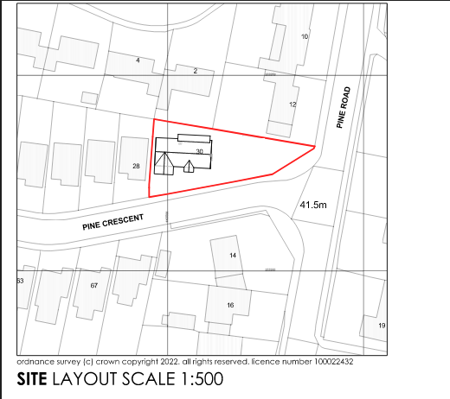

Figure 2. Street scene photo
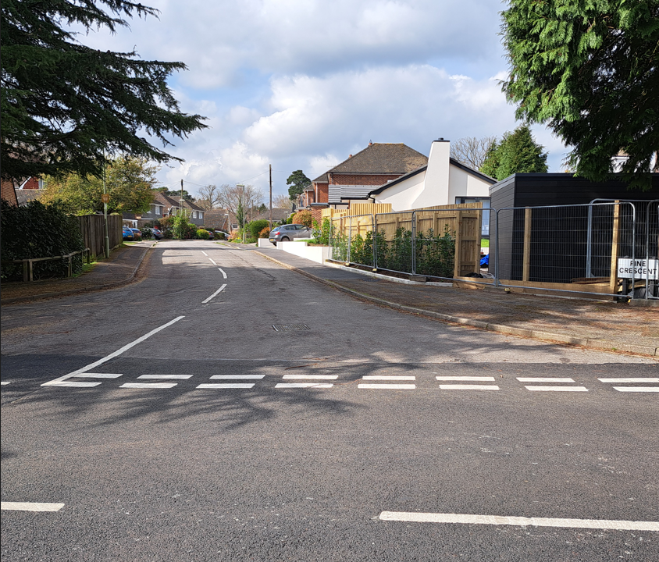
Figure 3. Street scene photo
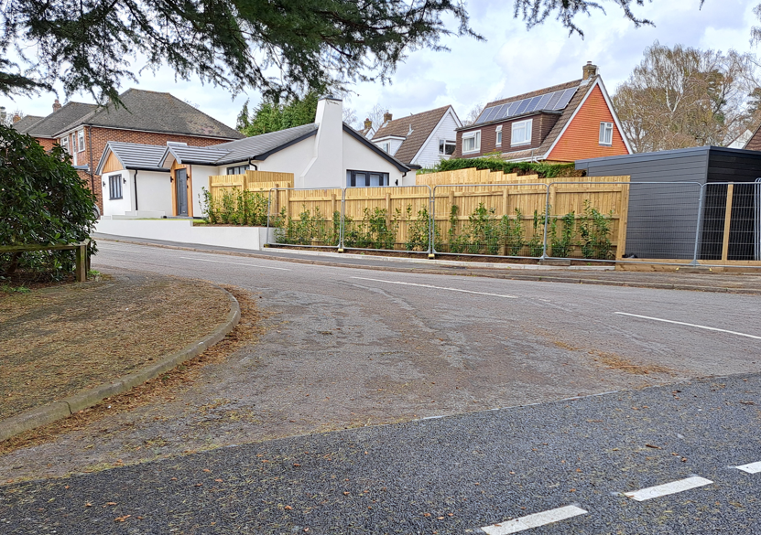

Figure 4. Street scene photo
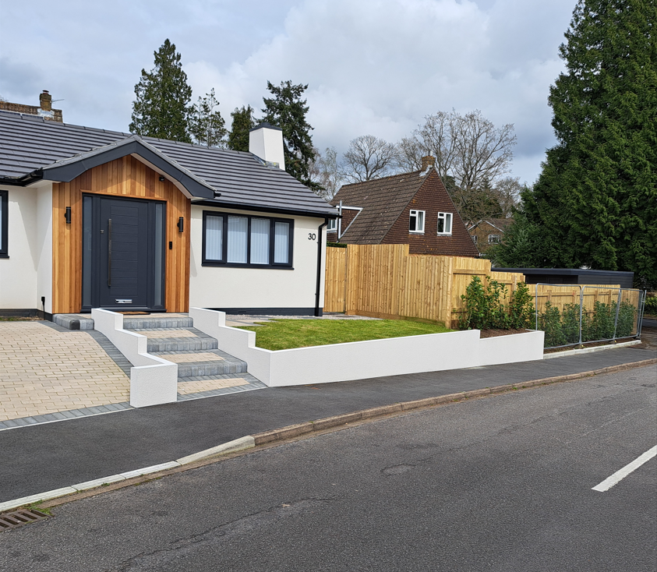

Figure 5. Levels as viewed up from Garden Room & Storage Area
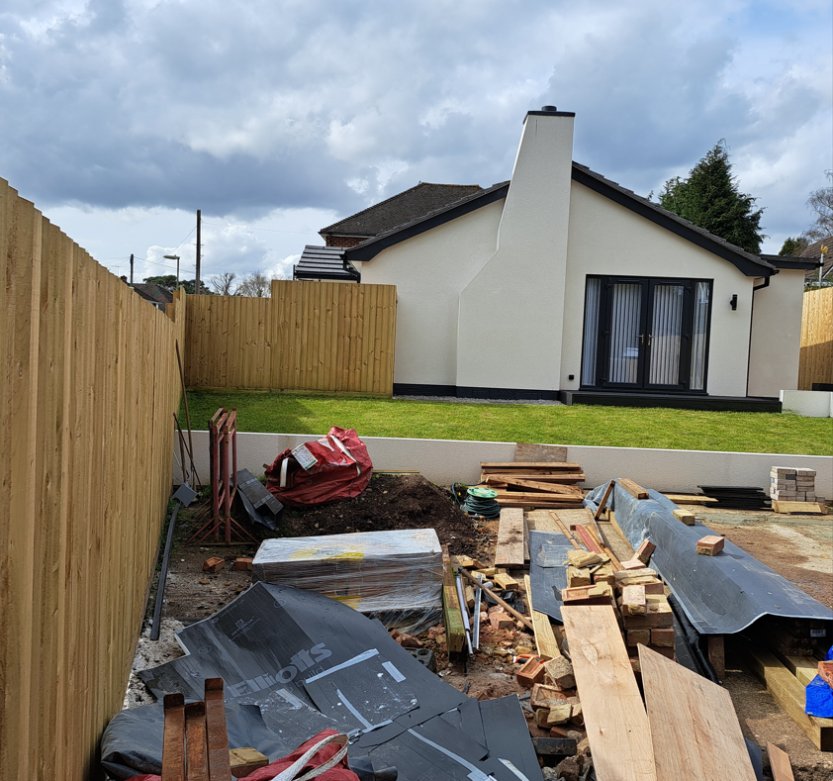

Figure 6. Levels as viewed down to Garden Room & Storage Area
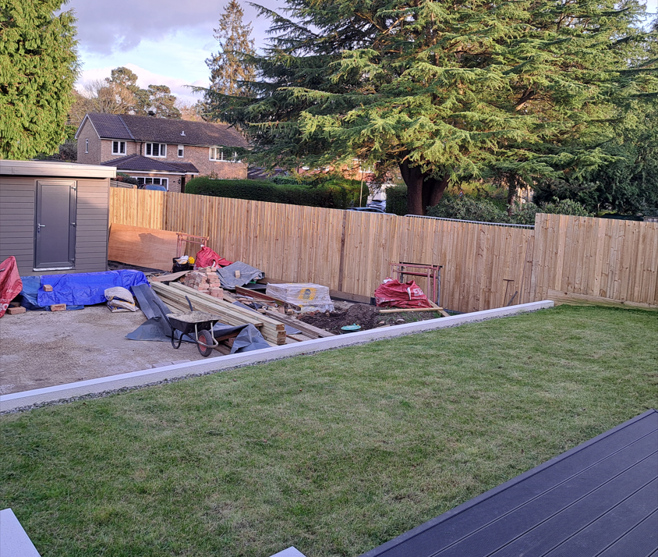
Planning History:
The property was permitted planning under the following application

H/22/94328 - 30 PINE CRESCENT, CHANDLER'S FORD, EASTLEIGH, SO53 1LL
Demolish existing garage, single storey front extension with addition of porch, new dropped kerb and alteration to fenestration. (Amended description and plans)
The property was refused planning under the following application

H/22/92307 - 30 PINE CRESCENT, CHANDLER'S FORD, EASTLEIGH, SO53 1LL
Raising of roof to provide first floor accommodation including 1no. front dormer, two storey front extension to incorporate integral garage, alterations to fenestration, raised decking to the side following demolition of existing detached garage, new dropped kerb and erection of 1.8m fence
Planning Proposal:
The proposal is seeking Retrospective Planning Permission for a wooden close border fence to the side of the property, on two different levels, to enclose the garden area of the plot and enclose the end area behind the new Garden & Storage room. The two, 2m sections on the upper level are 1.65m and 1.50m high respectively, stepping down to 1.8m high to the lower garden section that also encloses the Garden & storage room. The majority of the road facing fencing is set well back within the plot with laurel hedging planted, which once grown, over time, will conceal that fencing.
Assessment:
Due to the unusual nature of the plot, the bungalow has limited back garden, and sits considerably higher to the side garden’s lower level. Three tiered areas have been created, with steps down to utilise the space. As shown in the picture in Figure 3 street scene, the fence does not block out the view into the applicant’s patio doors looking up from Pine Road. Pedestrian and vehicle traffic are still visible from the decking and upper lawn areas looking down. If the fence was lowered, then the whole of the patio doors and top tier of garden would be on display, resulting in no privacy and security to the whole garden area.
The applicant has carefully thought out the siting of the fence and has planted a row of Laurel hedging on the property’s boundary line and has erected the fence behind the hedging. The fence is situated well away from the footpath’s edge and within a few years, the hedging will have grown and expanded, and you will not see the fencing. The aim is to allow the hedge to grow to a height, so the patio doors are not seen from Pine Road and thus creating privacy to the plot and a green entrance into Pine Crescent.
As seen in the street scene pictures 2,3,& 4, and in support of the Local Plan Policy 59.BE, the fence and laurel hedging have been well designed and are sensitive to the landscape of Pine Crescent and the view from Pine Road. The hedging and fence will enclose the garden area, providing privacy and security for the property. Figure 7 below, taken at No.8 Pine Road and the other entrance to Pine Crescent clearly shows how a grown hedge looks, screening a 1.8m road side fence.

Figure 7. Hedge screening 1.8m road side fence at Pine Road/Pine Crescent

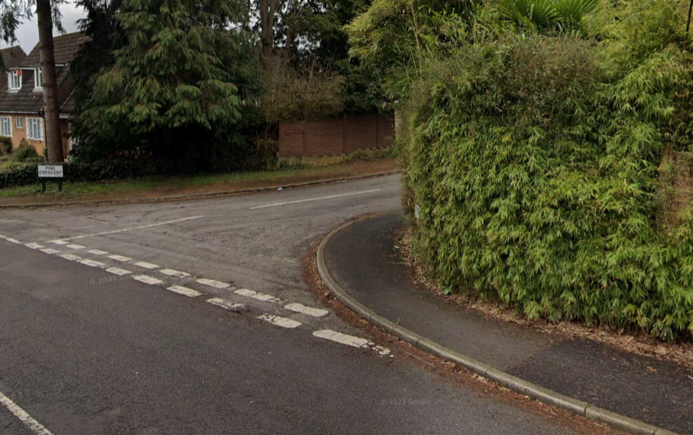

It should be noted that a 1.9m fence is erected directly opposite the applicant’s plot as shown in Figure 2. Street scene photo, and this fence is sited a full 8.5 metres past the start of the applicants fence into Pine Crescent. Also, a 1.9m fence is erected on the corner of the other entrance to Pine Crescent. Neither of these fences have hedging in front of them and both face directly onto the road enclosing garden areas.

It is also important to observe that the application fence does in no way interfere with any drivers view on entering and exiting Pine Crescent. In the previous planning application H/22/92307, Hampshire County Council Highways says regarding the fence Boundary “This is acceptable given the proposed fence line sits well outside the visibility splay requirements for the junction of Pine Crescent and Pine Road”.
The fence will not have an unacceptable impact on the amenity of any neighbouring properties in terms of loss of privacy, light or outlook.
Numerous precedents regarding corner plots, with road facing, boundary fencing within the Hiltingbury Area are illustrated below, support the planning proposals for the application.
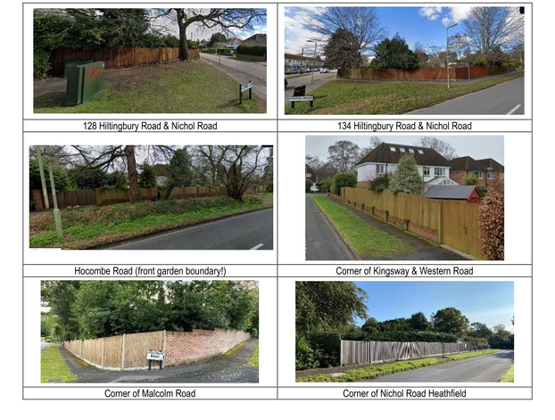
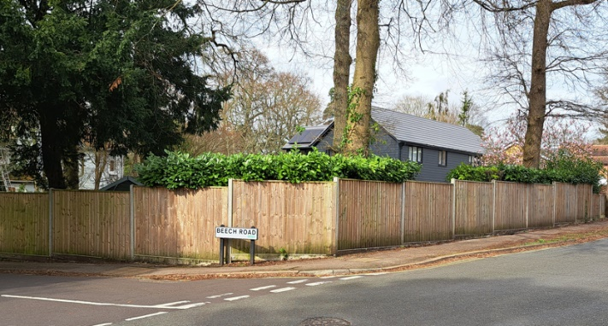 | 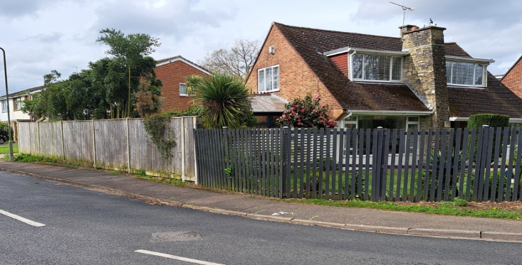
Corner Beech Road & Oakwood Road | Pine Road at bend
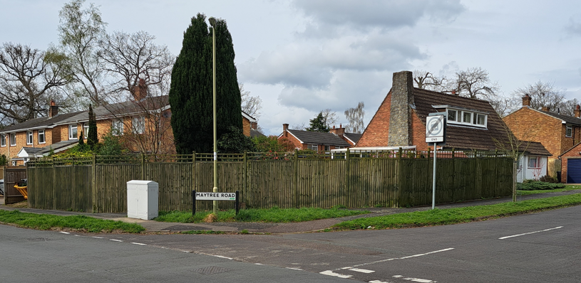 | 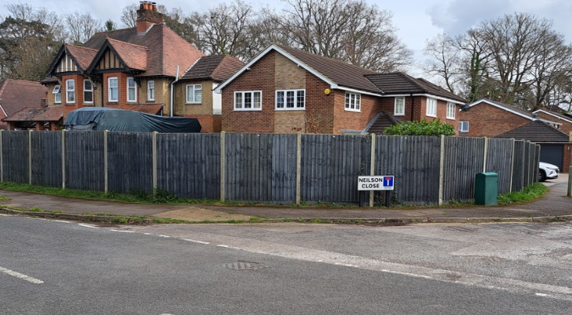
Corner Maytree Road & Heathfield Road Corner Neilson Close & Valley Road

Pine Crescent Builders Covenant:
Most Properties were built in the 1960’s by M K Welch and Co Ltd and had various Covenants attached to them with one being that “Purchasers and the persons deriving title under them will not erect any fence trellis work or other similar structure along the front boundary of the property hereby conveyed or on any part of the land forming the front garden or on the front elevations of the dwellinghouse erected on the land hereby conveyed."
M K Welch and Co Ltd have ceased trading, having been wound up in 1985 meaning that their Covenants are no longer valid as there is no entity to enforce them.

Conclusion:
As this document demonstrates, this proposal is in full accordance with all national local adopted and emerging planning policy guidance. This application proves, a well thought out and sympathetic approach to enclosing a large, multi-tiered garden area is achievable with much of the fence unseen within a few years of hedge growth.
We kindly ask the appointed case officer studies this document and other plan details and looks upon this application favourably and approves these proposals.

