Smiths pond proposed tree work.

Area 1. North bank of the pond to the right of the access.

7 willow trees on the outside of the boundary have grown over the boundary fence. Some have collapsed onto the fence. We would like to trim all of the branches along the fence line.

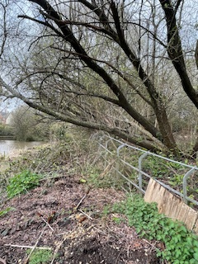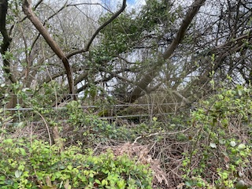

Area 2 North west corner of the lake adjacent to the inflow.

Willow tree 1, 2, 4, 5 and 6 are growing out of the bank of the lake and blocking light preventing marginal plant growth. We wish to coppice these trees.

Willow tree 1 and 2

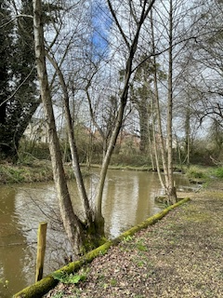

Willow Tree 3

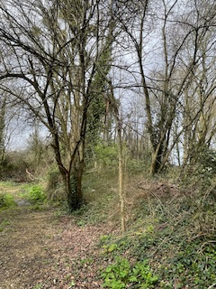

Willow Tree 4,5 and 6
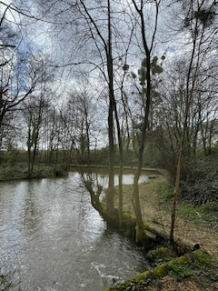

Willow Tree 7
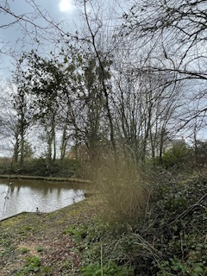

Area 3 West side of pond

10 willow trees to be coppiced

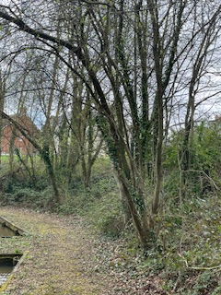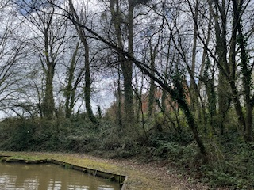

Area 4. Southwest side of pond

7 willow trees to be coppiced
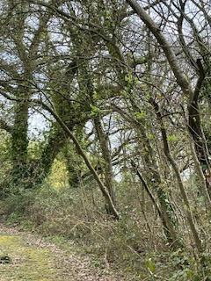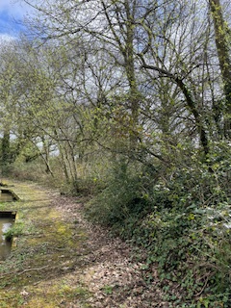

Oak tree 8. Lower branch over hanging lake to be removed.

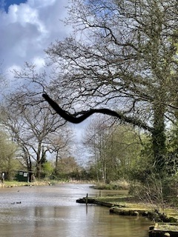

Area 5. South side of lake.

4 willow trees to be coppiced

Willow tree 8
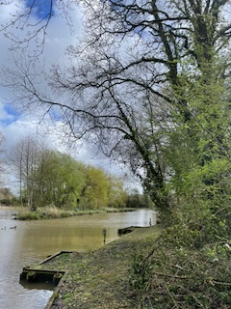

Willow Trees 9-11
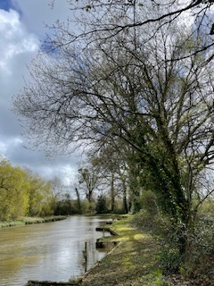
Oak tree 6 and 7. Lower branch from each tree that overhangs the lake to be removed as marked

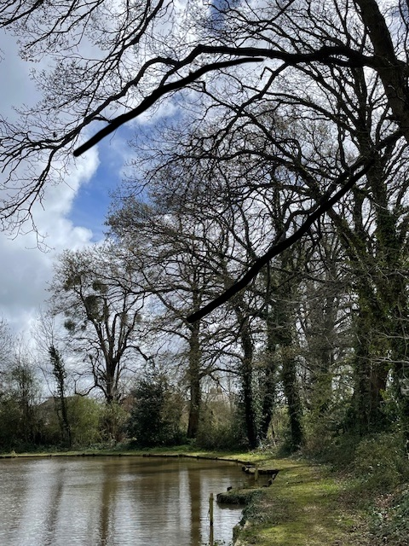

Oak tree 4 and 5. Lower branch from each tree that overhangs the lake to be removed
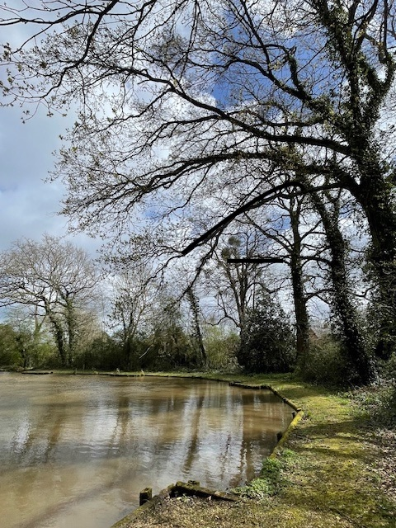

Area 6. East side of lake

Sycamore trees 1 - 6. Crown reduction to 2m height. NB all less than 12cm trunk diameter
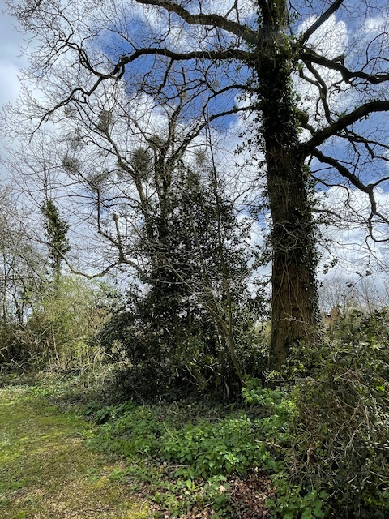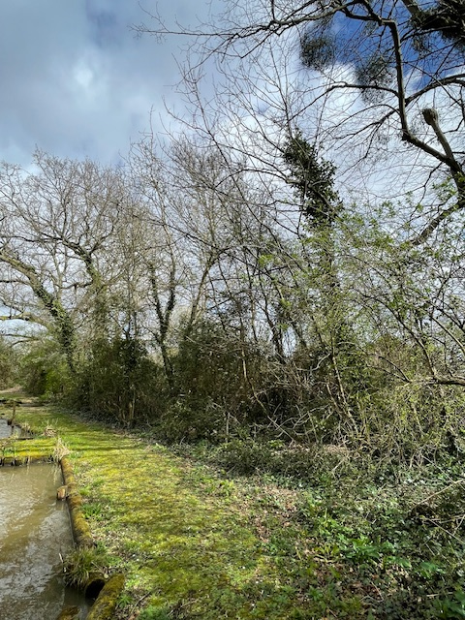

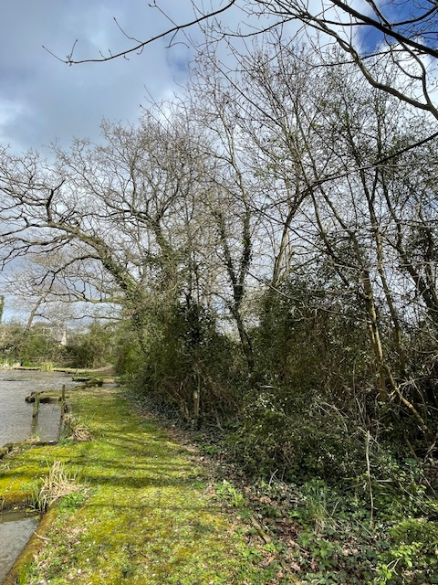

Oak tree 3. Lower 2 branches overhanging lake to be removed
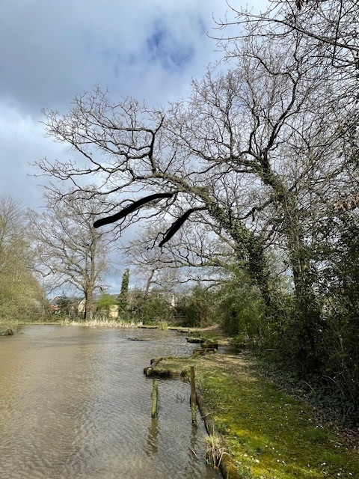

Area 7 North East corner of lake

Oak tree 1 and 2. 1 low branch overhanging lake on each tree to be removed

Oak tree 1
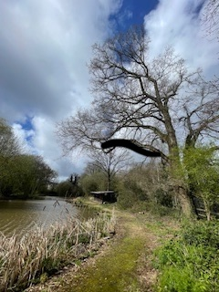

Oak tree 2

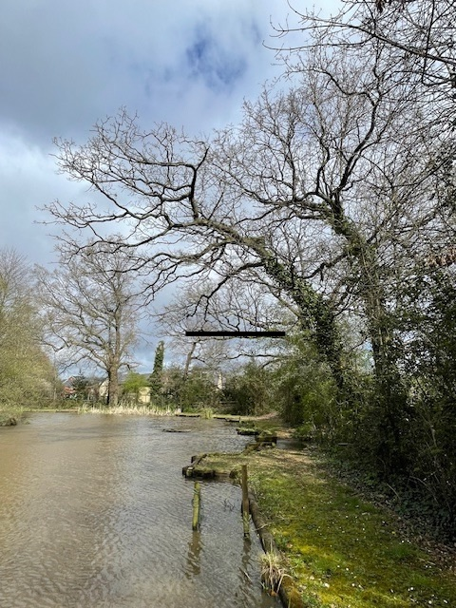

West Island (in front of area 2)

8 previously coppiced willow trees to be coppiced.
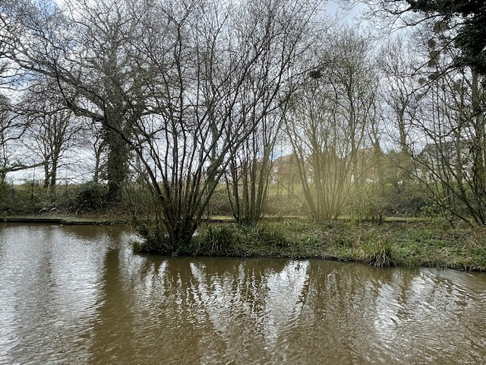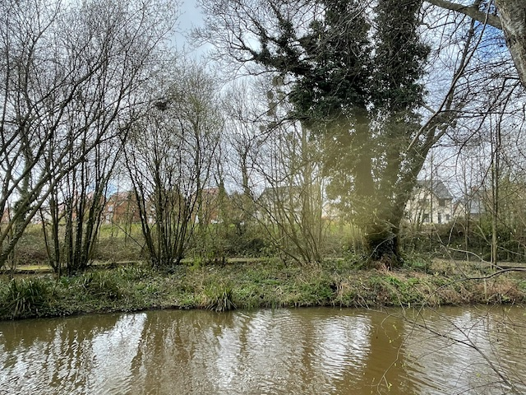

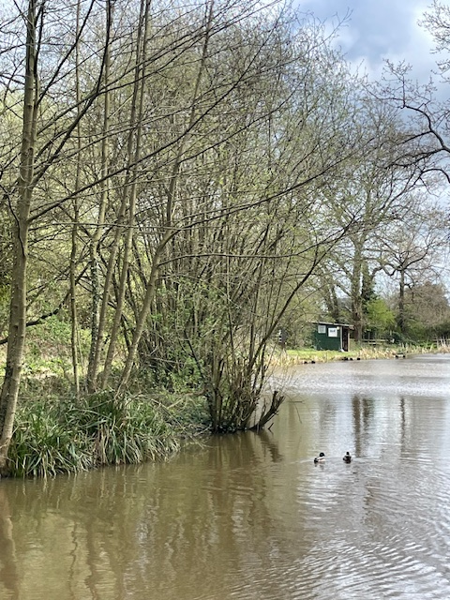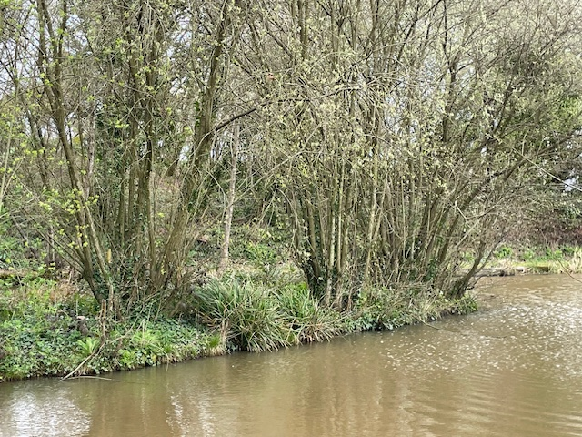

4 alder trees to be cut to ground level. There are 8 alder trees growing on the south/south west bank of the island. We would like to remove alternate trees.
Large alder tree in the centre of the island (marked on sketch with A with a circle around it) is to remain untouched.
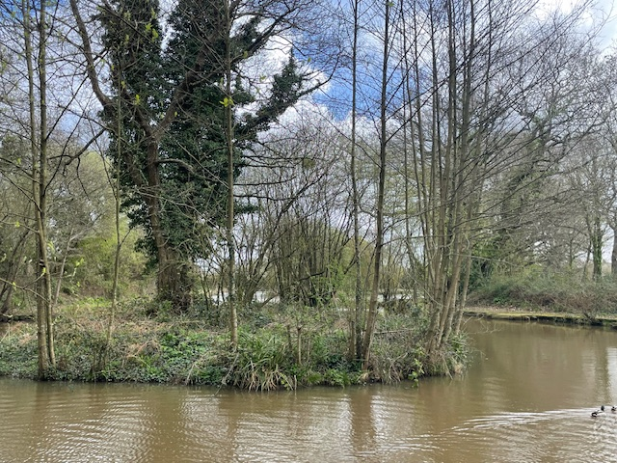

East Island (in front of area 6)

9 willow trees to be coppiced

Willow tree 12
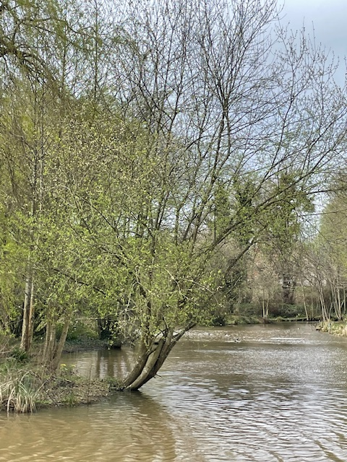

Willow tree 13
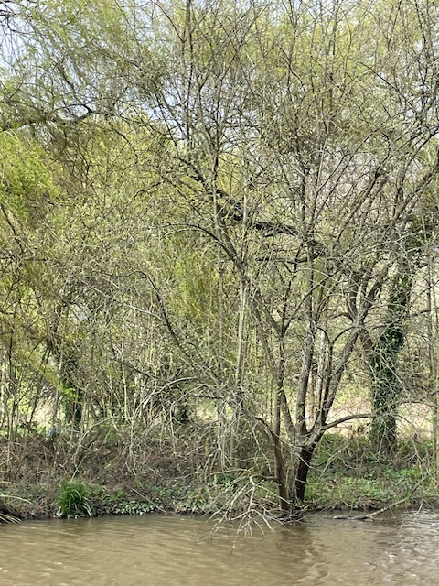

Willow tree 14
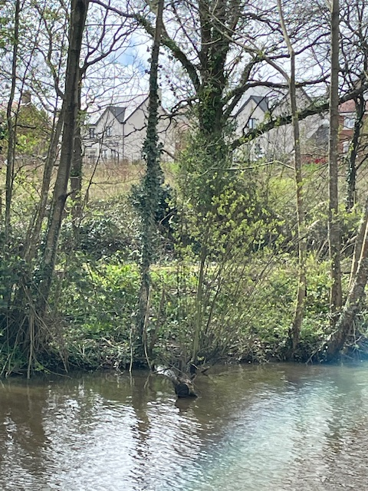

Willow tree 15
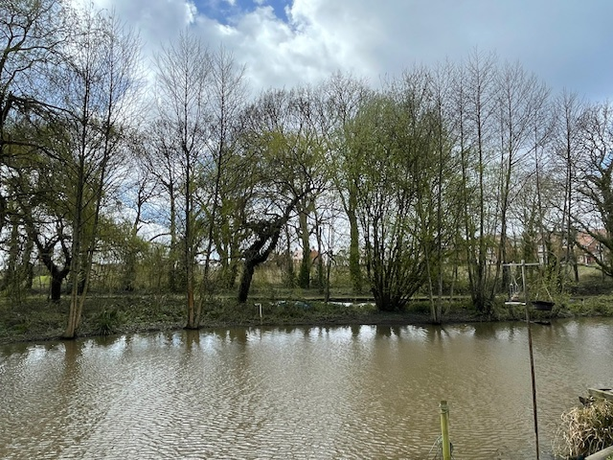

NB 3 large Weeping Willow Trees on the island to remain untouched.

