Bampton House Bin Store Compound
Design and Access Statement

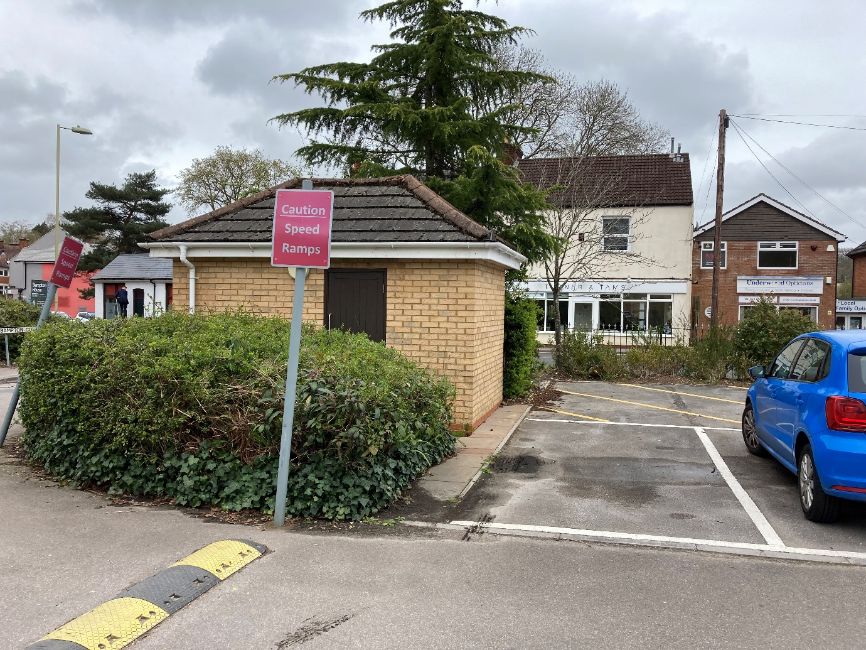

Bampton House
Hursley Road
Chandlers Ford
SO53 2TA

April 2024
The Building
Bampton House was constructed in the late 1980’s with planning permission having been granted for the construction of an office block with associated parking area.

Following planning approval in September 2023, Bampton House was converted into 11 one bedroom and 2 two bedroom flats.

The Proposal
The proposal is to provide an extra storage compound to house the recycling euro bins within the area to the rear of the existing brick built bin store area.
Two of the existing car parking spaces will be sacrificed and hatched over to provide safe access and to allow the loading/unloading when emptying the bins.

