Hampshire Water Transfer and Water Recycling Project
Statement of Community Consultation

March 2024
Version C02.1

Contents
1. Introduction 3
2. Background 4
3. Planning process 6
4. Principles of the public consultation process 8
5. Previous consultation 9
6. What we will consult on 9
6.1. Environmental Information 9
7. Who we will consult 11
8. How we will consult 12
8.1. Consultation documents 13
8.2. Deposit locations 14
9. When we will consult 16
10. How the community can provide comments 16
11. How we will respond to consultation feedback 16
12. Contact us 17

Introduction
Southern Water is developing proposals for the Hampshire Water Transfer and Water Recycling Project (HWTWRP). The HWTWRP, is a drought resilience scheme – it will ensure that we can maintain essential water supplies in a drought, while protecting the rare and sensitive River Test and River Itchen chalk streams.

The Project would use a full-advanced treatment process to turn treated wastewater into purified recycled water at a new water recycling plant south of Havant. The recycled water would then be transferred via a new pipeline to supplement the spring-fed water that will be stored in the planned Havant Thicket Reservoir. Another new pipeline would be constructed to transfer water from the reservoir to our Otterbourne Water Supply Works (WSW), some 40 kilometres to the northwest, to be treated to strict drinking water standards ready for supply to homes and businesses.

This Statement of Community Consultation (SoCC) describes how we intend to carry out our statutory consultation for the Project. The statutory consultation, to run from 29 May to 23 July 2024, is an important stage of the pre-application process providing an opportunity to raise further awareness and help shape the Project prior to the submission of an application for a Development Consent Order (DCO). The SoCC has been prepared in accordance with relevant legislation and guidance and sets out:

- When the consultation will be held.
- The information that will be included in the consultation.
- Who will be consulted.
- The approach and tools that will be used to reach consultees and gather their views.

The local authorities listed below fall within the proposed draft Order Limits (i.e. proposed Project boundary) and must be consulted on the content of the SoCC:

- Winchester City Council
- Eastleigh Borough Council
- Fareham Borough Council
- Portsmouth City Council
- East Hampshire District Council
- Hampshire County Council
- Havant Borough Council.

Background
We supply water and wastewater services to more than four million customers in the South East of England. Our operations cover Hampshire, the Isle of Wight, Sussex and Kent, including more than 700 miles of coastline, two national parks and several Areas of Outstanding Natural Beauty.

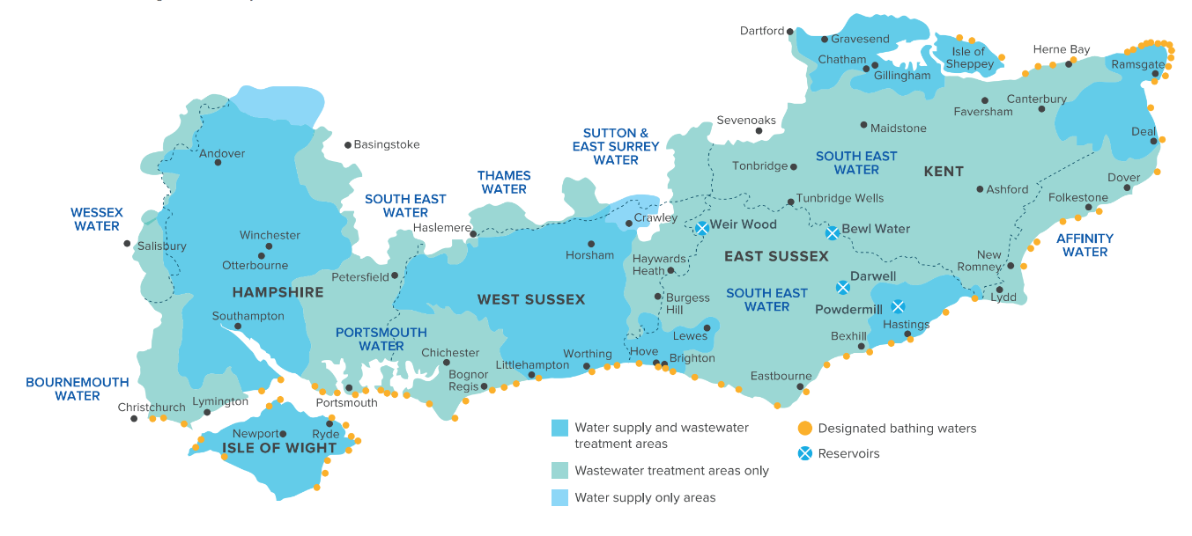

The South East of England is an area of water stress – where demand outstrips supply. In Hampshire the water resources challenge is especially acute due to the need to reduce abstraction of water from chalk streams and their associated aquifers, which have historically been the sole source of supply. New sources of water are needed to keep the county’s taps and rivers flowing today and in the future. Our Water for Life – Hampshire programme will transform the way we source, treat and supply water across the county, especially during a drought. A number of different initiatives are being progressed under the Water for Life – Hampshire programme, including reducing leakage and improving water efficiency but a large, new source of water is also needed to make up the shortfall and provide resilience. We propose to provide this new source of water by delivering the Hampshire Water Transfer and Water Recycling Project.

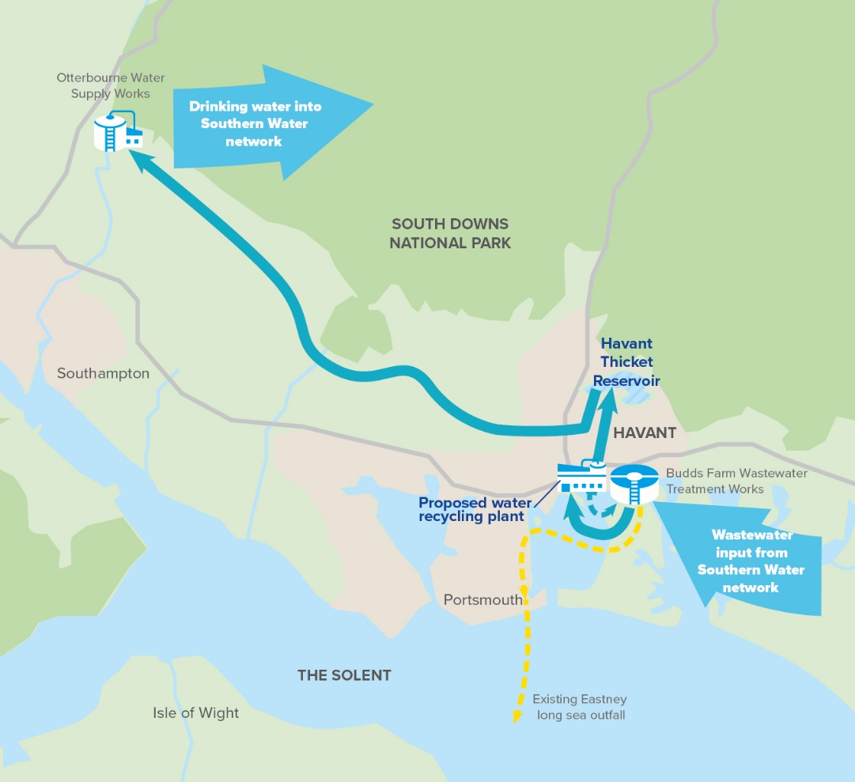
Figure 1 – the Project

The Project includes (see Figure 1 above):

- Proposed Water Recycling Plant and associated pumping stations
- Proposed Underground Pipelines between Budds Farm Wastewater Treatment Works and the proposed Water Recycling Plant
- Proposed Underground Pipeline between the proposed Water Recycling Plant and Havant Thicket Reservoir
- Proposed Underground Pipeline between Havant Thicket Reservoir and Otterbourne Water Supply Works, via a pumping station at the Water Recycling Plant
- Proposed Above Ground Plant comprising Intermediate Pumping Stations and Break Pressure Tanks located along the proposed Underground Pipeline between the Water Recycling Plant and Otterbourne
- Use of the Havant Thicket Reservoir for the storage of recycled water
- Use of the existing Eastney Long Sea Outfall at Budds Farm Wastewater Treatment Works for the release of reject water.
- Other associated and ancillary development.

Planning process
The Project has been directed by the Secretary of State for Environment, Food and Rural Affairs as a project of national significance. This means we need to submit an application for a Development Consent Order (DCO) to the Secretary of State. Once an application for a DCO is submitted, the Planning Inspectorate is responsible for administering the examination process. After the examination, the Secretary of State is responsible for making a decision on the application.

The Project is currently at the pre-application stage of the DCO process where we have a duty to, and actively want to, consult on our proposals. After the consultation is completed and having taken into account the views raised during consultation, we will refine our proposals and submit our DCO application to the Planning Inspectorate. When submitted, the Planning Inspectorate on behalf of the Secretary of State will decide if the Project can proceed to the examination.

An Examining Authority will then be appointed by the Planning Inspectorate on behalf of the Secretary of State to consider, examine and report on the accepted application. Members of the public, stakeholders, and organisations will be able to register as Interested Parties and will have the opportunity to comment verbally, at a hearing, and/or make comments in writing as part of the examination process. The Examining Authority has up to six months to complete the examination, then up to a further three months to make a recommendation to the Secretary of State.

At this stage of the process, the Secretary of State has up to three months to make a decision taking into account the recommendation from the Examining Authority.

Figure 2 – Generic DCO Planning Process

Further information about the DCO process is available on the Planning Inspectorate website at. https://infrastructure.planninginspectorate.gov.uk/application-process/the-process/. In addition, the Planning Inspectorate website provides an overview of the nationally significant infrastructure planning process for members of the public and others (Advice Note 8) and on responding to the developer’s pre-application consultation (Advice Note 8.1).

Principles of the public consultation process
Our objective for public consultation is to ensure that our customers, stakeholders and local communities who may be affected by the Project have an opportunity to understand, comment on and inform the proposals.

There are founding principles that apply to public consultation in the UK to ensure that projects such as the HWTWRP undertake lawful consultations. These are known as The Gunning Principles and they require that:

- The proposals are at a formative stage
- The information provided is sufficient to give ‘intelligent consideration’
- The consultation period is adequate to give time for consideration and response
- The product of consultation is conscientiously taken into account by decision makers.

Public consultation is a fundamental part of the pre-application process for a DCO. Its principal purpose is to raise awareness and seek stakeholders’ views to help inform the refinement of a Project prior to a DCO application being submitted. A Consultation Report will be submitted as part of the DCO application and will set out how the statutory consultation has been carried out and how feedback has been taken into account as part of the development of the Project. Upon submission of the DCO application, the Planning Inspectorate will determine whether the statutory consultation has been carried out in accordance with relevant legislation and guidance. It is important that our statutory consultation enables consultees to meaningfully engage with our proposals for the Project.

Our consultation will comply with the Gunning Principles through the following commitments:

- Formative stage - the consultation will be held before the project design and environmental assessments are finalised. The Project will be reviewed following the consultation and possible changes will be taken into account based on feedback received.
- Intelligent consideration - our consultation material will include information describing the design development process since the last consultation, alternative options assessed, and preliminary information on the likely significant environmental effects of the Project.
- Adequate time – our consultation will be 56 days (8 weeks) long, which is more than the 28 days (4 week) statutory requirement. This will ensure members of the community have adequate time to review our consultation documents and submit feedback.
- Consultation taken into account - we will collate and analyse all feedback received to find opportunities to inform and improve our Project. Following the consultation, we will provide a report outlining how feedback has been considered.

Previous consultation
In early 2021 we held a public consultation on our proposal to build a desalination plant on the Solent, located at Fawley in the New Forest. We also asked people for views on the alternative options, including the use of water recycling to use recycled treated wastewater as a new water source combined with a new pipeline to transfer more water from the planned Havant Thicket Reservoir for supply to the Hampshire area. We received 180 responses to the consultation, with key issues being raised around the potential environmental impacts of desalination. Respondents were generally supportive of water transfer and water recycling as alternatives to desalination.

Following our 2021 consultation, and a further options appraisal process, we engaged with our regulators and other statutory bodies to confirm that we would not be progressing our plans for desalination and that the combined water transfer and water recycling option (the Project) had been selected as our new preferred solution for addressing Hampshire’s water shortfall.

We continued to engage with key stakeholders on the Project during 2022 and held a non-statutory six-week public consultation over the summer period to seek views on the emerging proposals for the Project, including preferred pipeline corridors and a proposed site for the Water Recycling Plant. We continued to engage in the periods between consultations via forums, workshops, and meetings with local authorities, environmental stakeholders, landowners and community groups.

More than 550 responses were received in response to our Summer 2022 consultation. The feedback received, alongside ongoing engagement with key stakeholders on the Project, has helped to inform and refine the design of the Project, including the proposed pipeline routes and locations for Above Ground Plant.

What we will consult on
Following the Summer 2022 Consultation, we have had regard to the feedback received to select our proposed pipeline routes and locations for the Above Ground Plant. We now want to know what stakeholders think about the following to enable the proposals to be further shaped and refined:

- The proposed pipeline routes
- The proposed Water Recycling Plant and associated pumping stations
- Proposed Above Ground Plant along the pipeline routes
- The preliminary environmental and other impacts of the Project and initial proposals for mitigation.

We will also provide information that helps explain the need for the project and the use of water recycling in providing a new source of water.

Environmental Information
The Project is one for which an Environmental Impact Assessment (EIA) is required. EIA is a process where the likely significant environmental effects of a project are studied, surveys are carried out and mitigation measures (aimed at avoiding, reducing, managing, or compensating for environmental impacts) are identified.

The consultation will include the publication of the Preliminary Environmental Information (PEI) Report, providing information on the likely significant environmental effects of the Project. The PEI Report will provide environmental information and early assessment outcomes known at this stage of the Project, to help understanding and those responding to the consultation make informed responses about the proposals. The environmental assessments undertaken to date represent a point in the assessment process when the design of the Project is still in development, and the likely significant effects are continuing to be understood. Measures to address environmental effects will continue to be considered, and feedback from this consultation will continue to help inform the design development of the Project. Detailed environmental information, including the findings of our EIA, will be provided in the Environmental Statement that will be submitted as part of the DCO application.

Who we will consult
In consultation with the local authorities, and in accordance with Section 47 of the PA 2008, we have developed the following consultation zones, shown in Figure 3 below, to engage with the local communities who may be affected by the Project:

- Consultation Zone A comprises affected landowners within the draft Order Limits
- Consultation Zone B comprises people living within 1km of the draft Order Limits
- Consultation Zone C comprises people living within 5km of the draft Order Limits
- Consultation Zone D includes Hampshire and the wider area

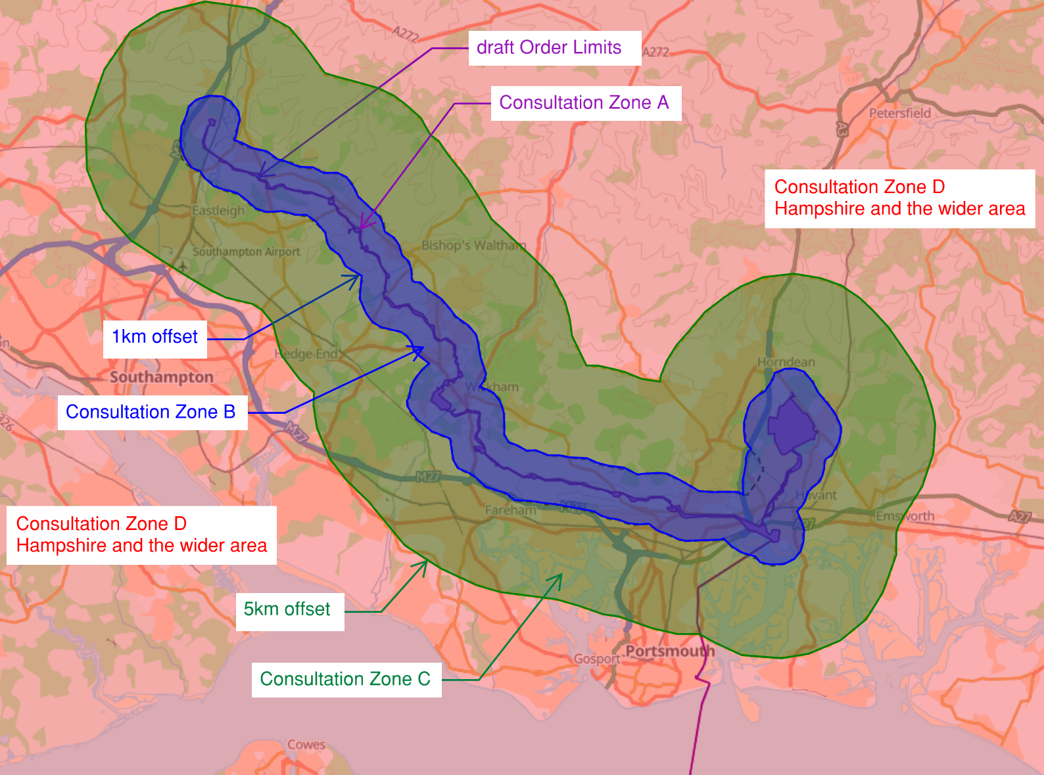
Figure 3 – Consultation zones

We will also consult with Statutory Consultees under the PA 2008 and relevant legislation and other relevant stakeholder groups.

How we will consult
We will use a range of approaches and media to maximise awareness of the Project and the consultation. These are designed to allow people with different needs across the community to take part in the consultation in a way that is accessible and convenient to them. Our consultation will include the following:

Method | Detail | Consultation Zone
Letters | Letters will be sent to landowners, tenants and businesses that qualify under section 44 of the PA 2008 with information about the Project, the consultation, and how to find out more and provide feedback. | Consultation Zone A
Leaflets | A leaflet summarising the Project, the consultation, and how to find out more and provide feedback will be sent. | Consultation Zones A and B
Posters | Posters will be distributed with details of the Project, the consultation events, and how to find out more and provide feedback. | Consultation Zones A, B and C
Adverts | Advertisements in publications such as the Hampshire Chronicle, Hampshire Independent, Portsmouth News, and Southern Daily Echo, to notify of the consultation and provide details of consultation events and how to find out more and provide feedback. | Consultation Zones A, B, C and D
Social Media | We will be using paid promotion and our own social media channels. Materials for social media will be produced and distributed to selected stakeholders who would be willing to help publicise the Project. | Consultation Zones A, B, C and D

Additional consultation methods listed below are aimed to capture wider areas beyond the specific consultation zones.
Method | Detail
Stakeholder briefings | We will contribute to stakeholder briefings (including local authority and parish councils) held prior to the launch of the consultation to advise them of the consultation and how they can find out more and provide feedback.  Stakeholders will also be advised of Southern Water’s social media campaign and information on how to interact with its posts.
Notices | Notices will be posted on land that is identified as unregistered.
Emails | We will send an email to all interested parties/registered users of the Water for Life – Hampshire website and respondents to the previous consultation that wished to stay in touch. This will signpost to key information and will include a link to the consultation website, details of the consultation events, and how to find out more and provide feedback.
Website | A Project website will be the digital hub for the consultation and will include the consultation materials, options to feedback virtually and to request further information or accessible versions of consultation materials.
Deposit locations | The consultation brochure, feedback form and technical information pack will be available for people to view at deposit locations in local and regional hubs (see Section 8.2 below).
Public consultation events | We will run a series of six public consultation events to provide information on the consultation and give people the opportunity to talk to the Project team. These will include exhibition boards describing the Project and members of the Project Team will be on-hand to answer questions. Visitors will be encouraged to ask questions to aid their understanding, complete/take away feedback forms and the consultation brochure.
Meetings with local organisations | We will offer to present at meetings where local organisations already meet and a request is made.

Consultation events will be held at the venues listed below.

Date | Time | Location
Monday  10 June | 2pm-8pm | Havant Rugby Football Club  Hooks Lane Ground  Fraser Road  Havant  Hampshire  PO9 3EJ
Saturday  15 June | 10am-4pm | Meridian Shopping Centre  Elm Lane  Havant  PO9 1UN
Thursday  20 June | 2pm-8pm | Southwick D-Day Memorial Hall  Priory Road  Southwick  PO17 6ED
Saturday  22 June | 10am-4pm | Jubilee Hall  Little Shore Lane  Bishops Waltham  SO32 1ED
Thursday  27 June | 2pm-8pm | Colden Common Community Centre  Saint Vigor Way  Colden Common  SO21 1UU
Friday  28 June | 2pm-8pm | Wickham Community Centre  Mill Lane  Wickham  PO17 5AL

Consultation documents
The following consultation documents will be available for viewing online, at deposit locations and at the public consultation events free of charge during the consultation:

- Consultation brochure - a plain English and visually accessible booklet that provides the key information about the proposals, the consultation and how to get involved
- Feedback form – a survey designed to collect feedback on the proposals
- Frequently Asked Questions – a document answering a range of questions about the Project serving as a one-stop reference point for concerns and providing signposts to further information should it be required.
- SoCC (this document)
- Preliminary Environmental Information Report – a report to enable consultees (both specialist and non-specialist) to understand the likely environmental effects of the Project.
- Preliminary Environmental Information Report Non-Technical Summary – a summary of the Preliminary Environmental Information Report
- Scheme Development Summary Part 2 – a summary of how the Project has developed to date, including refinements made following the Summer 2022 Consultation
- Book of Maps – plans of the proposed pipeline routes and Above Ground Plant.

To ensure accessibility (including seldom heard and hard to reach groups), on request, documents can also be translated, made available in large print, audio versions, braille and in a digital data format (e.g. USB). In addition, hard copies of consultation documents can be provided. Please see section 12 for our contact details to request these methods. We reserve the right to a charge for paper copies of some consultation documents as follows:

- Consultation pack (all documents including the PEI Report) - £350
- Consultation pack (all documents excluding the PEI Report) - £100

One copy of the consultation brochure and feedback form is free. We are keen to reduce the impact on the environment by reducing unnecessary printing and minimising paper use. The Preliminary Environmental Information Report is expected to be around 4,000 pages.

Deposit locations
Hard copies of our consultation documents will be available for the duration of the consultation period at the following locations:
Location | Address | Opening times
Cosham Library | Spur Road  Cosham  Portsmouth,  PO6 3EB | Monday 9:30am-6pm  Tuesday 9:30am-6pm  Wednesday 9:30am-5pm  Thursday 9:30am-6pm  Friday 9:30am-5pm  Saturday 10am-3:30pm  Sunday Closed
Paulsgrove Library | Paulsgrove Youth Community Centre  Marsden Road  Portsmouth  PO6 4JB | Monday 9:30am-12:30pm & 1:30-5pm  Tuesday Closed  Wednesday 9:30am-12:30pm & 1:30-5pm  Thursday 9:30am-12:30pm & 1:30-5pm  Friday 9:30am-12:30pm & 1:30-5pm  Saturday 10am-3:30pm  Sunday Closed
Fair Oak Community Library | Campbell Way  Fair Oak  Eastleigh  SO50 7AX | Monday 9:30am-1pm  Tuesday 2-5pm  Wednesday 9:30am-5pm  Thursday 2-5pm  Friday 9:30am-1pm  Saturday 9:30am-1pm  Sunday Closed
Fareham Library | Osborn Road  Fareham  PO16 7EN | Monday 9:30am-5pm  Tuesday 9:30am-5pm  Wednesday 9:30am-1:30pm  Thursday 9:30am-5pm  Friday 9:30am-5pm  Saturday 9:30am-5pm  Sunday Closed
Leigh Park Library | 50 Park Parade  Leigh Park  Havant  PO9 5AB | Monday Closed  Tuesday 9:30am-5pm  Wednesday Closed  Thursday 9:30am-5pm  Friday 9:30am-5pm  Saturday 9:30am-1:30pm  Sunday Closed
Havant Library | Havant Meridian Centre  Havant  PO9 1UN | Monday 9:30am-5pm  Tuesday 9:30am-5pm  Wednesday Closed  Thursday 9:30am-1:30pm  Friday 9:30am-5pm  Saturday 9:30am-5pm  Sunday Closed
Waterlooville Library | The Precinct  Waterlooville  PO7 7DT | Monday 9:30am-5pm  Tuesday 9:30am-1:30pm  Wednesday 9:30am-5pm  Thursday 9:30am-5pm  Friday 9:30am-5pm  Saturday 9:30am-5pm  Sunday Closed
Eastleigh Library | 1 Floor  Swan Centre  Eastleigh  SO50 5SF | Monday 9:30am-1:30pm  Tuesday 9:30am-5pm  Wednesday Closed  Thursday 9:30am-5pm  Friday 9:30am-5pm  Saturday 9:30am-5pm  Sunday Closed
Bishops Waltham Library | Free Street  Bishop’s Waltham  Southampton  SO32 1EE | Monday Closed  Tuesday 1-5pm  Wednesday 9:30am-1:30pm  Thursday Closed  Friday 1-5pm  Saturday 9:30am-1:30pm  Sunday Closed

When we will consult
Consultation will be carried out over an eight-week period. A timeline for the consultation is outlined below:

Date | Activity
10 May 2024 – 28 May 2024 | Pre-awareness engagement (emails, leaflet, social media, adverts)
29 May 2024 – 23 July 2024 | Consultation Period including holding consultation events

Consultation responses must be submitted to us by 11.59pm on 23 July 2024.

How the community can provide comments
The following official feedback mechanisms will be provided as part of the consultation:

- Online feedback form – fill in and submit the online questionnaire, accessed via the Project website: www.HampshireWTWRP.co.uk
- Email comments to – FeedbackHWTWRP@southernwater.co.uk
- Letters or hard copy of the feedback form: FREEPOST HAMPSHIRE WTWRP CONSULTATION

We cannot guarantee that responses sent via any other channel will be taken into account, unless agreed in advance with Southern Water.

How we will respond to consultation feedback
Once the consultation has closed, we will collate and analyse the responses received. We will carefully consider all issues raised and will have regard to this feedback when finalising the proposed application. As part of the DCO application we will publish a Consultation Report, detailing how we have engaged and consulted on the Project, whilst adhering to legislation and guidance and reporting on the issues raised in the consultation and our response to them. In having regard to feedback and refining our proposals, it may be necessary to make further changes to the proposed Project following the statutory consultation process. If we deem a significant change is made to the Project, or new statutory consultees are affected, we will consider further targeted consultations beyond what is specified in this document, to help inform the final design of the Project. If further consultation is carried out, we will provide appropriate notification to relevant stakeholders who may be affected by the change(s) in question. Otherwise, we will continue to update the public and other stakeholders on our proposals at appropriate milestones throughout the Project and keep them informed of changes through the various communication channels available to us such as email and through stakeholder engagement activities. We will also keep our Project website up to date with the latest information.

Any comments received will be analysed and may be made available in due course to the Secretary of State, the Planning Inspectorate, appointed Examining Authority, and other relevant statutory authorities so that feedback can be considered as part of the application process. We will ensure that any personal details are not placed on public record, except where it is required in accordance with legislation or legal duty such as land referencing, but held securely in accordance with the General Data Protection Regulation (GDPR), the Planning Inspectorate’s Customer Privacy Notice and the Data Protection Act 2018. Personal details will be used solely in connection with the consultation process and subsequent DCO application.

In addition to the Consultation Report, we will prepare a ‘Summary of Consultation Feedback’ report after the close of the consultation which will be published on our Project page. This document will focus on the feedback we received during the statutory consultation. Ahead of the submission of the DCO application, a separate ‘Response to Consultation Feedback’ report will follow which will summarise our response to feedback provided through the Summer 2024 Consultation and demonstrate, at a high level, how we have been considered issues raised in the refinement of the Project.

Contact us
If you have any queries about the Project, including requests for hard copy versions of any of the consultation documents, and any particular accessibility needs, please contact us at:

Email: HampshireWTWRP@southernwater.co.uk
Post: FREEPOST HAMPSHIRE WTWRP CONSULTATION
Phone: 0800 254 5138

Section 47 of the Planning Act 2008 - https://www.legislation.gov.uk/ukpga/2008/29/section/47
Planning Act 2008: guidance on the pre-application process for major infrastructure projects - https://www.gov.uk/government/publications/guidance-on-the-pre-application-process-for-major-infrastructure-projects
https://infrastructure.planninginspectorate.gov.uk/legislation-and-advice/advice-notes/advice-note-eight-overview-of-the-nationally-significant-infrastructure-planning-process-for-members-of-the-public-and-others/
https://infrastructure.planninginspectorate.gov.uk/legislation-and-advice/advice-notes/advice-note-8-1/
The 1km buffer does not include Eastney Long Sea Outfall as no new development is assumed.
The Infrastructure Planning (Applications: Prescribed Forms and Procedure) Regulations 2009 (as amended), https://www.legislation.gov.uk/uksi/2009/2264/made
Customer Privacy Notice – Planning Inspectorate https://www.gov.uk/government/publications/planning-inspectorate-privacy-notices/customer-privacy-notice

