One Horton Heath : Overall Green Infrastructure
Planning Application F/24/96895

Comments from

Barley Fields Residents Group
Barley Fields, Horton Heath, Eastleigh

4th June 2024

This response to the above application is being submitted on behalf of the Barley Fields Resident Group (BFRG). The BFRG comprises of the owners of homes situated in Barley Fields. They are listed at the foot of this document.

1. Summary

Whilst a significant amount of new and existing landscaping is proposed the Planning Application requires revising for the following reasons -
- The application does not provide Green Infrastructure in Upper Acres and consequently the uncertain impact of the overall OHH development remains outstanding. The application should confirm an allocation of any green space or planting along the sensitive edge with Barley Fields
- The proposal should be reconsidered with the objective of ensuring capacity for a green zone along the boundary with Barley Fields whilst maintaining the required net developed area across the OHH development Site. Such provision is considered possible and entirely reasonable and should not be left to a final design stage.

2. Barley Fields setting and context

The houses in Barley Fields were constructed in 2003. A key feature of these houses is their small gardens and outlook across open farmland (see pictures of rear elevations)

The Barley Fields site is bounded by a thin hedgerow, ditch and in places just a barbed wire fence. The ditch is often close to flooding following heavy rain due to poor drainage from the fields, which are frequently waterlogged. The fields to the west of Barley Fields are on a gradual incline, such that the land rises as you move away from Barley Fields and into the new development site.

The houses in Barley Fields are the only ones immediately adjoining the OHH development with no landscape/green buffer. As demonstrated by this application almost all other existing houses in Horton Heath have been afforded the benefit of a new or existing green buffer and natural planting to alleviate the impact of development. It is considered essential that the properties in Barley Fields should be given the same consideration.

3. Comments on proposal

BFRG consider the application will provide a pleasant landscape and greening for new and existing residents in the north part of the OHH development site. This is a welcome design approach but ignores the sensitive edge with Barley Fields.

Substantial landscaping/greening should be possible along this sensitive edge without adversely impacting the net developed area and therefore scheme viability. It seems odd that additional green space is planned along other boundaries
- Native mix hedgerow and low level shrub/woodland to enhance landscape buffers is proposed adjoining existing houses in Hammerley Road, Farm Road
- Where additional planting is not proposed existing trees, hedges and larger gardens provide mitigation
Whilst various planning applications relating to OHH development highlight improving biodiversity in parts of the site there is insufficient consideration of impact on existing residents adjoining the scheme. This is inconsistent with Councillor Keith House’s quote on page 3 of the Design Code “…this Design Code is the delivery mechanism for the Council’s aspiration to improve lives and support existing and new communities.” This planning application fails to reflect this clear intent in relation to existing communities.

4. Planning Permission granted on 22 July’23 (O/20/89498)

Horton Heath Development Management Committee 22 June 2023 Report of the Service Director for Planning and Environment for Application No. O/20/89498 states in Paragraph 180

“Significant effects are also identified for some residents overlooking the eastern edge of the site, including those living in Barley Fields, Bramley Gardens, Crispin Close, Farm Road, Angelica Gardens, Fir Tree Lane, Fir Tree Close and Burnetts Lane and on transient users of parts of Burnetts Lane, Blind Lane, Fir Tree Lane and Allington Lane. The design and layout of the detailed phases would need to recognise and address the unique relationship of neighbouring properties and public rights of way with the development and respond accordingly in order to reduce negative impacts. Mitigation through landscaping and the appropriate siting, height and orientation of buildings and uses would be necessary”.

This application does not address the requirement to provide mitigation through landscaping around Barley Fields and therefore fails to comply with the requirement highlighted in bold text above.

5. Conclusion

The Overall Green Infrastructure for the OHH development site should address the requirement to mitigate the impact of the scheme in relation to Barley Fields and other roads indicated above.
- A minimum 20m landscaped zone to apply to the sensitive boundary with Barley Fields
- A planting zone to be implemented before the construction of any houses enabling time for trees to mature

Barley Fields Residents Group

Lisa & James Irving - Summerlea
Ian Gaywood & Sarah Mountstephens - Golowys
Helen & Mark Roberts - Craggy House
Peter & Pauline Grant - Rivendell
Andy Norman - Otham Court
Morgan Ebert & Alana Cunningham - The Tamerisk
Adam & Dinny Wallis - Kenreg House

Barley Fields Photographs

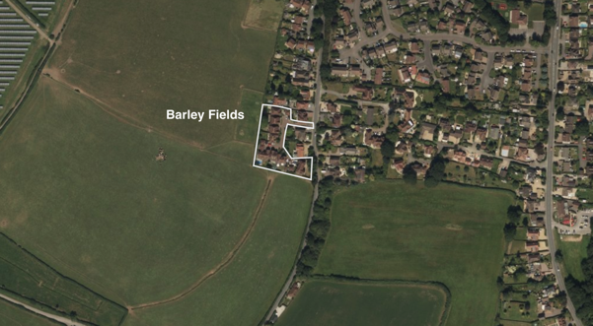

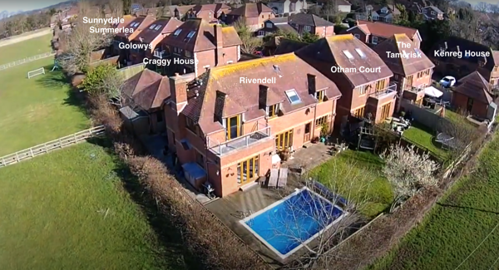

Left to right : Sunnydale, Summerlea, Golowys, Craggy House, Rivendell, Otham Court, The Tamerisk, Kenreg House

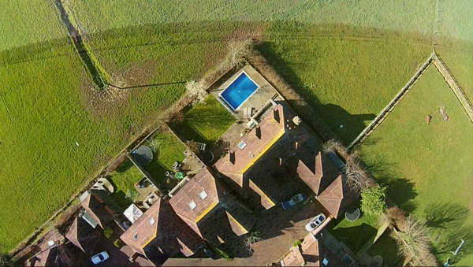

Left to right – Kenreg House, The Tamerisk, Otham Court, Rivendell

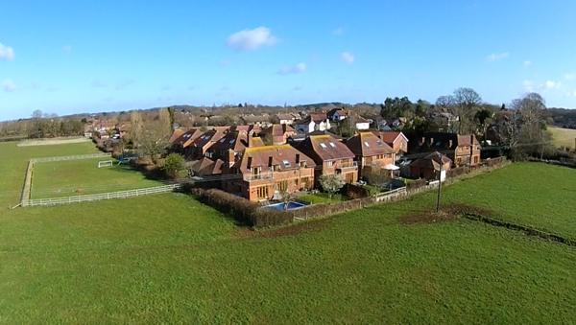

Left to right : Sunnydale, Summerlea, Craggy House, Rivendell, Otham Court, The Tamerisk, Kenreg House

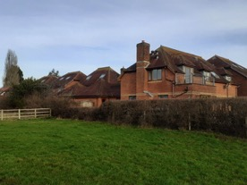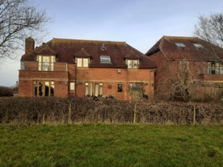
Rivendell – Viewed from west Rivendell – Viewed from south

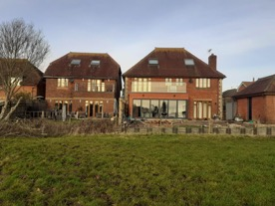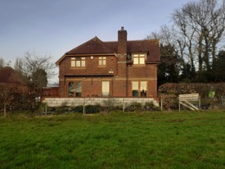
Otham Court (left), The Tamerisk Kenreg House – viewed from south
(right) – viewed from south

