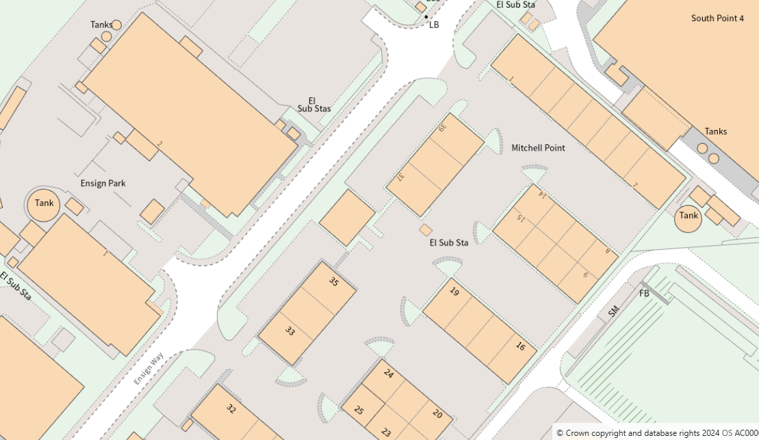
T5
T4
T3
T2
T1

