13 Kenilworth Drive Boyatt Wood Eastleigh SO50 4PST 052450

T1 - Ash sp. In accordance Visual Tree Assessment.
Reduce tree by 4-5m around the entire canopy and crown raise over garden by 3 m.
Works to be carried out in accordance withBS3998(2010), nearest pruning points.
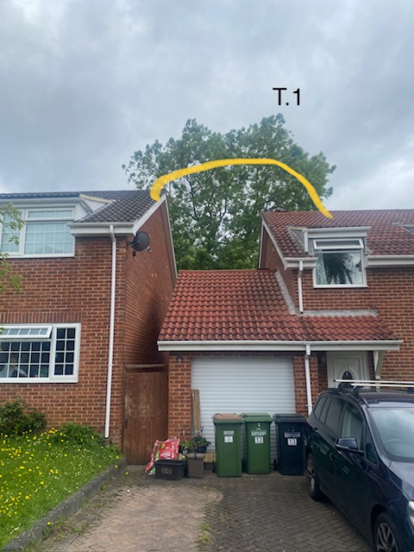
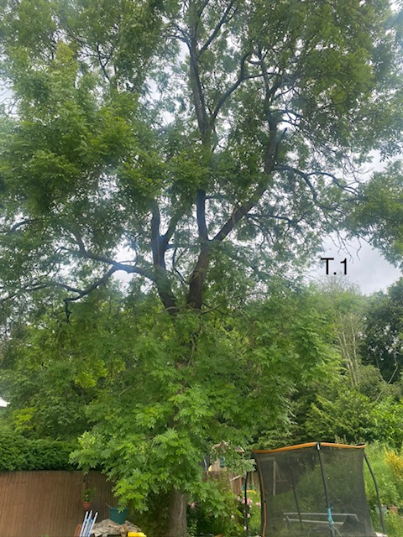
T1

