Tree Protection Method Statement

Proposed Alterations
Walton Flints
Reservoir Lane
Hedge End
Southampton
Hampshire
SO30 4AX

For

Mr & Mrs Camp

Dated: July 2024
Revision: A

Introduction

This statement has been prepared in support of a householder planning application submitted to Eastleigh Borough Council for the an alteration project at Walton Flints, Reservoir Lane, Hedge End.

This statement, which should be read in conjunction with the proposed plans, aims to detail the protection measures to the adjacent trees.

Tree Protection
To the north west of the property is an oak tree (TPO ref: 196-E).

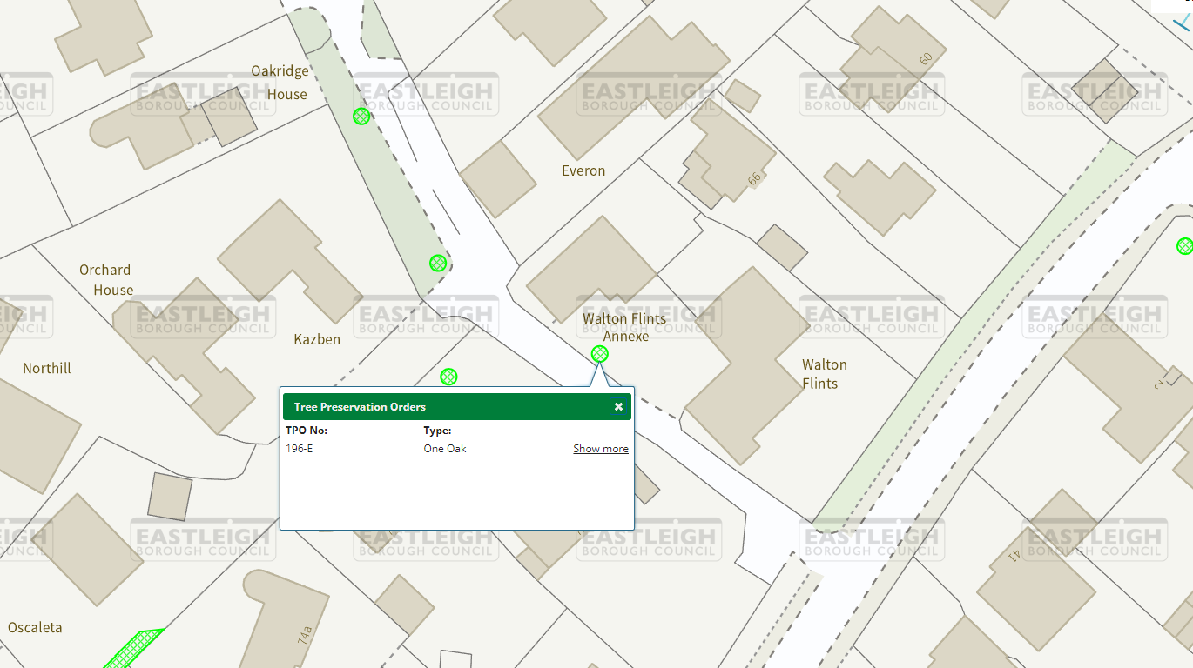

Image 1 – Extract from Eastleigh Borough Councils Tree Map

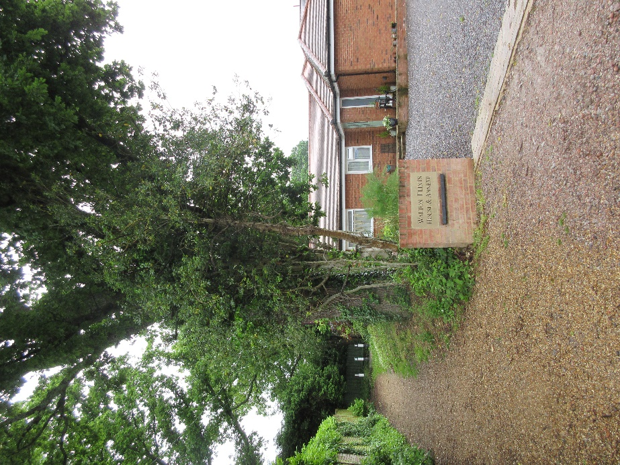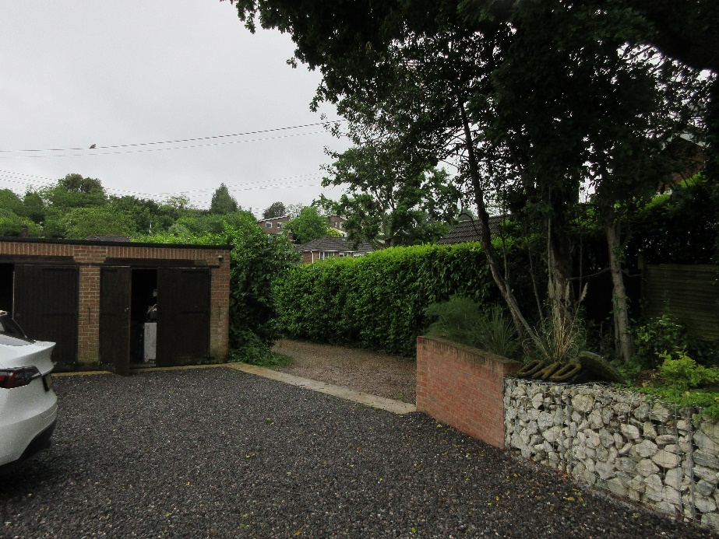
Photographs of the tree

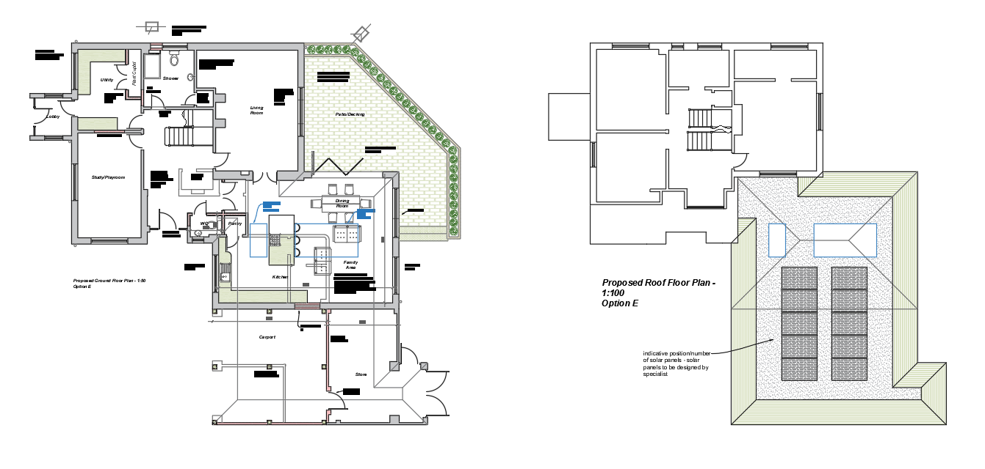
Image 3 showing proposed project
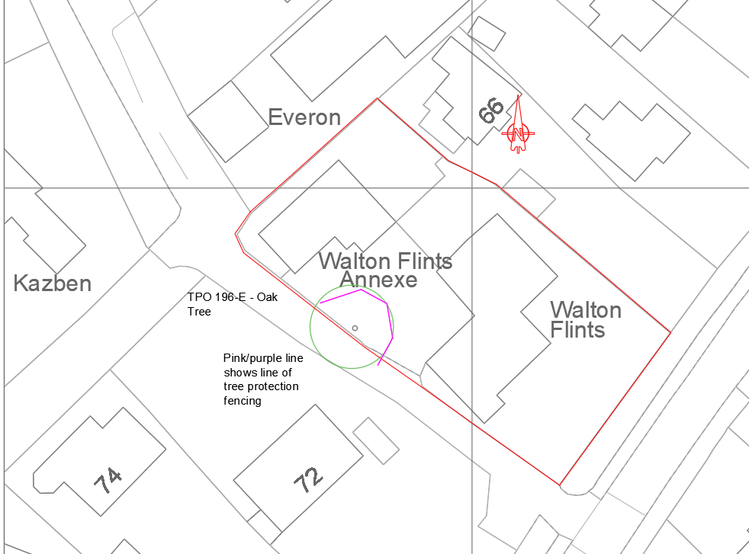

The proposal is to carry out a range of alterations to the existing building, primarily to remodel the existing roof structure. The property will not be extended as part of the project and all works will be within the existing footprint of the property.

The works to remodel the roof are outside of the canopy of the tree.

The existing external walls to the garage will be altered to form a car port. It is anticipated that the existing foundations will be suitable and can be re-used as part of this project. A small amount of foundation excavation will be carried out within the footprint of the building – with these new foundations supporting brick piers/posts and an internal masonry wall.

Any new excavations will be carried out by hand.

Heras fencing (secured to a scaffolding frame) will be erected on the line shown on the proposed plans. The tree protection will be in accordance with BS 5837 (and shown below), and should contain signage to detail the protective nature of the fencing and the restrictions within the fenced area. The fencing should consist of a scaffolding framework, comprising vertical and horizontal poles, well braced to resist impacts, with vertical tubes spaced at maximum intervals of 3m. Onto this, mesh panels should be securely fixed with wire or scaffold clamps.

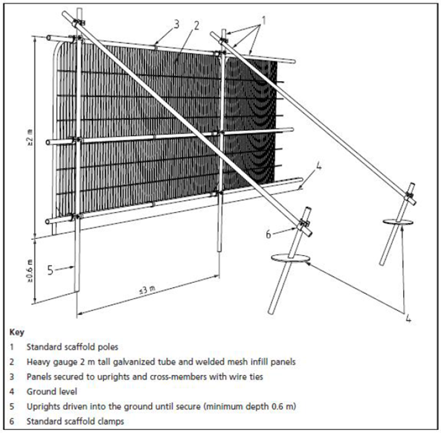

Within the fenced area there should be no excavations, no changing of ground levels, no storage of plant or materials, no cement mixing/washing, no vehicular access and no fire lighting. The line of the fencing is displayed by the red line on the above image

Materials storage, plant storage, cement mixing/washing will all be carried out on the western boundary of the site; i.e. away from the trees.

All excavations will be carried with care, and in a manner to minimise disturbence to the roots. No roots with a diameter larger than 25mm are to be severed. Any roots smaller than this will be pruned with a clean cut with a suitable sharp tool. Any roots exposed will be protected from dessiccation or rapid temperature changes by wrapping in Hessian, which will be removed prior to backfilling.

