Design and Access Statement

Single Storey Rear Extension

158 Southampton Road, Eastleigh.
SO50 5QX

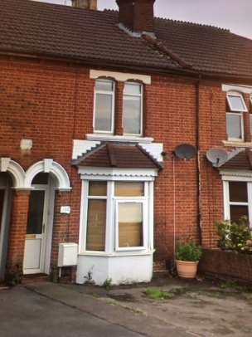

Contents:

- Introduction

- Site Description

- Description of Proposed Development

- Access

- Trees and Landscaping

6 Conclusion

1 Introduction

This Design and Access Statement has been prepared in support of a householder planning application, for the construction of a single storey rear extension at 158 Southampton Road, Eastleigh. SO50 5QX.

2 Site Description

The site is located on the western side of Southampton Road within a residential area. Opposite the house runs the railway line. The area has a strong mix of households including 2 – 3 bedroomed properties and flats.

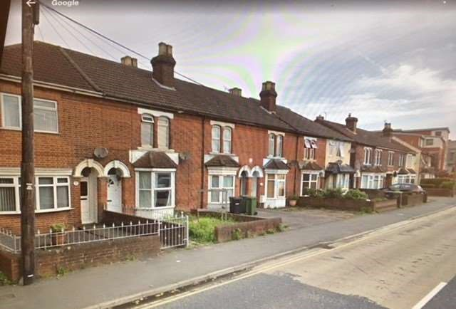

3 Description of Proposed Development

The proposal involves the construction of a single storey rear extension. The new extension will extend the kitchen, move the position of the bathroom and create a bedroom with an en-suite.

The new construction will replace an existing single storey rear extension (as seen in the picture below.) The materials used for the new extension will be as close as match as the existing.

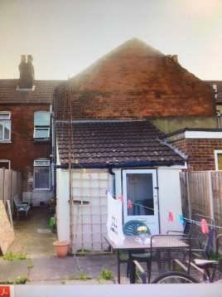

4 Access

The site is accessible in regards parking and local amenities. The College is a quarter of a mile away and the train station only 300 yards.

5 Trees and Landscaping

No trees or hedges will be lost as a result of the proposed extension.

6 Conclusion

The design of the extension is of a high quality in keeping with the style of the existing houses and thus appropriate for the site.

There is already an existing rear extension and the new construction will simply replace it.

