Sketch plan for 3 Hocombe Park Close, Chandlers Ford, SO53 5PT
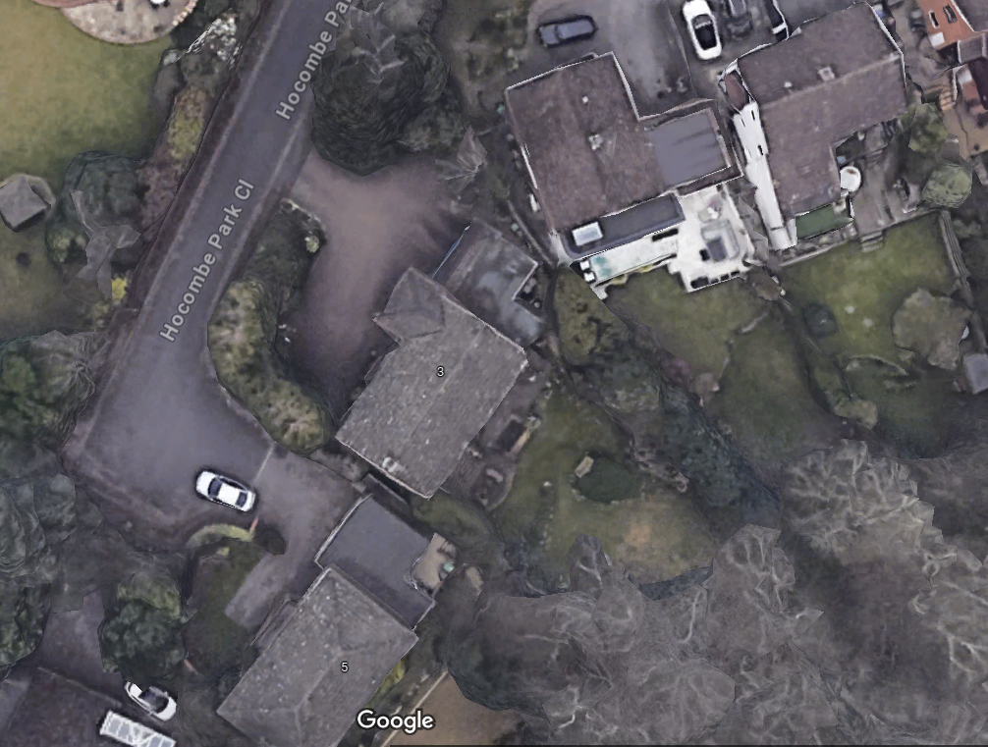
G1
T3
T2
T1

- T1 Acre to be reduced by approximately 2 meters
- T2 Beech tree limbs growing towards house top be reduced by approximately 3 metres
- T3 Sweet Chestnut tree to be pollarded and left at approximately 8 metres in height
- G1 Group of Rhododendron along boundary to be reduced by approximately 2 metres

