PROPOSED CHANGE OF USE
from Engineering works (General Industrial use Class B(2),
to use the premises for Class E(g)(i) for use as offices,
and E(g) (ii) for research and development of products or processes,

Unit 17, Solent Industrial Estate, Hedge End,
Southampton, SO30 2FQ

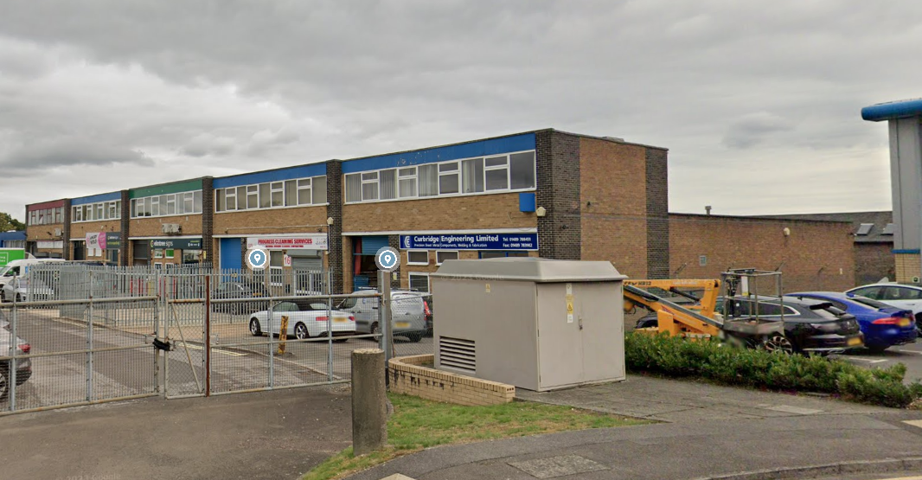

PLANNING STATEMENT SEPTEMBER 2024

Colin Tebb, Planning Consultant,
BA(Hons), Btp,

NATIONAL GUIDANCE:

The Department for the Communities and Local Government (DCLG) released Circular 01/2006, which required, inter alia, the submission of Design and Access Statements (DAS) with all but the most modest planning applications. A Planning, Statement is therefore required in association with this Planning Application for the proposed development set out below:

PROPOSED CHANGE OF USE from Engineering works (General Industrial use Class B(2), to use the premises for Class E(g)(i) for use as offices, and E(g) (ii) for research and development of products or processes,

The National Planning Policy Framework – NPPF (As amended) is the mainstay to planning in England and Wales, and this provides more recent detailed guidance to Councils, and this includes some important changes to guidance on dealing with underused, redundant or vacant buildings, and their potential re – use for alternative economic uses, particularly in our Towns and Cities.

So, the current premises are restricted by two extremely tightly drawn “Personal” planning conditions:

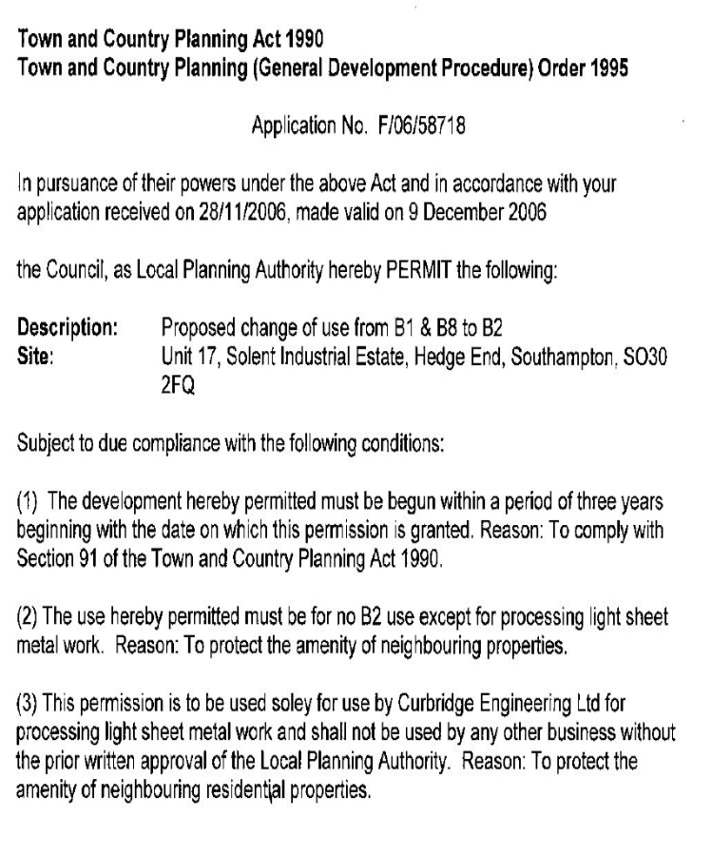

So, the conditions above are essentially a personal permission, as it restricts the premises for use purely by Curbridge Engineering Ltd for processing light sheet metal work. The reason for the condition was to “Protect the amenity of neighbouring residential properties.”

17 years later, the personal – business needs and circumstances of Curbridge have now changed are so they are seeking to sell or let the premises to new clients, and so are seeking a change of use to Class E(g)(i), enabling it to be advertised for use as offices, and E(g) (ii) for research and development of products or processes. The existing and proposed plans are shown below.

LOCAL PLANNING POLICY.

More locally is the Adopted Eastleigh Local Plan 2016 to 2036, which was adopted by Full Council in April 2022. It sets out the Council’s policies for the use and development of land across the whole of the Borough. The local plan is the main part of the development plan for the Borough and will be given full weight by the Council in making decisions on planning applications. The Adopted Plan:

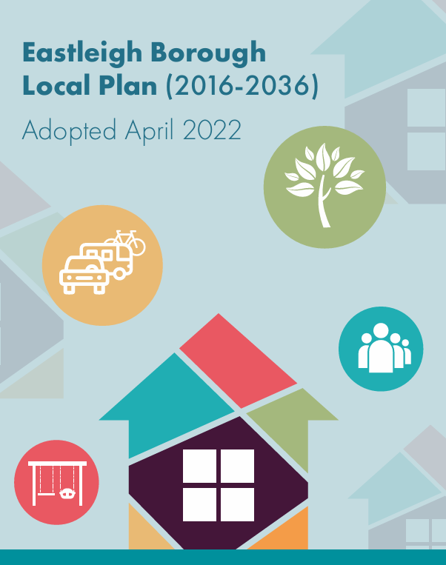

The most relevant policy is Policy DM15, which seeks to safeguard exisitng Employment Areas. This states:

Policy DM15, Safeguarding existing employment sites

1. The major existing employment sites as identified on the policies map shall be retained predominantly in employment use classes B2, B8 and E(g). Within these sites the Borough Council will permit:

a. the redevelopment and intensification of use of sites for Use Class B2, B8 and E(g)(ii)/(iii) employment uses;
b. changes of use between use classes B2, B8 and E(g)(ii)/(iii); and
c. workforce training opportunities as defined in policy DM16 below;
subject to the general development criteria and transport policies of this Local Plan including the impact on residential areas.

2. Exceptionally, employment uses other than those in use classes B2, B8 or E(g)(ii)/(iii) (but not E(a)/ (b)/(c) uses or pubs, drinking establishments or hot food takeaways) may be permitted on these sites provided that:
a. they would not have a significant impact on the continued primary use of the site
b. the existing site is causing, or could cause, significant harm to highway safety or to the amenities of the area or to local residents

3. The redevelopment or change of use of other existing employment sites not identified on the policies map currently in class B2, B8 or E(g)(ii)/(iii) uses to non-employment uses, where this is not permitted development, will be permitted provided that it can be demonstrated that the site is no longer in demand for employment use and that criteria a. and b. above are satisfied.

The Borough Council considers that it is important to retain employment sites in employment use in order to retain a diverse choice of employment opportunities, to enable industries already established on these sites to grow, and to minimise the need to allocate further greenfield sites for employment use. All the major existing employment sites were reviewed and found to be viable and valuable employment sites

Importantly, we note that these premises form part of a Designated main Employment Site, within Eastleigh area, where new employment generating uses and businesses are to be concentrated. The wider Employment designation is shown by the RED shaded area below:

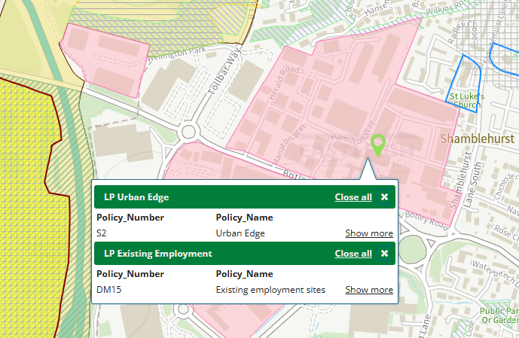

On the question of Eastleigh’s economy, the Adopted Local Plan recognises the role different employment developments plays in the overall borough – wide economy:

“The Borough Council considers that it is important to retain employment sites in employment use in order to retain a diverse choice of employment opportunities, to enable industries already established on these sites to grow, and to minimise the need to allocate further greenfield sites for employment use. All the major existing employment sites were reviewed and found to be viable and valuable employment sites…”

On the question of National guidance, the National Planning Policy Framework, advises that:

“Planning policies should avoid the long term protection of sites allocated for employment use where there is no reasonable prospect of a site being used for that purpose”

THE SUSTAINABLE LOCATION:

In this case, the site is in an extremely sustainable location, just north east of the main Hedge End Retail and Commercial Park, and all its shops, restaurants, leisure uses, etc, so “easily accessible by Public transport, walking and cycling”, in accordance with the National Planning Policy Framework:

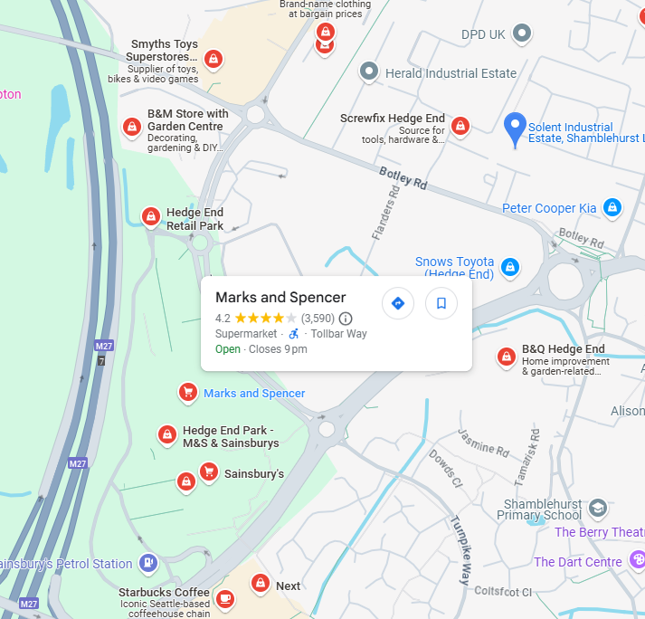

The application seeks a more flexible E(g) use, so will be offering new employment opportunities locally.

THE PROPOSED CHANGE of USE

In this case, the original restrictive conditions were imposed upon the applicant Corbridge Engineering Ltd almost 20 years ago, presumably because the specific type of “processing light steel metal work” was perhaps more than a typical old style Use Classes Order definition B1 (Office type) use. Unfortunately the Eastleigh Borough Council, (Planning area of their website) does not contain the planning Officers report at that time, so we can only assume the more restrictive personal condition was imposed because of the quite specific steel fabrication.

We also note that the Environmental Health Officer, and Hedge End Town Council were consulted, but their comments were also not on the planning file: F/06/58718. However, the original 2007 Planning Permission was granted subject to much more personal – restrictive conditions 2 and 3.

Now the current owners (still Curbridge Ltd) of the business are considering marketing the premises, however the current extremely tight restrictive, effectively personal Planning Permission, means they are extremely unlikely to find a new potential Company to take the unit.
Consequently, this application and potential more relaxed Planning Permission, will enable the applicants to market the unit to a considerable wider audience, with a corresponding greater chance of finding a new Company.

The existing and proposed plans are shown below, but clearly until a new owner is found, there are no changes proposed, either internally or externally; we are purely seeking a wider range of potential uses/users, with a Class E(g)(i) and Eg(ii) use:

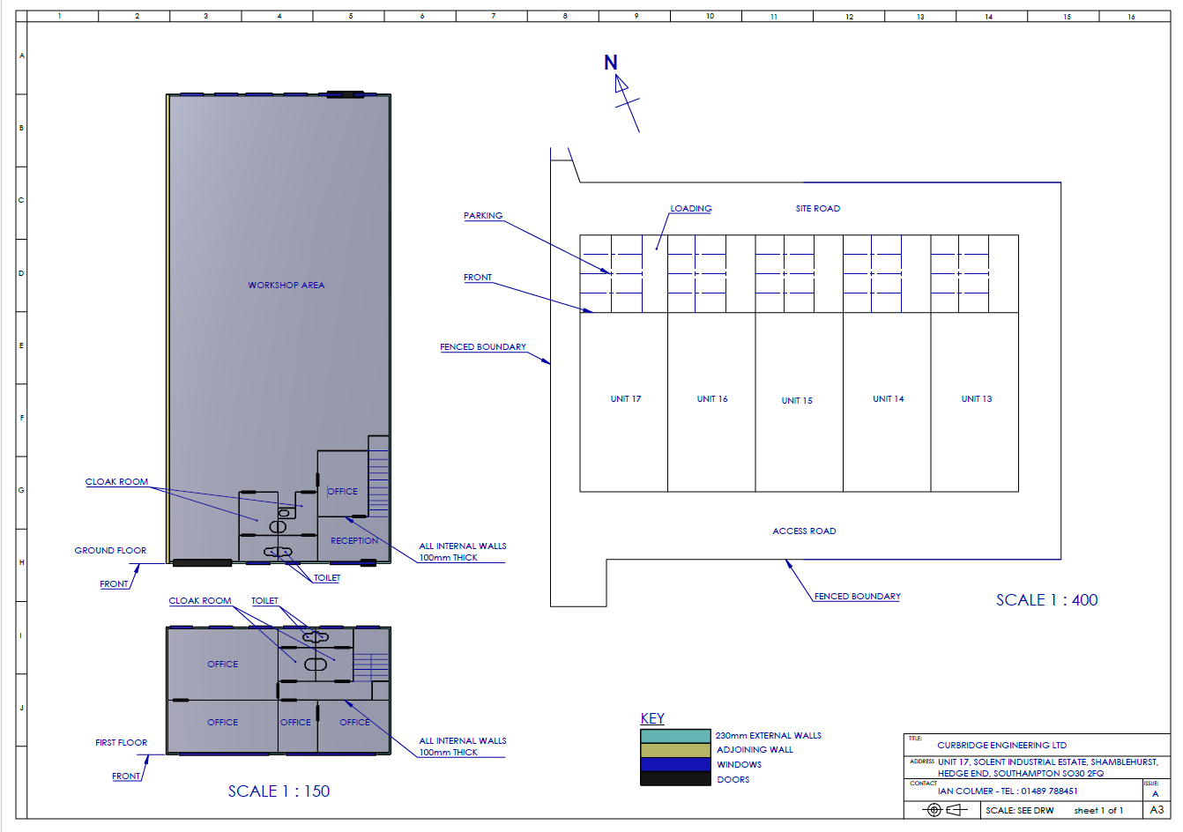

PARKING:

We assume that, as part of your determination of this application, the Eastleigh Borough or County Highways Officer will be consulted. The exisitng Unit 17 has 8 specifically allocated car parking spaces, as well as a dedicated loading and unloading area to the front of the unit and its main full – height loading bay doors.

NOISE:

Clearly, the 2007 Planning Permission was much more restrictive permission, but without the Officers report and/or Environmental Health Officers comments, we are unsure why it was so restrictive. So, we are seeking either an Eg(i) or Eg(ii) user, which are either an Office user or Research and Development Company, and NOT an Eg(iii) “Industrial Process” user.

Again, we assume both Highways and the Environmental Health Officers will be consulted as part of the consideration of this application. We would be delighted to discuss any feedback from either of these Consultees, or indeed any other comments received, from the Town Council for example.

CONCLUSION:

So, in Planning Policy terms, and to reiterate, the Planning Permission is being sought to provide the current Company to market the premises to a much wider audience and retaining some form of commercial – employment use, offering local employment for local people.

With this in mind, the new potential uses will accord with the objectives of both National and Local guidance and polices, in particular Policy DM15, Safeguarding existing employment sites.

Indeed, it will also be situated in this sustainable location, all in accordance with the National Planning Policy Framework and the more local Adopted Local Plan, and Policy DM15.

Our clients would therefore be happy to meet the appointed Case Officer on site, either at the time they erect their site notice or at any specified time/day/date?

CONTACT DETAILS:

With this in mind, my contact details are:

Colin Tebb, BA(Hons) Btp,
Planning Consultant
TEL: 07824 116423
Email: dorsethome@btinternet.com

In addition, whilst I am currently a freelance Planning Consultant, I have previously worked for various Local Planning Authorities across the South East and more recently South coast LPA’s of the UK, so would prefer to commence a dialogue with the Case Officer, respond to any questions or issues and respond accordingly.

We are also open to Extensions of Time where necessary.

