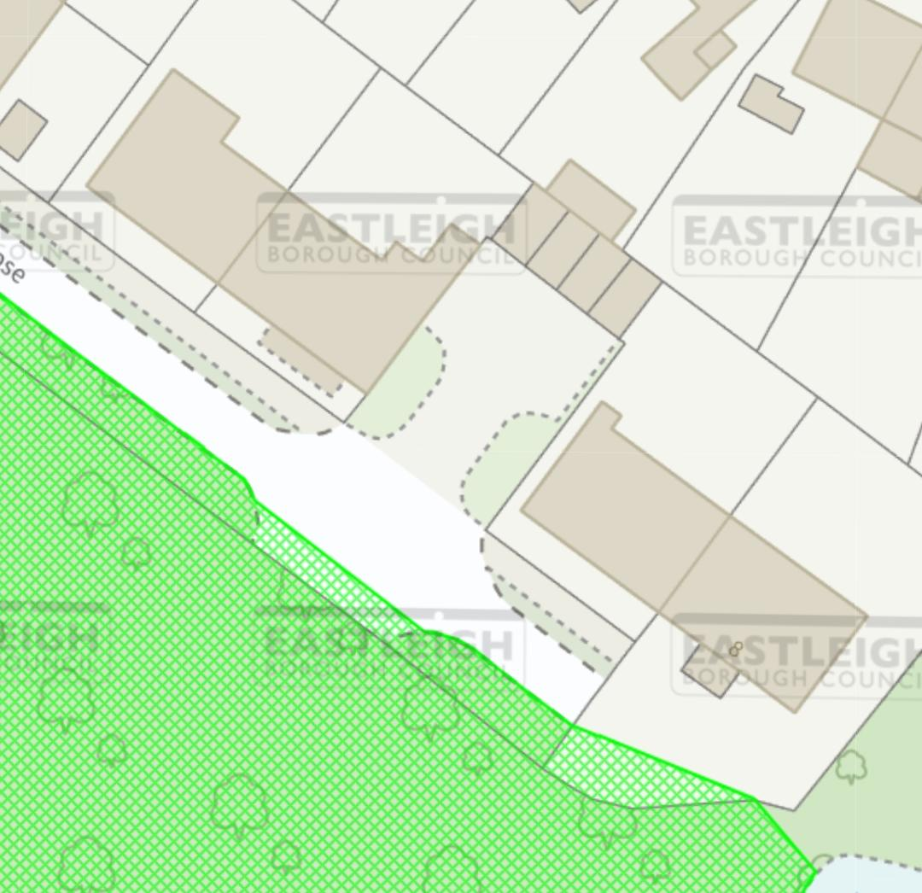
T3
T2
T1
Beech close
8
5
5

