Page 1 – Tree Plan
15 Firs Drive, Hedge End, SO30 4QQ

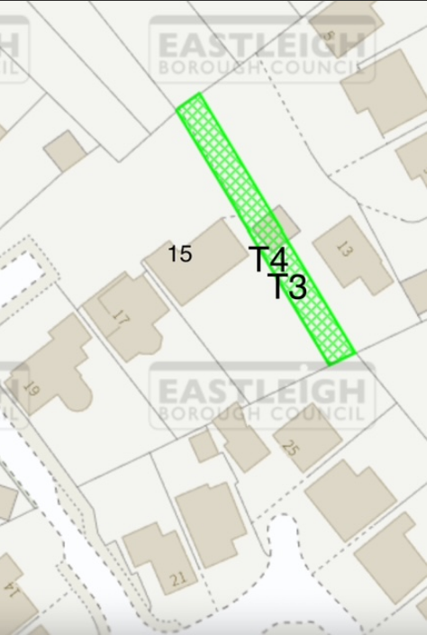

T1

