- Photos showing the garden of 12 Ingersley Rise and overhanging branches of beech tree

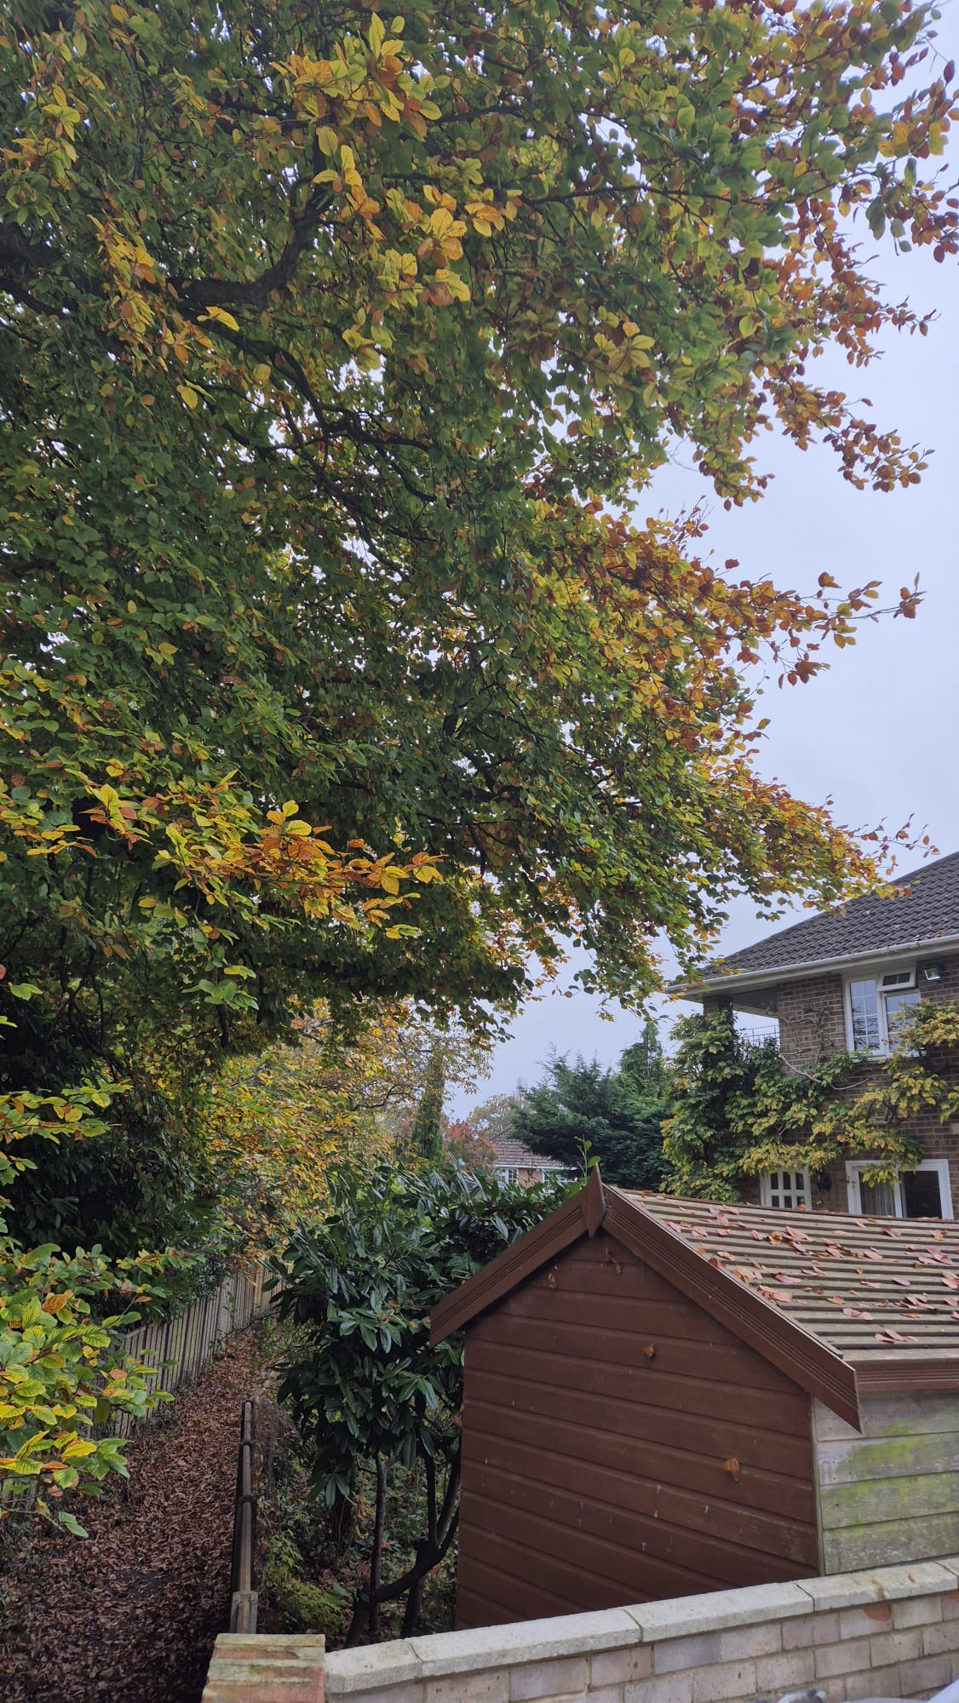

- Taken from the neighbouring garden (no 11) looking southwest, and showing the fence-line on the left.

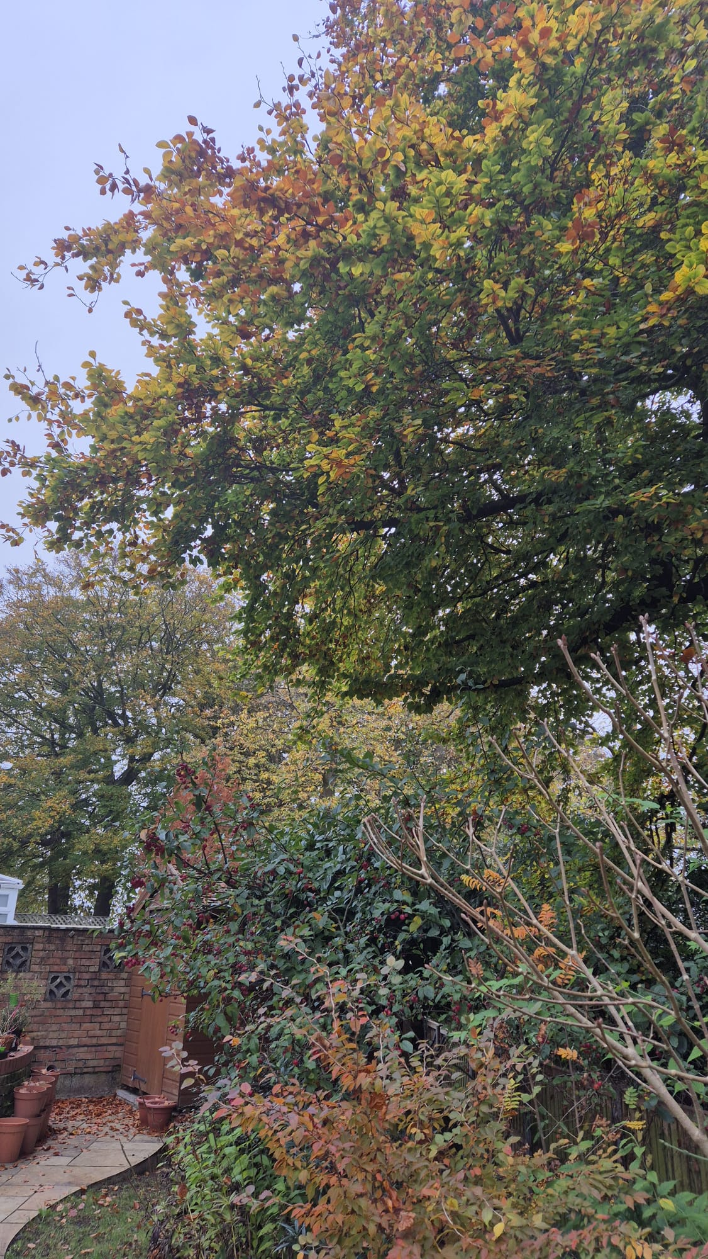

- Taken in the garden of no 12 looking northeast, and showing the fence-line on the right.

