



Project
2 Western Road
Bat Roost Survey
Project No
EC2174
Client
Joe Cross, Linkert Homes
Date
September 2024







P Project
2 Western Road
Bat Roost Survey
Project No
EC2174
Client
Joe Cross, Linkert Homes

Bat survey:
Fraser Gurney, Holly McIndoe, Rhys Davies, Daisy Irons-Small, James Bates, Amber Titchner
Report consultants
Final Version completed by:
Fraser Gurney
Technical check completed by:
Paula Richings MCIEEM
Project Manager Disclosure:
The advice which we have prepared and provided is true to the best of our knowledge and utilises information available at the time. The advice has been prepared and provided in accordance with the CIEEM’s Code of Professional Conduct.

Quality check completed by:
Beth Hill
Date
September 2024

This Assessment is only valid for the named client and the project described. enims Ltd accepts no responsibility or liability for the consequences of this document being used for a purpose other than the purpose for which it was commissioned. The assessment is only valid for a period of 12 months. If the scope of works or timing of the project is altered the advice given in this report may not be valid.

Contents

Summary 4

1 Introduction 5
1.1 Context and Survey Objectives 5
1.2 Site Description 5
1.3 Project Overview 6
1.4 Legislation and Planning Policy 6

2 Methodology 8
2.1 Emergence Survey 8
2.2 Impact Assessment 10
2.3 Approach to Mitigation 11

3 Survey Results 12
3.1 Emergence/Re-entry Survey Results 12

4 Evaluation, Assessment and Recommendations 13
4.1 Evaluation 13
4.2 Potential Impacts of Proposed Works 13
4.3 Mitigation Requirements 13
4.4 Ecological Enhancements 14
4.5 Data Constraints 14

5 Conclusion 15

6 References 16

Appendix A: Bat Roost Survey Data 17

Summary
Following the Preliminary Roost Assessment carried out by enims on the 20th of June 2024, it was considered necessary that bat roost surveys be carried out in order to establish whether bats species were roosting on site at 2 Western Road, West End, Hampshire SO30 3EL (UK Grid Reference SU 47193 14191). This is in order to support a planning application for the site. The proposed development is to extend the existing dwelling (B1) and remove the current garage (B2).
Three bat roost surveys were conducted, with the first on the 24th of July 2024, the second on the 14th of August 2024 and the third on the 12th of September 2024. During the first and third survey visits, B1 was surveyed by four surveyors, with a surveyor at each aspect of the building. During the second survey visit, a fifth surveyor was present to the west of B2 in order to survey the additional building. Bat detectors and thermal and infra-red cameras were used to record bat activity to establish both the species of bats utilising the area, and bat behaviour presented during the survey. All surveys were carried out in strict accordance with Good Practice Guidelines published by the Bat Conservation Trust (Collins, 2023).
No bats were identified as roosting within B1 or B2 over the course of the three survey visits. Common pipistrelle, soprano pipistrelle, serotine, brown long-eared bat, noctule, Myotis sp. and barbastelle all use the site for foraging and/or commuting purposes.
A European Protected Species Mitigation Licence is not required for the proposed development to proceed. Bat sensitive lighting should be implemented during and following the development, and bat boxes can be installed on B1 or the trees to the south.
With adherence to the mitigation steps proposed here, it is predicted that no negative impact to protected bat species, or their local conservation status, will be sustained as a result of the proposed works.

Introduction

Context and Survey Objectives
Enims Ltd were commissioned in July 2024 to undertake further bat survey work following a Preliminary Roost Assessment carried out in June 2024, which had identified the building as having high potential to support roosting bats.
As all native bat species are material planning considerations, which must be accounted for before a planning decision is made, it is important to establish their presence or likely absence prior to the removal of, or works to, any building which may potentially act as roosts. For this reason, a bat roost survey was conducted in order to identify if bats were roosting and, if so, the species and type of roost present. This information is required to fully assess the potential impacts of the proposed development and to recommend appropriate mitigation measures.

Site Description
The site at 2 Western Road is an approximately 0.1Ha residential property located in West End, Hampshire SO30 3EL (UK Grid Reference SU 47193 14191). The property consists of a residential bungalow with associated garage, driveway and garden. The site is surrounded by residential properties, vegetated gardens and street roads to the north, east and west of site and a woodland named “Telegraph Woods” is noted to the south of site. The site falls within the administrative authority of Eastleigh Borough Council. Plans of the application site can be seen in Figures 1 and 2 below.
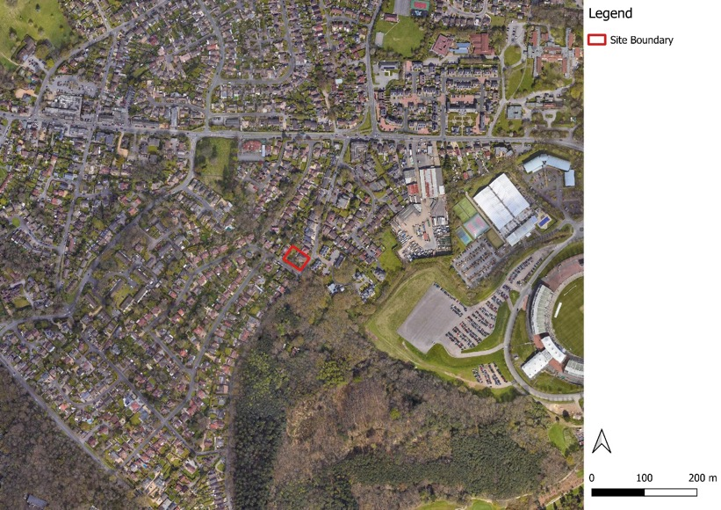
Figure 1. Location of application site and surrounding landscape. QGIS 2024

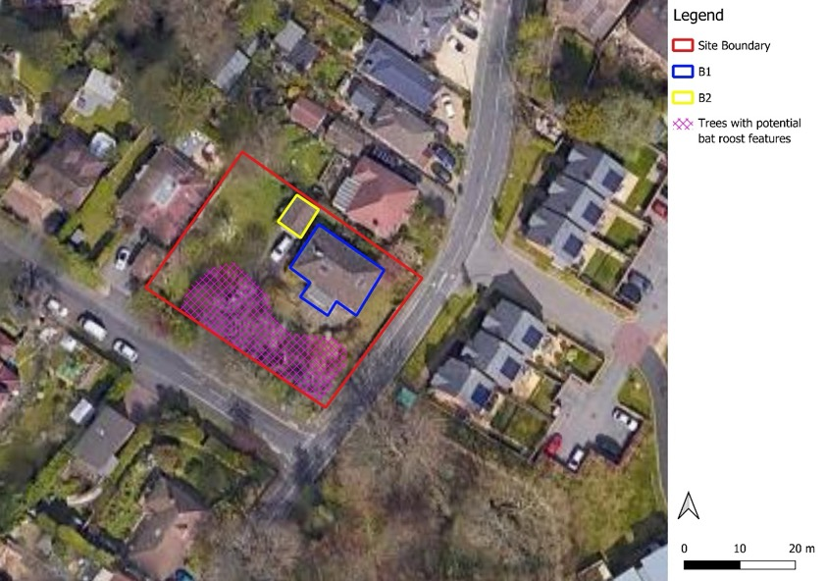
Figure 2. Location of application site - near view showing location of B1, B2 and trees with bat potential. QGIS 2024.

Project Overview
The proposed details of the work are currently unknown at the time of writing; however, it is understood that the assessment will be to support for a planning application for the site, and as such all structures and habitats at the site could be affected by any works.

Legislation and Planning Policy
All native bat species are fully protected by nature conservation legislation. Protection is afforded by Section 9 of the Wildlife and Countryside Act 1981 (as amended) through the species’ inclusion under Schedule 5. All native bat species are also defined as European Protected Species (EPS) through inclusion in Schedule 2 of the Conservation of Habitats and Species Regulations 2017 (as amended), the UK implementation of the EU Directive on the Conservation of Natural Habitats and of Wild Fauna and Flora.
In England, these legislative instruments make it an offence to deliberately capture, injure, or kill any bat. Bat roosts are protected from damage or destruction, even when occurring accidentally, and from the deliberate or reckless obstruction of access for bats. Furthermore, it is an offence to deliberately or recklessly disturb a bat, whether roosting or otherwise.
The following native bats are adopted as Species of Principal Importance in England under Section 41 of the Natural Environment and Rural Communities Act 2006:
- Barbastelle bat - Barbastella barbastellus
- Bechstein's bat - Myotis bechsteinii
- Noctule - Nyctalus noctula
- Soprano pipistrelle - Pipistrellus pygmaeus
- Brown long-eared bat - Plecotus auritus
- Greater horseshoe bat - Rhinolophus ferrumequinum
- Lesser horseshoe bat - Rhinolophus hipposideros
The National Planning Policy Framework (DfCLG 2023) requires local authorities to avoid and minimise impacts on biodiversity and, where possible, to provide net gains in biodiversity when making planning decisions. Paragraph 174 states that:
“Planning policies and decisions should contribute to and enhance the natural and local environment by protecting and enhancing valued landscapes, sites of biodiversity or geographical value and soils”.
Paragraph 180 sets out the principles that local planning authorities should apply when determining planning application and states that:
“Development whose primary objective is to conserve or enhance biodiversity should be supported; while opportunities to improve biodiversity in and around development should be integrated as part of their design, especially where this can secure measurable net gains for biodiversity”.

Methodology

Emergence Survey
An emergence survey comprising of three visits was undertaken in accordance with the Good Practice Guidelines published by the Bat Conservation Trust (Collins, 2023). B1 was the focus of the survey as per PEA/PRA report concluding it had high potential compared to B2 that had low potential. As per the best practice guidelines for a high and low potential structure, B1 was surveyed on all three survey visits, while B2 was surveyed once (included in survey visit two). Details of the survey timings and weather conditions are given in Table 1 below. The trees with bat potential were not included as it was not anticipated they would be impacted by the development proposals.
Table 1. Details of survey
Date | Sunset time | Start and end times | Temperature at sunset | Weather conditions
24.07.2024 | 21:03 | 20:48 – 22:32 | 16ºC | 100% cloud cover, wind using Beaufort scale was 1, no precipitation.
14.08.2024 | 20:27 | 20:12 – 21:57 | 17ºC | 100% cloud cover, wind using Beaufort scale was 0, very brief and light drizzle.
12.09.2024 | 19:25 | 19:10 – 20:55 | 12ºC | 40% cloud cover, wind using Beaufort scale was 2, no precipitation.

During the survey, surveyors were positioned around the building to look for bats emerging from their roosts. The survey was carried out using Echo Meter Touch 2 Pro and Peersonic bat detectors to listen and record bat calls to aid species identification. Each surveyor was equipped with a night vision aid (NVA), either a Guide Track IR Pro 19mm thermal camera or a Teayoc 1080p 4k camera infrared camera.
Surveyors were positioned with maximum visibility of potential emergence points for roosting bats. Four surveyors were used to survey B1, with an additional surveyor included during the second survey visit to survey for B2. Information was collected on species, number of bats, access points, roosting locations and flightpaths. Supplementary information, such as nearby foraging and commuting behaviour, was also noted in order to develop best possible understanding of how the site is utilised by bats. Figure 3 below shows the position of surveyors, while Photographs 1-12 show the field of view of the NVAs around the building(s). The NVA photo of the field of view of the surveyor west of B1 from the second survey visit was lost due to a corrupted file.
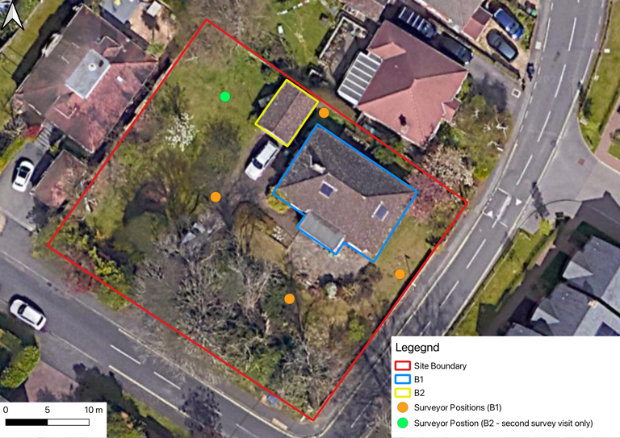
Figure 3. Buildings being surveyed and the positions of surveyors with night vision aids. QGIS 2024.

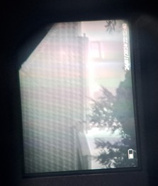  Photograph 1. Field of view of NVA south of B1 from first survey visit. | 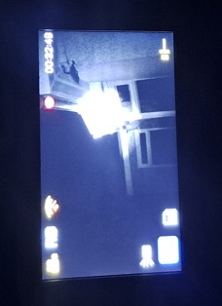  Photograph 2. Field of view of NVA east of B1 from first survey visit. | 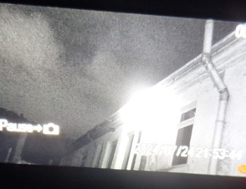  Photograph 3. Field of view of NVA north of B1 from first survey visit.
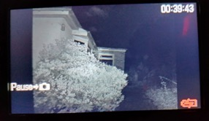  Photograph 4. Field of view of NVA east of B1 from first survey visit. | 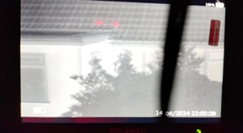  Photograph 5. Field of view of NVA south of B1 from second survey visit. | 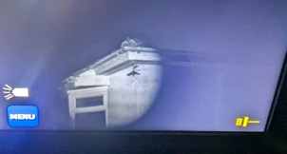  Photograph 6. Field of view of NVA east of B1 from second survey visit.
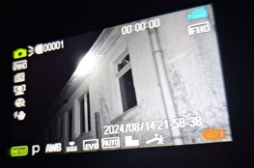  Photograph 7. Field of view of NVA north of B1 from second survey visit. | 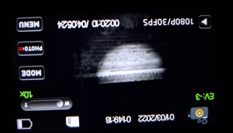  Photograph 8. Field of view of NVA west of B2 from second survey visit. | 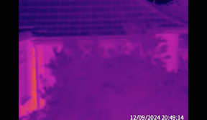  Photograph 9. Field of view of NVA south of B1 from third survey visit.
  Photograph 10. Field of view of NVA east of B1 from third survey visit. | 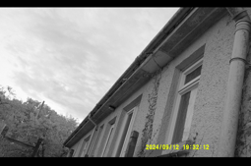  Photograph 11. Field of view of NVA north of B1 from third survey visit. | 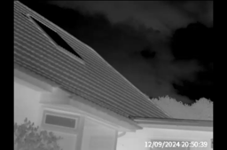  Photograph 12. Field of view of NVA west of B1 from third survey visit.

Where necessary, post-survey analysis of bat call data was undertaken to identify species/species group using appropriate software including Kaleidoscope by Wildlife Acoustics and the British Trust for Ornithology (BTO) Acoustic Pipeline. Video footage was reviewed where there was uncertainty or queries noted at the time of the survey.

Personnel
Surveys were led by Fraser Gurney, a Consultant Ecologist at enims Ltd. Fraser is experienced in undertaking habitat assessments, bat ecology and field survey techniques and has assisted on ecological supervision of works under bat mitigation licences. Fraser was assisted in the surveys by experienced bat surveyors Daisy Irons-Small, James Bates and Amber Titchner.

Survey Limitations
The roof of the north aspect of B1 could not be seen during any of the survey visits, as the north aspects of the building was very close to the property boundary.

Impact Assessment
In identifying the potential impacts on bats, all stages of the proposed development were considered including any advance works as well as during and after construction. Potential impacts include the loss, damage or modification of a roost, the modification or obstruction of roost access points, mortality, injury or disturbance to bats in roosts and disruption to bat flight paths into roosts.
When assessing the significance of impacts on bats from development operations, the following factors were considered:
- Value of the roost.
- Positive or negative biodiversity outcome.
- Confidence in predictions.
- Magnitude of impact.
- Extent of impact.
- Duration of impact.
- Reversibility of impact.
- Timing and frequency of impact.

Approach to Mitigation
The approach to mitigation follows the mitigation hierarchy, where measures to avoid impacts are explored in the first instance. When options for avoidance have been exhausted, then measures to reduce the adverse effects must be incorporated and where residual effects remain then these need to be compensated.
Appropriate levels of mitigation in this report were taken from the UK Bat Mitigation Guidelines (Reason and Wray, 2023), as summarised in Table 2 below.
Table 2. Guidelines for proportionate mitigation, taken from the UK Bat Mitigation Guidelines (Reason and Wray, 2023).
Roost category | Value of receptor
Roost category | Site | Local | District | County | Regional | National
Feeding perches; night roosts; individual or very small occasional /transitional/opportunistic roosts | Flexibility of roost type and timing of works
Non-breeding day roosts |  |  | Like-for-like replacement. No timing constraints
Mating sites; small numbers of hibernating bats | Flexibility of roost type. Bats not to be left without a roost |  | Like-for like replacement. Bats not to be left without a roost
Larger transitional roosts | Flexibility of roost type and timing of works
Hibernation sites |  |  | Like-for-like replacement (as close as possible or better). Bats not to be left without a roost |  | Like-for-like replacement (as close as possible or better). Bats not to be left without a roost and available in relevant seasons before original removed | As for Regional as a minimum, more likely required. Early discussion with statutory body needed.
Autumn swarming sites
Maternity sites | Flexibility of roost type. Bats not to be left without a roost

Survey Results

Emergence/Re-entry Survey Results
No bats were seen emerging or re-entering B1 or B2 during any of the survey visits.
Common pipistrelle (Pipistrellus pipistrellus), soprano pipistrelle, and serotine bat (Eptesicus serotinus) were recorded on all three survey visits, with common pipistrelle being by far the most common species on each visit. Noctule and brown long-eared bat were also recorded during the second survey visit, while barbastelle and a Myotis sp. were recorded during the third survey visit.
During all three survey visits, particularly the first two, multiple bats were observed passing or foraging along the row of large trees south of B1, with many of these bats moving between the northwest and southeast corners of the site (Figure 9).
Refer to Appendix A for full survey data.

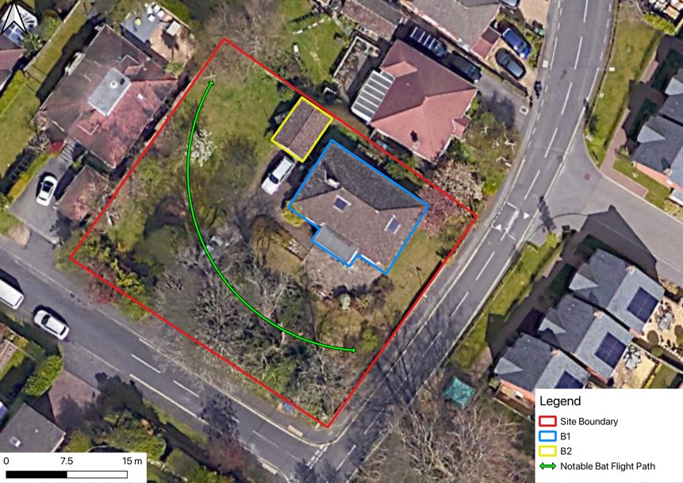
Figure 9. Map of notable bat flightpath at 2 Western Road. QGIS 2024.

Evaluation, Assessment and Recommendations

Evaluation
No bats were observed roosting in B1 or B2 during the survey, therefore it is concluded that bats are likely absent. High numbers of common pipistrelle, moderate numbers of soprano pipistrelle, and low numbers of serotine, noctule, brown long-eared, Myotis sp. and barbastelle bats were observed using the garden for foraging and commuting.
No bats were seen flying near the PRF and associated droppings (hole in the soffit on the southern aspect of B1) identified during the PRA. However, this PRF was observed during all three survey visits with no emergences or re-entries seen.

Potential Impacts of Proposed Works
Short term impacts
It is unlikely that the proposed works will result in injury, death or disturbance to a bat as no bats were observed emerging from buildings B1 and B2
Long term impacts
The development proposals are not anticipated to lead to physical fragmentation of commuting routes, or impact to significant bat roosts. However, there is potential for nearby roosting, foraging and commuting bats to be disturbed by increased lighting during and after construction.

Mitigation Requirements
The lack of emergences mean it is unlikely that roosting bats are present at 2 Western Road. Therefore, it will not be necessary to apply for a European Protected Species Mitigation Licence to carry out the proposed development.
The use of external lighting on site during and following the development should be sensitive to the presence of bats in the area. If possible, lighting should be avoided. But if lighting does need to be installed, the following measures are sympathetic to bats:
- Lighting kept to a minimum.
- Directional lighting carefully positioned and aimed to avoid illumination of vegetation, especially trees south of B1.
- No/little upward tilt.
- Warm-white light with no/little UV component.
- Use of motion detection sensors or timers to limit the duration lighting is on.
- Consideration of internal light spill.
Any lighting should follow the guidance note in Bats and Artificial Lighting at Night (Institute of Lighting Professionals, 2023.)
It should be noted that the building still has roosting potential and as bats are highly mobile species the situation may change in the future. It is important to recognise that in the UK all bat species and their roosts are legally protected, by both domestic and European legislation. This means it is a criminal offence to:
- Deliberately capture, injure or kill a bat.
- Intentionally or recklessly disturb a bat in its roost or deliberately disturb a group of bats.
- Damage or destroy a bat roosting place (even if bats are not occupying the roost at the time).
- Possess or advertise/sell/exchange a bat (dead or alive), or any part of a bat.
- Intentionally or recklessly obstruct access to a bat roost.

Should a roosting bat be found during the works, all works must immediately stop, and the governing body Natural England consulted. Contractors should be made aware of this during the site introductions and work briefings.

Ecological Enhancements
The surveys at 2 Western Road showed the location is used for bat foraging and commuting. Providing roosting opportunities for bats may increase bat numbers at a local level and bring a greater species diversity to the area. Bat boxes can be mounted on buildings away from artificial light or on trees south of B1.

Data Constraints
The roof of the north aspect of B1 could not be seen during the emergence surveys. However, the line of sight of surveyors positioned on the north and east aspects of B1 would have seen any bats emerging from the north aspect of the roof, as the bats flew away from or along the roof. As such, this lack of visibility is not considered a limitation.
The data and conclusions presented here are an evidence-based assessment of the current status of the application site. Should the development be delayed beyond 12 months of the date of surveys, it is recommended that repeat assessment be undertaken in order to ensure the continued validity of these recommendations.

Conclusion
No bats were detected or recorded emerging or re-entering building B1 and B2 during the three bat roost surveys, suggesting they do not contain any active bat roosts. As such, 2 Western Road is not thought to support roosting bats.
A European Protected Species Mitigation Licence is not required for the proposed development to proceed. Bat sensitive lighting should be implemented during and following the development, and bat boxes can be installed on B1 or the trees to the south.

References
Collins, J. (ed.) (2023). Bat Surveys for Professional Ecologists: Good Practice Guidelines (4th ed.). Bat Conservation Trust, London.
DfCLG. (2023). National Planning Policy Framework. Department for Communities and Local Government, London.
enims Ltd. (2024). EC2174, 2 Western Road, West End - Preliminary Ecological Appraisal. enims Ltd, Southampton.
Institute of Lighting Professionals. (2023). GN08/23 Bats and Artificial Lighting at Night. Institute of Lighting Professionals, Rugby.
Reason, P.F. and Wray, S. (2023). UK Bat Mitigation Guidelines: a guide to impact assessment, mitigation and compensation for developments affecting bats. Chartered Institute of Ecology and Environmental Management, Ampfield.

Appendix A: Bat Roost Survey Data
Survey Visit 1
Location: | 2 Western Road | Project No: | EC2174
Weather: | 100% cloud cover, wind using Beaufort scale was 1, no precipitation.
Start temp: | 16°C | End temp: |  | 16°C
Date: | 24.07.2024 | Sunset time: |  | 21:03
Start time: | 20:48 | End time: |  | 22:33
Time | Species | Notes (flight path, emerging/ re-entering, location observed, behaviour)
21:02 | Common pipistrelle | Passing south past west corner of B1. Heard not seen.
21:06 | Common pipistrelle | Two Passing around trees south of B1. Heard not seen.
21:07 | Common pipistrelle | Passing south of B1. Heard not seen.
21:12 | Common pipistrelle | Passing southwest of B1. Heard not seen.
21:13 | Common pipistrelle | Passing south of B1. Heard not seen.
21:15 | Common pipistrelle | Passing west of B1. Heard not seen.
21:17 | Common pipistrelle | Passing west of B1. Heard not seen.
21:19 | Common pipistrelle | Passing southeast of B1. Heard not seen.
21:20 | Serotine | Passing east along trees south of B1. Heard not seen.
21:24 | Common pipistrelle | Passing west south of B1.
21:24 | Serotine | Heard not seen.
21:27 | Common pipistrelle | Foraging around trees southwest of B1.
21:29 | Common pipistrelle | Passing west, south of B1.
21:30 | Soprano pipistrelle | Passing east, south of B1.
21:31 | Common pipistrelle | Foraging southwest of B1.
21:33 | Common pipistrelle | Passing west, south of B1.
21:40 | Soprano pipistrelle | Foraging around B1.
21:41 | Serotine | Passing. Heard not seen.
21:45 | Common pipistrelle | Consistent from this point onwards, heard not seen.

Survey Visit 2
Location: | 2 Western Road | Project No: | EC2174
Weather: | 100% cloud cover, wind using Beaufort scale was 0, very brief and light drizzle.
Start temp: | 18°C | End temp: |  | 17°C
Date: | 14.08.2024 | Sunset time: |  | 20:27
Start time: | 20:12 | End time: |  | 21:57
Time | Species | Notes (flight path, emerging/ re-entering, location observed, behaviour)
20:32 | Common pipistrelle | Passing, west of B2.
20:33 | Unidentified pipistrelle | Heard not seen.
20:36 | Common pipistrelle | Passing, west of B2.
20:37 | Soprano pipistrelle | Heard not seen.
20:37 | Common pipistrelle | South past B2.
20:39 | Common pipistrelle | Heard not seen.
20:41 | Common pipistrelle | Passing, west of B2.
20:45 | Serotine | Passing, west of B2, southeast of B1.
20:49 | Common pipistrelle | Heard not seen.
20:51 | Common pipistrelle | Foraging south of B1.
20:56 | Common pipistrelle | Foraging south of B1.
20:57 | Noctule | Heard not seen.
21:00 | Common pipistrelle | Passing southeast over B1.
21:04 | Soprano pipistrelle | Foraging southeast of B1.
21:16 | Brown long-eared bat. | Heard not seen.
21:21 | Common pipistrelle | Heard not seen.
21:22 | Brown long-eared bat | Heard not seen.
21:26 | Brown long-eared bat | Heard not seen.
21:29 | Unidentified pipistrelle | Heard not seen.
21:30 | Common pipistrelle | Heard not seen.
21:31 | Soprano pipistrelle | Heard not seen.
21:34 | Noctule | Heard not seen.
21:35 | Common pipistrelle | Heard not seen.
21:37 | Soprano pipistrelle | Heard not seen.
21:40 | Common pipistrelle | Foraging, SE of B1.
21:42 | Common pipistrelle | Foraging, SE of B1.
21:44 | Soprano pipistrelle | Foraging, SE of B1.
21:46 | Common pipistrelle | Foraging, SE of B1.
21:48 | Common pipistrelle | Foraging, SE of B1.
21:50 | Common pipistrelle | Heard not seen.
21:51 | Serotine | Heard not seen.
21:52 | Unidentified long-eared bat | Heard not seen.
21:55 | Soprano pipistrelle | Heard not seen.
21:57 | Soprano pipistrelle | Heard not seen.

Survey Visit 3
Location: | 2 Western Road | Project No: | EC2174
Weather: | 40% cloud cover, wind using Beaufort scale was 2, no precipitation.
Start temp: | 12°C | End temp: |  | 9°C
Date: | 12.09.2024 | Sunset time: |  | 19:25
Start time: | 19:10 | End time: |  | 20:55
Time | Species | Notes (flight path, emerging/ re-entering, location observed, behaviour)
19:33 | Pipistrelle sp. | Seen not heard, passing east of B1.
19:37 | Common pipistrelle | Heard not seen.
19:39 | Common pipistrelle | Heard not seen.
19:43 | Common pipistrelle | Heard not seen.
19:46 | Common pipistrelle | Heard not seen.
19:49 | Soprano pipistrelle | Heard not seen.
19:50 | Common pipistrelle | Passing west.
19:53 | Common pipistrelle | Passing east.
19:56 | Common pipistrelle | Heard not seen.
20:01 | Common pipistrelle | Heard not seen.
20:03 | Common pipistrelle | Heard not seen.
20:04 | Serotine | Heard not seen.
20:05 | Common pipistrelle | Heard not seen.
20:05 | Barbastelle | Heard not seen.
20:06 | Soprano pipistrelle | Heard not seen.
20:08 | Common pipistrelle | Passing east along north aspect of B1.
20:11 | Common pipistrelle | Heard not seen.
20:13 | Myotis sp. | Heard not seen.
20:14 | Unidentified bat | Seen not heard, passing south over B1.
20:15 | Myotis sp. | Heard not seen.
20:18 | Common pipistrelle | Heard not seen.
20:19 | Myotis sp. | Heard not seen.
20:19 | Common pipistrelle | Heard not seen.
20:26 | Unidentified bat | Heard not seen.
20:48 | Unidentified bat | Heard not seen.

