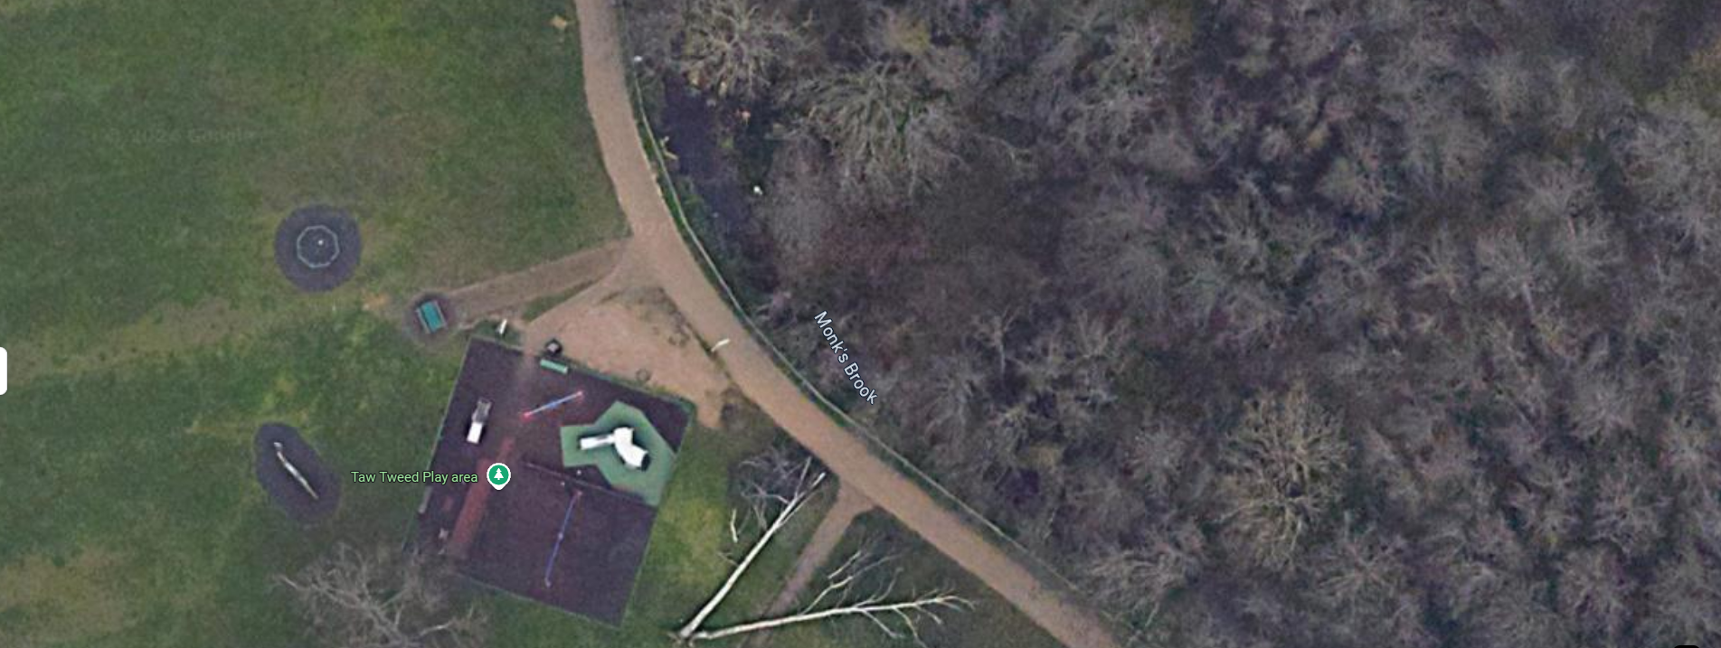
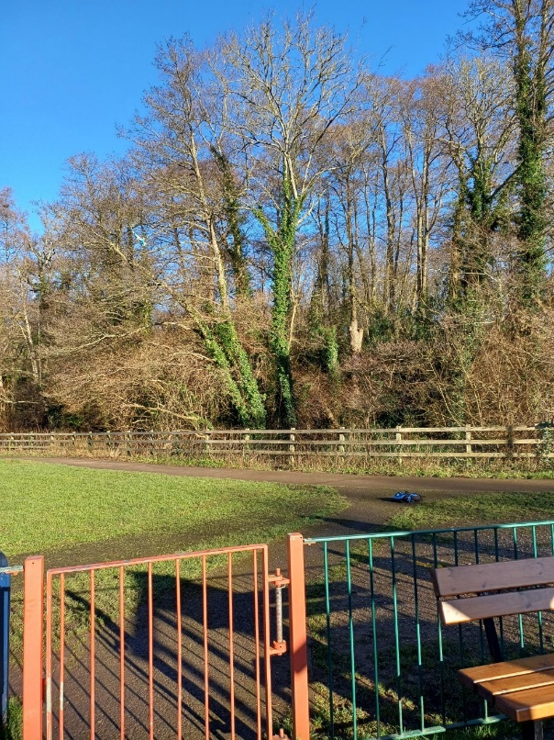
EARLY MATURE IVY CLAD ASH OPPOSITE ENTRANCE TO TAW TWEED PLAY AREA SHOWING SIGNIFICANT SIGNS OF ASH DIE BACK.

