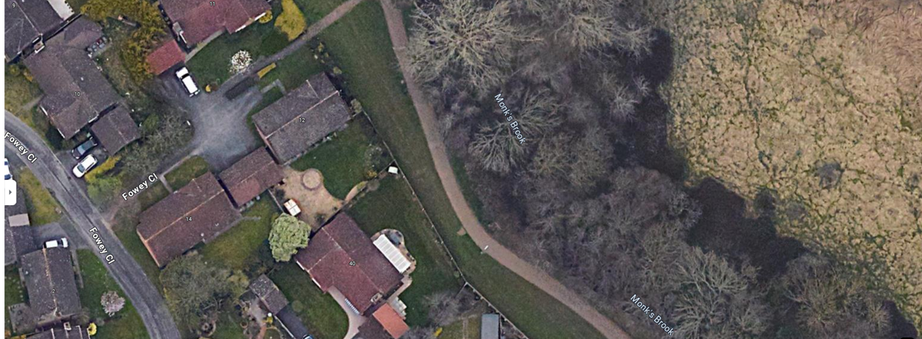

SINGLE STEMMED ASH ON EAST BANK OF MONK’S BROOK OPPOSITE TAW DRIVE
