Trees in the Spine Road

The engineer has flagged up that Tilia cordata ‘Green Spire’ which was previously proposed along the spine road does not comply with NHBC due to the size and water demand of the tree. This could in time impact foundations and cause latent defects.
We have recommended they are replaced with Carpinus betulus which is a lower water demand tree and will be NHBC compliant. Carpinus betulus will still provide a substantial amenity street tree. They are shade tolerant and tall trees with smooth grey bark and ovate foliage.

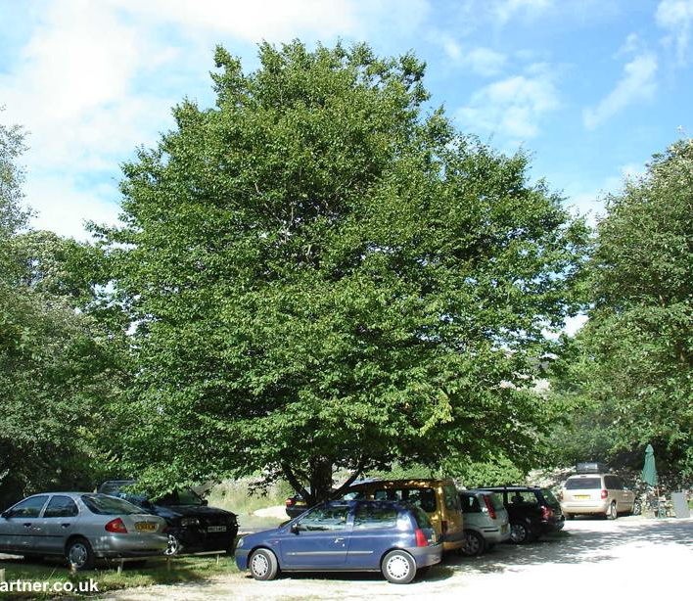
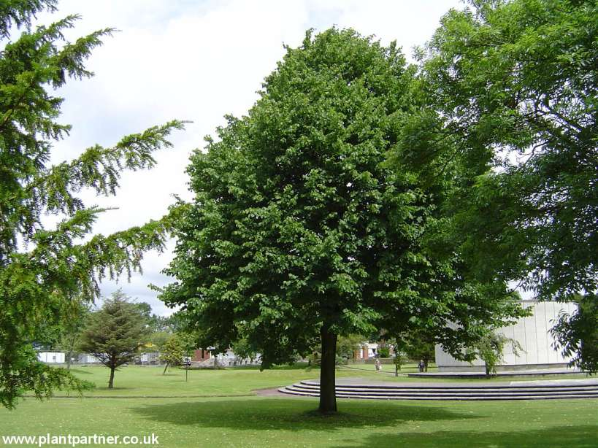

Tilia cordata ‘Green Spire’ (small-leaved lime) Carpinus betulus (hornbeam)

