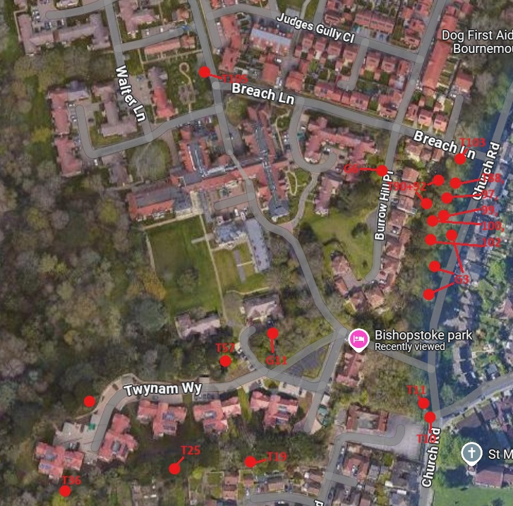

T105 - Goat Willow - Pollard to 3m – large amounts of dieback and deadwood. Old Pollard.
G6 - x2 dead Cherry Plum – remove – Risk of failure
T88, T97, T99, T100, T102 - Lime - cut back epicormic – to allow for inspection of base
T10 - Beech - Dismantle to ground level – Interfering with power lines and large vehicles
T11 - Western Red Cedar - dismantle to ground level – Interfering with power lines
T36 - Horse Chestnut - dismantle to ground level – in severe decline and leaning over neighbours boundary
T57 - Monterey Pine - Reduce upper crown by 1m spread to reduce loading on main union of upper leader – Worried about limb failing in future
T92 + T90 - Holm Oak - Lift branches over garden to height of 3m – Hanging low over neighbours garden and interfering with sheds
T103 - White Poplar - Remove deadwood – Danger to pedestrians and traffic
G3 – Mixed - Acacia - remove dead stems over road and clear street lights – Risk to traffic
T19 - Dead Ash - dismantle to ground level – Overhanging neighbours and risk to life
T25 - Dead Ash - dismantle to ground level – Overhanging neighbours and risk to life
G15 - Dead Sycamores - dismantle to ground level – Risk to vehicles and residents
G11 - Dead Cherry - dismanle to ground level – Risk to vehicles and residents

