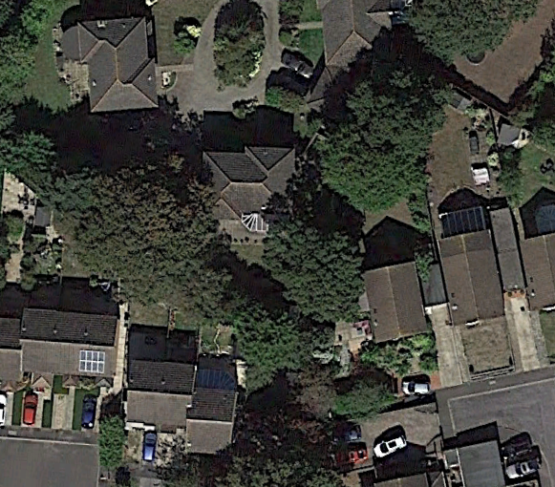
Key
T1
T1 - Oak

