

14 Torwood Gardens, Fair Oak, Eastligh, SO50 8PD
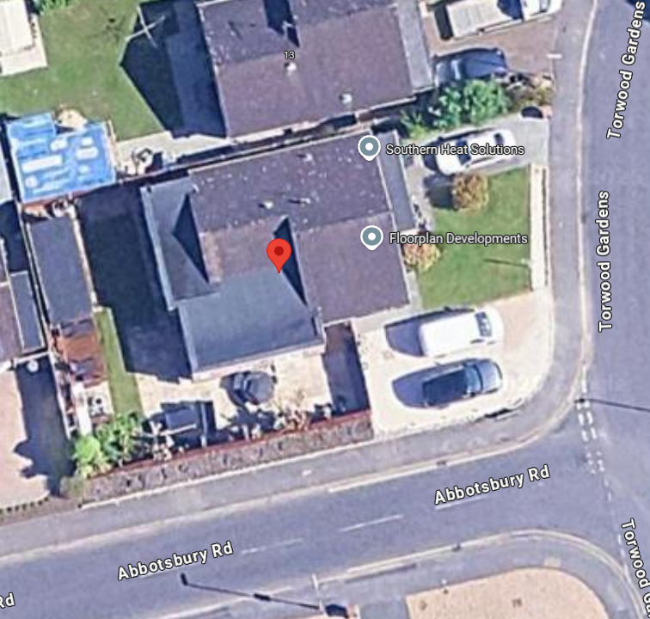

- Site
  - The application site contains a detached property and is located within the built-up area of Fair Oak.
Application Site

- Site & Planning History
  - Eastleigh District Council website shows 1 planning history for the application of Single storey side and rear extension, and erection of 1.8 metre boundary fence.

- Proposal
  - This application seeks to obtain permission for the addition of another storey to the existing bungalow to move the add a further 3 bedrooms upstairs along with a family bathroom.

  - The Materials being used will be within keeping of the street scene. The neighbours at 2 Abbotsbury Road have hang tiles to the front of the property which is also a 2 storey dwelling. The existing apex of the bungalows in Torwood Gardens also have hang tiles. The tiles on the new roof will match those of the existing building and the pitch of the roof will remain shallow at 20 degrees to reduce the impact to neighbouring properties.

  - The bulk, mass and design of the additional storey is within keeping of other properties in the close proximity. See photos in Appendix A for evidence of this. There is a mixture of different types of houses within Torwood Gardens and Abbotsbury Road, ranging from bungalows, chalet bungalows (with steep tall roofs) and 2 storey dwellings. Therefore adding another storey to this property would not be out of context of the street scene.

  - The design of the first floor storey has been well thought out by ensuring that there is no overlooking to neighbouring properties. The window to the rear of the property (closest to No 13 Torwood Gardens) is to be utilised for a bathroom window and will be frosted glazed with a small openable window at the top for ventilation purposes. There are no toher windows to the rear as to minimize the privacy issues. All other windows are to the front elevation and side elevation looking on to Abbotsbury Road.

  - The additional storey has also been set back far enough as to reduce any light implications to the neighbours at No 13. As the property is facing East the sun shadow will cast on the brick wall of No 2 Abbotsbury Road (which already occurs, there are no windows on that elevation) and during the day will reduce and the shadow will then be cast on to the road of Torwood Gardens, not impacting any other properties.

  - There is already sufficient parking on the existing driveway easily accommodating 3 cars.

APPENDIX A
2 Abbotsbury Road – 2 storey building

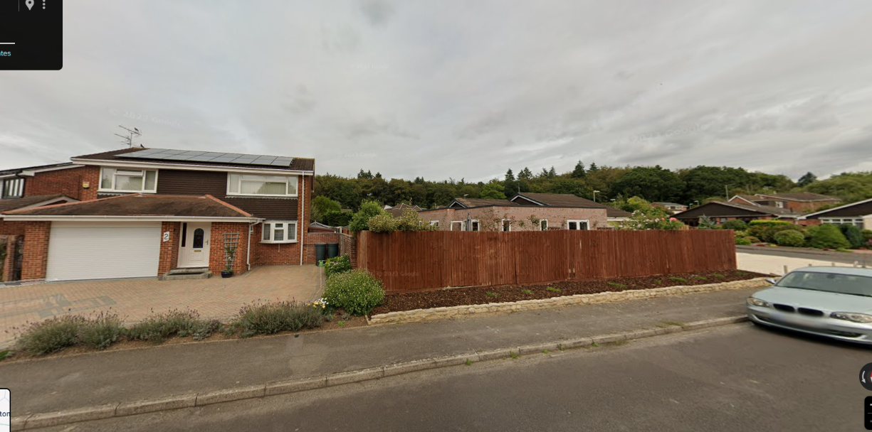
2 Abbotsbury Road
14 Torwood Gardens

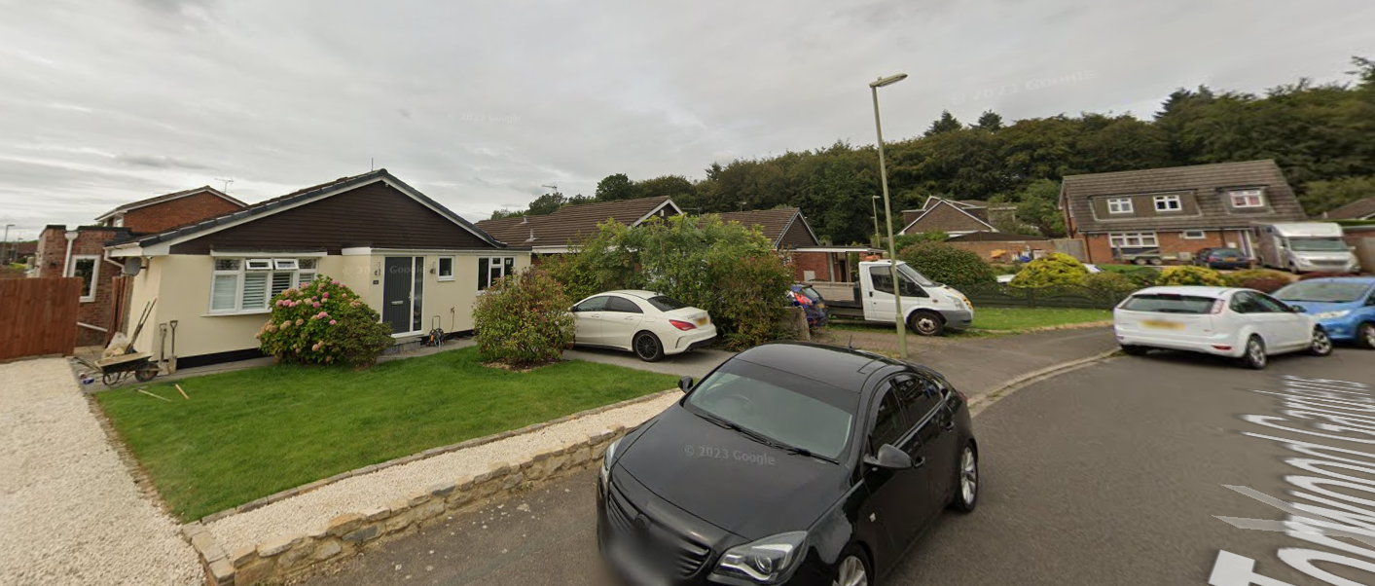

1 ½ storey property
With large roof
13 Torwood Gardens
14 Torwood Gardens

