4 Ashley Providence hill Bursledon SO31 8AA pine TPO REF 183-E enquiry as to which pine as there are two separate stems. The TPO office confirms this is regarded as a twin stemmed tree comprising of two stems.
Tree positioned adjacent to access of cul-de-sac comprising of 4 dwellings, picture to support and demonstrate tree’s location and condition.
Within the assumed root plate area canopy drip line there are the following. Multiple boundary walls. Two of which show obvious damage conclusive with root and footing interference. Damage cracks in wall behind lean of larger of the two stems within 6m is consistent with trees natural response to its lean and balance regarding anchorage
With in the crip line of canopy there is Tarmac and Block pave construction road and driveway with damage consisting of lifting and rolling as expected within proximity to such a substantial root system of this species. Drains and services are located under access road well within the tree’s root plate. (Please see location of inspection chamber in photos) it is assumed power and water also occupy this area, Several parking spaces for dwellings, Residential gardens and one residential dwelling.
The tree owner states the property and infrastructure where install in the 90’s given the trees maturity I would expect installation of services and road construction had some impact on the root system at this time.
Pine 183-E. the conditions and vigor. Both stems have considerable lean over access way residential gardens and dwelling. Dead wood over 75mm diameter is present throughout the canopy some being lengthy and laden with cone. The canopy overall is needle sparse and losing fine twiggy structure throughout. Browning of inner canopy needles. And branches taking a lion’s tail appearance suggest tree health is on a continued decline. A sample of dead needles from the tree shows very faint red banding and black dot like spores with the other symptoms of decline might suggest needle blight Is present although not conclusive with small sample observed. Present on both stems is secretions of sap over a large area up the first 2.5 m of the stems is another indication present that the trees are under stress.
Tree owner expresses concern over trees leaning towards neighbor’s dwelling although not in immediate threat of catastrophic failure. The current cone baring dead limbs in the canopy pose a threat to all people accessing dwellings and in grounds neighboring gardens. The continued decline will increase the probability of risk to harm. Due to the nature of decline a reduction of end weight and dead wood leave the scaffold striped dead wood and leave the canopy without sufficient foliage to continue to photosynthesis
Due to this we would like to remove the trees prior to their condition declining to the point where it is probable to inflict harm on residents or the public. The tree holds an amenity value to the area more so since the loss of nearby oak and spruce in neighboring property removed in recent years. This has also made it apparent in passing that the canopy and been thinning over the past few years.

The Tree owner would like to re-plant in the center of the area where the pines reside.
I have suggested perhaps something in keeping with the borough council’s local plan or something with a less vigorous root system.
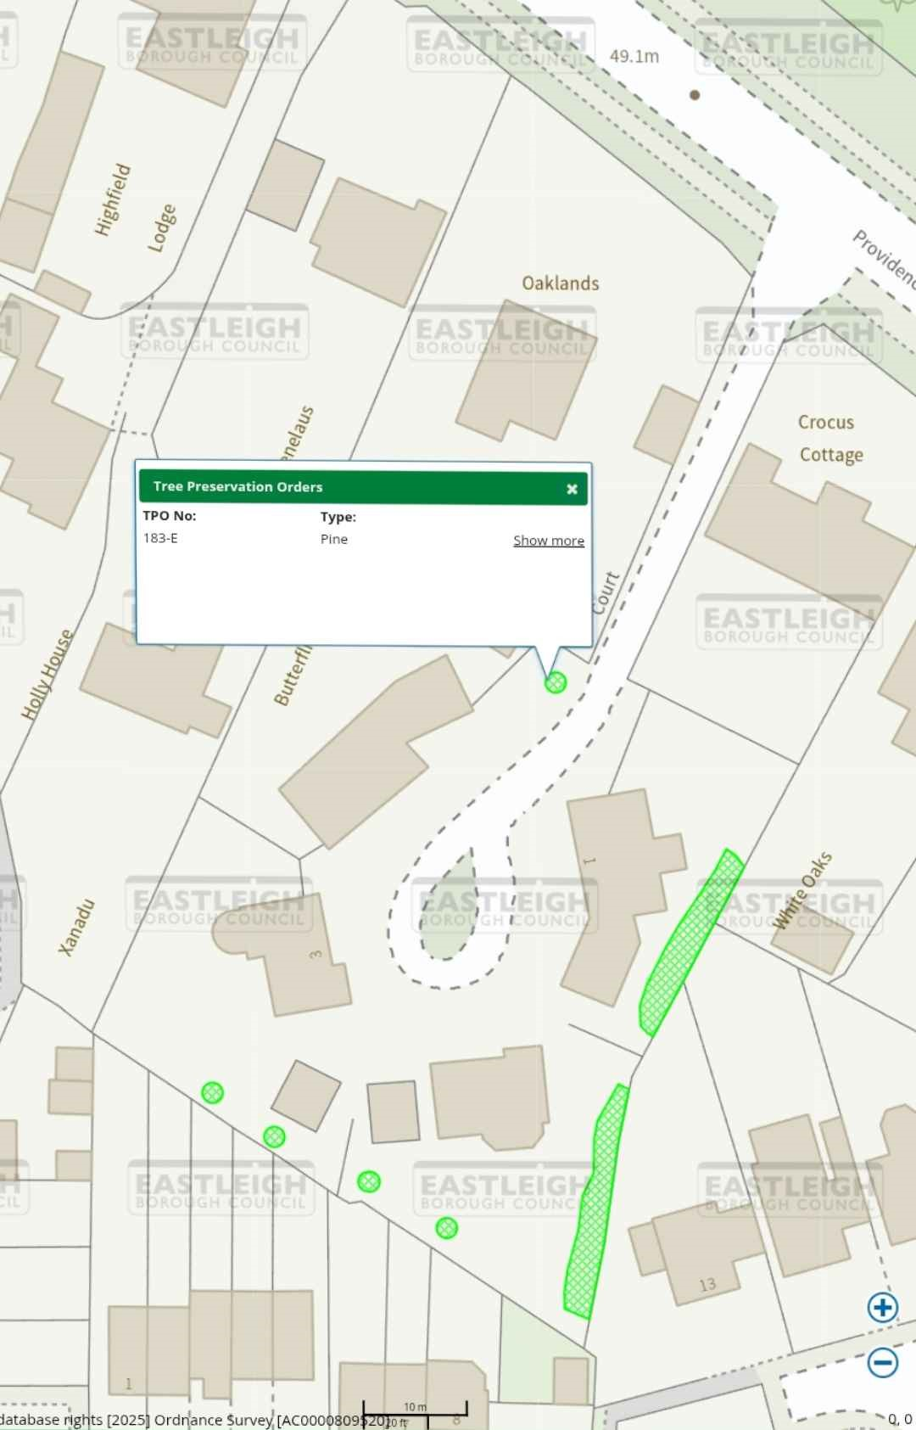
cOU/CIL
EAS
8
OROU
A9.1M
ASTLEIG
COUNCIL
Highfield
Lodge
EASTLEIGH
OROYH
COUNCIL
Oaklands
EASTLEIG,
BOROUH
COUNCIL/
Providen
"elaus
Tree
Preservation
Orders
TPO
No:
Type:
183-
E
Pine
Show
more
Crocus
Cottage
Holly
House
Butterf
EASTLEIGY
8
OROUGH
COUNCY
Xanadu
ASTLEeH
ROUGYCOUNCIL
EASTUEIGH
OROGHEOUNC)
ASTIGH)
ROUcoCI
AST EI4H
BPRO
GH
OUCIL
EASTLEIGH
BOROUGH
COUNC
EATLEaH
GH
COUNG
13
10
m
database
rights
(2025]
Ordnance
Survey
(
ACo000809F20jo
F
0
,
0

