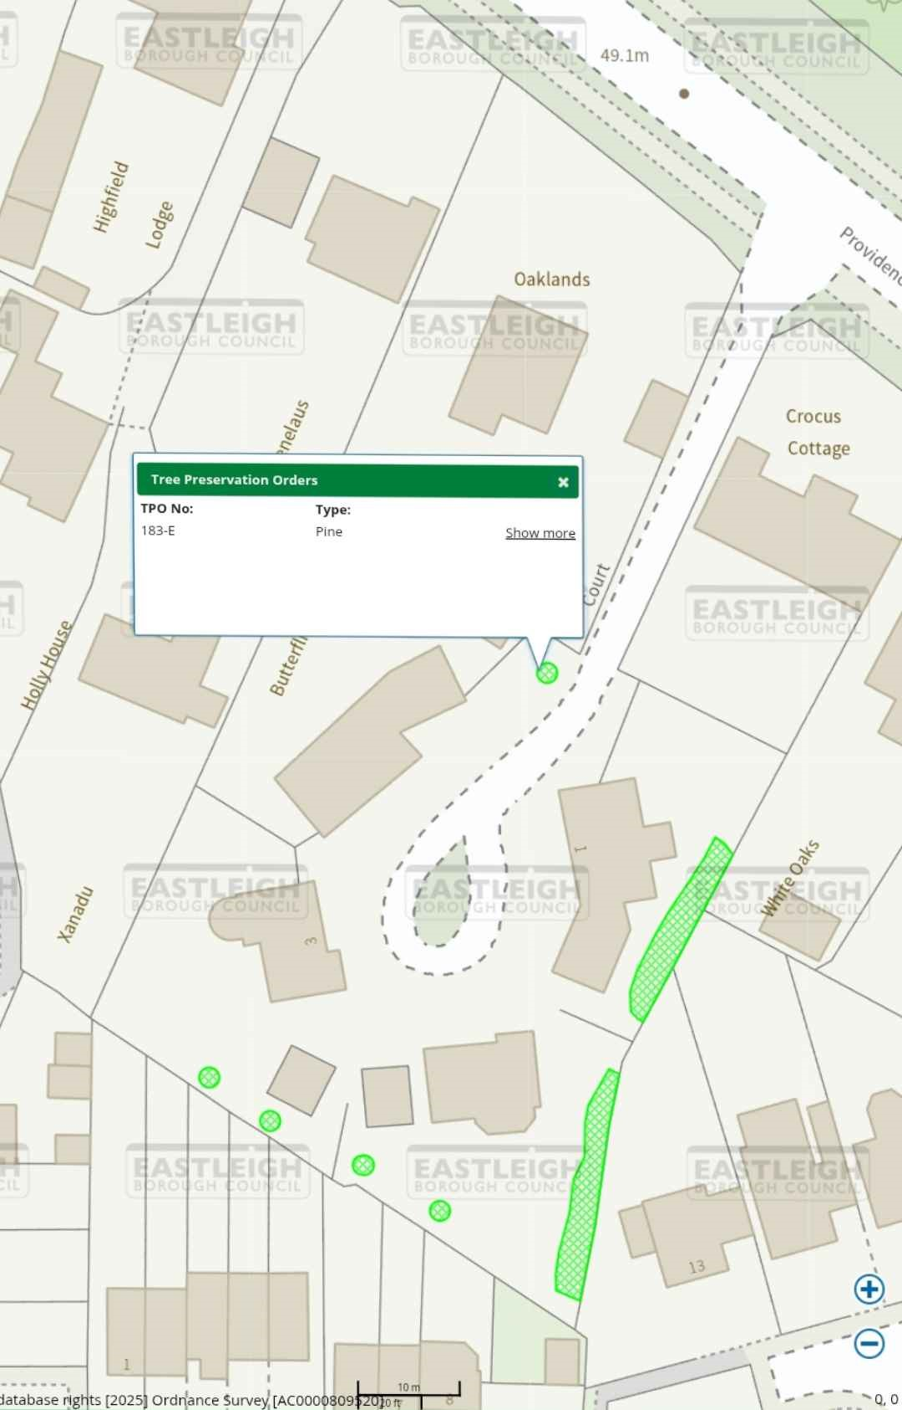
cOU/CIL
EAS
8
OROU
A9.1M
ASTLEIG
COUNCIL
Highfield
Lodge
EASTLEIGH
OROYH
COUNCIL
Oaklands
EASTLEIG,
BOROUH
COUNCIL/
Providen
"elaus
Tree
Preservation
Orders
TPO
No:
Type:
183-
E
Pine
Show
more
Crocus
Cottage
Holly
House
Butterf
EASTLEIGY
8
OROUGH
COUNCY
Xanadu
ASTLEeH
ROUGYCOUNCIL
EASTUEIGH
OROGHEOUNC)
ASTIGH)
ROUcoCI
AST EI4H
BPRO
GH
OUCIL
EASTLEIGH
BOROUGH
COUNC
EATLEaH
GH
COUNG
13
10
m
database
rights
(2025]
Ordnance
Survey
(
ACo000809F20jo
F
0
,
0

