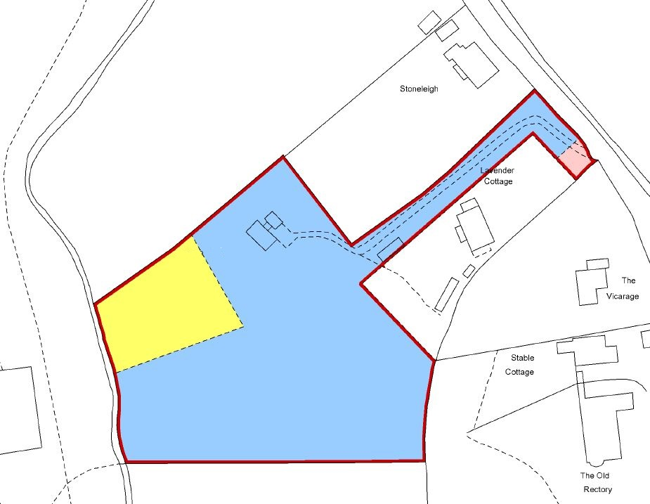
Bluebell Wood
Tree works:
Reduction in height of laurel, either side of the driveway area highlighted by green rectangle.
Removal of fire damaged beech (approx. location highlighted by green circle.
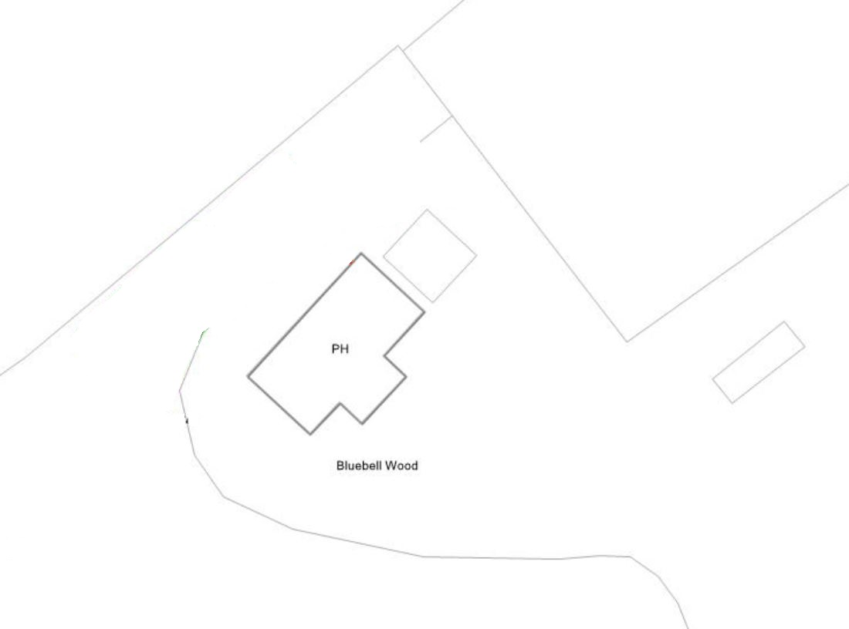
New shed

