Ampfield Commercial Limited – Meller House, Bishopstoke SO50 6HF
Design & Access statement, with BNG, Nutrient, Heritage and Highway details (10/6/25)

Located on the corner of Church Road and Oakbank Road, Bishopstoke, until 2024, Meller House was a semi-sheltered housing association site with 21 dwellings but more precisely, contained a 17m2 visitor bedroom, two 1bed flats, one 2bed manager flat (with offices) and seventeen bedsits (at 30m2 each). Units were sold on the open market in more recent years. In addition, there was a laundry area and common room/kitchen along with various landlord stores. The entire internal gross area is 1208m2 (with non-dwelling accounting for 535m2 of that). The total site is 1532m2 and presently there are six parking spaces and shared grounds. Bins are at the rear corner facing Oakbank Road.
Our client purchased the site late 2024. The proposal here is to convert the accommodation down from 21 to 15 units by merging some of the studios and amalgamating other spaces. The new accommodation would consist of four unchanged studios, two unchanged 1bed, two new 1bed, three new 2bed and four new 3bed. Nine dwellings therefore are created out of existing dwellings. Eleven of the dwellings will now have external private amenity. A new bin & cycle compound (timber clad see drawing KC 09) is proposed near one of the Church Road access points and the parking is proposed to be increased to 15 to avoid offsite spillage. This requires a slight reduction in footprint (reduced by 35m2) and 115m2 of sloping lawn would be replaced with block paving and a retaining wall (to preserve the stone perimeter wall). In compensation, 55m of new hedgerow will be planted to all new private amenity boundaries (see KC 09).
Drawings to demonstrate the proposal in conjunction with this statement:
KC-01 A EX A Existing Floor Plans
KC-02 A PP A Proposed Floor Plans
KC-03 A EL Existing Elevations
KC-04 A PPEL Proposed Elevations
KC-05 A EX A Existing Site Plan
KC-06 A PP A Proposed Site Plan
KC-07 A EX Existing Roof Plan
KC-08 A PP Proposed Roof Plan
KC-09 A PP A Proposed Site Details

Externally, the building currently lacks appeal, and one key enhancement proposed is to add a new eave/soffit detail (in white UPVC) and replace the roof covering (maintaining the same ridgeline). Presently the roof has an aged reconstituted slate covering (suspect asbestos cement) which has reached the end of its natural life and is delaminating and has become very brittle. It has also bleached and suffered moss attack over the past 50years and we propose replacing with Cedral Thrutone (or equivalent) in blue/black (see below). This work is underway as there are many serious leaks within the building and the guttering system has failed. The fibre cement slate present bay windows also are proposed to be dropped to French doors (for residents to access their private amenity) at ground floor. 1.2m estate railing style fencing (black) will give demarcation without a sense of enclosure – each private amenity area with new planting meeting the BNG requirement. However, to further enhance, housing for bats, swifts, sparrows, tits and bee/insects (one of each to the west, south & east elevations). Presently there is one window at first floor in the north flank wall which faces No.3 Church Road. We propose a second new window but with obscured glass below 1.5m above floor level and a restricted opener to preserve the private amenity for No.3. All new windows and doors in white UPVC to match existing.
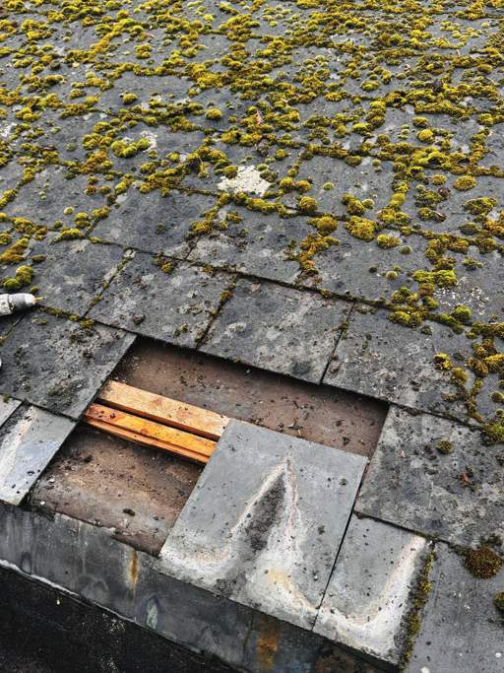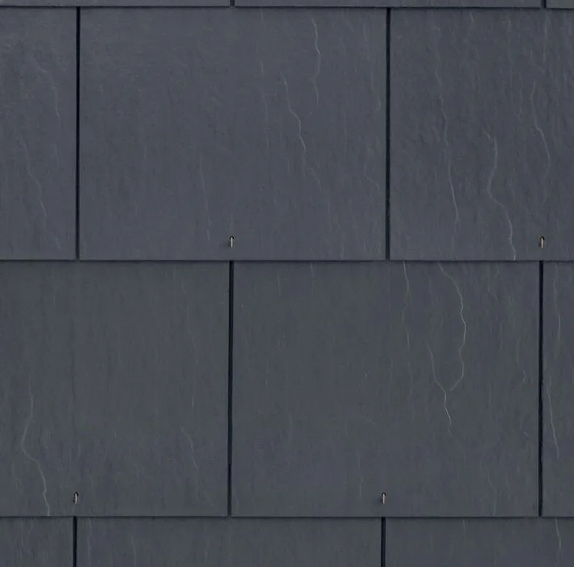
The site qualifies for BNG Small Site Metrics, and the calculator is attached. Note there were no trees on the site and the overgrown shrubbery has been removed to return to the previous open garden layout.
With the proposed move from 6 to 15+1 parking spaces and with secure cycle storage facilities, all leads to a deintensification of highway impact than present and with public transport directly outside the site, the train station within 10minutes walk and retail, employment, education and health facilities all in walking distance – along with public open space and play areas, the location is ideal for residential use and is a highly sustainable position. More details on the standards employed can be found in later in this report.
The proposal utilises the current soakaways and retains the same rainwater downpipes. The new parking will have a sustainable urban drainage system with a permeable asphalt and is not in the area neighbouring the site which has evidence of flood zone 2 from surface water.
We propose 200l of waste for multi person units and 120l for single occupancy (plus the same for recycling) and therefore have provided for 7No. 1100l Eurobins in the screened top of site adjacent to the pavement entrance although a private collection company would be used to aide management. Submitted plans detail the bin & bike areas
The site is within the Bishopstoke Conservation Area, so the mission to preserve and enhance has been met as proposed above with a tidying of the roofline and sensitive garden demarcation. The Victorian boundary walls are to be repaired and modified where proposed using site reclaimed bricks and lime mortar.
With a net reduction in dwelling numbers, we suggest this deintensification along with the opportunity to introduce water saving measures with lowered flow for cisterns, taps, showers etc – we’d present this scheme as a non-nutrient intensifier and we trust, in your competent authority status, you see no added risk to the environment after wastewater treatment. We include a water-use calculation at appendix B.
The scheme is not CIL payable with lawful use of the site for more than 6 of the previous 36 months.
We believe moving this site from vacant to a mixed new community including family units – will bring a building to life and enhance the wider community and we trust therefore this application be seen as a limited impact and ‘minor’ in nature. The new dwellings formed exceed the national prescribed space standards and the converted and refurbished dwellings will all receive upgrades that will exceed the building regulations, with quality accommodation delivering rentable units for those unable to get on the first rung of the housing ladder.

Photographic evidence for setting and context
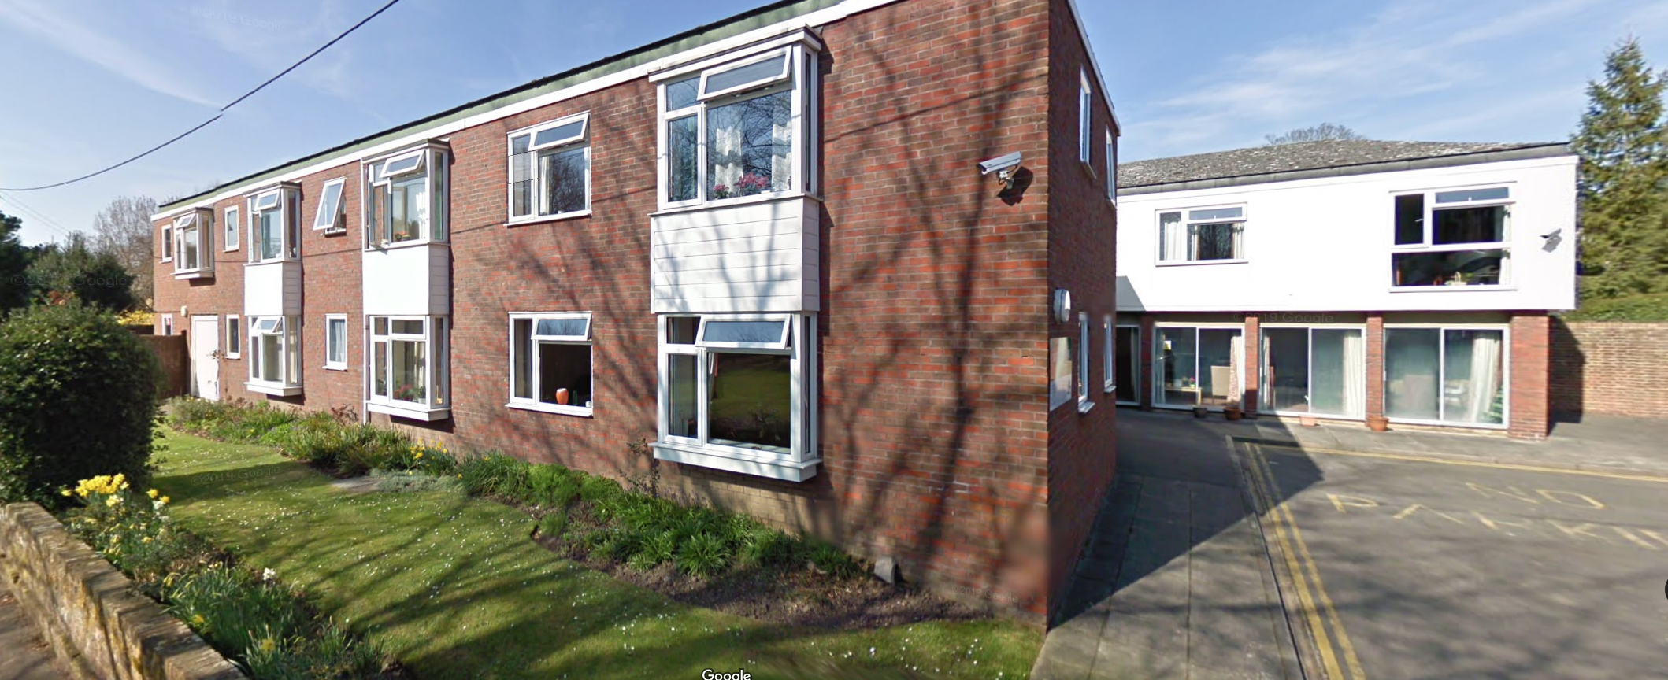
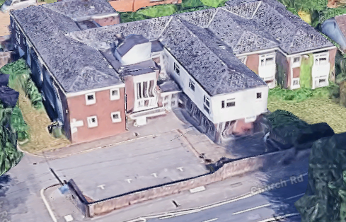

Evidence the site is in Flood Zone 1 (not susceptible to ponding or fluvial flooding)
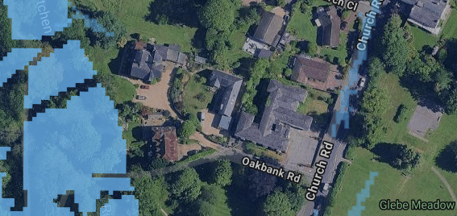

Accommodation Schedule (and evidence of compliance with National prescribed minimum standards)
Ex or Pp | Unit | Description | Floor | Area (m2) | Bed Size | Bed 1 (m) | Bed 1 (m2) | Bed 2 (m) | Bed 2 (m2) | Bed 3 (m) |  | Bed 3 (m2)
Existing | 1 | one bed | ground | 44.4 | 1Bed/ 1person | 3.9 x 3.2 | 12.7 | n/a | n/a | n/a |  | n/a
Existing | 2 | Studio | ground | 30.1 | 1Bed/ 1person | 5.5 x 3.3 | 15.5 | n/a | n/a | n/a |  | n/a
Proposed | 3 | one bed | ground | 38.7 | 1Bed/ 1person | 2.2 x 3.8 | 8.7 | n/a | n/a | n/a |  | n/a
Proposed | 4 | 2 floors | ground/first | 122 | 3Bed /5 people | 3.3 x 5.3 | 19.5 | 3.5 x 2.8 | 10.1 | 5.1 x 2.7 |  | 13.7
Existing | 5 | Studio | ground | 31.3 | 1Bed/ 1person | 3.6 x 5.4 | 17 | n/a | n/a | n/a |  | n/a
Proposed | 6 | 2 floors | ground/first | 109 | 3Bed/ 5 people | 4.0 x 3.6 | 13.7 | 4.7 x 2.8 | 13.6 | 3.0 x 2.8 |  | 8.7
Proposed | 7 | 2 floors | ground/first | 70 | 2Bed/ 3 people | 2.9 x 3.6 | 9.5 | 2.5 x 2.6 | 7.5 | n/a |  | n/a
Proposed | 8 | 2 floors | ground/first | 70 | 2Bed/ 3 people | 2.9 x 3.7 | 9.5 | 2.5 x 2.6 | 7.5 | n/a |  | n/a
Proposed | 9 | 2 floors | ground/first | 70 | 2Bed/ 3 people | 2.9 x 3.7 | 9.5 | 2.5 x 2.6 | 7.5 | n/a |  | n/a
Proposed | 10 | 2 floors | ground/first | 95.5 | 3Bed/ 5 people | 2.6 x 4.1 | 10.6 | 2.3 x 3.7 | 8.7 | 2.7 x 3.4 |  | 8.7
Proposed | 11 | 2 floors | ground/first | 84 | 3Bed/ 4 people | 3.0 x 3.4 | 10.1 | 2.3 x 3.8 | 8.8 | 2.3 x 3.4 |  | 7.6
Existing | 12 | one bed | first | 44.3 | 1Bed/ 1person | 3.9 x 3.2 | 12.7 | 3.9 x 2 3 | n/a | n/a |  | n/a
Existing | 13 | Studio | first | 30 | 1Bed/ 1person | 5.6 x 3.3 | 15.1 | n/a | n/a | n/a |  | n/a
Proposed | 14 | one bed | first | 38.3 | 1Bed/ 1person | 2.2 x 3.7 | 8.6 | n/a | n/a | n/a |  | n/a
Existing | 15 | studio | first | 31.3 | 1Bed/ 1person | 3.6 x 5.4 | 17 | n/a | n/a | n/a |  | n/a

Heritage Statement
Given this site is in a conservation area but outside of the County Sites of Archaeological Importance, in appendix A is a potted history of Meller House and the surrounding neighbourhood along with historic mapping. In principle with regards to this application, the only relevant factor is the 1860 perimeter brick wall (primarily to Church Road) which we fully intend to retain and our proposed works in the immediate vicinity will preserve the structure of the wall.
Biodiversity
Please see appendix D for a completed Checklist which raised no issue.
Cycle & Parking Provision & Travel Plan
The former 21No. units only had 5 parking spaces to the front carpark with a single space to the side. This proposal has 6 of those former dwellings retained and the remainder amalgamated into 9 proposal dwellings. Eastleigh’s SSPD seeks to reduce reliance on cars, and this scheme introduces x20 secured cycle spaces. These allow natural surveillance from the nearest dwellings, are well lit, are conveniently located to the main entrance, are signed and in a weatherproof enclosure. We are proposing a stacking modular rack with upper rails, usable by all (as commonly found out in society). The provision exceeds the minimum requirements.
Also proposed now are x15+1 car spaces. This conforms again to the SSPD for apartment schemes. Apartments of one bed require 0.75 of a space and two bed plus, 1.5 spaces. The x9 proposed units therefore require 12 spaces. The 6 existing units in this format – would require 4.5 spaces. In principle then, this scheme accords with the provisioning when non-allocated. Please note however, there is extensive ‘on street’ controlled parking in what is primarily a non-residential area opposite– which would be ideal for visitors.
In addition to the onsite requirements, Bishopstoke is well served with public transport (10min walk to mainline train & bus terminals) with the No2 Bluestar bus into Eastleigh/Southampton every 15mins from the post office 250m south-east of the site (at the Post Office stop – in the neighbourhood centre with full retail options). See appendix E for bus timetable.

