TECHNICAL REPORT ON A SUBSIDENCE CLAIM

Crawford Reference: SU2206173

Mrs Amanda Dempster
34 Lakewood Road
Eastleigh, Hampshire
SO53 1EW
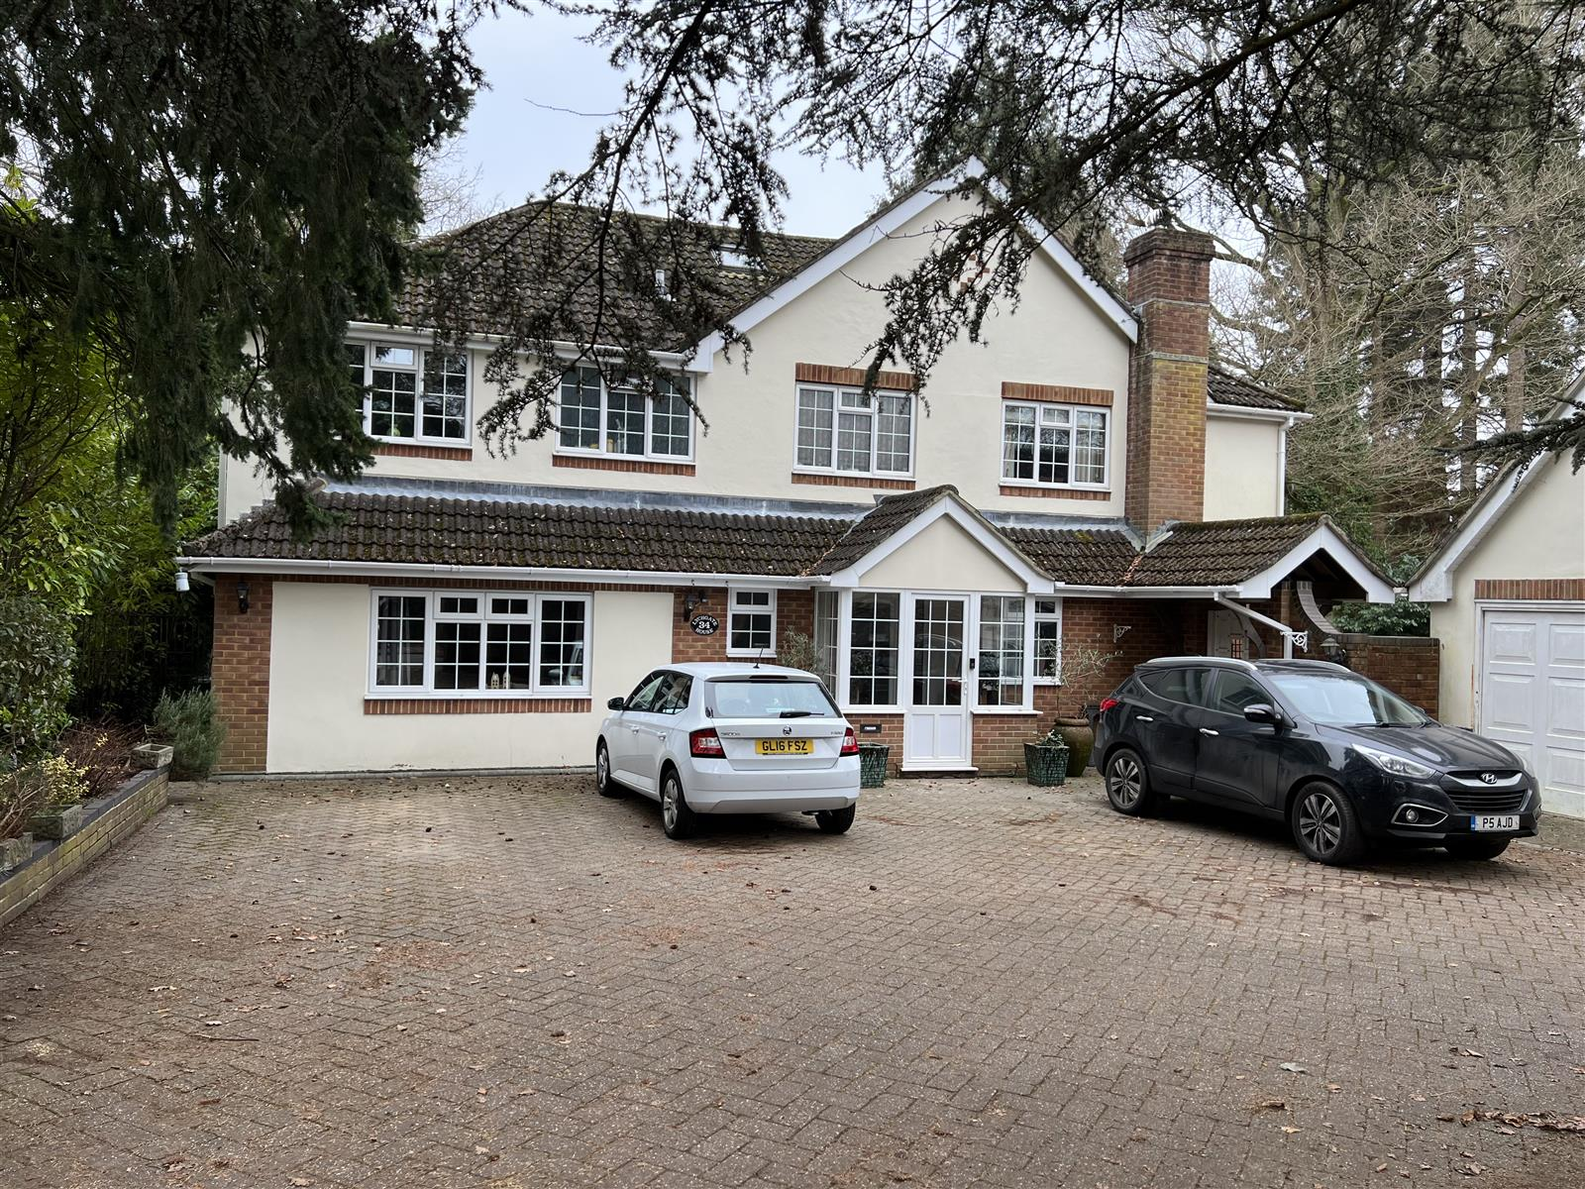

prepared for

AXA Retail - Avantia
PO Box 7073, Willenhall, WV1 9ZW

Claim Reference 12573186E

SUBSIDENCE CLAIM

DATE 11 February 2023

Crawford Claims Solutions – Subsidence
Cartwright House, Tottle Road,
Riverside Business Park, Nottingham, NG2 1RT
Tel: 0115 943 8260

Site Plan |  |  |  | This plan is Not to Scale
This plan is diagrammatic only and has been prepared to illustrate the general position of the property and its relationship to nearby trees etc. The boundaries are not accurate, and do not infer or confer any rights of ownership or right of way. Position of utilities is only indicative and contractors must satisfy themselves regarding actual location before commencing works.
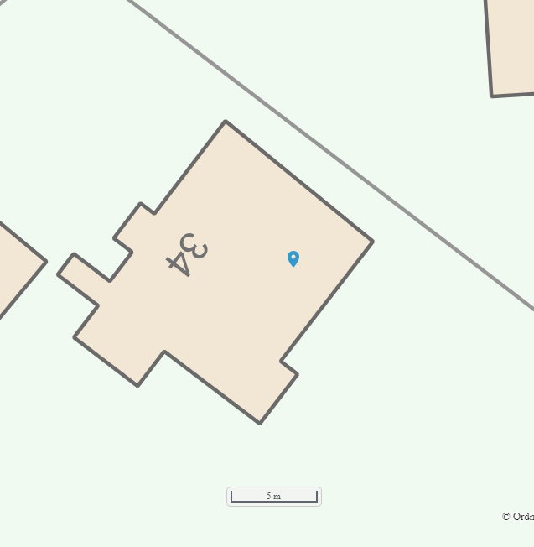
EH2
EH1
TPO Oak
© Bluesky International & © Infoterra 2006.
Map Reproduced with the Permission of Ordnance Survey License Number ########
Key:
 | Tree: Deciduous |  | Tree: Conifer |  |  | Shrub
 | Hedge |  | Area of Damage |  |  | Bore Hole
 | Trial Hole |  | Trial & Bore Hole |  |  | Level Monitoring
 | Rain Water Manhole |  | Rain Water Gulley |  |  | Rain Water Pipe
 | Waste Water Manhole |  | Waste Water Gulley |  |  | Toilet Pipe
 | Rain Water Drain |  | Waste Water Drain |  |  | Electricity Cable
 | Water Supply Pipe |  | Gas Supply Pipe |  |  | Incoming Gas Pipe
 | Incoming Water |  | Incoming Electrics

INTRODUCTION
We have been asked by AXA Retail - Avantia to comment on movement that has taken place to the above property. We are required to briefly describe the damage, establish a likely cause and list any remedial measures that may be needed.

Our report should not be used in the same way as a pre-purchase survey. It has been prepared specifically in connection with the present insurance claim and should not be relied on as a statement of structural adequacy. It does not deal with the general condition of the building, decorations, timber rot or infestation etc.

The report is made on behalf of Crawford & Company and by receiving the report and acting on it, the client - or any third party relying on it - accepts that no individual is personally liable in contract, tort or breach of Statutory duty. Where works address repairs that are not covered by the insurance policy we recommend that you seek professional advice on the repair methodology and whether the works will involve the Construction (Design & Management) Regulations 2015. Compliance with these Regulations is compulsory; failure to do so may result in prosecution. We have not taken account of the regulations and you must take appropriate advice.

We have not commented on any part of the building that is covered or inaccessible.

TECHNICAL CIRCUMSTANCES
The cracking was noticed last summer.

PROPERTY
Two storey detached house of traditional construction with part rendered brick walls surmounted by a hipped, tiled roof. There is a single storey extension at the rear left which was present on purchase and a conservatory on the rear right which was rebuilt around 2 years ago on new deeper footings.

HISTORY & TIMESCALE
Next Steps
Site investigations, arboricultural report and monitoring for 12 months before TPO application.

Date of Construction c.1960s
Purchased October 1993
Policy Inception Date 05/11/2016
Damage First Noticed 28/10/2022
Claim Notified to Insurer……………………… 28/10/2022
Date of our Inspection 09/02/2023
Issue of Report 16/02/2023
Anticipated Completion of Claim Summer 2025

TOPOGRAPHY
The property occupies a relatively level site.

GEOLOGY
Reference to the 1:625,000 scale British Geological Survey Map (solid edition) OS Tile number SUSW suggests the underlying geology to be London Clay.

London Clays are marine deposits characterised by their silty, sandy composition. They are typically stiff, dark or bluish grey, weathered dark to mid-brown superficially with fine particle size (less than 0.002mm). Tomlinson describes it as a ‘fat’ clay with high loadbearing characteristics due to pre-consolidation pressures in its geological history.

The upper horizon is often encountered at shallow depth, sometimes just below ground level. They have high shrink/swell potentials, and can be troublesome in the presence of vegetation.

The solid geology appears to outcrop in this location, although we cannot rule out the presence of superficial deposits at shallow depth.

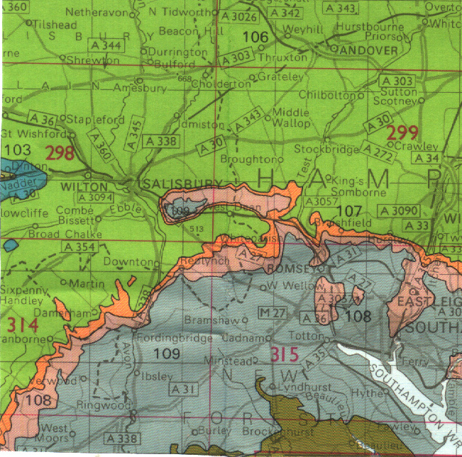
Geology. Reproduced with consent of The British Geological Survey at Keyworth.
Licence IPR/34-7C CSL British Geological Survey. ©NERC. All rights Reserved.

VEGETATION
There are several trees and shrubs nearby, some with roots that may extend beneath the house foundations. The following are of particular interest:-

Type Height Distance Ownership
Oak 20 m 5 m Owners

See sketch. Tree roots can be troublesome in cohesive (clay) soils because they can induce volumetric change. They are rarely troublesome in non-cohesive soils (sands and gravels etc.) other than when they enter drains, in which case blockages can ensue.
Oak trees (Quercus) are deciduous and native to Europe. They can reach heights in excess of 35m, but more typically grow to between 18 - 25m, depending on health, environment and soil conditions. They have a medium growth rate of around 250mm per year and strong root activity.
Typical proportions of an Oak showing the potential root zone. They have by far the most aggressive of root systems,
often spreading considerable distances (1.5 x height or more).

Maximum tree-to-damage distance recorded in the Kew survey was 30mtrs, with 50% of all cases occurring within 9.5mtrs. Life expectancy > 100 years, although they are vulnerable to insect and fungal attack. Old and young trees are tolerant of quite heavy pruning and crown reduction, although re-growth can be an ongoing problem.

Oaks are, in my experience, worthy of considerable respect when dealing with subsidence claims. Their root system extends for surprising distances and can be associated with particularly high soil suctions.

Because of difficulties in controlling the oak, and its vigorous root system, I regard it as being far more significant (in terms of a subsidence league table) than either the willow or poplar tree.

OBSERVATIONS
The area of damage is the rear left corner of the house.

The following is an abbreviated description. Photographs accompanying this report illustrate the nature and extent of the problem.

INTERNAL

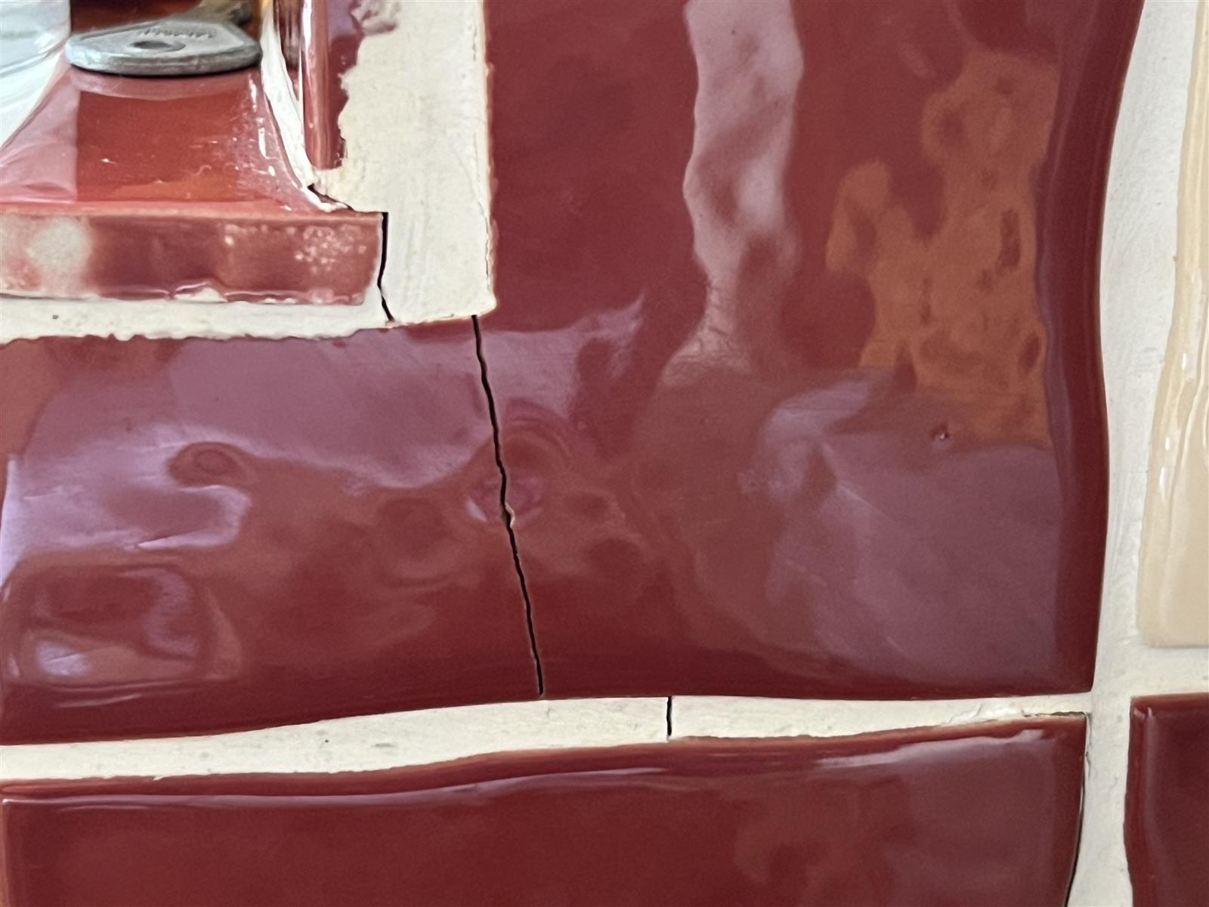 | 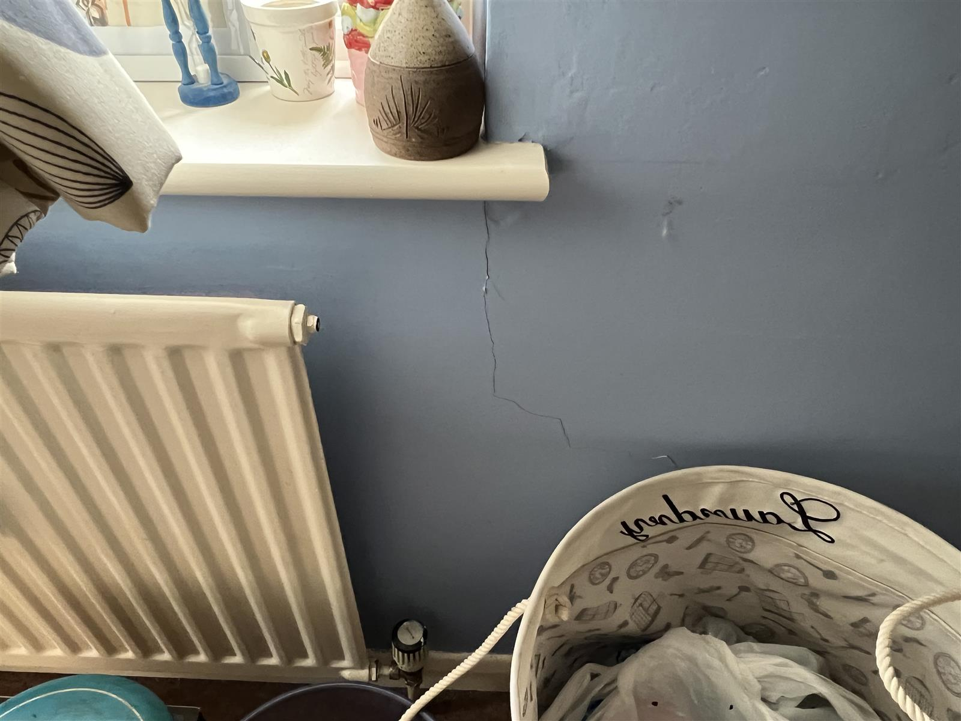
Kitchen tiles | Bedroom

Study
- Fine cracks around lintel on rear wall
- Hairline crack above side window
- Diagonal crack on lounge internal wall

Kitchen
- Stepped crack in tiled splashback below right corner of rear window, extending through a tile

Lounge
- Cracking at coving/ceiling junctions with some coving at rear left becoming detached.

Rear left Bedroom
- Diagonal crack below corner of rear window and vertical crack above opposite corner
- Fine diagonal crack below corner of side window

There are also some more longstanding cracks to the landing ceiling, above the right spare bedroom door and in the lounge walls, none of which appear related to the current subsidence movement.

EXTERNAL

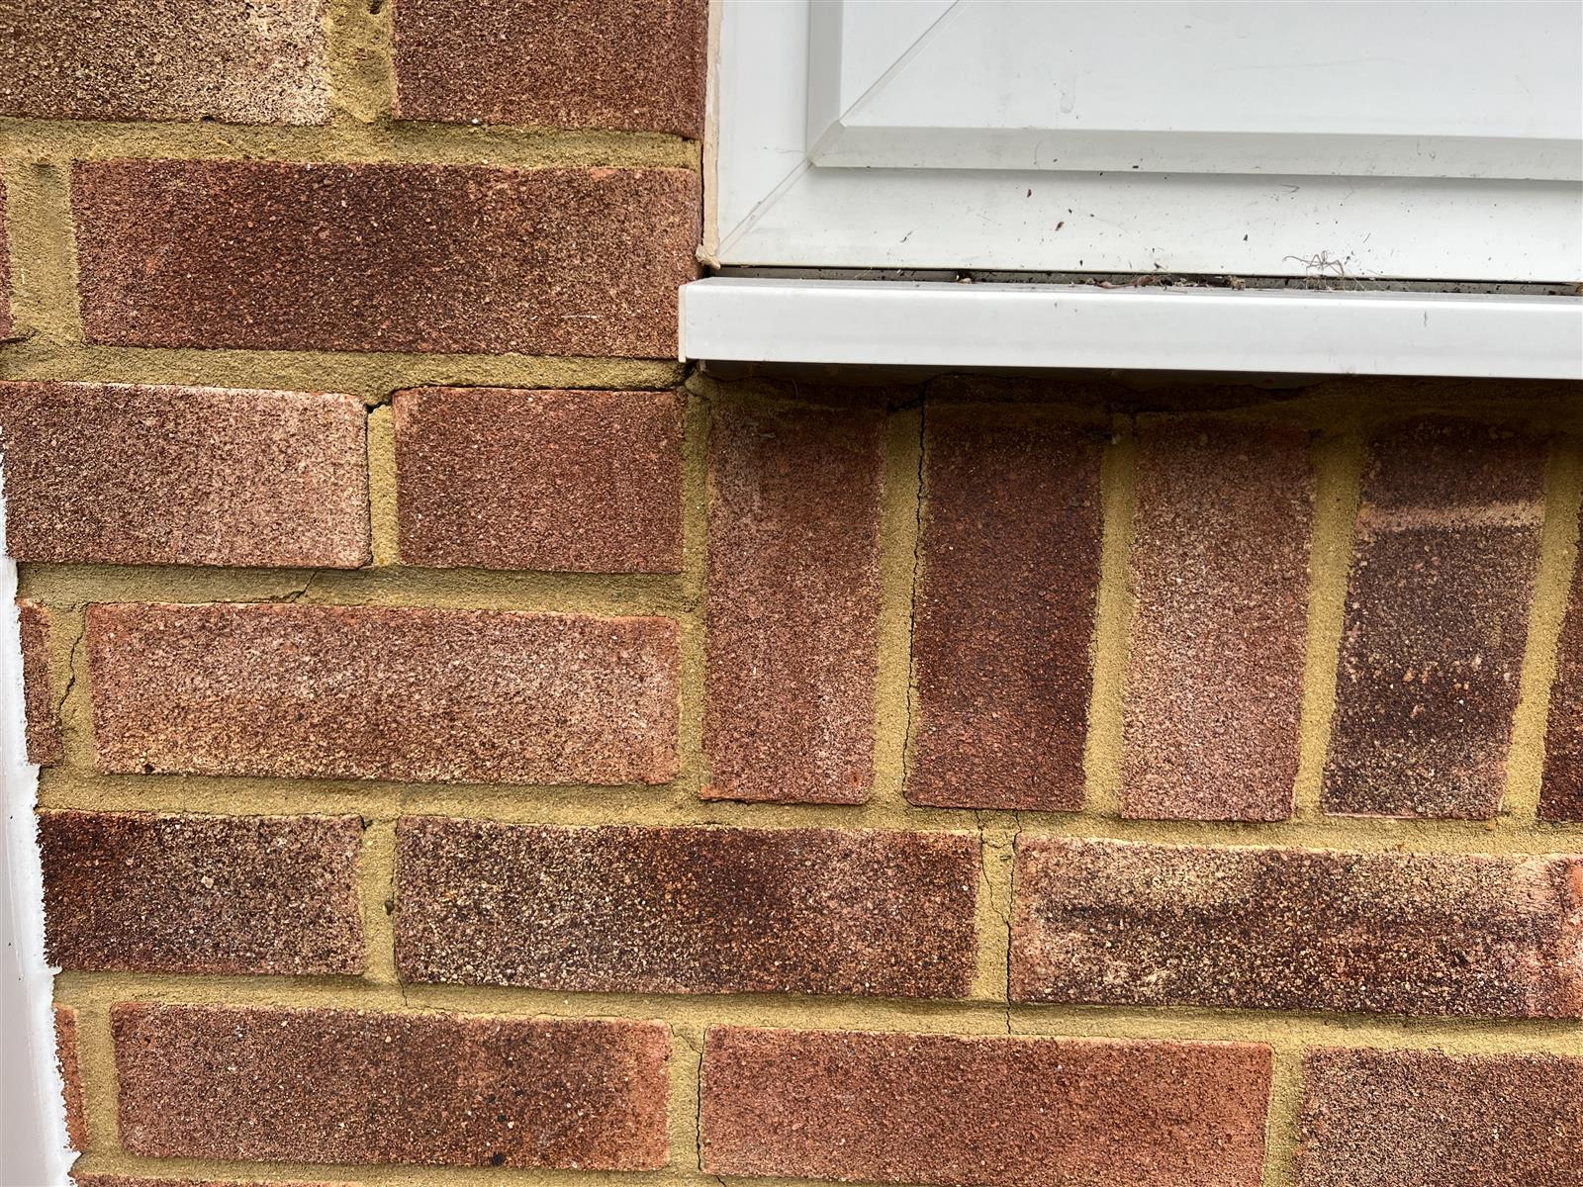 | 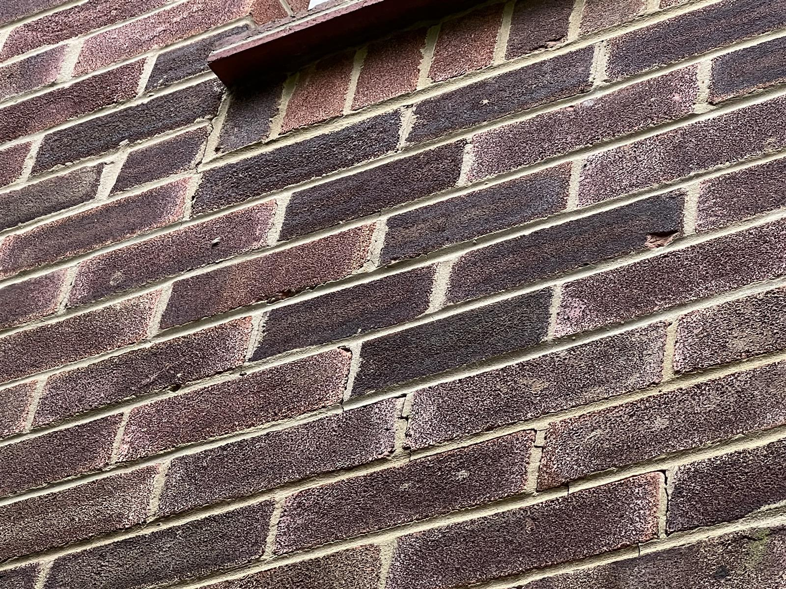
Below kitchen window | Left flank wall

Rear Elevation
- Stepped diagonal crack below rear right of kitchen window (tile crack internally)
- Stepped crack above left of kitchen window
- Stepped crack below left of Study window

Left Flank Elevation
- Stepped crack below rear left bedroom window

CATEGORY

In structural terms the damage falls into Category 2 of Table 1, Building Research Establishment Digest 251, which describes it as “slight”.

Category 0 | "negligible" | < 0.1mm
Category 1 | "very slight" | 0.1 - 1mm
Category 2 | "slight" | >1 but < 5mm
Category 3 | "moderate" | >5 but < 15mm
Category 4 | "severe" | >15 but < 25mm
Category 5 | "very severe" | >25 mm

Extract from Table 1, B.R.E. Digest 251
Classification of damage based on crack widths.

DISCUSSION
The pattern and nature of the cracks is indicative of an episode of subsidence. The cause of movement appears to be clay shrinkage.

The timing of the event, the presence of shrinkable clay beneath the foundations and the proximity of vegetation where there is damage indicates the shrinkage to be root induced. This is a commonly encountered problem and probably accounts for around 70% of subsidence claims notified to insurers.

Fortunately, the cause of the problem (dehydration) is reversible. Clay soils will re-hydrate in the winter months, causing the clays to swell and the cracks to close. Provided the cause of movement is dealt with (in this case, vegetation) there should not be a recurrence of movement.

No structural changes to the building have been carried out which has contributed to the current subsidence related damage under investigation. We are not aware of any previous underpinning.

RECOMMENDATIONS
Although the cause of the movement needs to be dealt with, we note the vegetation is subject to a Preservation Order. Unfortunately, current legislation requires certain investigations to be carried out to support an application for the tree works.

Typically, these investigations would involve trial pit(s) to determine the depth and type of footings, boreholes to determine the nature of the subsoil/influence of any roots and monitoring to establish the rate and pattern of movement. The monitoring data provided must be sufficient to show a pattern of movement consistent with the influence of the vegetation and therefore it may be necessary to carry out the monitoring for up to a 12 month period.

It will also be necessary to obtain a specialist Arboricultural Report.

We will report further once these investigations have been completed.

Neil Crawford CEng BEng (Hons) MICE
Crawford Claims Solutions – Subsidence
subsidence@crawco.co.uk

11 February 2023
PHOTOGRAPHS

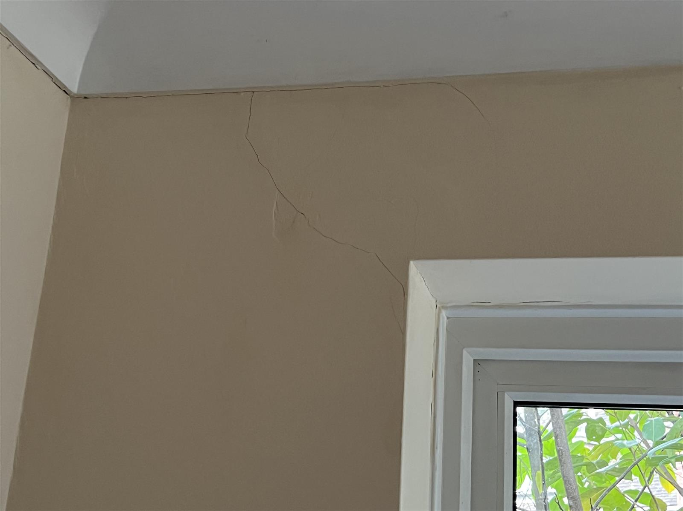 | 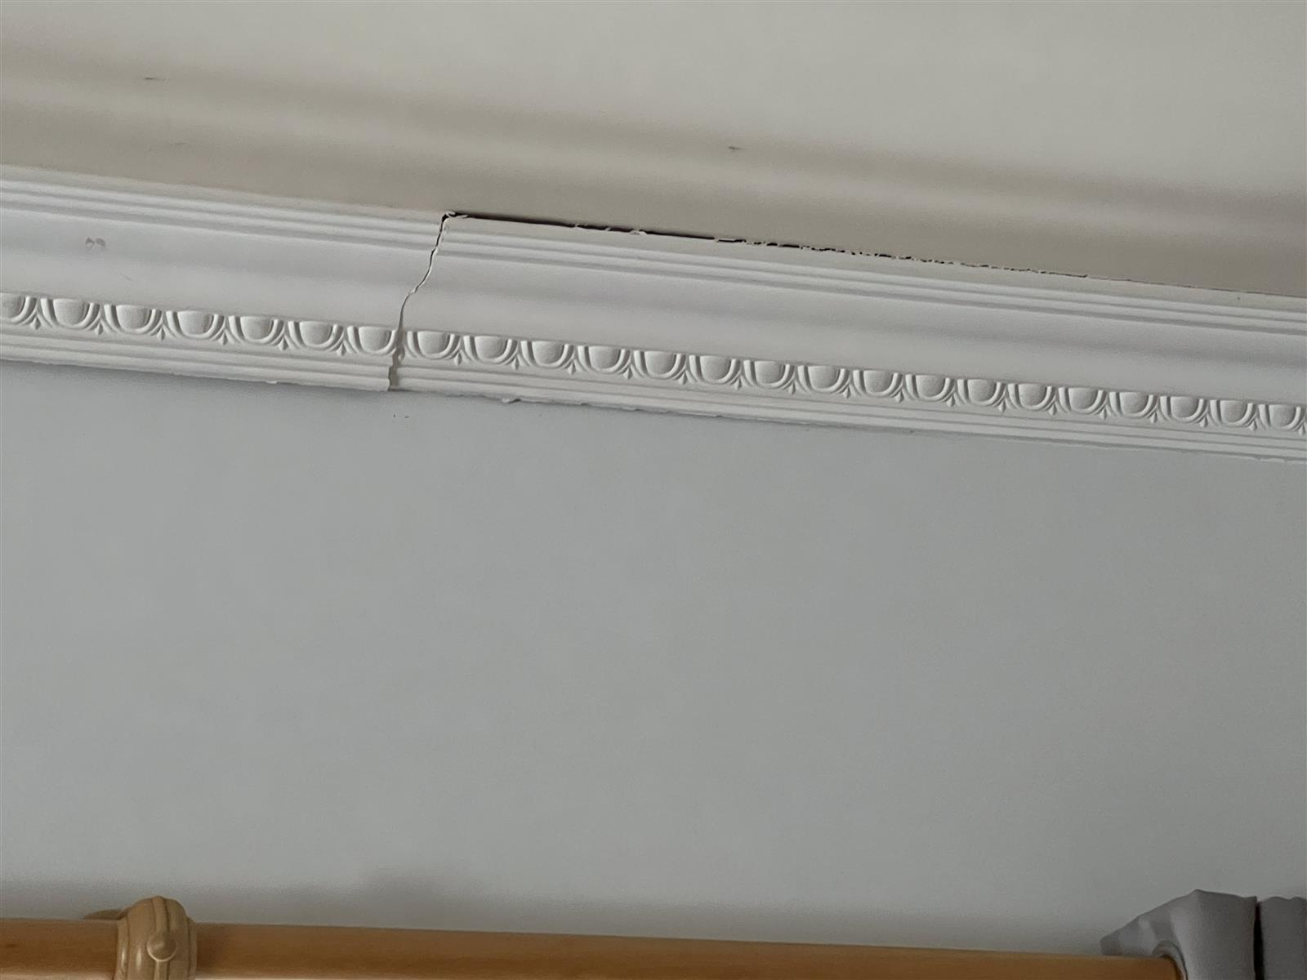
Study | Lounge
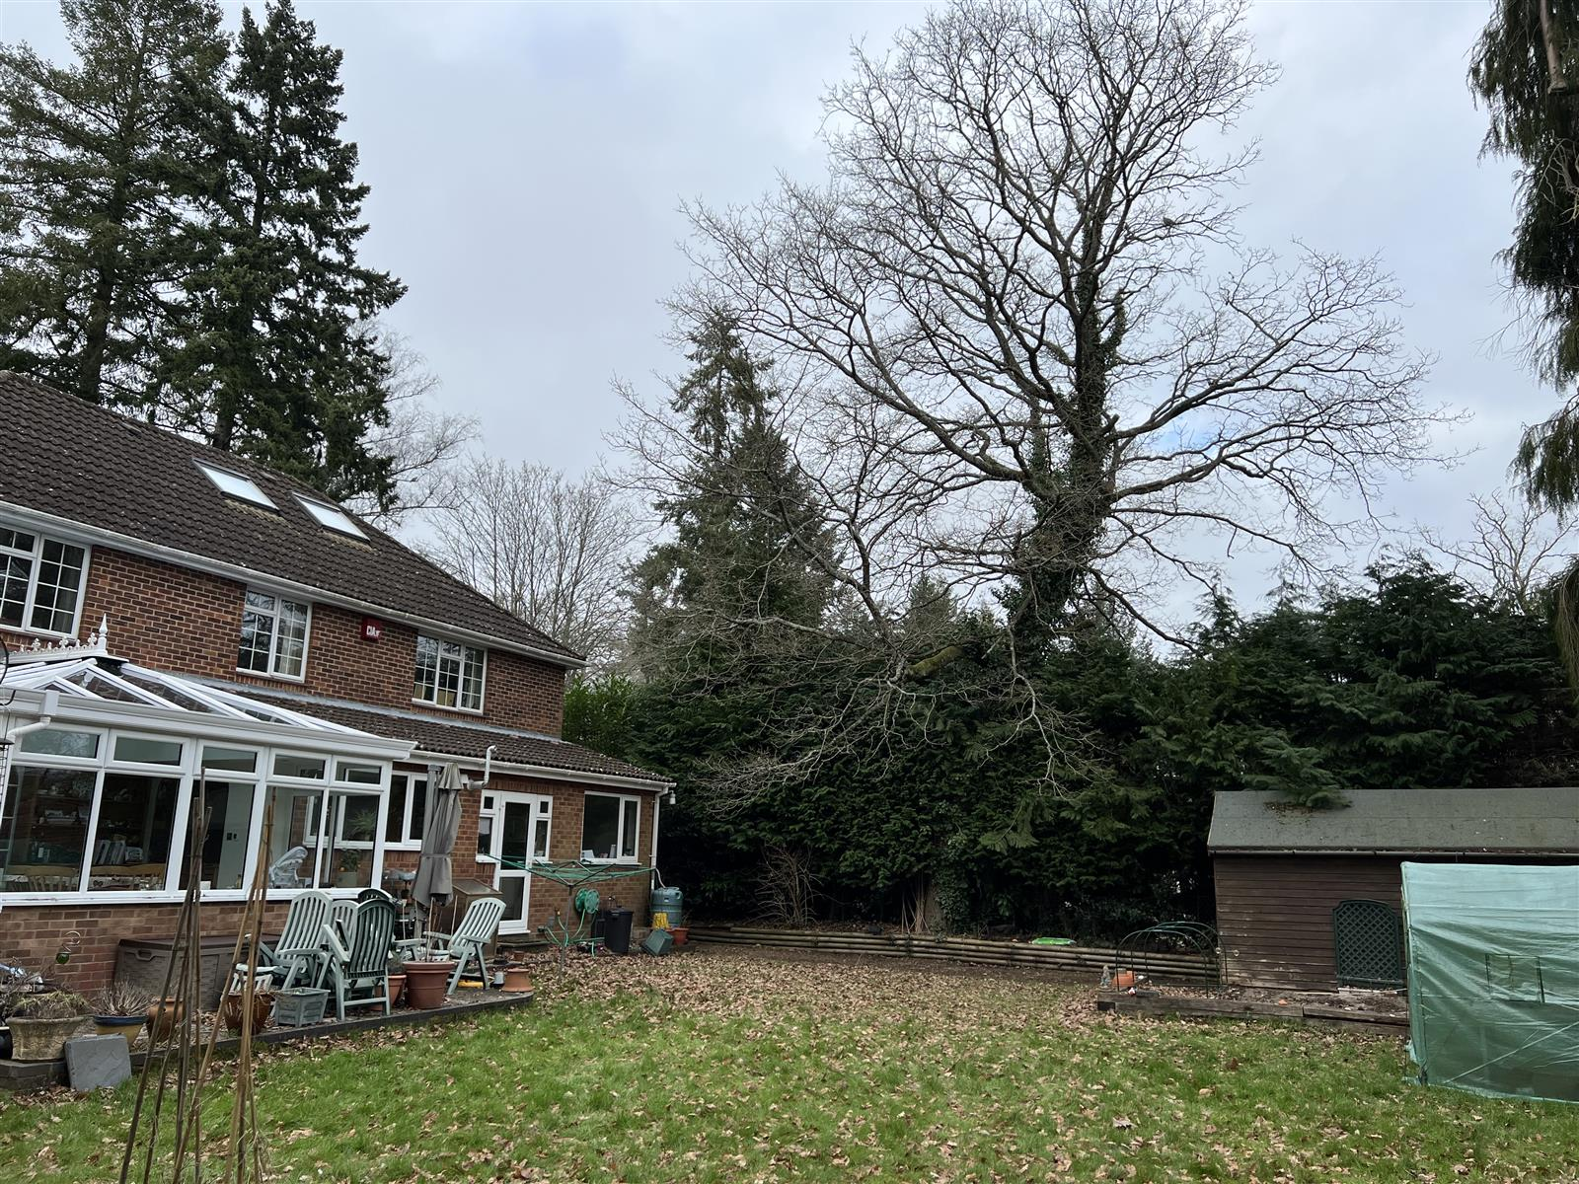 | 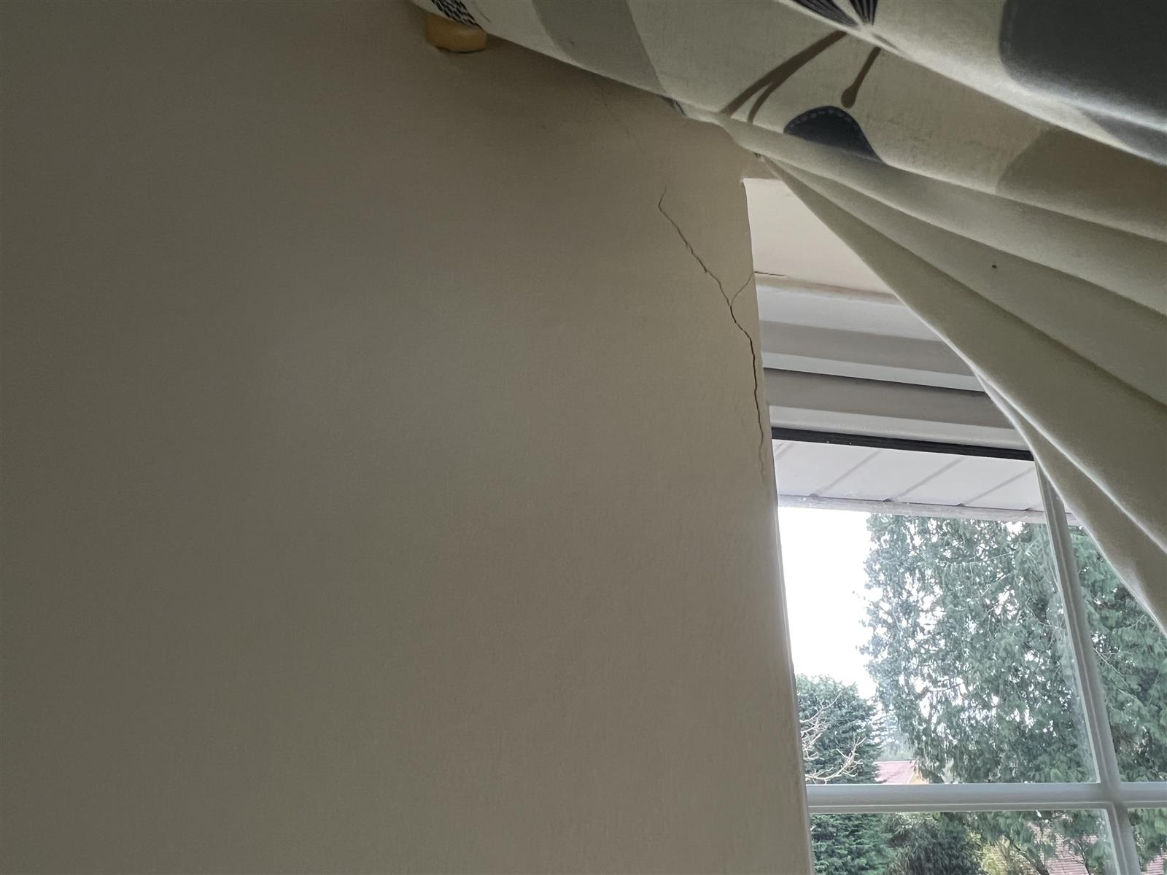
Oak tree | Bedroom

Tomlinson M.J. (1991) “Foundations Design & Construction” Longman Scientific Publishing. B.S. 5930 (1981) “Site Investigations”
DriscollL R. (1983) “Influence of Vegetation on Clays” Geotechnique. Vol 33.
Table 1, Chapter 4.2, Para. 2.3 of N.H.B.C. Standards, 1986.
Richardson & Gale (1994) "Tree Recognition" Richardson's Botanical Identifications
Cutler & Richardson (1991) “Tree Roots & Buildings” Longman Scientific
Building Research Establishment, Garston, Watford. Tel: 01923.674040

