ADDENDUM ARBORICULTURAL REPORT

SUBSIDENCE CLAIM

Crawford Reference: 1786559
Insurer Claim Reference: 12581502C

5 Clausentum Close, Chandlers Ford, Hampshire, SO53 2AQ

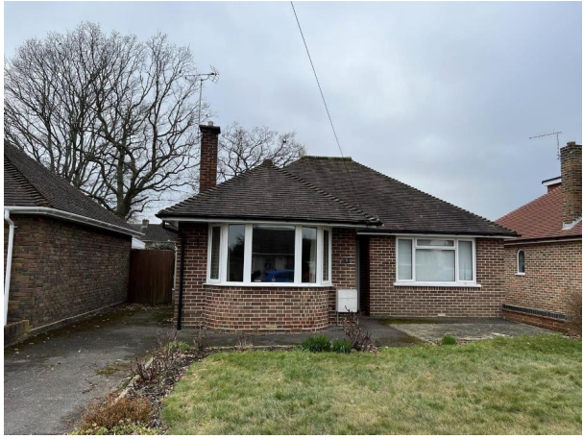

Prepared for

AXA Retail - Avantia

17 June 2025


Crawford Claims Solutions – Subsidence
Cartwright House,
Tottle Road,
Riverside Business Park, Nottingham, NG2 1RT
Tel: 0115 943 8266

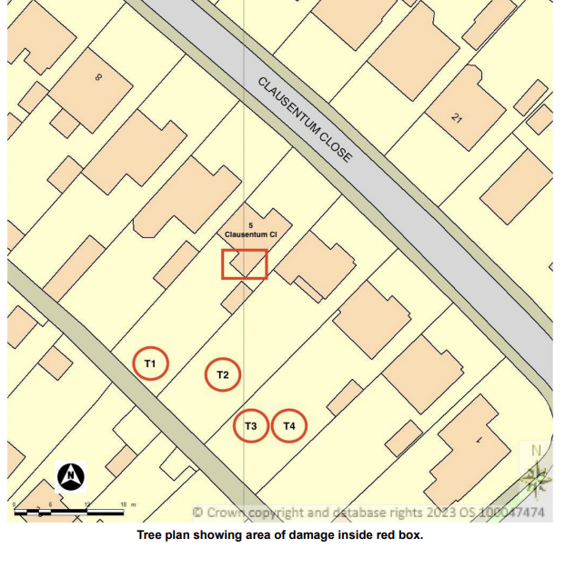

INTRODUCTION
We have been asked by Axa Retail - Avantia to comment on movement that has taken place to the above property. We are instructed to describe the damage, establish a likely cause and list any mitigation or remedial measures required to stabilise the property.
Our report does not constitute a full structural survey of the property and it has been prepared specifically in connection with the present insurance claim and should not be relied on as a statement of structural adequacy. It does not deal with the general condition of the building, decorations, timber rot or infestation etc. All locations are identified as if viewing from the front of the building.
The report is made on behalf of Crawford & Company and by receiving the report and acting on it, the client - or any third party relying on it - accepts that no individual is personally liable in contract, tort or breach of Statutory duty. We have not commented on any part of the building that is covered or inaccessible.
This report outlines the arboricultural issues and should be read in conjunction with the MWA Arboricultural Report and the site investigations including soil and root testing and level monitoring, which are summarised within this report.
This report is to support a TPO Application to remove Oaks T1 & T2 in the Envirotrees Arboricultural Appraisal Report, as an effective, long-term remedy to the subsidence damage they are causing. The trees are subject to a Tree Preservation Order.

TECHNICAL CIRCUMSTANCES
The property has been tenanted for the last 9 years. The tenant reported fine cracking around 3 years ago and this was referred to a builder who suggested in just be monitored. The Insured set up an Avonguard tell-tale across this crack and it has not moved. Around Summer 2021, the tenant reported a new crack in the kitchen/lounge wall which the Insured investigated. This was minor and so no action was taken but it worsened significantly in Summer 2022 opening up to around 10mm before closing again in recent months. The Insured obtained a Report from Robin Austin Surveyors who suggested the damage was due to subsidence and that Insurers should be notified.

PROPERTY
Single storey detached bungalow of traditional construction with brick walls surmounted by a hipped, tiled roof. There is a conservatory to the rear.

HISTORY

Date of Construction 1958

Date Damage First Noticed Summer 2022

TOPOGRAPHY
The property occupies a reasonably level site with no unusual or adverse topographic features.

OBSERVATIONS

Following our initial inspection it was established that the damage to the property was caused by subsidence, believed to be as a result of root induced clay shrinkage. the area of damage is the rear left corner of the bungalow.

INTERNAL DAMAGE

Kitchen

Diagonal crack from loft hatch on internal lounge wall extending to left flank wall at ceiling level, tapering open with height. Vertical crack below loft hatch. Crack was open 10mm during summer and has now closed to c.3mm.

Cracking at coving/ceiling junction on left flank wall
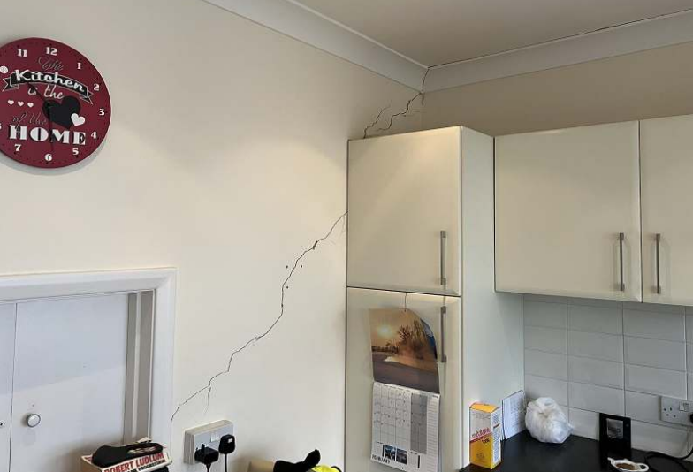
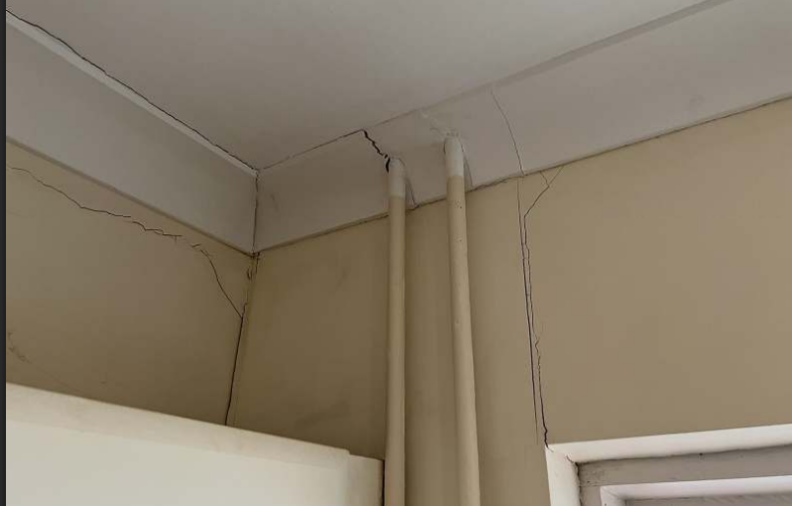

Vertical crack above left side of rear window. Past repair but has re-opened.

Door to conservatory is sticking. Frame has become out of square with movement to left side at top.

Conservatory

Soldier course brickwork above window frame has become loose and detached.

Vertical crack above right side of door frame

Lounge

Main diagonal crack on internal kitchen wall is reflected on other side.

Vertical crack above arch and extending into ceiling. This has been monitored and shows no signs of movement.

Fine crack from internal wall to fireplace on ceiling

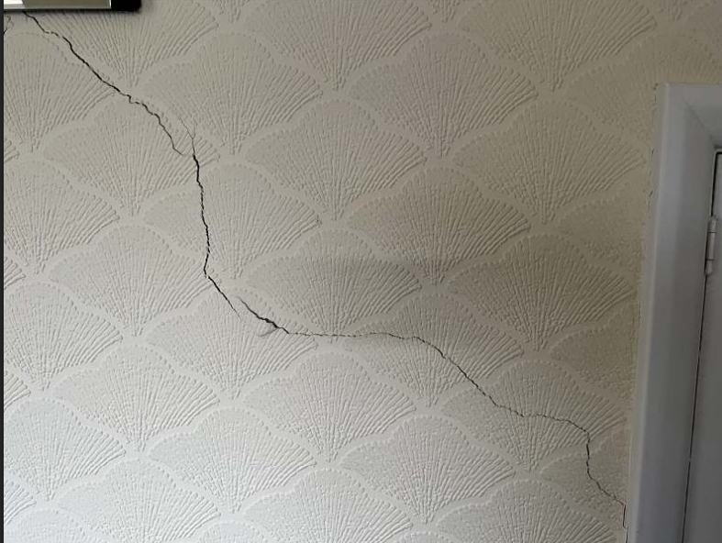
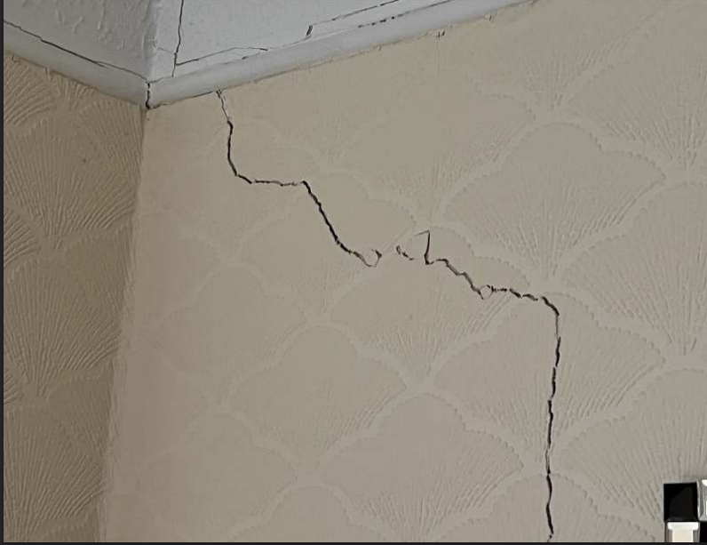
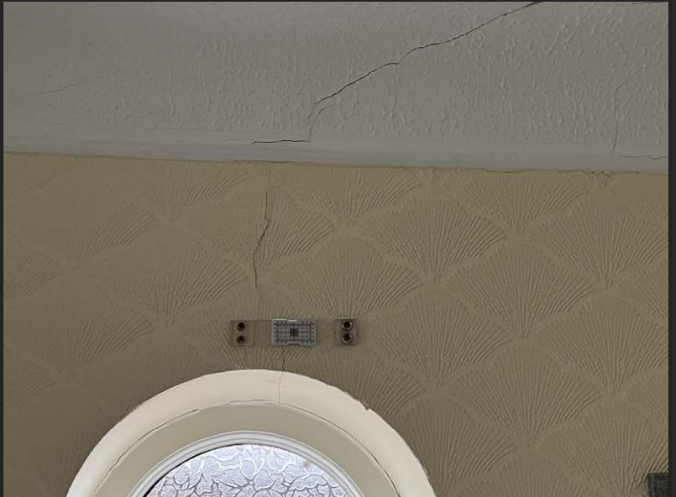

Hall

Vertical crack above door to kitchen, extending into artex ceiling

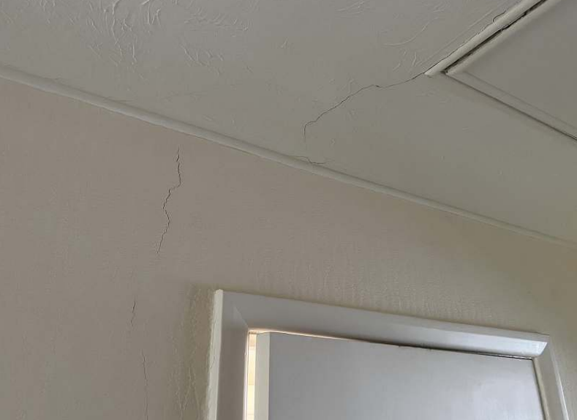

Bathroom

Minor cracking at rear left corner high level in grouting and coving junction
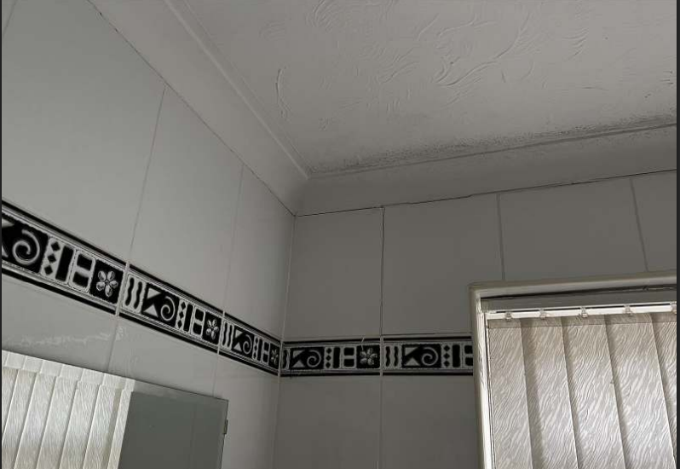

EXTERNAL DAMAGE

The movement suggests that the left flank wall will be tilting out slightly.
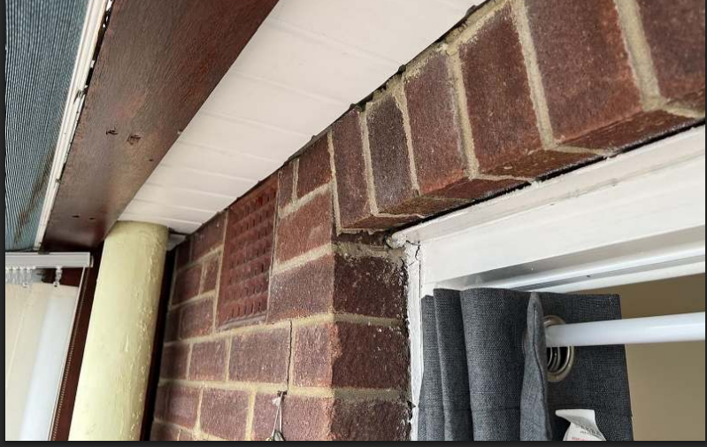

CATEGORY OF DAMAGE
In structural terms, with reference to Table 1, Building Research Establishment Digest 251, the damage is categorised as Moderate (>5 but <15 mm) with maximum crack widths of 10.0mm.

Category 0 | "negligible" | < 0.1mm
Category 1 | "very slight" | 0.1 - 1mm
Category 2 | "slight" | >1 but < 5mm
Category 3 | "moderate" | >5 but < 15mm
Category 4 | "severe" | >15 but < 25mm
Category 5 | "very severe" | >25 mm

Extract from Table 1, B.R.E. Digest 251
Classification of damage based on crack widths.

GEOLOGY & SOIL
Reference to the BGS Geology Viewer confirms the underlying geology to be Wittering Formation (sand, silt and clay) with superficial deposits of sand and gravel.

Clay soil is also confirmed by the site investigations.
SITE INVESTIGATIONS

The following investigations were undertaken during April 2023 to identify the cause of movement.
Foundation depth confirmed at 550mm bearing onto clay soil that has high to very high plasticity, meaning it can significantly shrink and seal seasonally due to fluctuations in moisture content.

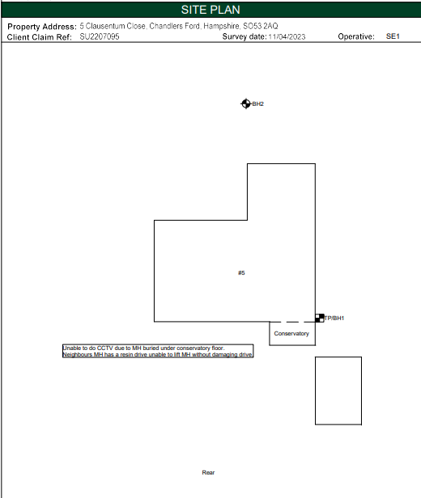

Laboratory tests confirm the onset of desiccation has occurred where roots were observed, the moisture contents being less than 0.5x the Liquid Limit, this indicates abnormal soil drying in the presence of tree roots.

It is notable that the sampling was undertaken at a time of year when soil moisture deficits due to root activity would be at their lowest and we would expect significantly drier soil during summer months when roots are active.

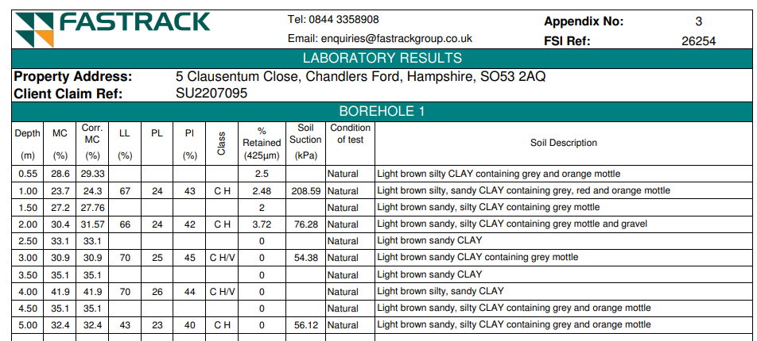

Desiccation is also confirmed by the Sample Soil Suctions at 208.59 kPa.
From BRE Digest 412 “Desiccation in Clay Soils” 1996:

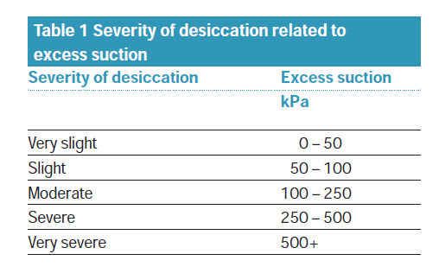

ROOTS

The recovered roots were sent for laboratory testing and the results are as follows:

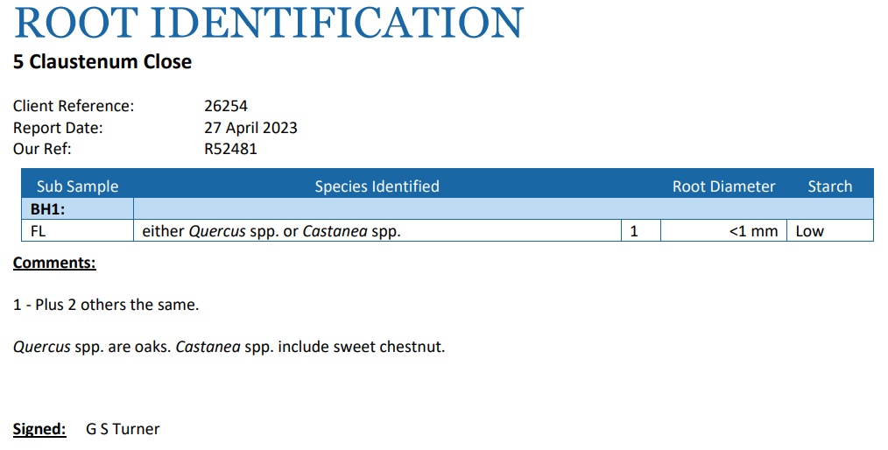

The roots tested positive for starch meaning they were recently alive and active and will be having an influence on soil moisture at rooting depth.

Roots can die during very dry weather. Roots recovered from beneath foundations, whether alive, recently alive, negative for starch or decayed indicate that the roots must have been alive when they extended beneath the foundations. If root from a certain species have been identified then that species becomes implicated as the roots must have been alive when they grew under the foundations.

Like the crown of a tree or shrub, death of the end of a branch/twig, or if it is pruned will stimulate secondary growth from further back, the same thing happens with roots, a dead end of a root will likely mean that other side roots further back will develop to take over the function of moisture extraction. Also, roots can cause soil to become desiccated and it then becomes unsuitable for root growth and roots may die back due to insufficient moisture being present.

DRAINS
No drain defects have been identified. The desiccated condition of the soil indicates that soil softening due to an escape of water is not a factor in the damage.

VEGETATION
There are trees and shrubs nearby, some with roots that may extend beneath the foundations. The following are of particular interest and recommendations have been made to provide a remedy to the damage:-

T1 Oak – Fell to ground level and treat stump to inhibit regrowth
T2 Oak – Fell to ground level and treat stump to inhibit regrowth

The removal of T1 alone is unlikely to be effective due to the closer proximity of Oak T2.

PHOTOGRAPHS

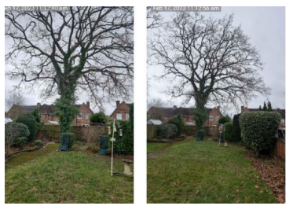
Oak T1

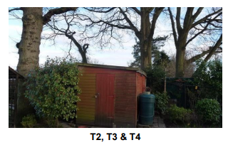

VEGETATION INFLUENCE
According to the standard published work on the subject (Cutler, D.F. and I.B.K. Richardson, (1989) further confirmed by Mercer, Reeves & O’Callaghan (2011) in shrinkable clay soils, Oak (Quercus) species are capable of causing subsidence damage at distances up to 30m, with 75% of cases occurring where the tree was within 13m and 90% of cases occurring where the tree was within 18m.
Trees T1 & T2 at 23m and 17m, respectively, are therefore well within the species’ potential rooting and influencing distance of the building and would be capable of causing seasonal soil drying beneath foundations. The site investigations confirm rooting of Oak beneath foundations in any event.

PATTERN OF MOVEMENT
Damage was observed to worsen during summer 2022 at a time of year when soil moisture deficits due to tree root activity would be reaching their peak during a hot, dry summer.

The area of movement and damage is consistent with the locations of the subject trees.

The pattern of movement is entirely consistent with the seasonal, cyclical influence of tree roots on soil moisture, foundations moving down during summer months when roots are active and extracting soil moisture, then returning to recovery and uplift as soil moisture increases during winter when tree roots are inactive.

Precise Level Monitoring

The results are as follows:

Level monitoring clearly shows evidence of cyclical seasonal movement consistent with root induced clay shrinkage, with downward movement during the summer and corresponding upward movement over the subsequent winter. The movement which is focused at points located in the area of subsidence damage affecting the property.

The pattern of movement is not uniform around the property so ‘nominal clay shrinkage’ can be discounted as a cause.

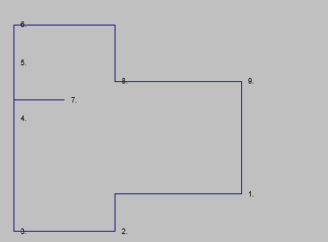

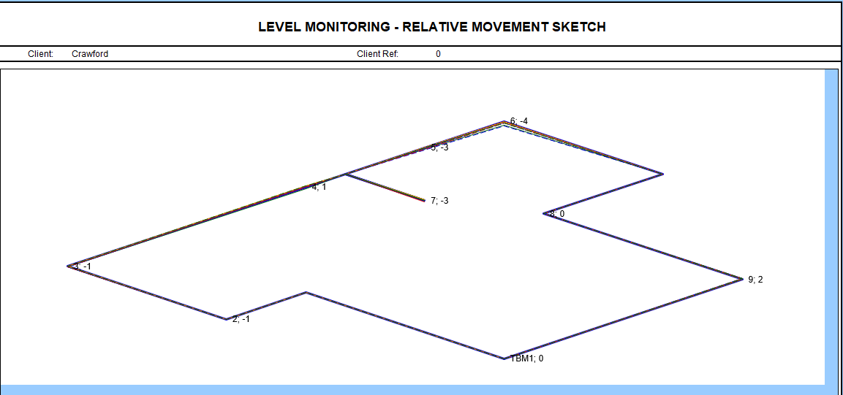

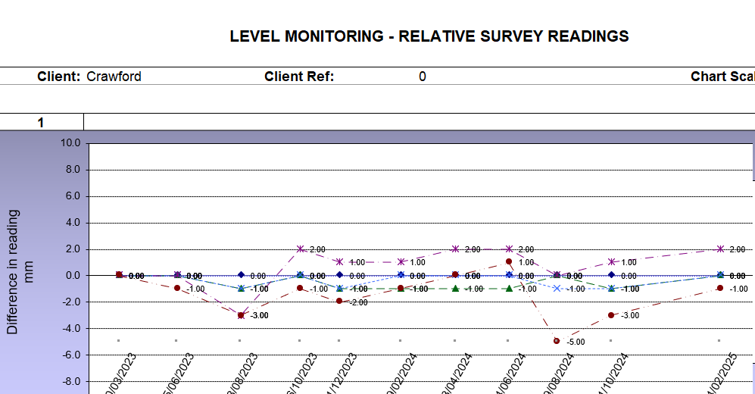

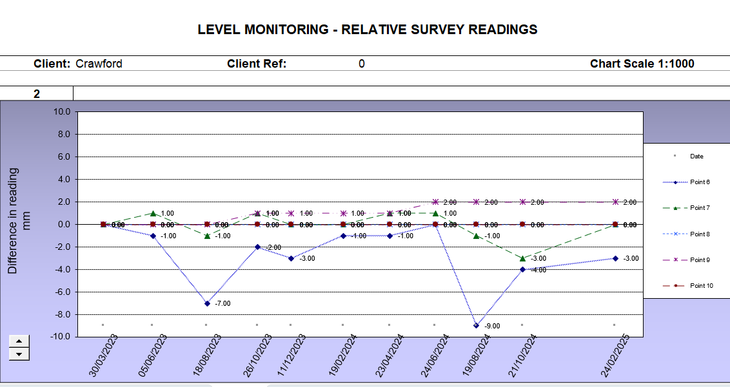

The level monitoring indicates a clear seasonal and cyclical pattern of movement consistent with root induced clay shrinkage with the greatest amplitude of movement being consistent with the location of Oaks T1 & T2.

The level monitoring indicates a cyclical pattern of movement which shows both downwards movement during the drier summer months of up to 9mm; when trees are in leaf and actively demanding moisture from the ground; and subsequent recovery and upward movement during the wetter winter months when the trees lose leaf and become dormant. Patterns of movement such as those observed at the risk address are consistent with clay shrinkage subsidence and are only consistent with the effects of shrinking and swelling of clay soils exacerbated by the presence of roots.

Downward foundation movement occurred during the summers of 2023 and 2024, despite these being far wetter then summer 2022 when damage occurred. We therefore anticipate a recurrence of significant seasonal foundation movement during the next hot, dry summer if the trees are not attended to.

DISCUSSION
The results of the site investigations confirm that the cause of subsidence damage to the property is root-induced clay shrinkage. The clay is plastic and thus will shrink and swell with changes in moisture content. Roots have extracted moisture below the depth of the footings, thus causing differential foundation movement to occur. This is supported by the following investigation results:-
- Our initial site inspection and professional engineering opinion has identified damage to the property consistent with subsidence caused by root induced clay shrinkage.
- Atterberg limit testing indicates that the soil is plastic and hence will shrink and swell with changes in moisture content.
- The pattern of movement shown by level monitoring readings confirms seasonal cyclical movement with downward movement in the summer and upward movement over the winter / upward recovery of a desiccated clay soil consistent with root induced clay shrinkage. The movement is not uniform around the property so 'nominal clay shrinkage' can be discounted as a cause.
- Roots were found to the underside of the foundation and were identified as Oak. Starch was present which indicates that the roots were alive at the time of retrieval.
- An expert Arboricultural report has confirmed that nearby vegetation is the cause of the subsidence related damage to the property and identified tree management works required to stabilise the property.
- The trees can be felled without risk of heave related damage occurring to the building as the implicated trees are of a similar age or younger than the affected structure.

Root identification implicates Oak as the main cause of the damage.

Whilst the foundation depth may be shallow by modern standards, they are the depth that would be expected for a property of this age and type. The building had stood the test of time until the influence of oak roots on soil moisture beneath foundations caused the seasonal movement that has led to the damage.

As per the recommendations, the Oaks T1 and T2 require removal. The implicated trees benefit from Tree Preservation Order and an application should be made to allow the recommended works to be carried out.

Localised superstructure repairs shall proceed once all required tree management works have been completed and monitoring confirms stability of the property at a cost of circa £14,000. Should consent not be granted or third parties refuse to allow the required tree reduction works to be carried out a root barrier or partial underpinning to the property will be required to arrest the movement, with costs rising over £80,000.

MITIGATION OPTIONS

Tree reduction option - Pruning is generally unreliable as a means of controlling water uptake. Whilst the tree remains, even if heavily pruned, damage is likely to continue or worsen, as the roots will continue to extract moisture from beneath foundations of the damaged building. In any event, the tree is sufficiently close to the structure that even heavy pruning is very unlikely to reduce root moisture uptake. There is no linear relationship between foliage volume and the amount of water lost. Being dynamic organisms, trees react to pruning by trying to restore the root to shoot ratio by producing as many leaves as they can. These new leaves are usually juvenile leaves with a larger surface area and generally more pores on the underside, these pores stay open for longer compared to an unpruned tree and increase the degree of water uptake by the roots. Research has shown that even a heavily pruned tree will quickly return to absorbing soil moisture and the seasonal movement and damage will continue. This is particularly the case with the subject trees due to their size, age and species characteristics, and this species grows back successfully following pruning. These trees are so close to the area of damage that root activity would continue even if the trees were to be heavily pruned.

The publication “CONTROLLING WATER USE OF TREES TO ALLEVIATE SUBSIDENCE RISK” © 2004 BRE on behalf of the Link Consortium for Horticulture Link Project No. 212 concluded that:

• For practical soil moisture conservation, severe crown-reduction 70-90% of crown volume would have to be applied. Reduction of up to 50% crown volume is not consistently effective for decreasing soil drying.

• To ensure a continued decrease in canopy leaf area and maximise the period of soil moisture conservation, crown reductions should be repeated on a regular managed cycle with an interval based on monitoring re-growth.

For trees of the age and proximity of the subject trees, a severe crown reduction would diminish its amenity value and would cause decays in the large pruning cuts that would be required. Also, repeated regular pruning (bi-annually) would be an expensive but not necessarily effective means of controlling above ground growth of the tree that would not be guaranteed to negate root activity beneath foundations.

Therefore, if the trees remain (even in a heavily pruned state) roots beneath foundations will remain active and seasonal subsidence damage is likely to continue to the damaged part of the property (and possibly more extensively in future).

We would also refer to the “Pilot study to determine the feasibility of using existing claims data to determine the impact of tree pruning on subsidence incidents on swelling clay soils” Hipps & Atkinson 2014.
Conclusions of that publication are as follows:
“1. Nine cases were studied
2. In three cases pruning eliminated foundation movement
3. In four cases pruning reduced foundation movement
4. In two cases pruning had no effect
Pruning can be used as a reasonable way of minimising risk and preventing first instance of subsidence: (30% linear crown reduction every two years).
However, once subsidence damage has occurred pruning is not a consistently reliable means of mitigation as the structural integrity of the building has already been compromised.
However, if pruning rather than felling is desirable then 40 – 50% linear crown reduction is required.”
Also, it is the case that when a building has suffered damage and its structural integrity has been compromised, the property remains at risk therefore (as in the “Delaware” judgement) measures need to be taken to ensure stability in the presence of active tree roots.
We would also refer to the comments made by Dr Biddle on page 5 of Arboriculture Research Note 108/92/EXT ‘Tree Roots and Foundations’, specifically “Greatest benefits will be achieved if the building is near the outer limits of influence of the tree; pruning a large tree which is only a few metres from a building will probably have little benefit. If reducing the amplitude of movement is unacceptable, complete felling may be needed”.

Therefore, taking all reasonable tests the insured property is within the likely zone of influence of the subject trees. This is further verified by the fact that Oak roots were recovered from the underside of foundations.
From Dr Biddle’s comments it would appear that even an eminent proponent of pruning as a remedy to subsidence appears to agree that in instances where species, such as Oak, are growing within close proximity to damaged properties, felling is the only appropriate action.

Once subsidence damage has occurred pruning is not a consistently reliable means of mitigation.

On page 98 of the BRE publication “Has your house got cracks?” Second Edition Freeman, Driscoll & Littlejohn 2002 it states “Removing the tree altogether will have the greatest and most immediate effect on the levels of desiccation in the soil.”

Also, from page 98 “In most cases there is no advantage in a staged reduction in the size of the tree and the tree should be completely removed at the earliest opportunity.

If the subject trees are not removed, then damage will almost certainly continue and worsen. Roots from these trees have almost certainly encroached beneath foundations and caused seasonal soil drying that has led to the damage.

Root pruning option - Root pruning as a form of mitigation is inherently unreliable as the level of excavation required could include many cubic meters of soil to be guaranteed to have removed all roots causing a nuisance, to effect such a remedy might materially make the tree unsafe or so biologically damaged as to destroy the amenity being the subject of the attempted remedy. Also, new roots will immediately seek to colonise the soil subject to the root cutting and the nuisance will recur.

Root barrier option – We have considered the feasibility of installing a root barrier within a deep trench. The excavations sever all roots, and a geotextile membrane provides a physical barrier to root growth and incorporates a repellent which diverts and inhibits roots. The severed roots then die and no longer absorb soil moisture and the clay will then rehydrate, causing foundations to become stable again.

Due to the limited or lack of access into the rear garden, it would not be practical to install a root barrier as all machinery and materials would need to be placed into the rear garden over the building, this would require the use of a crane (and a road closure).

A root barrier has been considered and the estimated cost is £35,000 plus VAT, dependant on there being no adverse site factors such as underground obstructions that would prevent its successful installation. However, the actual cost of the root barrier may be significantly higher and we will obtain a quotation based not only on its extent but considering the additional costs that may be involved regarding e.g. access issues, road closures, physical obstructions and other factors.

To be effective, the root barrier would need to extend into neighbouring land, providing consent can be obtained from the landowners.

If a root barrier is not possible then the only alternative solution would be underpinning.

Underpinning – if the tree remains then the only appropriate solution would be underpinning to stabilise foundations, the cost of which is currently estimated at £80,000. However, the actual cost of the underpinning may be significantly higher, if for example a deep piled raft scheme is required.

Tree removal – The removal of any trees that are causal or contributory will allow the soil beneath foundations to rehydrate and to recover its original moisture content. Once trees are removed the activity of roots is negated and foundations will stabilize and repairs can be undertaken. If appropriate tree removal is not undertaken then the damage is likely to continue and worsen.

Drains - There are no apparent issues in relation to drains, and soil softening/washing by an escape of water is not considered to be a factor in the damage. This is confirmed by the desiccated condition of the soil.

Heave Potential – Our investigations conform that the risk of adverse heave occurring is within acceptable tolerances, see heave calculations in the site investigations:

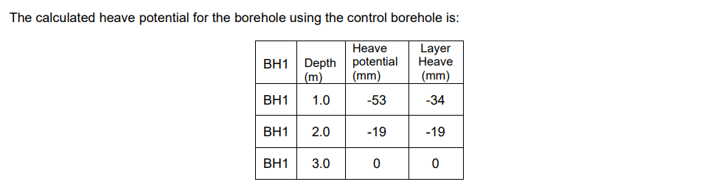

RECOMMENDATIONS

T1 Oak - Fell to near ground level (subject to consent being granted under the TPO)
T2 Oak – Fell to near ground level (subject to consent being granted under the TPO)

Statutory Controls – The trees are covered by a Tree Preservation Order administered by Eastleigh Borough Council, therefore an application is required and consent needs to be granted prior to any tree works occurring.

The trees are located within the insured address (T1) and within the rear garden of the neighbouring property, number 4 (T2).

RESERVES

Superstructure repairs - £14,000
Estimated Engineering solutions and superstructure repairs - £80,000 (Minimum)

Yours faithfully

Chris Davies Dip.Arb.(RFS), F.Arbor.A
Arboricultural Consultant - Subsidence Team
Crawford & Company

Standard References:
Anon, British Standard BS 5837 (2012), “Trees in Relation to Design, Demolition & Construction, Recommendations”, British Standards Institute. London.
Anon, British Standard BS 3998 (2010), “Tree Work - Recommendations”, British Standards Institute. London.
Biddle, P.G, (1998), “Tree Root damage to Buildings”, Willowmead Publishing Ltd. 2 Volumes, 376 & 299 pp.
Building Research Establishment, BRE Digests 63, 64, 67, Soils & Foundations, 240, 241 & 242, Low Rise Buildings on Shrinkable Clay Soils.
Cutler, D.F., (1995), “Interactions of Tree Roots & Buildings”, In Watson, G., and Neely, D., (Eds.), Proceedings of Trees & Buildings Conference, Lisle, Illinois, ISA Publications.
Cutler, D.F. and I.B.K. Richardson, (1989). Tree Roots and Buildings. Longman Scientific and technical. 2nd Ed. 71pp.
Gasson, P.E. and Cutler, D.F. (1990) Tree root plate morphology. Arboric. Journal 14, 193-264
Hipps, N.A., Atkinson, C.J. & Griffiths, H. 2006. “Pruning Trees to Reduce Water Use”. Information Paper 7/06 Building Research Establishment. Watford UK. 8pp.
Lonsdale L (1999) Principles of Tree Hazard Assessment and Management HMSO
Marshall, D., D. Patch and M. Dobson, (1997) Root barriers and building subsidence. Arbor Practice Note 4, AAIS. 8pp.
Mattheck, C. and Breloer, H. (1994) The body language of trees. HMSO 240 pp
Matheny N.P & J.R.Clarke, (1994), “A photographic guide to the Evaluation of hazard trees in urban areas”, 2nd Edition, International Society of Arboriculture.
Mercer G, A Reeves and D O’Callaghan “The Relationship between Trees, Distance to Buildings and Subsidence Events on Shrinkable Clay Soil” Arboricultural Journal 2011, Vol. 33, pp. 229–245, © AB Academic Publishers 2011
Shigo, A.L., (1986) A new tree biology. Shigo & trees, associates, Durham, New Hampshire, USA, 595 pp
Shigo, A.L. (1991) Modern Arboriculture. Shigo & trees, associates. Durham, New Hampshire, USA , 490pp
Strouts R.G & T.G. Winter (1994) “Diagnosis of ill health in trees”, HMSO 307pp
Town & Country Planning Act Part VIII (1990). Issued by the Secretary of State for the Environment, HMSO

Building Research Establishment, Garston, Watford. Tel: 01923.674040

