Front Landscaping Plan:
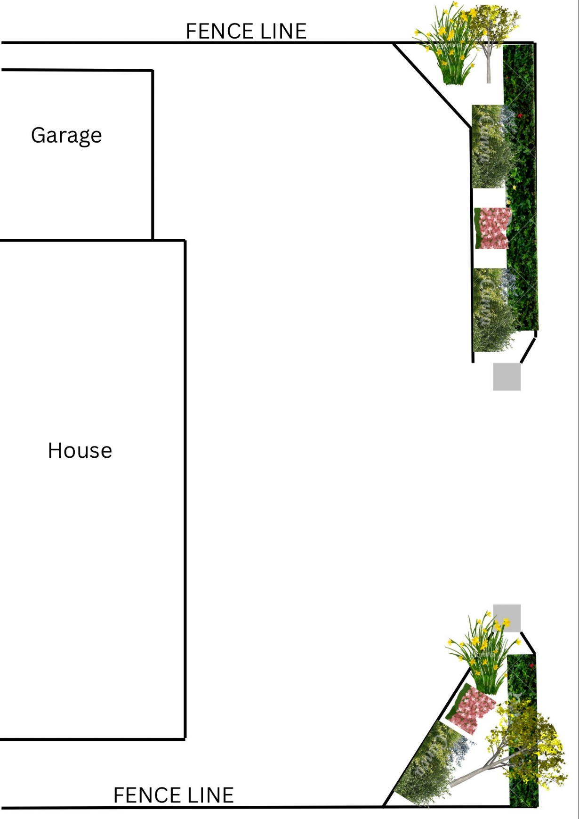

For maintenance:
- We plan to cut and prune at the correct times of year ensuring all wildlife stay protected.
- We plan to regularly water when needed especially for the first establishing of the planting phase; Regularly assess the health of the plants; Ensure we have weed control in place when needed. We will consider local biodiversity.

