

291 Market Street, Eastleigh, SO50 5QE
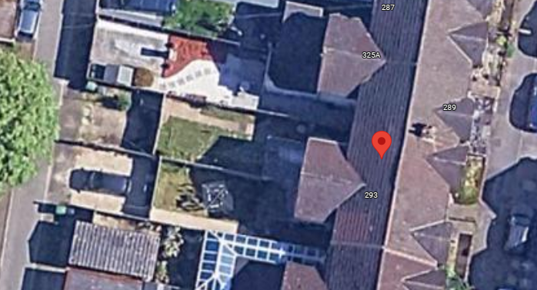

- Site
  - The application site contains a terraced property and is located within city of Eastleigh.
Application Site

- Site & Planning History
  - Eastleigh planning website shows 0 planning history for the application site.

- Proposal
  - The Proposal is for a change of use from a C3 dwelling house of 3 bedrooms to a HMO of 7 bedrooms (9 person).
  - The proposal will consist of a first-floor rear extension above the existing single storey to create another bedroom. There will be no issue with privacy or light to neighbours as there are no windows on the rear elevation that would affect the neighbouring property. The loft will also be converted as part of the proposal, including a rear dormer to accommodate a further bedroom.
  - The layout of the HMO allows for all bedrooms to meet the minimum space standards, with 2 bedrooms benefitting from an ensuite. The other bedrooms will be sharing the 2 shower rooms. The kitchen space provided meets the space standards of minimum of 7m² for 5 occupants plus an additional 1m² for every other occupant which equates to 11m².
  - The ceiling height in all rooms meets the minimum space standards of 2.3m. The larger room in the loft is partially under this limit but it well over the 75% floor space allowance of 2.3m ceiling height.
  - The parking space at the rear of the property is being maintained. There will be provision for bikes to be stored in the rear garden where there is access to a track from Market Street to Derby Road. Due to the location of the site within walking distance of Eastleigh train station and its close proximity to the town centre then the parking policy can be overlooked.
  - There will be a bin store to the rear of the property for general waste and recycling and will be stored within the boundary of the plot. Collection will also be to the rear of the property where the bins are currently collected from.
  - The amenity space equates to 77m² which is ample space for the number of occupants. There is also local public parks (Lakeside Valley Park) in close proximity too.

