JUNCTION CHURCH – Proposed replacement signage at 2 Romsey Road SO50 9FE

Current ERI sign :

210cm (W) x 80cm (H)

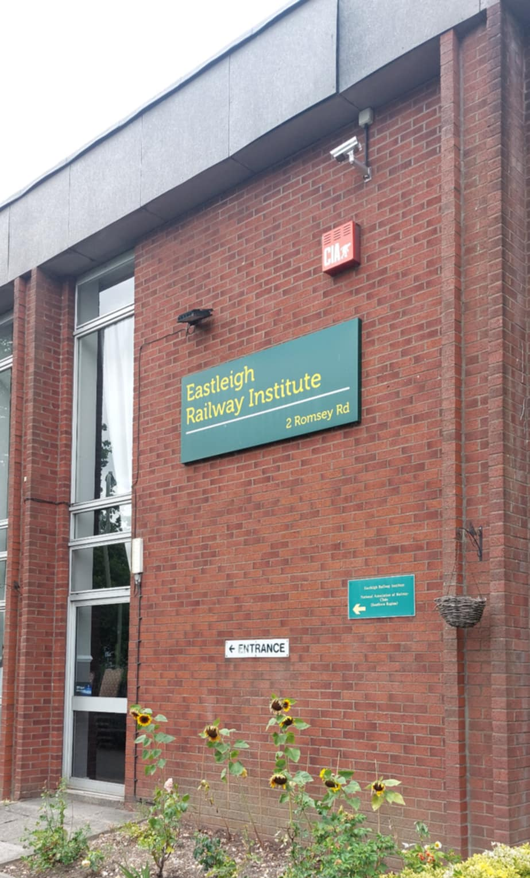

Proposed replacement sign :

210cm (W) x 210cm (H)

