Installation of catering hut – Deer Park Secondary School
Deer Park Secondary School, Sika Avenue, Botley.

Full-Application
Design and Access Statement (DAS)
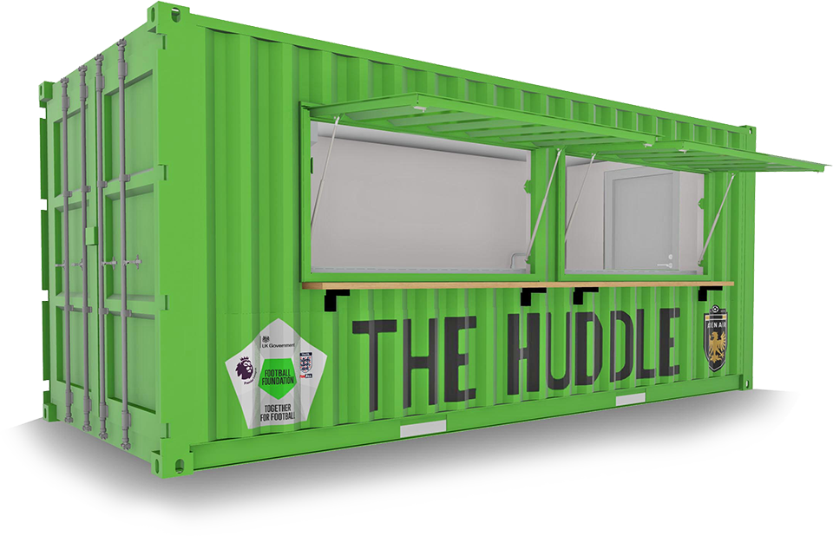
Contents
- Introduction and Background Page 2
- Context Page 3
- Design Principles Page 3
- Access Page 5
- Environmental Considerations Page 5
- Consultation Page 6
- Summary Page 7

- Introduction and Background
Hedge End Rangers Football Club are pleased to share proposals to deliver a pitch-side catering unit adjacent to the 3G football pitch facility at Deer Park Secondary School to improve the experience for players and spectators and provide a secondary income opportunity for the club.

Deer Park Secondary School was constructed and opened in September 2021. Shortly afterwards a Floodlit 3G Football Turf Pitch was delivered on the school playing fields under planning application reference F/20/89418 to enhance the quality of sports provision for both the school and local community. Since its installation, the pitch has been brilliantly used by the school and by community sports clubs out of school hours. In particular, local community football club, Hedge End Rangers, have formed a partnership with the school and use Deer Park as their home venue for their teams training and fixtures. The club also utilise the 3 community football pitches at the adjacent ‘Berrywood Fields’ for matches at weekends. Since moving to the new facilities in 2022, the club have grown from 26 to 44 teams and now boast men’s teams, and male and female junior teams from Under 7 to Under 18 age groups.

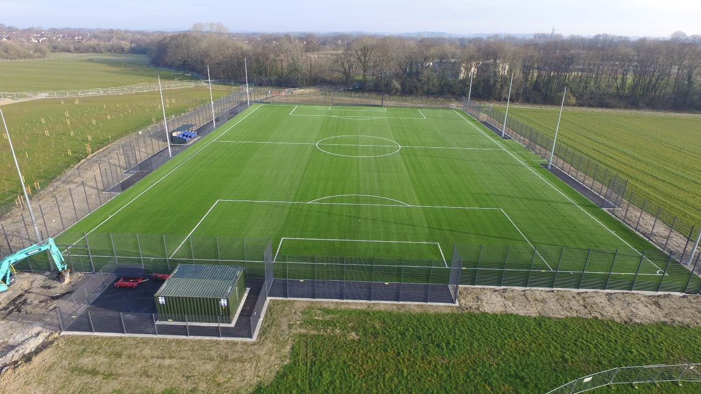
Figure 1 Existing 3G Football Turf Pitch at Deer Park School

The catering unit proposals form part of a Football Foundation initiative to improve the experience for players and spectators and provide a secondary income for community sports clubs to improve their viability. The delivery of the catering unit at Deer Park Secondary School will be subject to planning approval and a successful grant application to the Football Foundation.

- Context
Deer Park Secondary School is located off of Sika Avenue, Botley. The school playing fields - where the catering unit is proposed - form the southern half of the school site and consist of natural turf pitches used for school PE lessons and a floodlit 3G pitch used by the school and also hired by the community. Berrywood Fields resides to the West of the site consisting of public open space and 3 community football pitches. A residential development is located to the south west of the site. The north and east of the site are former arable land but have outline planning approval for 605 new dwellings under planning reference O/18/83634.
Please see ‘Location Plan’ and ‘Block Plan_Existing’ attached for context, along with a photo below providing context of the site.
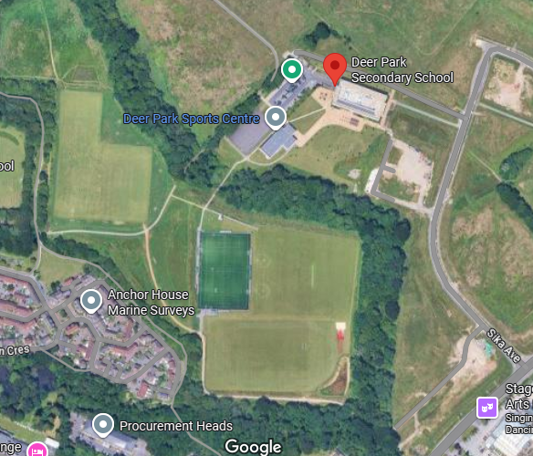

- Design Principles
  - Concept

As previously stated, the converted container catering units are part of a Football Foundation initiative to provide pitch-side refreshments for players and spectators to enhance their overall experience and help provide a secondary income for community sports clubs to improve their financial sustainability. The unit will only be used when the pitch facilities are already in use by the community, which will primarily be at weekends for matches during the football season, as well as occasional weekday evenings.

  - Layout Principles

The proposed location for the catering unit is as shown below, on maintained grassland and away from any trees or their root protection zones. This location has the following benefits:
- Adjacent to existing bollard-lit footway ensures the hut can be easily accessed safely in varying light conditions.
- Close to the 3G pitch for players and spectators to utilise
- Along the route from the car park at Deer Park School to the 3G pitch and Berrywood Fields pitches to benefit from pedestrian through-traffic from pitch users.
- Accessible for players and spectators of the 3 community grass pitches at Berrywood Fields to use at weekends.
- Within the secure fenced school boundary.
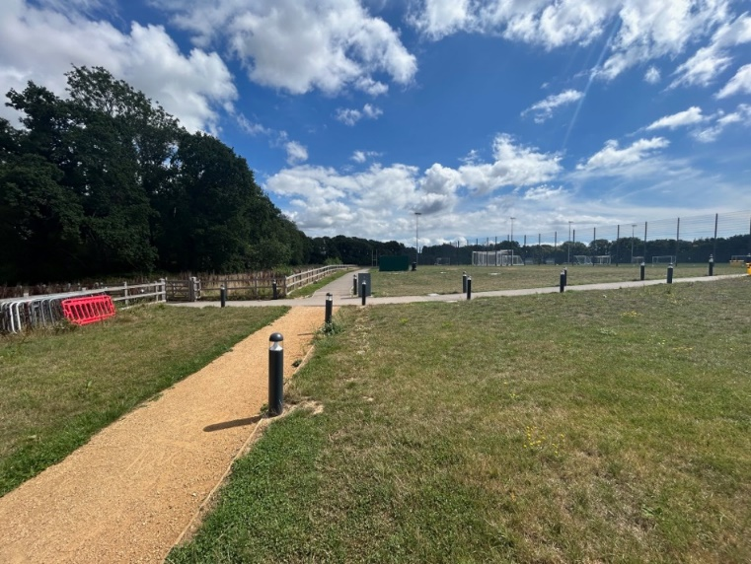
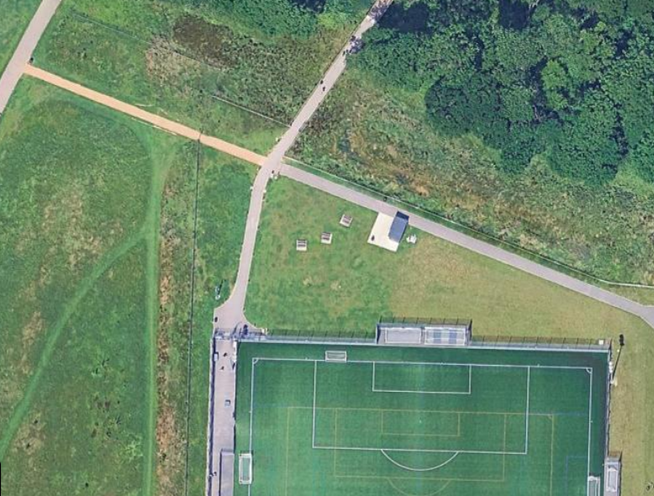
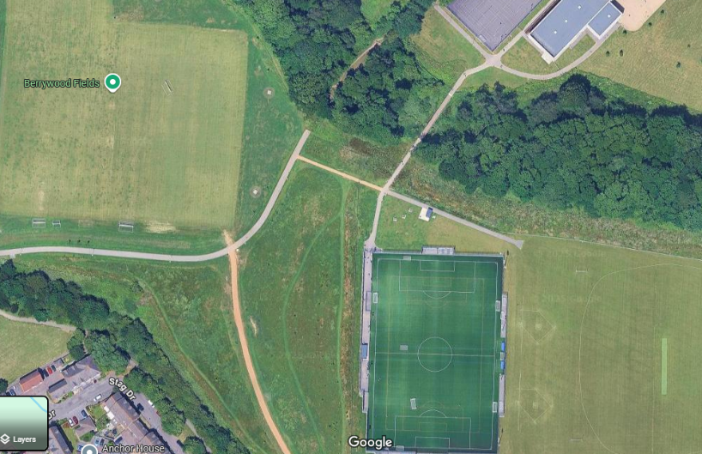
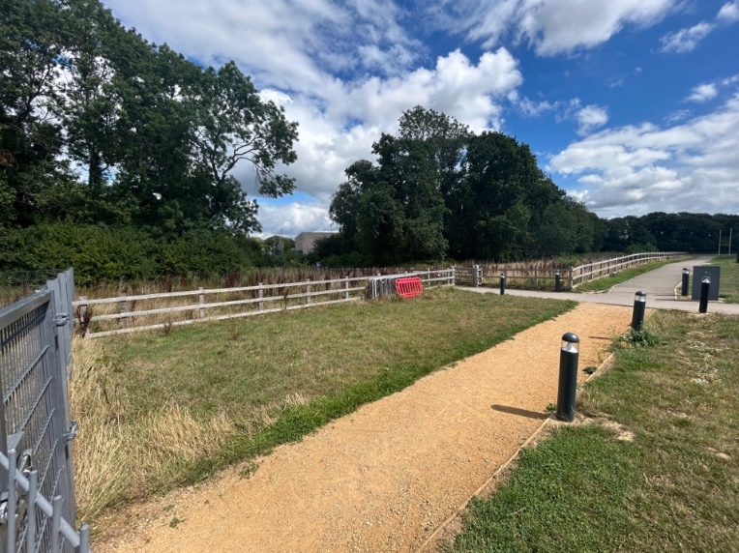
The converted container is a standard 20ft container with the following dimensions 6.06m (L) x 2.44m (W) x 2.59m (H) . Please see, ‘Floor Plan_Catering Hut’ and ‘Elevations_Catering Hut’ which accompany this application for details.

  - Elevations/External Finishes
The catering unit is a 20ft converted container solution – a set format and delivery model as part of the Football Foundation grant programme. An image can be seen below. Please see ‘Elevations_Catering Hut’ enclosed as part of the application for full elevation details.

This provides a cost effective and highly robust and secure solution given the relatively remote location of the unit, with ASB and security important considerations. However, the design still seeks to ensure it is in keeping with its location. Its location means it is not overlooked by any other properties.

- Access
The unit will be accessible by foot and bicycle only and used by those already using the Deer Park Community Sports Facilities or the adjacent facilities at Berrywood Fields.
This is an enhanced provision for existing hirers / users of the facilities so is not expected to generate any additional user traffic.

- Environmental Considerations
6.1 Conversation Areas and Trees: No trees will be lost or negatively impacted by the proposals. An ancient woodland SINC forms part of the school site and resides to the north of the proposed location for the catering hut. A GIS maps extract below shows the extent of the SINC boundary with the catering hut location more than 20m from the nearest tree canopy within the woodland SINC.

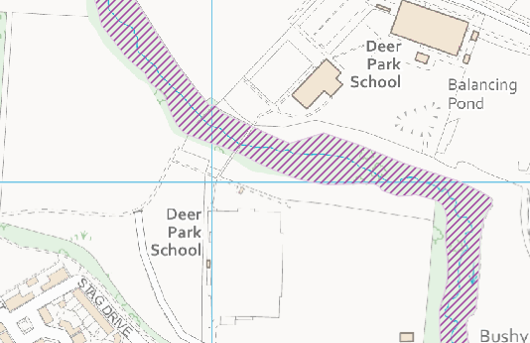
Figure 2 GIS Maps extract showing location of ancient woodland SINC >20m north of the catering hut proposed location
6.2 Lighting: The catering unit is adjacent to footways which are lit by existing low level bollard lighting. No additional lighting, temporary or permanent, forms part of the proposals apart form internal lighting within the container. The only external opening in the containers are the serving hatches (see Elevations), which will face southwards. Accordingly, any very minimal light spill would be away from the SINC located to the north. This aligns with policy DM34 guidance by avoiding an urbanising effect that would impact negatively on biodiversity.
6.3 Noise: A noise impact assessment to assess the possible noise impact on the local residential properties as a result of the development is not deemed required. The catering unit is located over 180m away from the nearest residential properties (to the south) and will only be used during usage times of the existing sports facilities, which generate significantly more noise, are closer to residential properties and had noise assessments approved as part of their respective planning applications.

- Consultation
Local Planning Authority: Contact was made with the local planning authority on 14th August 2025 to confirm if planning approval was required for this proposal and it was confirmed that it was.

Stakeholder Consultation: Consultation has taken place with RAISE Education Trust who run Deer Park Secondary School to agree the proposals and Hampshire County Council have also been notified of the application as landowner.

- Summary
The proposals are a low impact development which will enhance the experience for users and spectators at the community sports facilities at Deer Park School and the adjacent Berrywood Fields. The location has been carefully considered to avoid any adverse impact on the local residents or the local environment whilst remaining convenient for users.

In conclusion, the proposed development represents a valuable addition to this very well used community sports facility, whilst providing a secondary income opportunity for local community football club, Hedge End Rangers Football Club to enhance their financial sustainability.

