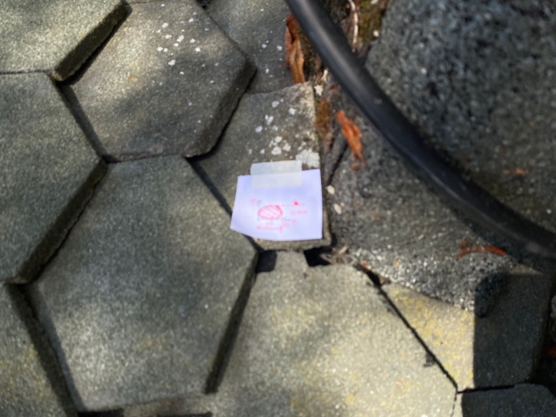  Including scale drawing of bat profile  5 | 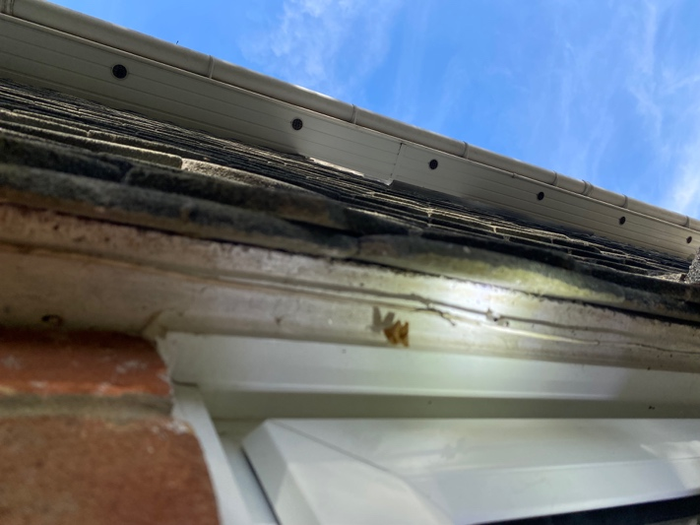  6
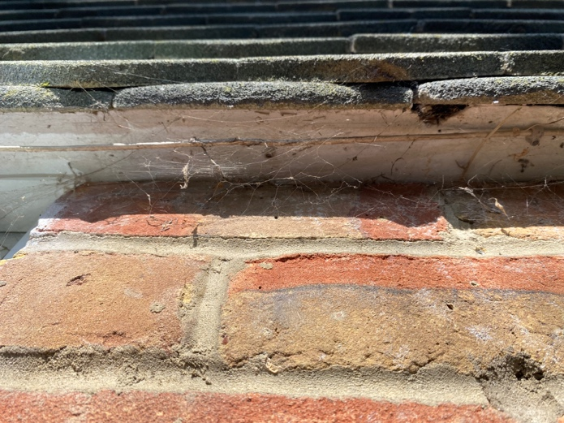  7 | 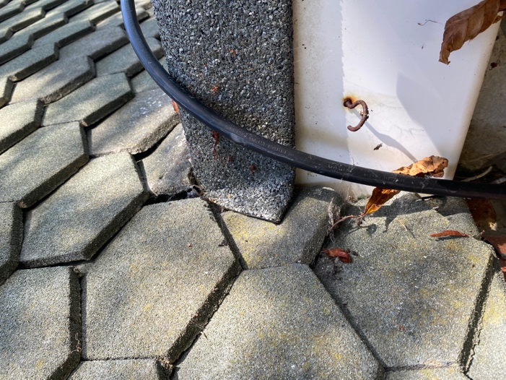  8

Alterations at  113 Brownhill Road  Chandlers Ford  SO53 2FH | ECOLOGY PHOTOS 5-8

