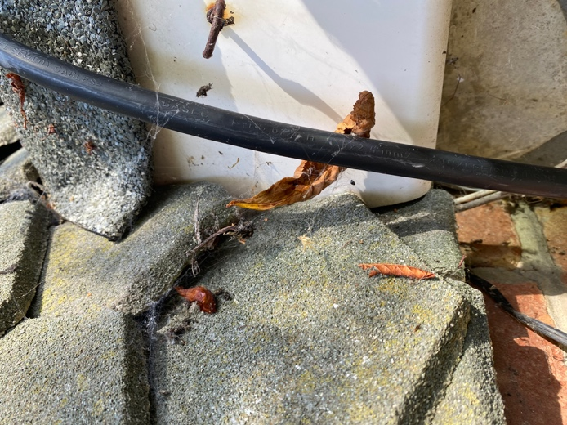  1 | 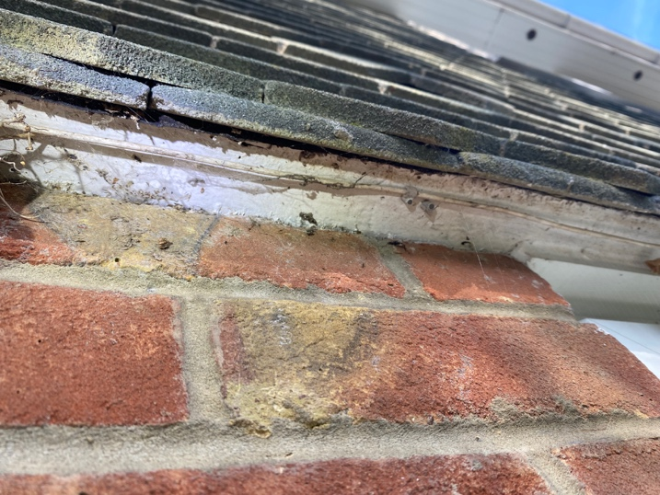  2
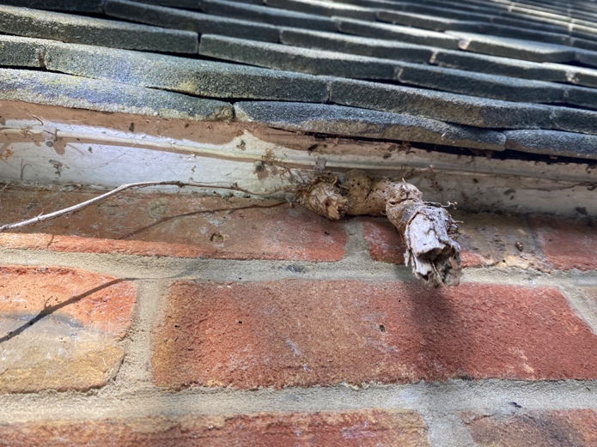  3 | 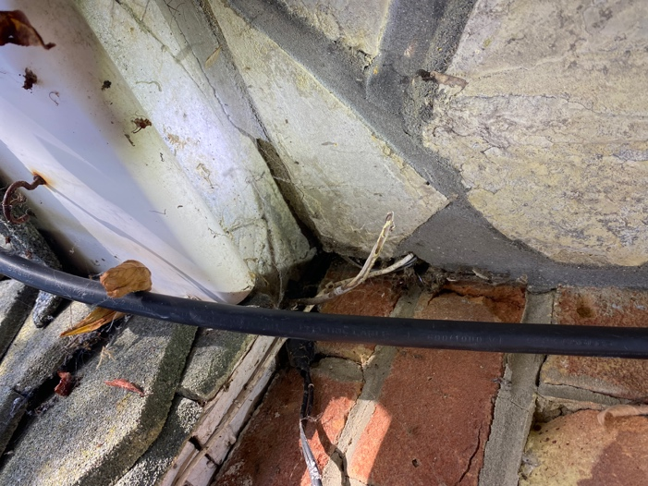  4

Alterations at  113 Brownhill Road  Chandlers Ford  SO53 2FH | ECOLOGY PHOTOS 1-4

