Planning Application for Tree Works
16 Crowsport, Hamble-le-Rice, SO31 4HG (Conservation Area)
To: Tree Officer, Planning Department
Local Authority: EASTLEAGH
Date: 6/10/2025
Dear Sir or Madam,
I am writing to request permission to carry out arboricultural works to specified trees and hedges within the garden of 16 Crowsport, Hamble-le-Rice. This application is based on assessed recommendations from Titchfield Tree Services and aims to ensure the safe, healthy management of significant trees and garden features in accordance with conservation area regulatory standards.

Site Overview & Supporting Images
The following aerial and situational images provide an overview of the garden layout and indicate tree and hedge placements relevant to this application:
- Aerial overview
- Rear garden Oak and general context
- Oak proximity to neighbouring property
- Laurel hedge aspect
- Camellia location

Proposed Works and Justifications
T1: Veteran Oak (Rear Garden)
- Condition: Veteran Oak with good vitality, demonstrated by leaf density and twig structure. Crown is biased to the south, likely as a result of historic pruning from approximately 2015.
- Action: Repeat localized reduction by reducing to previous reduction points on the southern crown (no more than 3m in length, live pruning wounds not exceeding 75mm). No reduction to tree height proposed.
- Deadwood: Remove major deadwood greater than 25mm diameter or 1m in length.
- Justification: Pruning to maintain structural balance and health, in accordance with past management and arboricultural advice.
- Supporting images:library+1

H1: Laurel Hedge (Southern Boundary)
- Action: Reduce eastern aspect of hedge by up to 1m in height to retain privacy for neighbouring dwelling.
- Justification: Maintains healthy growth and manages boundary screening without exposing adjacent property.
- Supporting image:library

T2 & T3: Camellia x 2 (Garden)
- Action: General trim to optimum size, retaining greenery and promoting healthy ornamental structure.
- Justification: Encourages healthy growth and maintains landscape aesthetics.
- Supporting image:library

Conservation Area Compliance
These works are minor maintenance interventions, consistent with previous authorised management and professional arboricultural advice. All proposed works adhere to British Standard BS3998:2010 “Tree work – Recommendations”. Live pruning cuts are minimal and carefully considered, ensuring the continued health and amenity value of these specimens.
Photographic documentation and the extract from Titchfield Tree Services (above, supported by attached images) are submitted to facilitate assessment. I confirm no tree is proposed for removal and the visual landscape character will be preserved.

I am happy to provide further information or arrange a site visit should you require clarification of any aspect. Thank you for your consideration.
Yours faithfully,
Nick O Donnell
16 Crowsport

This draft includes all necessary sections for a compliant application and clearly references the provided images for effective planning assessment.library+4
- https://www.perplexity.ai/search/9a9b580d-11d8-4d1e-82b1-f8266347c604
- https://www.perplexity.ai/search/7210a63e-f93d-48f3-bf15-e37a166bd664
- https://www.perplexity.ai/search/59624fbe-f41e-4caf-9399-29cb96c14c45
- https://www.perplexity.ai/search/4651ff12-c18f-415e-8429-8e02d0cd75cd
- https://www.perplexity.ai/search/fe747b5e-7d39-4579-9c70-a115292fecda
Images
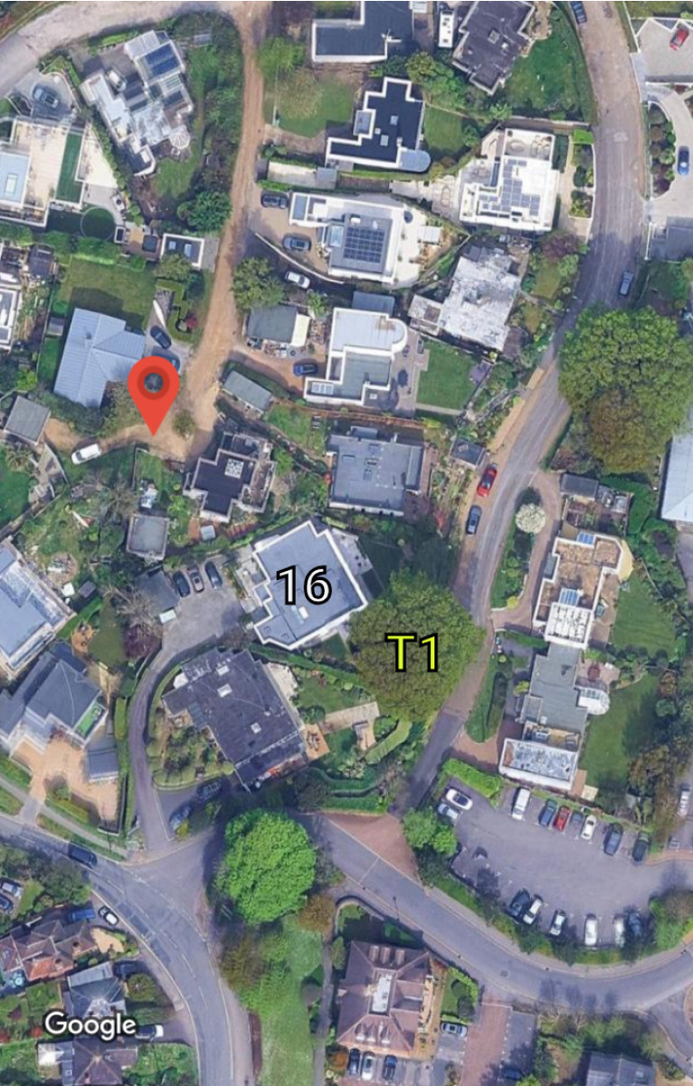

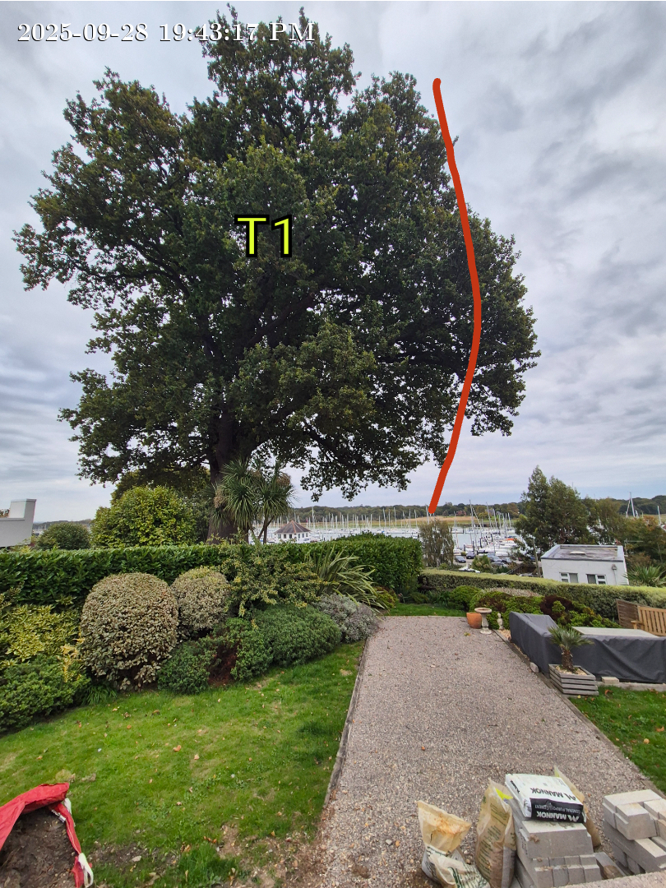

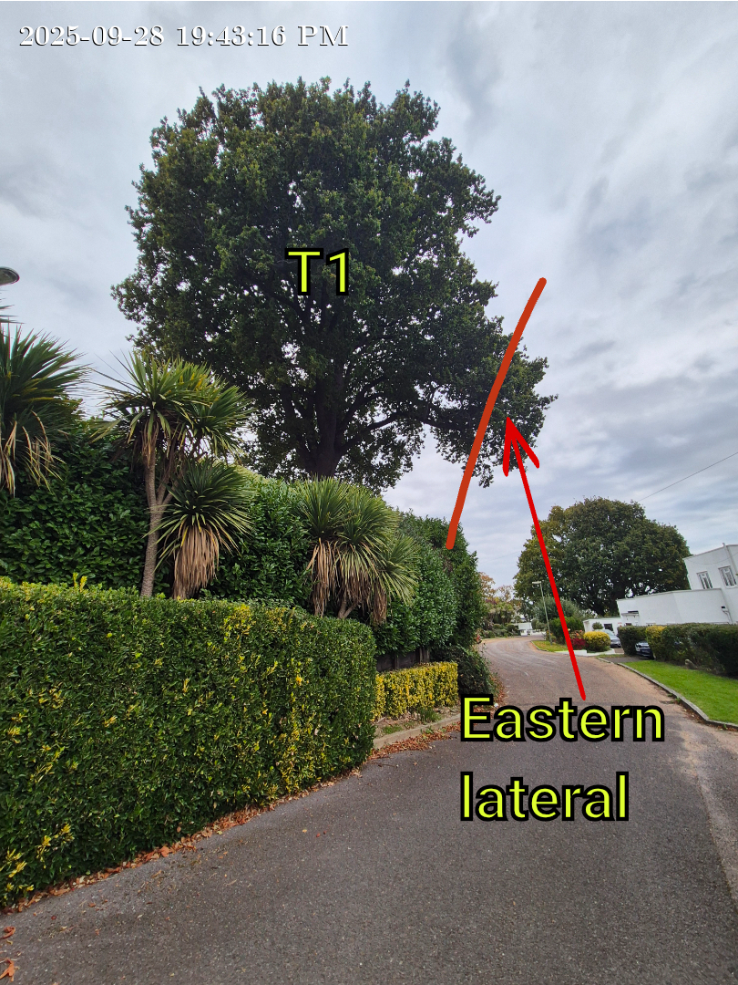

T2 and T3 Minor shaping
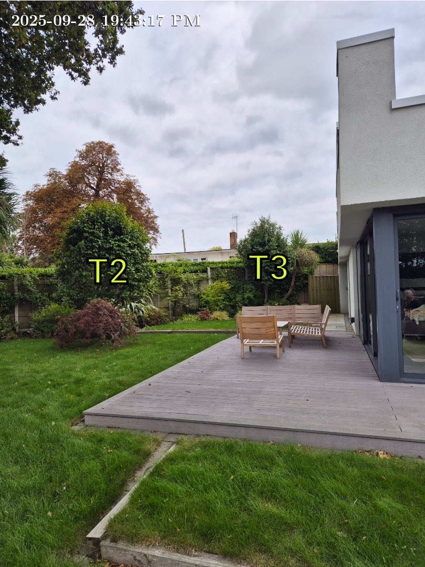

H1 – laurel hedge lowering by approx. 3 ft
