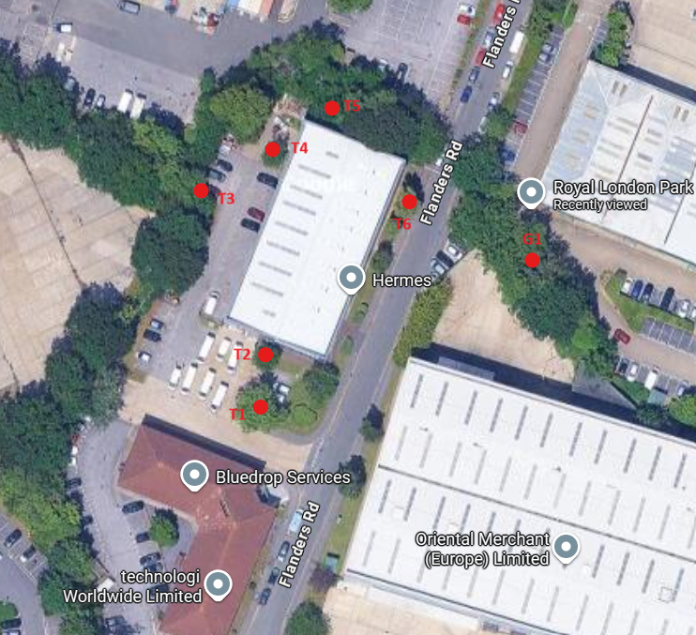

T1 – London Plane – Crown raise to height of 5.2m
T2 – Cherry – crown raise to height of 5.2m and reduce by 1.5m on building side to clear building by 2m as needed
T3 – Holly – crown raise to height of 3.5m
T4 – Cherry – reduce branches on building side by 2m to clear roller shutter doors by 2m
T5 – Cherry – reduce branches on building side by 1.5m to clear building by 2m
T6 – Lime – crown raise over road to height of 5.2m
G1 – x4 Oaks – Crown raise to height of 5.2m

