O/24/98619 Land south of Mortimers Lane, Fair Oak
Outline application with all matters reserved (apart from access) for the construction of up to 245 dwellings (Use Class C3) and up to 350sqm multi-functional building (Use Class E - commercial, business or service or Use Class F2 - Community), with associated open space and play area, landscaping, SuDS, infrastructure, mobility hub and vehicular access off Mortimers Lane.

Ecology comments Nov ‘25
Excessive loss of hedgerows along Mortimer’s Lane:
The redline boundary has now been extended to show the extent of proposed loss of the mature species rich hedgerow for the visibility splays and cycle path and hedgerow loss at the north of Mortimers Lane for road widening.
I am still opposed to the extent of loss of hedgerow (approx. 200m mature species rich hedgerow). I do not think it has been adequately demonstrated that alternative options have been fully explored, such as securing a cycle path link to Pembers Hill Drive at the north of the site’s western boundary which will significantly reduce the hedgerow loss along Mortimers Lane (although some removal will still be required for visibility splays).

Hedgerows in the BNG metric:
If the loss of the mature species-rich hedgerow is permitted, BNG rules will need to be met. A 5.63% net gain for hedgerows is currently proposed. The shortfall (10% BNG required) is proposed to be achieved via an off-site solution. It is not clear if this will be from the purchase of units or if there will be a bespoke off-site delivery solution. More clarity at this stage is required.
A BNG plan has not been provided and therefore proposals are still uncertain. Any replacement hedgerows must be located where they provide functional green links through the site, in particular mimicking those lost, such as the east-west connection at the north of the site.
More certainty of the BNG proposals would be preferred prior to consent to ensure effective BNG is deliverable.

Watercourses in BNG metric:
The extract below is taken from Habitat Survey (drawing number edp 7852_d011i) within the Ecological Appraisal.
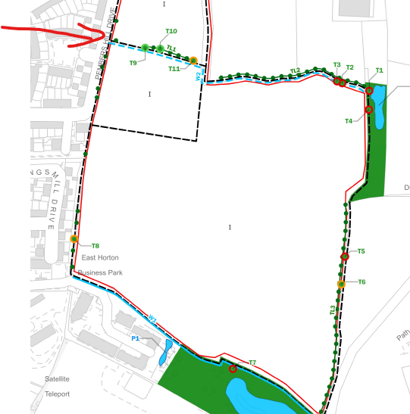
Watercourse W2 is currently not included in the metric. It runs through the site and continues just to the north of site boundary as shown above. The whole length needs to be included in the metric. A short section of this watercourse will be lost for the vehicular access. This needs to be recorded in the metric. As the nature of the watercourse changes, this may need to be recorded as multiple stretches. The same potentially applies to W1.
I remain convinced that both W1 and W2 are modified headwater streams (not ditches). I do not believe however that changing the classification will significantly change the net gain outcome of the watercourse component of the metric or require a significant change to the current schematic design of the site. It will just mean that 10m of riparian habitat (as opposed to 5m) will need to be enhanced (i.e. remove any existing or proposed encroachment), which appears to already be shown on the schematic design. However, making changes to the metric and securing a 10m riparian corridor at this stage now will provide certainty that 10% BNG will be delivered.
Regarding the enhancement of the riparian watercourse habitat, information on how this will be achieved within Appendix 8 is limited. Widening the functioning riparian corridor through favourable habitat management and by removing any obstructions, such as fencing can be specified. Additionally, as W2 partially passes through the site (as opposed to being adjacent) in-channel enhancements can also be delivered (which will compensate for any loss of channel for the vehicular access).
Note: The schematic plan shows two pedestrian crossing points across watercourse W1. These crossings, which would result in the loss of watercourse habitat (and potentially increased recreational impact on the Knowle Lane SINC), are not included in the application area and therefore cannot form part of the application.

Surface water drainage strategy:
The proposed scheme does not mimic the natural surface water pathways or catchments. All surface water from the site will be discharged at one discharge point (marked D.P. on the surface water flooding plan below). This means that surface water will be intercepted and effectively bypass the existing modified stream (W2 as shown on the habitat survey) which will reduce available water within the stream at this location and downstream to the confluence with the main river and is likely to adversely impact on its ecology. It may also adversely affect pond P3 for the same reasons. Similarly, watercourse W1, upstream of the discharge point (D.P.), may also experience reduced flows as existing flows are intercepted and diverted downstream to the discharge point.
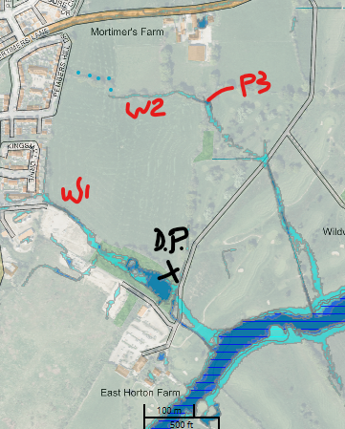
The surface water in the southernmost parts of the scheme will only pass through two stages of filtration (the forebay and main pond) as opposed to the required three stages.
Although I’m opposed to the current drainage proposals and plans, I anticipate an acceptable surface water drainage scheme can be designed. If permission is granted, a suitably worded condition will be required to ensure an appropriate scheme is delivered which must not preclude the necessary changes to the currently submitted scheme.
Please be aware that any changes made to the surface water drainage features may affect the BNG calculations.

Recommended conditions:
In addition to the above comments regarding BNG and the drainage strategy, we recommend conditions be placed on any permission granted on the matters below. Please consult us again for advice on wording:
- Drainage strategy.
- BNG (including HMMP).
- A minimum 20m biodiversity buffer to the SINC, free of any development including SuDS, fences and footpaths, must be provided.
- A minimum 10m biodiversity buffer to the watercourses free of any development including SuDS, fences and footpaths, must be provided.
- An appropriately sized biodiversity buffer to the retained perimeter habitats (such as treelines) free of development (including gardens, footpaths and other access) must be provided. This will either be a minimum of 10m or extent of tree canopies (allowing for future tree growth), whichever is the greater.
- CEMP.
- Ecological construction method statement.
- Soft landscaping scheme details.
- LEMP – to include details of ecological enhancements for species (e.g. hibernacula and integrated nest and roost boxes).
- Other mitigation measures identified in the Ecological Appraisal.
- Artificial lighting strategy.
- Shading assessment to ensure there are limited shading impacts from the development on the retained and created habitats i.e. building heights and massing must be designed appropriately.
- Any additional proposed tree loss beyond that required for the site’s vehicular access would need to be identified and approved by the LPA at the appropriate RM stage.

BNG Monitoring Fees:
If permission is granted monitoring fees will need to be secured through a Section 106 at grant of permission to cover the LPA’s costs for monitoring the BNG habitats for the legally required 30 years.

Sarah Boyd
Ecologist

