Sketch Plan for Ivor Lodge, Windmill Lane, Burseldon, SO31 8BG

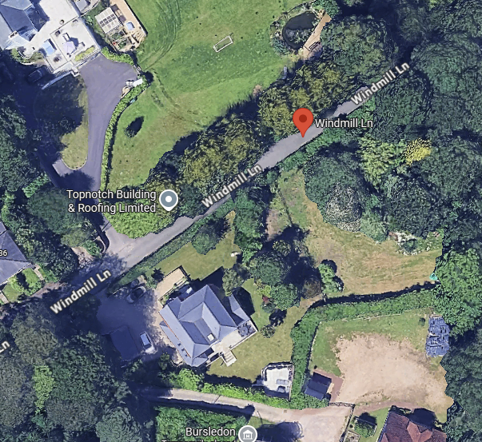
T2
T1

