Hi Gregg,
Please find below the combined landscape and urban design comments.

These are primarily Tim Griffin’s comments, with a few additional notes from me highlighted in blue.

Kind regards
Marta

Marta | Oliveira | ​​​​

Contractor

Senior Urban Designer
Planning & Environment - Urban/Landscape Design
Ext.: | 8032

From: Griffin, Tim (Contractor) <Tim.Griffin.Contractor@eastleigh.gov.uk>
Sent: 20 November 2025 15:52
To: Oliveira, Marta (Contractor) <Marta.Oliveira.Contractor@eastleigh.gov.uk>
Cc: Ellison, Mark <Mark.Ellison@eastleigh.gov.uk>; Dyer, Tim <Tim.Dyer@eastleigh.gov.uk>
Subject: Re: DC/25/99538 Land west of Burnetts Lane - landscape comments

Hi Marta,
I have taken the time to review the numerous landscape plans submitted for this Lower Acre site.
In way of background, this is my first look at the planting details. I am not aware of any landscape comments that may have been made on earlier landscape plans for the site.
Was a landscape strategy plan submitted as part of the full application package? If not, this was a mistake as comments on the overall approach to tree planting should have proceeded fully detailed planting plans.
I picked up a landscape explanatory note ref. tree planting which states:
'The revised layout has been carefully coordinated with the foundation, drainage, and lighting designs to ensure all elements can be delivered efficiently and without future maintenance conflicts'.
I fear that the internal tree planting may have been unduly limited by these criteria. Further coordination work is required. It would appear that with a relatively simple re-routing of some service runs, additional tree planting is feasible.
For future phases at Horton Heath, we should insist on the opportunity to comment on an initial landscape strategy plan. This would be the ideal stage to agree the distribution of tree planting across the site. This would also avoid abortive design work.
My landscapecomments follow below.
Landscape General Arrangement Plans Sheet 1 to 4
(Note - comments apply across all drawings).
a/ Overall, the density of new tree planting within internal areas of this site are far too low. In particular, internal street tree planting will be a key component to creating an attractive setting for the development, whilst also contributing to Green Infrastructure.
Looking at this plan there appears to be a considerable number of missed opportunities to introduce street trees. I have taken a few snapshots of example areas from Sheet 1 where this would seem to be the case:

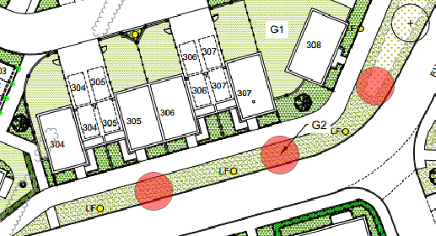

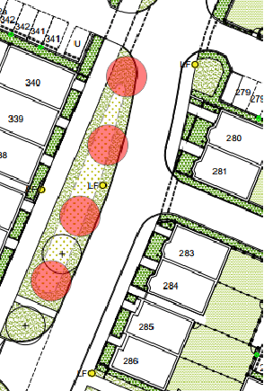

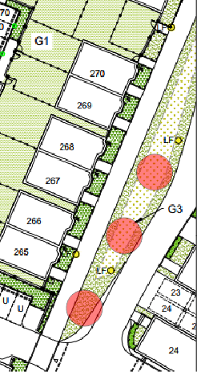

Please ask the Landscape Architects to review all the plans and maximise opportunities for street tree planting. This will require close co-ordination with the Engineers, with some service routes being adjusted as required. Where tree planting is not feasible, the reasons should be given (including evidence of service runs etc.).

b/ It is extremely disappointing to note that many parking courts are devoid of tree planting. These spaces will be bland and exposed as a result. The designers need to review the plans and maximise every opportunity to introduce additonal trees. As examples, here are a few examples from sheet 1 where tree planting should be feasible:

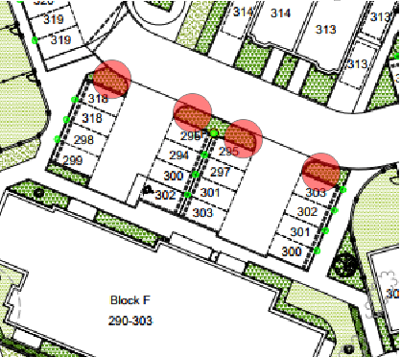

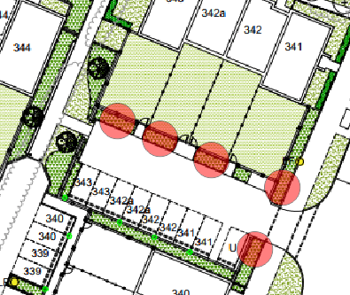

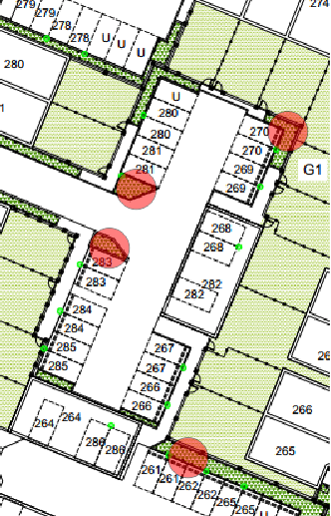

I totally agree that the parking courts are particularly exposed and risk becoming bleak spaces unless additional landscape structure and enclosure are introduced.

I appreciate some of these trees will be in restricted beds, but with the correct species selection there is no reason why these trees can't survive.

c/ The mown grass paths (G3a) have varying shape/widths. How will these demarcated to aid maintenance crews?

d/ Narrow strips of grass along base of buildings should be replaced by shrub planting to soften built form - a few examples Plots 27-31, Plots 32-36, Plots 46-50 & Plots 92-94 - (check other locations on plans where same situation).

e/ There are a number of small oval beds of shrub planting in areas of grass that will complicate maintenance work - for example W of Plot 231, W of Block E, N Plot 68&69 & N of parking bay 199 etc. These should be omitted/rationalised/re-shaped te ease management.

Landscape General Arrangement Plan Sheet 1 of 4

There appears to be new trees planted within an existing hedgerow? Please adjust.

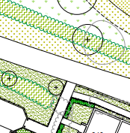

I am struggling to understand the rationale of the tree planting in this OS. Neither formal or truly random? My own view would be that a more formal arrangement of tree planting, with reduced species mix, would provide the space with a stronger framework.

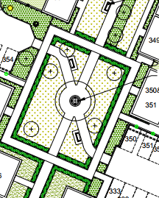

The current tree arrangement appears to sit uncomfortably between a formal and informal (or naturalistic) approach. Trees are neither aligned to a clear geometry nor arranged with enough randomness to feel intentional. As a result, the landscape lacks a readable hierarchy and a strong visual rhythm.

It would be encouraged to adopt a more formal, structured layout, aligning trees with key axes, pathways and geometries of the space (particularly the central circular feature and radiating paths). A formal approach is advised given the strong geometric structure of the hardscape.

Landscape General Arrangement Plan Sheet 2 of 4

No additional comments to those above.

Landscape General Arrangement Plan Sheet 3 of 4

Although the layout of this key space is noted as 'indicative' the arrangement of tree planting shown at the moment lacks coherence. This should be redesigned and there is scope here to create a more formal effect using a limited number of species. At present the species mix is too diverse, and in some cases, impractical (e.g. line of Corylus avellana 1m from footpath).

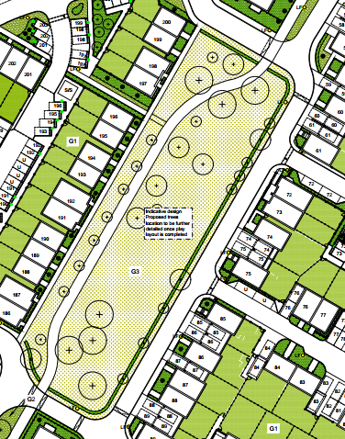

Some desires lines can be predicted, so occasional gaps in the hedge along the E edge of the OS should be allowed to avoid damage to the hedging by residents creating their own access routes.

The arrangement of landscape elements—particularly the tree planting—lacks an underlying structure or clear guiding principle. The result is a space that feels visually fragmented and weak in identity. It would be encouraged to redesigned the space with a clear spatial hierarchy, establishing a legible structure that reflects its importance within the wider layout. I also agree with the Landscape Officer regarding the need to allow for occasional gaps in the hedge to accommodate likely desire lines.

Landscape General Arrangement Plan Sheet 4 of 4

No additional comments to those above.

Tree Planting Strategy Plans (sheets 1 - 12)

The plans reveal that the density of internal tree planting is too low to create an attractive setting for the development. The majority of parking courts lack any medium/large trees, and in some cases, the only higher-level softening is tall specimen shrubs. I hope that this situation can be improved for the benefit of future residents and local fauna.
The tree planting plans that show service/drainage runs need to be reviewed since there are locations where services are running directly through tree pit:

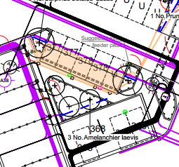

Specific comments:

1/ Some key open spaces have too diverse a range of tree species. Reduce the range of species so that the spaces have coherence and individual character.
2/ Tree planted adjacent parking bay 318 - in smaller bed. Replace Birch with known robust species such as Acer campestre 'Elsrijk' or Carpinus 'Lucas'.
3/ Planting schedule - Fagus spp to be pot grown. Include some Sorbus aucuparia (reduce Hupehensis?). Replace Goat Willow with an alternative native species (unless Ecologists specifically requested Goat Willow).
4/ 61 Corylus avellana are specified. Usually these are supplied as multi-stemmed but on the schedule specified as selected standards? Are stds. of this species widely available? How would these be maintained to prevent GL suckering?
5/ The sizes of trees supplied varies greatly. Would it be easier to standardise the sizes to min. Ext. Hvy. Stds. 14-16cm girth?

Tree Pit Details

These are generic details and generally acceptable. Can the applicant confirm if any specialist pits are proposed (TP01 and TP03) on this site, and if so, their location. The Landscape Management Plan states street trees will be planted in specialist tree pits?
TP2 - supporting band around tree and stakes - biodegradable options preferred.

Soft Landscape Specification

Development sites often suffer from waterlogging post completion because contractors fail to loosen compacted ground before importing and spreading topsoil. Although this is noted in the specification, (subsoil preparation, Clause 665), perhaps a note on the title page could highlight that this is a critical stage of work so it is not missed by groundworks contractors and the site manager. It would helpful if the depth of loosening was specified and the means (using a toothed bucket).

Root barriers - where will these occur (indicate on plan).

Landscape Management Plan

Genrally acceptable. Provide increased detail on watering, especially of trees in first 2 years after planting. Indicate frequency, quantity of water per tree etc.

Detailed Planting Plan (sheets 1 - 12) - Note please review all plans to accomodate the comments below.

The Landscape General Arrangement Plans do not accord with the planting shown on these detailed drawing. For example, front gardens indicated as grass on the GA plans are shown as planted on the planting plans. Please check.

Shrub planting is shown hard up to the kerbline around parking bays which will result in planting being trampled as people access cars. Please ensure planting will not be damaged with 300mm wide strip of mulch or 20mm shingle as required.

There is a wide species mix in most planting beds which is likely to revert, long-term, into a 'jumbled' mass of planting. Simpler sweeps of individual species would be preferred.

Some locations indicate very low groundcover which will have limited positive visual impact, and in other cases, the beds are likely to get trampled/damaged over time. A few examples:

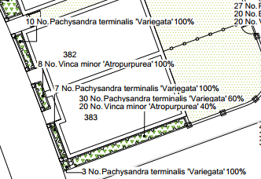

Is planting in narrow strips that are around 300mm wide realistic bearing in mind kerb haunching/foundations? Realstically, very narrow strips best shown as hard paved.

The species specified on the snapshot above are too low growing to have any softening effect. Especially along the flank wall, some low shrub planting (Hebe 'White Gem', Lavender, Rosemary etc) with occasional climbers would be far more effective.

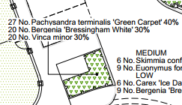

Groundcover planting around a BCP/store? No screening value.

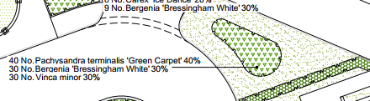

This island bed is a very odd proposal. I could understand the groundcover species mix if there was a group of 3 taller specimen shrubs included, but as designed, it will have low visual impact and be problemtaic to maintian (edging curved bed). Please re-consider (applies to a number of other locations on this site).

Other detailed points:
a/ On the latest revised planting plans climbers appear to be missing. Please check. Climbers will have an important role to soften walls and fences.
b/ There is an over-reliance on Hebe rakaiensis which can suffer from sudden dieback - please replace a % with other robust Hebes.
c/ Further sun loving plants such as Caryopteris, Nepeta racemosa 'Walker's Low', Potentilla, etc could be added to the species mix for added interest.
d/ Check Sarcococca spp. will adapt to the soil conditions on this site. The performance of this species is variable. May be worth replacing with failsafe alternative evergreen species.
e/ Other species that have been over-used on this site include; Euonymus 'Silver Queen', Hebe 'Burgundy Blush', Pachysandra spp., Skimmia spp. and Vinca spp. Please introduce alternatives for improved effect and resilience.
f/ Across plant categories (excl. formal hedges and native hedgerow) - generally stock min. 3L pot grown for reasonable immediate impact.

I appreciate the significance of the above comments, so if the applicant wishes to either have a face-to face or teams meeting I am happy to attend.
For remaining phases at 1 HH, I suggest an initial team meeting to discuss the landscape approach before the landscape architects produce detailed plans would be really helpful and would avoid abortive work/frustration.
Let me know if you need any clarification. Happy to adjust my comments as needed.
KR Tim

Tim Griffin
Landscape Consultant
Working on behalf of Eastleigh Borough Council
Mobile: 07974 900280

