46 Station Road,
Netley Abbey,
Southampton,
SO31 5AF

PRELIMINARY ECOLOGICAL
APPRAISAL
November 2025
Dr.Jonty Denton (Chartered Ecologist) FRES FLS MCIEEM CECol

Prepared by
Dr. Jonty Denton BSc (Hons) D(Phil) FRES, FLS, MCIEEM, CEcol
31 Thorn Lane, Four Marks, Hampshire, GU34 5BX
Phone: (01420) 565647 mobile: 07385752793

The contents of this report were correct at the time of the site visit. The report is provided for the sole use of the named client and is confidential.

All rights in this report are reserved. No part of it may be reproduced or transmitted, in any form or by any means, electronic, mechanical, photocopying, recording or otherwise, or stored in any retrieval system of any nature, without our written permission. Its content and format are for the exclusive use of the addressee in dealing with this. It may not be sold, lent, hired out or divulged to any third party not directly involved in this situation without written consent.

EXECUTIVE SUMMARY
Consultant Chartered Ecologist Dr.Jonty Denton FRES FLS MCIEEM CEcol (Bat license: 2025-82187-CL17-BAT) was commissioned to produce a Preliminary Ecological Appraisal of land at front of 46 Station Rd., Netley Abbey, Hampshire SO31 5AF (National Grid Reference SU458084).

The survey area was systematically walked and surveyed according to Phase 1 Habitat Survey criteria during daylight hours by Dr.Jonty Denton on 29th November 2025. Phase 1 Habitat Survey is a standardised system for classifying and mapping semi-natural vegetation and wildlife habitats in Great Britain. Vegetation is mapped in terms of standard habitat types as defined in the JNCC Handbook for Phase 1 Habitat Survey (2010).
The proposed redevelopment does not fall on any UKBAP habitats. It would result in the loss of a small area of species poor amenity grassland, and a 5m of ornamental hedge which will be replaced with a native hedge. A trading summary has been produced and off site compensation will be required

METHODS
Phase 1 Habitat Survey Methods
The survey area was systematically walked, and habitats mapped according to Phase 1 Habitat Survey criteria during daylight hours on 29th November 2025. Phase 1 Habitat Survey is a standardised system for classifying and mapping semi-natural vegetation and wildlife habitats in Great Britain. Vegetation is mapped in terms of standard habitat types as defined in the JNCC Handbook for Phase 1 Habitat Survey (2010).
In addition, habitats were appraised for their suitability to support protected or notable (UK Biodiversity Action Plan/Species of Principle Importance [S41]) species, e.g. breeding birds, badgers, bats, herptiles, stag beetle, that might be affected by the proposed development; in accordance with the ‘Guidelines for Baseline Ecological Assessment’ (IEA, 1995).

Background Data Search
A desk-based assessment was carried out using the DEFRA MagicMap website https://magic.defra.gov.uk/MagicMap.aspx to identify all designated sites within 5km of the site and all other designated sites and protected species within 2km.
A search was made for information on statutory designated sites (often internationally and nationally important sites for ecology) and non-statutory designated sites (often important in a local context) within 1 km of the site boundary.
Phase 1 Bat Survey Methods
The Daytime Bat Assessment / Phase 1 Bat Survey was undertaken in accordance with the Bat Conservation Trust Guidelines (Collins, 2023).
The Phase 1 Bat Survey was carried out and comprised of a daytime walkover of the site.
The survey conformed to current Bat Conservation Trust guidelines (Bat Conservation, (2023) Bat surveys for professional ecologists: Good practice guidelines 4th edition).

RESULTS
Phase 1 Habitat Survey Results

Background Data Search
A desk-based assessment was carried out using the DEFRA MagicMap website https://magic.defra.gov.uk/MagicMap.aspx to identify all designated sites within 5km of the site and all other designated sites and protected species within 2km.
A search was made for information on statutory designated sites (often internationally and nationally important sites for ecology) and non-statutory designated sites (often important in a local context) within 1 km of the site boundary.
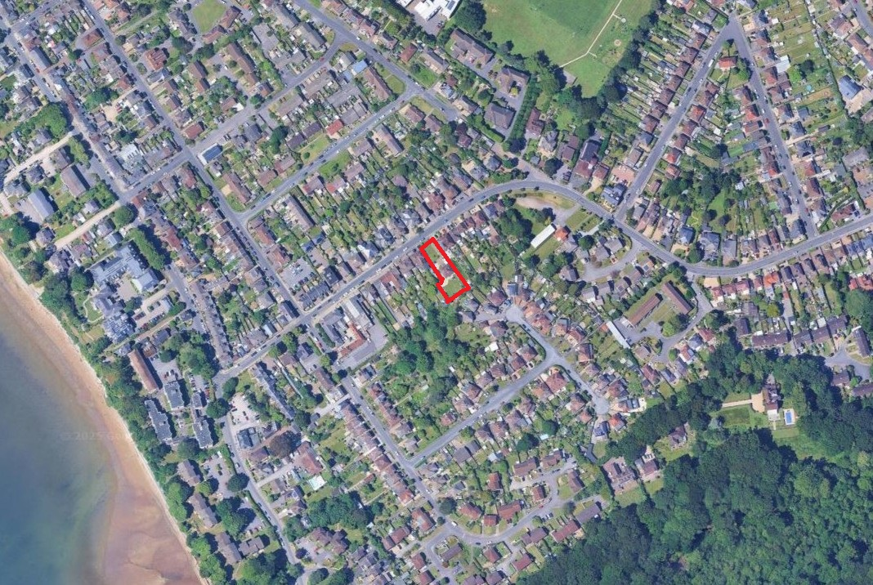
Figure 1. Site location. Courtesy of Google images
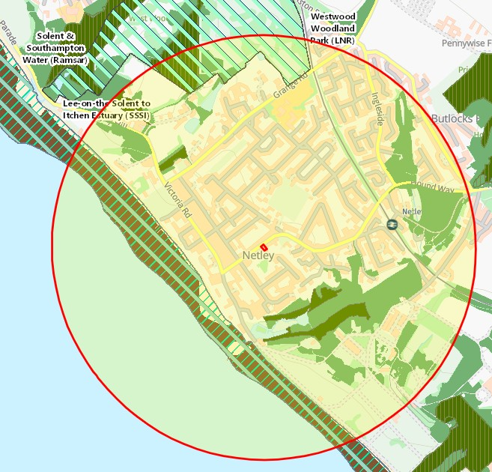
Figure 2. Priority habitats and designated sites within 1000m. Courtesy of Magicmaps.

PROTECTED HABITATS
UK Biodiversity Action Plan (UK BAP) Priority Habitats are also Habitats of Principle Importance (HPI) listed under The Natural Environment and Rural Communities Act 2006 Section 41 (NERC S41). These habitats do not receive statutory protection, but the S41 list is intended to provide guidance to decision-makers, e.g. those representing public bodies and local/regional authorities, in implementing their duty under Section 40 of the NERC Act to ‘…have regard to the conservation of biodiversity in England when carrying out their normal functions’.

The site lies inside the Nitrate Vulnerable Zone as defined by DEFRA 2017.
The plot is 333m to the northeast of Lee-on-Solent-Itchen Estuary SSSI and Solent & Southampton Water Ramsar site. Westwood Woodland LNR is 786m to the north. (See figure 2).
The site lies inside the Nitrate Vulnerable Zone as defined by DEFRA 2017.
There are woodlands included in priority habitats inventory 278m to the southeast and mudflats 333m to the southwest.

SITE DESCRIPTION
The property is situated in south of Station Road in Netley Abbey, in a suburban setting at the edge of the Southampton conurbation (See figure 1).
The site comprises amenity grassland block paved driveway and ornamental shrubbery (see figures 3-6).
Reptiles
All native British reptiles are protected under the Wildlife and Countryside Act (1981) from killing and injury. Sand Lizards and Smooth Snakes also receive additional protection under the Conservation (Natural Habitats &c) Regulations 2010 from intentional killing and injury and from intentional damage, destruction or obstruction of access to a place of shelter. All native UK reptiles are UK BAP Priority Species and SPI.

The site has no structured habitat and therefore has negligible potential for reptiles.

Amphibians
Great Crested Newts are protected under schedule 5 of the Wildlife and Countryside Act 1981 and of the Conservation (Natural Habitats &c) Regulations 2010 from intentional killing and injury and from intentional damage, destruction or obstruction of access to a place of shelter. In addition Great Crested Newts and Common Toads are UK BAP Priority species and SPI.

The nearest GCN return is from over 3.4km away to the north in Sholing and 4.4km to the east at Swanwick Pits. Amphibians such as Common Frog and Common Toad (UKBAP/SPI) may occur in the wider.
The site has no structured habitat and therefore has negligible potential for amphibians.

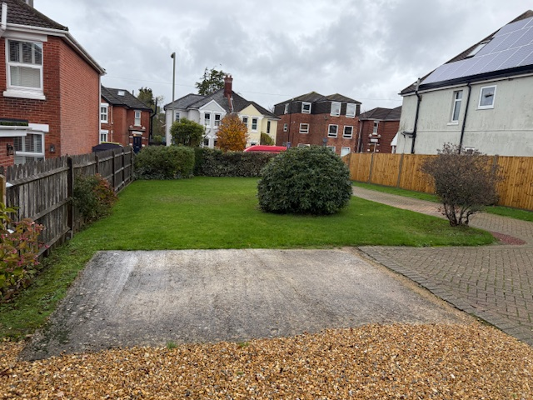
Figure 3. Site looking north

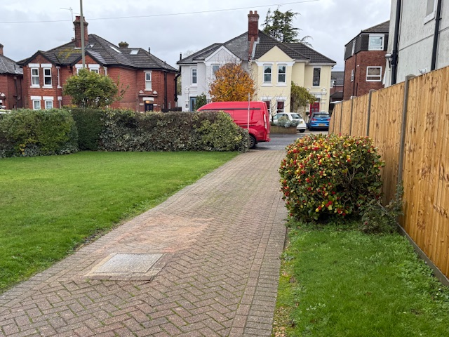
Figure 4. Site looking north along drive

Badgers
Badgers are protected under the Protection of Badgers Act 1992, which makes it illegal to kill, injure or take a badger or to interfere with their setts; such as by the use of heavy machinery nearby.

There was no sign of any badger activity on site, but badgers occur in the wider area.

Phase 1 Bat Survey Methods
The Daytime Bat Assessment / Phase 1 Bat Survey was undertaken in accordance with the Bat Conservation Trust Guidelines (Collins, 2023).
The Phase 1 Bat Survey was carried out and comprised of a daytime walkover of the site, internally and externally, to record evidence of any protected bat species.
Details of the survey methods are given below.
The survey conformed to current Bat Conservation Trust guidelines (Bat Conservation, (2023) Bat surveys for professional ecologists: Good practice guidelines 4th edition).
There are no structures or trees on site.

Breeding Birds
All wild birds are protected under Wildlife and Countryside Act 1981, as amended, from damage or destruction of their nest whilst in use or construction, some birds listed on Schedule 1 receive additional protection from disturbance during nesting.

There are no features on site which birds could use for nesting. The Solent is internationally important for wildfowl and waders and Brent geese commute between the mudflats and sports fields and grassy areas where they graze, but the property is separated from the mudflats and any regular flightpaths by 330m of suburbia, and no impacts are foreseen by the proposals.

EVALUATION, IMPACTS AND RECOMMENDATIONS
Protected Habitats
The proposed redevelopment does not fall on any UKBAP habitats. It would result in the loss of a small area of species poor amenity grassland, and a 5m of ornamental hedge which will be replaced with a native hedge. A trading summary has been produced (see appendix 1). The development has a small shortfall and 10% net gain cannot be created on site.
Protected Species
Reptiles & Amphibians
The plot has negligible potential for reptiles and limited potential for common amphibians.

Badgers
No badger activity was detected on site. Badgers occur in the wider area, therefore good building practice should be followed (such as placing boards over holes or trenches overnight) to prevent animals being harmed during site works.
Bats
There are no buildings on site and no trees on site or within 25m with any potential for bats.

Breeding Birds
Any removal of vegetation on or adjacent to the site should be undertaken outside of the bird nesting season, which is typically 1st March to 31st August.

REFERENCES
- CIEEM (2011) Professional Guidance Series 10: Guidance on metadata Standards: Reporting, sharing and archiving ecological data.
- Collins, J. (ed.)(2023) Bat Surveys for Professional Ecologists: Good Practise Guidelines (4th edn). The Bat Conservation Trust, London
- Communities and Local Government (2012) Technical Guidance to the National Planning Policy Framework. Department of Communities and Local Government, London.
- English Nature (2001). Great crested newt mitigation guidelines. English Nature, Peterborough.
- English Nature (2004) Reptiles: Guidelines for developers. English Nature, Peterborough.
- English Nature (2006) Wildlife and development. English Nature, Peterborough.
- Institute of Environmental Assessment (1995). Guidelines for Baseline Ecological Assessment. Institute of Environmental Assessment, London.
- JNCC (1998) Herpetofauna Workers’ Manual. JNCC, Peterborough.
- JNCC (2010) Handbook for Phase 1 Habitat Survey: A technique for environmental audit. JNCC, Peterborough
- Natural England (2009) Badgers and Development. A Guide to Best Practice and Licensing (Interim Guidance)
- Natural England (2011) Reptile mitigation guidelines. Natural England.
- ODPM (2005) Government circular: biodiversity and geological conservation – statutory obligations and their impact within the planning system. The Stationary Office.
- The British Standards Institution (2013) Biodiversity – Code of practice for planning and development. BSI Standards Limited.

